Required Components
1.  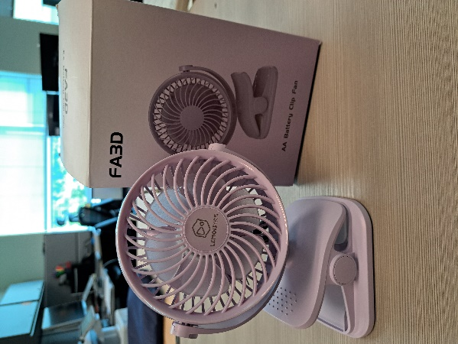 | 2.  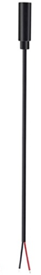 | BOM  - Lemoistar – Battery Operated Clip On Fan  - (2x) 3.5 mm Female Mono Cable  - (2x) Mini Zip Ties  - (3x) AA batteries
3.  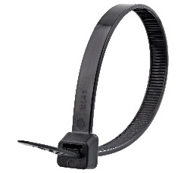 | 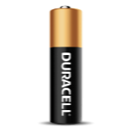      4

Required Tools
- Screwdriver (Phillips)
- Wire strippers
- Soldering iron and solder
- Drill and 5/32” drill bit
- Slip joint pliers
- Flush cutters

Required Personal Protective Equipment (PPE)
- Safety glasses

Assembly Instructions
- Carefully remove the toy from its packaging without damaging it (we will be repackaging the toy after adapting).  Remove the front cover off of the fan, then locate and remove the 4 screws behind the fan blade as shown in the photo and remove the back panel.  Then, remove the 2 screws from the PCB board, shown in the second photo.  *Note: keep screws, and keep track of where they came from if there are multiple different sized screws | 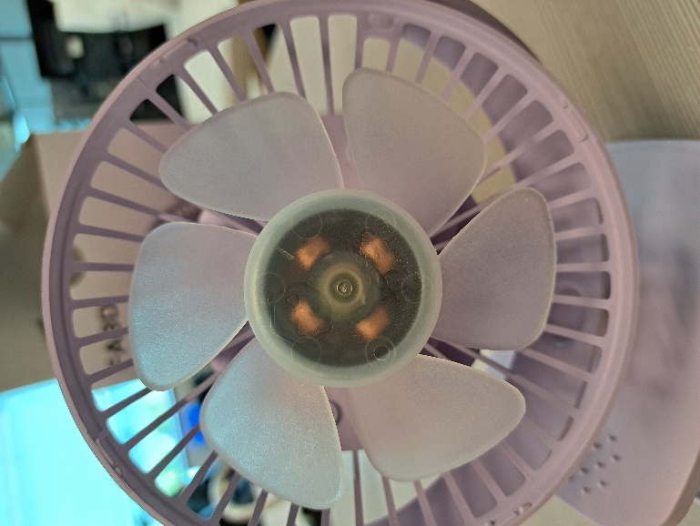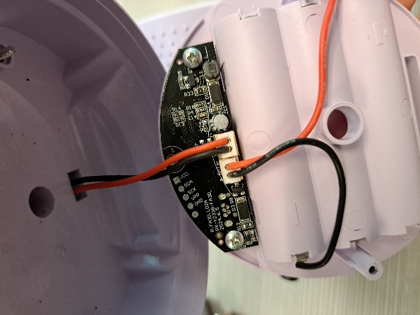
- Carefully separate the two halves of the toy. | 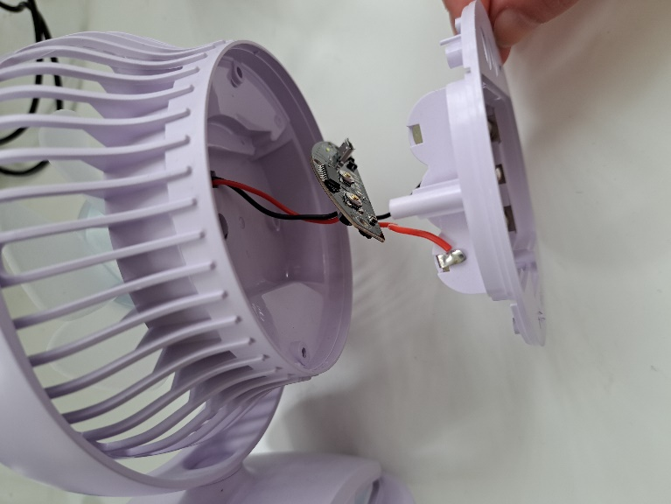
- Use wire strippers to strip approximately 2 cm off the outer wire casing, revealing two internal wires. | 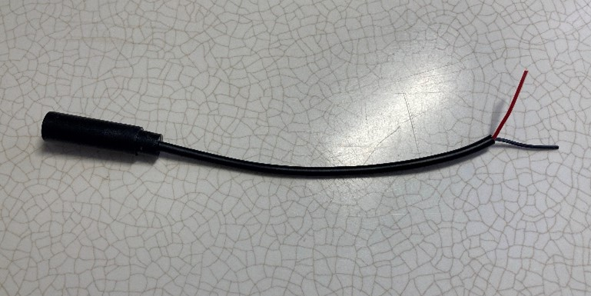
- If there are 2 internal wires, strip approximately 0.5 cm off each wire. | 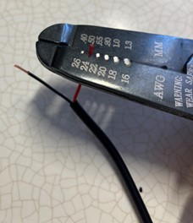
- If there are three internal wires (red, black, and exposed), strip off 0.5 cm of the red insulation and twist the red wire and exposed wire together. Strip 0.5 cm from the black wire. | 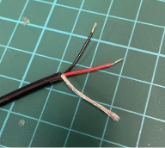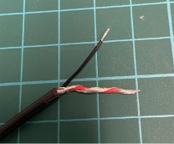
- Melt a small amount of solder over the exposed ends of the wire. | 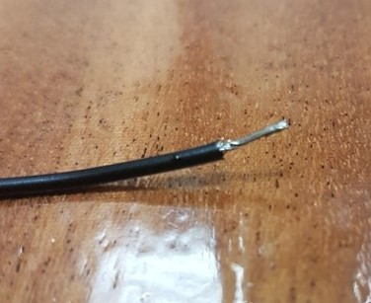
- Using a 5/32”” drill bit, drill two holes into the positions shown on the right. Remove any loose plastic and insert the mono cables through the hole, from outside to inside. | 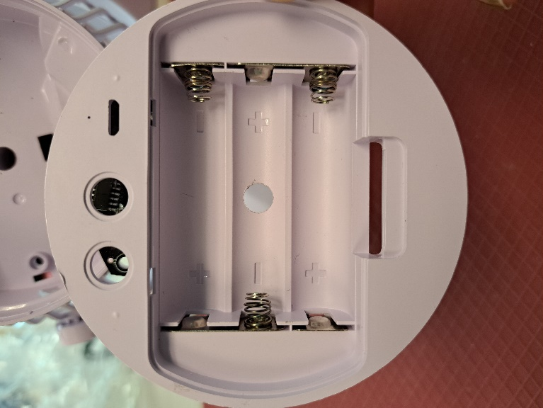
- Attach the two wires from the first mono cable to the toy in the positions shown. | 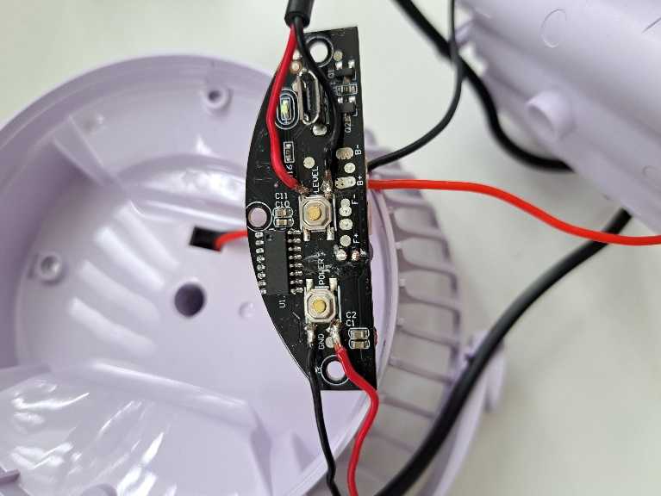
- Attach the two wires from the second mono cable to the toy in the positions shown. | 
- It is now time to test the toy. Insert batteries into the battery compartment and assistive switches into the mono cables. One switch should turn the fan on with one press and off with the second press, and the other should change the fan speed. Test both cables.  Notes:  - If the fan does not turn on, please check the soldered connections.  - If the fan does not turn off, please check the soldered connections.  - If the fan does not change speeds with the other switch, please check the soldered connections. | 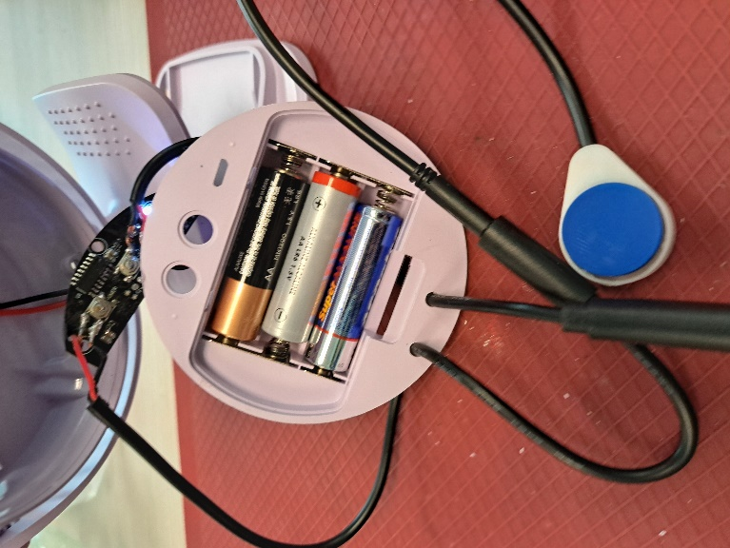
- Once the wires are connected, attach zip ties to the cable on the inside of the case as close as possible to where it enters.  Tighten the zip tie as much as you can and snip the excess zip tie using the flush cutters.  The zip ties will serve as strain relief, so the soldered connections do not get pulled and break. | 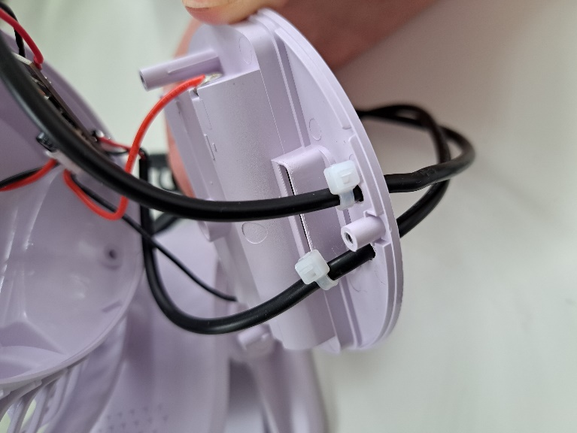
- Reassemble the fan using the screws set aside earlier.  Test the fan again. If it is still working properly, repackage the toy and the adapted toy is complete! | 