Required Components
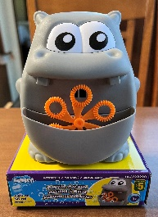 | 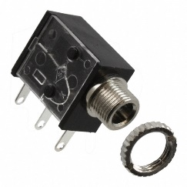 | BOM  - Dollarama – Motorized Bubble Machine (Hippo or Frog)  - 3.5 mm Mono Jack and Nut  - 22 AWG Wire  - 2 AA Batteries  Refer to the Tool and Component List for purchasing details.
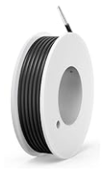 | 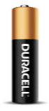

Required Tools
- Philips head screwdriver
- Ruler
- Flush cutters
- Wire strippers
- Soldering iron and solder
- Drill and 1/4” drill bit

Required Personal Protective Equipment (PPE)
- Safety glasses

Assembly Instructions
- Carefully remove the toy from its packaging without damaging it. Locate and remove the six screws along the body of the toy and keep in a safe place. | 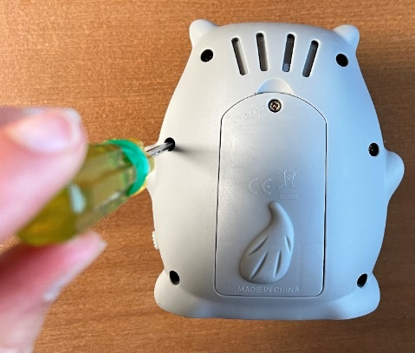
- Carefully separate the two halves of the toy and set aside the front half. | 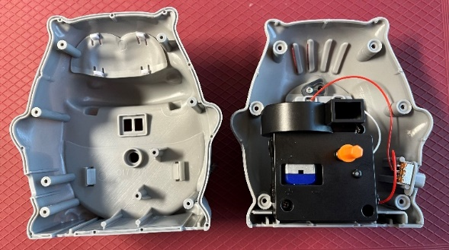
- Cut 2 pieces of wire, each approximately 8cm long. | 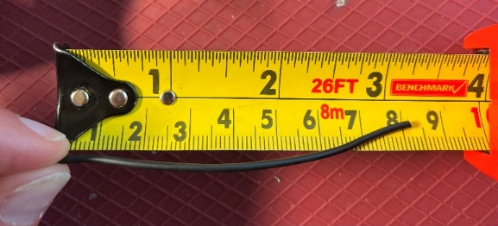
- Use wire strippers to strip approximately 0.5cm off each end of the wires. | 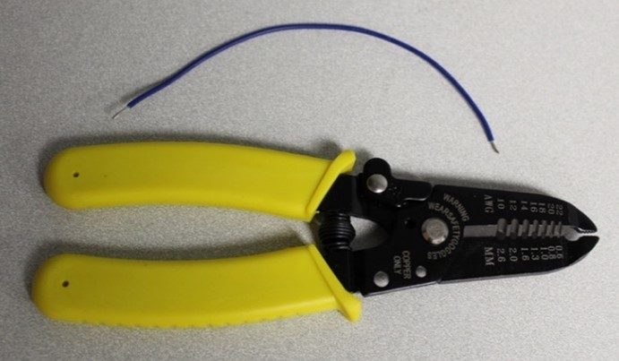
- Solder the two wires onto the two legs of the jack closest to the mono jack hole. | 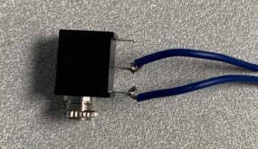
- Tin the other ends of the wires by placing a small amount of solder on each wire. | 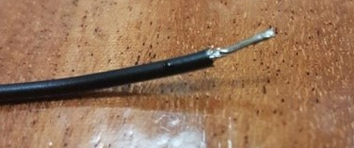
- Solder the new wires in parallel with the existing red wires that connect to the switch. Do this by carefully soldering the new wires on top of the red wires, one at a time. | 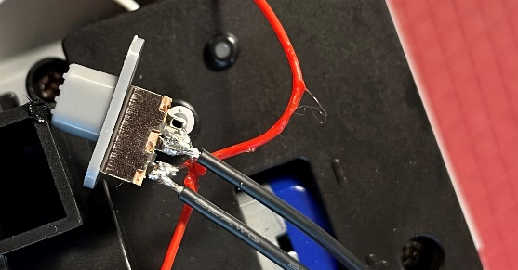
- It is now time to test the toy. Insert 2 AA batteries into the battery compartment and insert an assistive switch into the mono jack. When the switch is pressed, the toy will turn on and you can move onto the next step. You should also still be able to control the toy with the original switch.  Note: If the toy does not turn on, please check the soldered connections. | 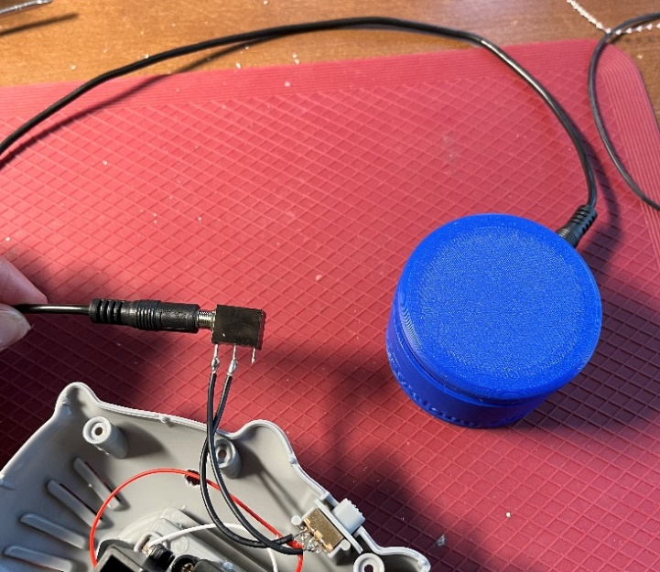
- Using a ¼” drill bit, drill a hole into the back of the toy, near the original switch. Cut away any loose plastic. | 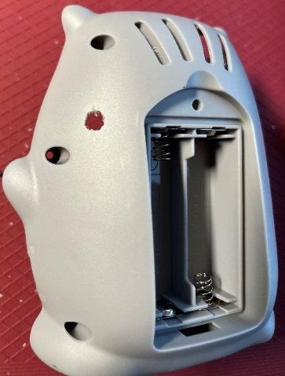
- Remove the nut from the mono jack and push the mono jack through the hole from the inside. Reinstall the nut on the outside of the toy and tighten to secure. | 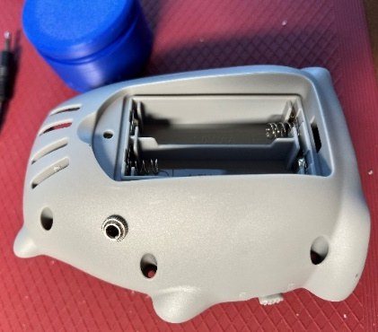
- Reassemble the toy using the 6 screws from earlier. | 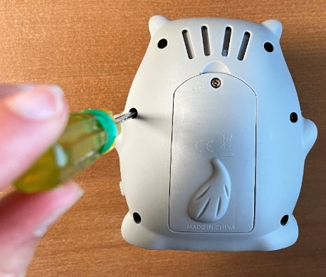
- Test the toy again. If it is still working properly, remove the batteries, repackage the toy and the adapted toy is complete! | 