Required Components
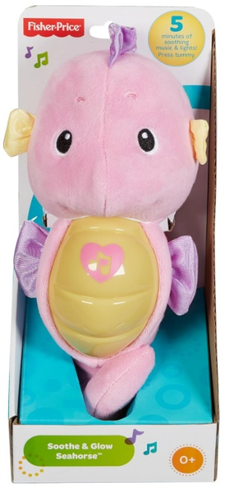 | 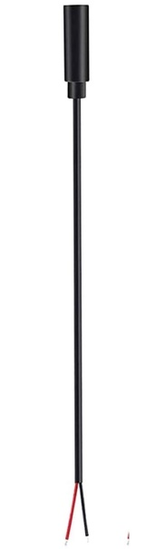 | BOM  - Fisher-Price Soothe and Glow Seahorse  - 7” stereo cable with 3.5mm female jack

Required Tools
- Flat head screwdriver
- Wire strippers
- Soldering iron and solder
- Drill and 1/8” drill bit
- Slip joint pliers

Required Personal Protective Equipment (PPE)
- Safety glasses

Assembly Instructions
- Remove the internal plastic case from the back of the toy | 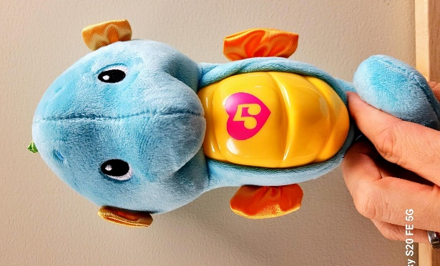
- Insert a flat head screwdriver into the 5 plastic notches to open the case.  Be sure to insert the screwdriver from the side with the transparent dome as shown. | 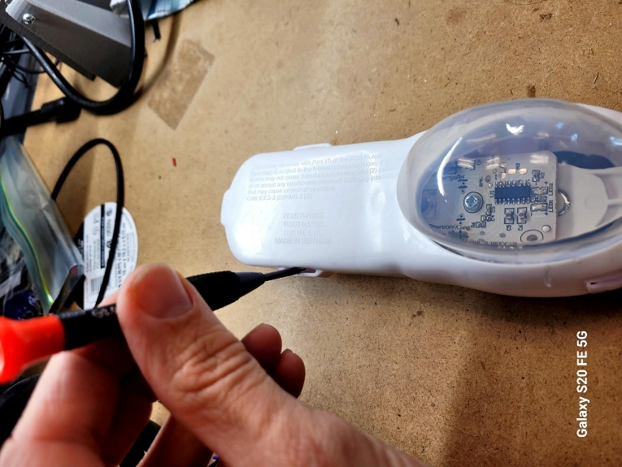
- Strip approximately 4 cm off of the cable, revealing small wires inside. | 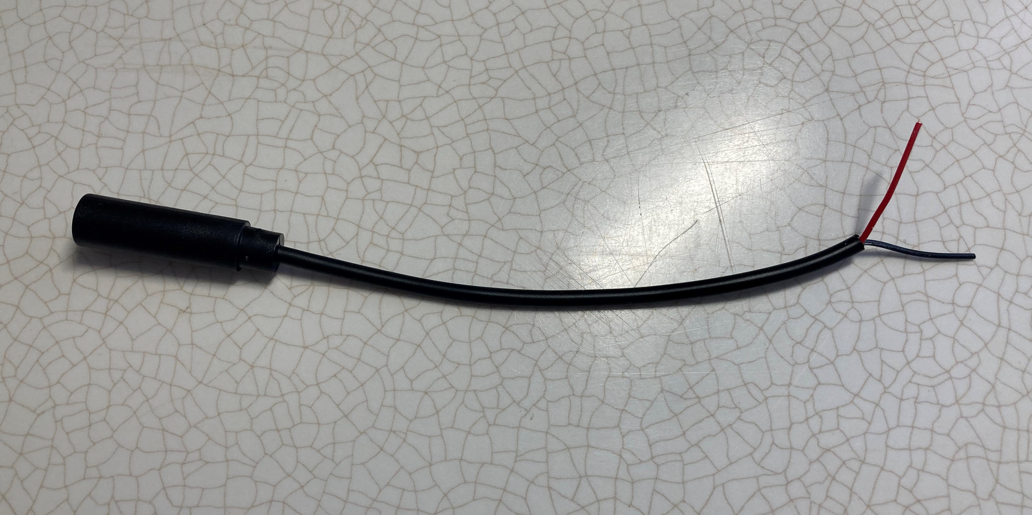  2 cm
- Strip approximately 0.5cm off of the small wires. | 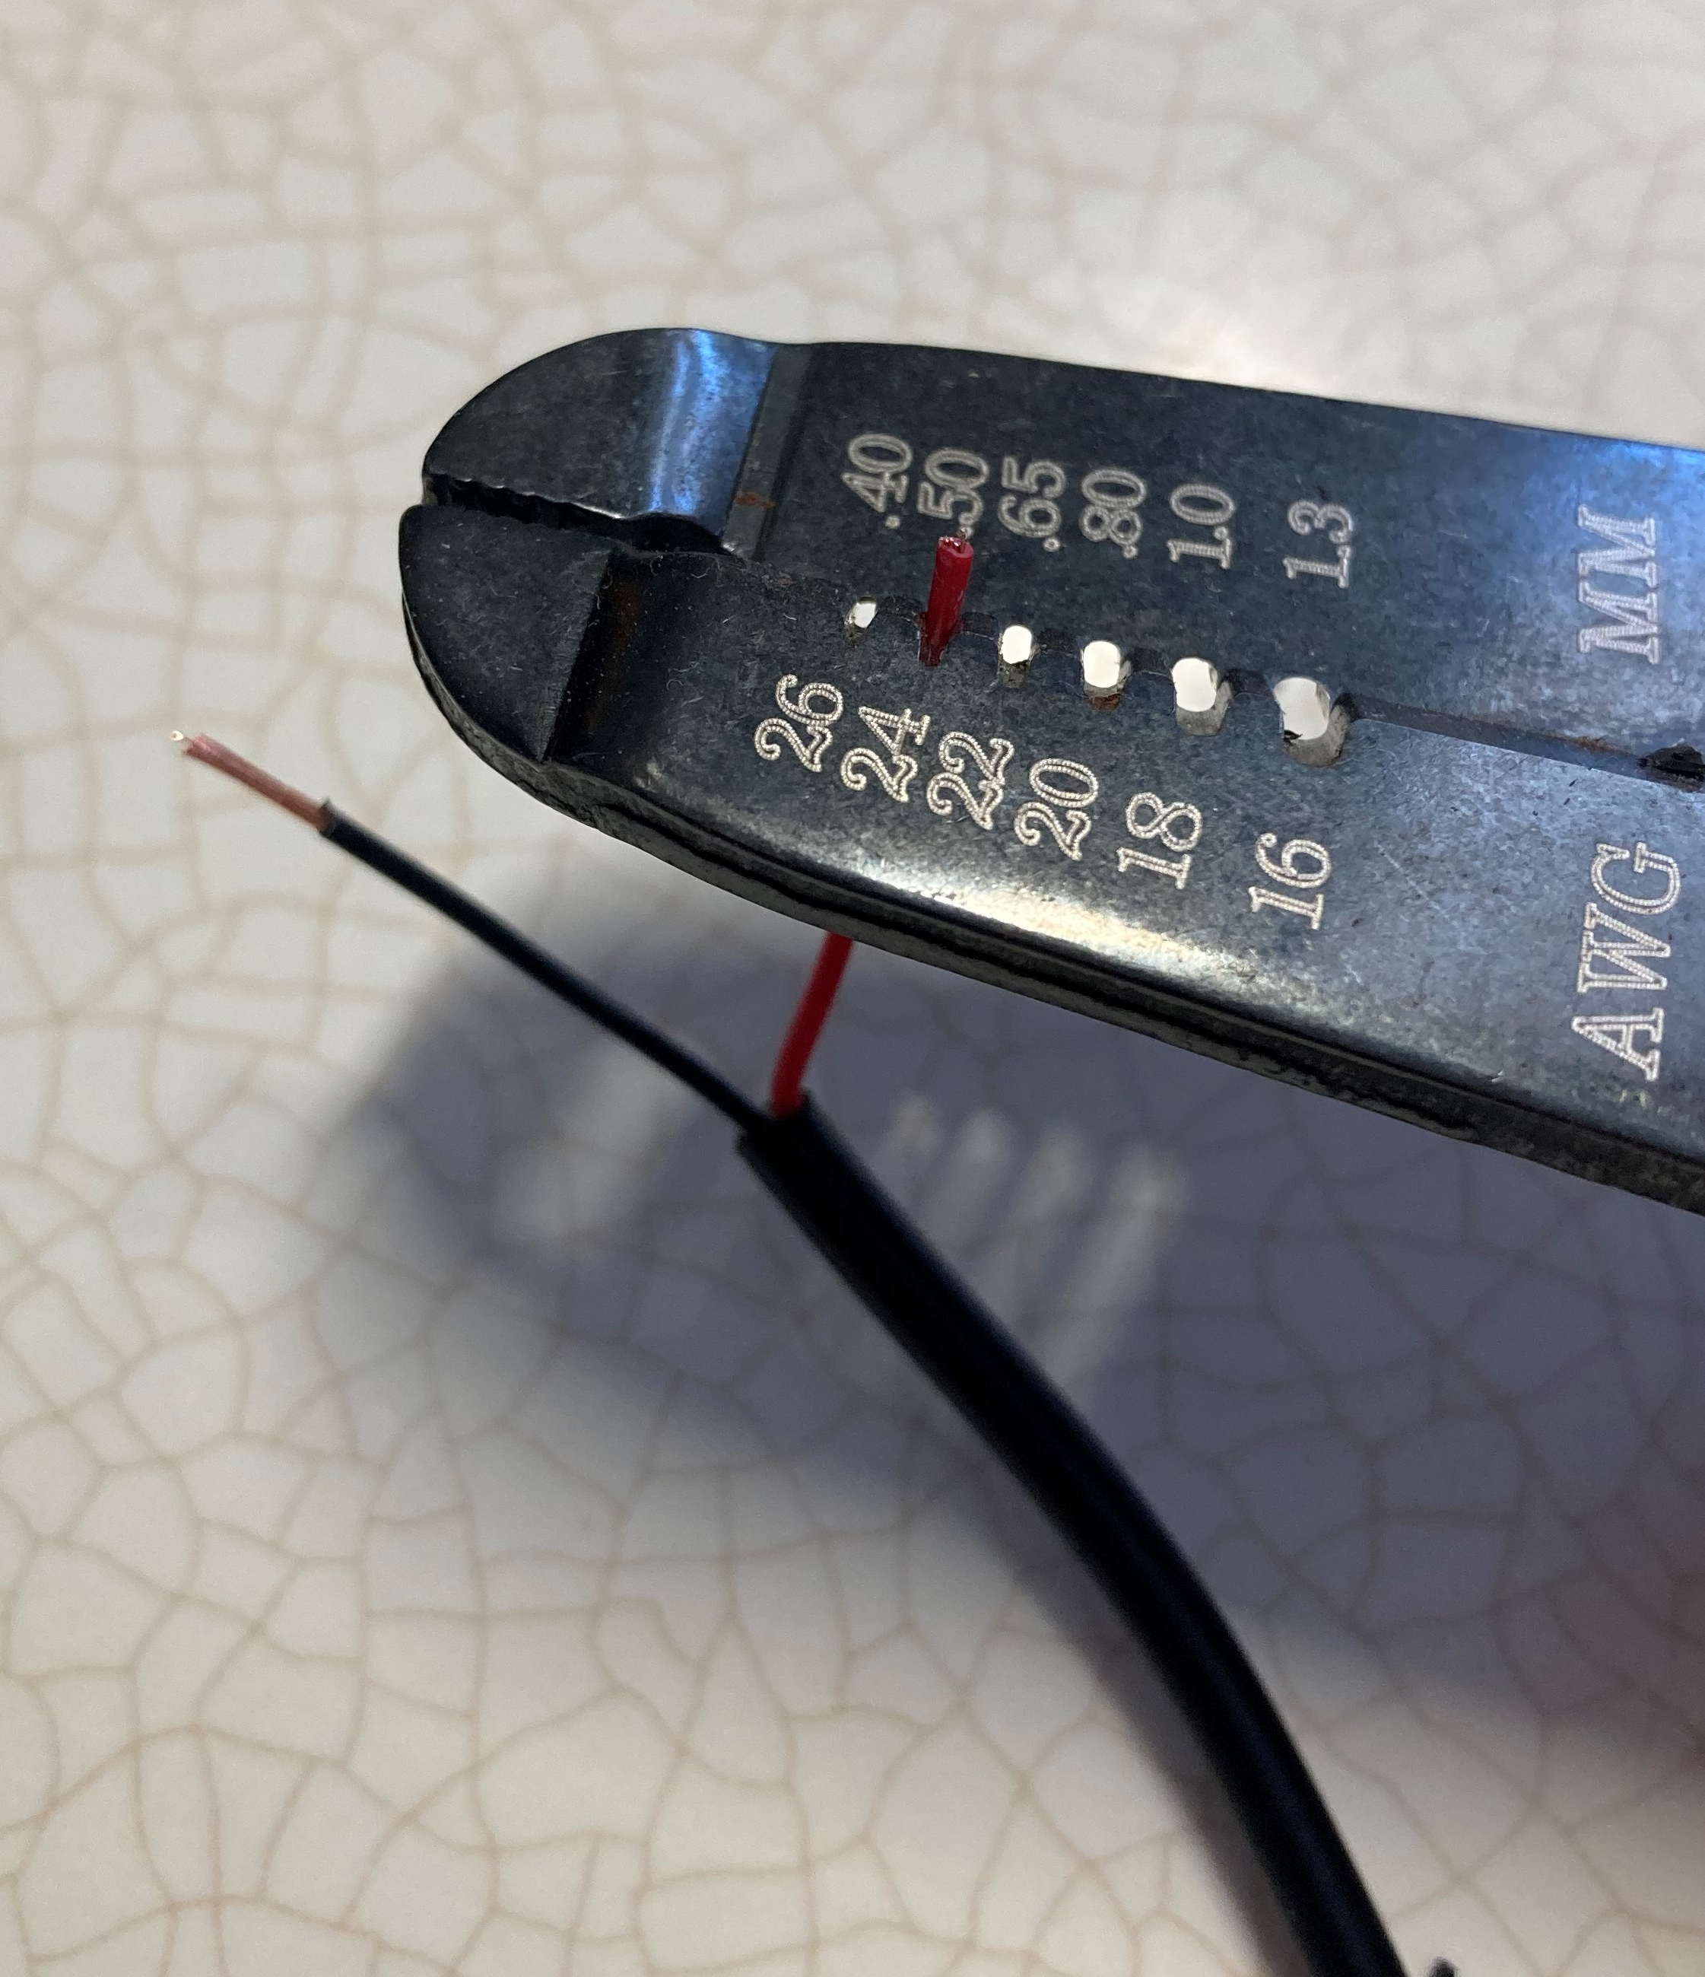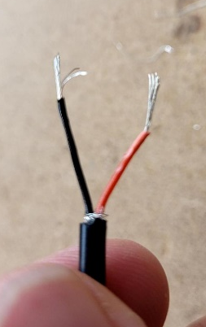
- Drill a hole in the location shown using a 1/8” drill bit.  Feed the stripped wire end of the cable into the white plastic case from the outside (the female jack end will sit outside of the toy when it’s put back together).  Leave about 10 cm of wire inside the case. | 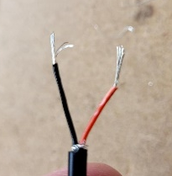  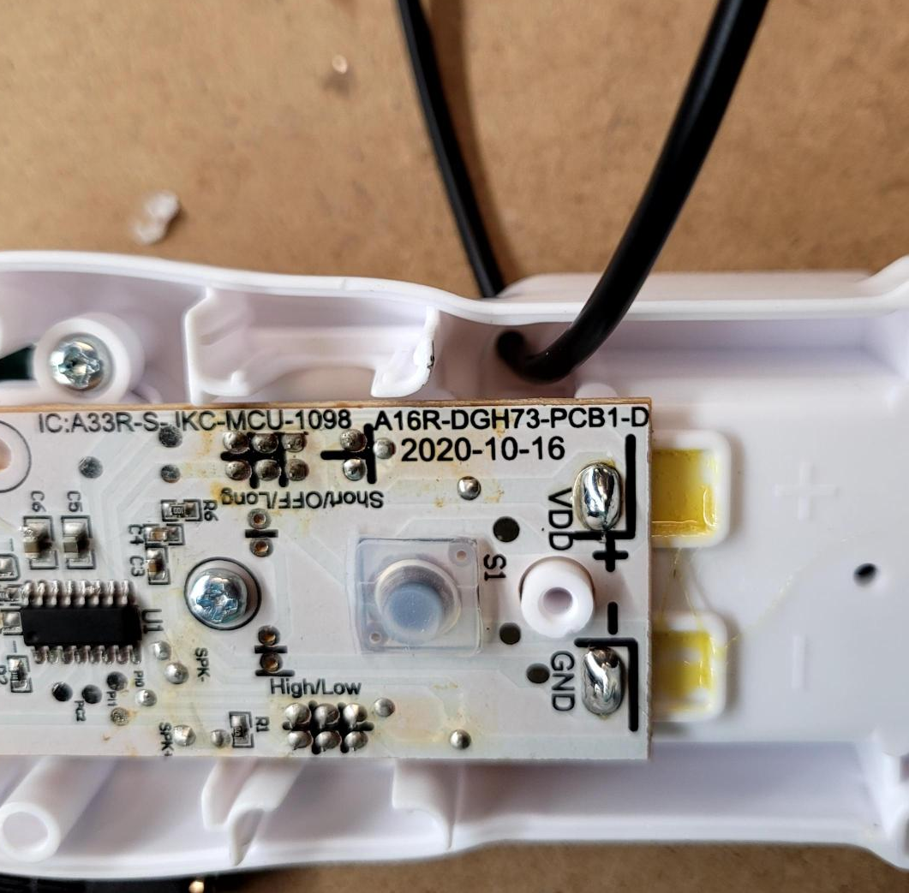
- Tie a knot for strain relief. | 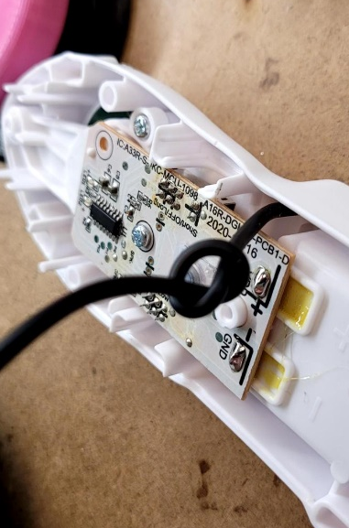
- Tin the wires by melting solder around the exposed ends of the 2 wires. | 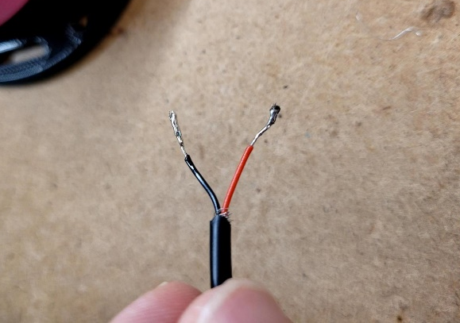
- Tin the 2 outlined pads. | 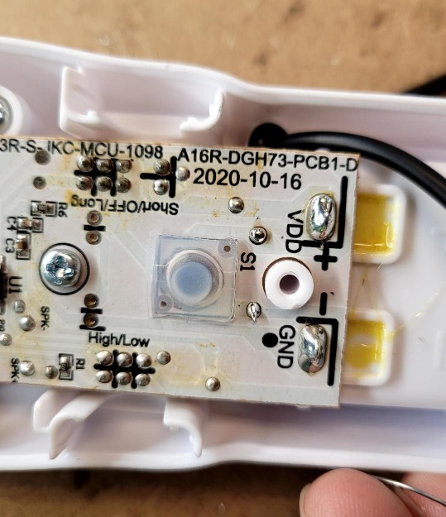
- Hold a wire (black or red) against a pad and place your soldering iron on top to solder the wire to the PCB.  Repeat this step for the other pad. | 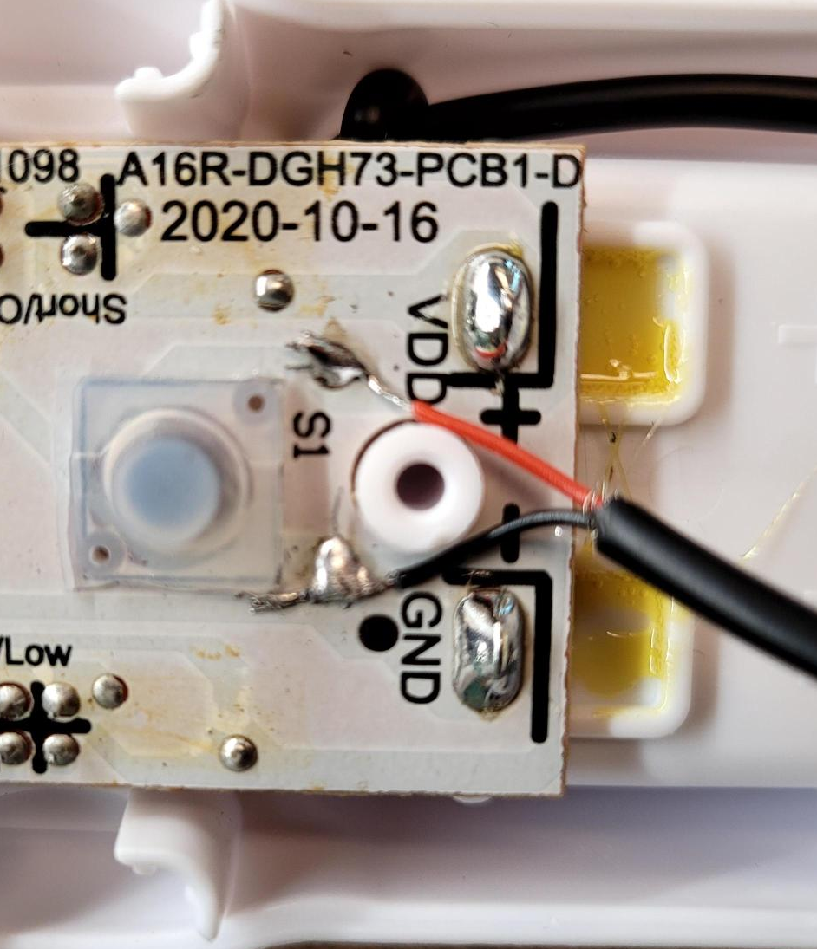
- Reassemble the toy. Place the transparent dome back in place. | 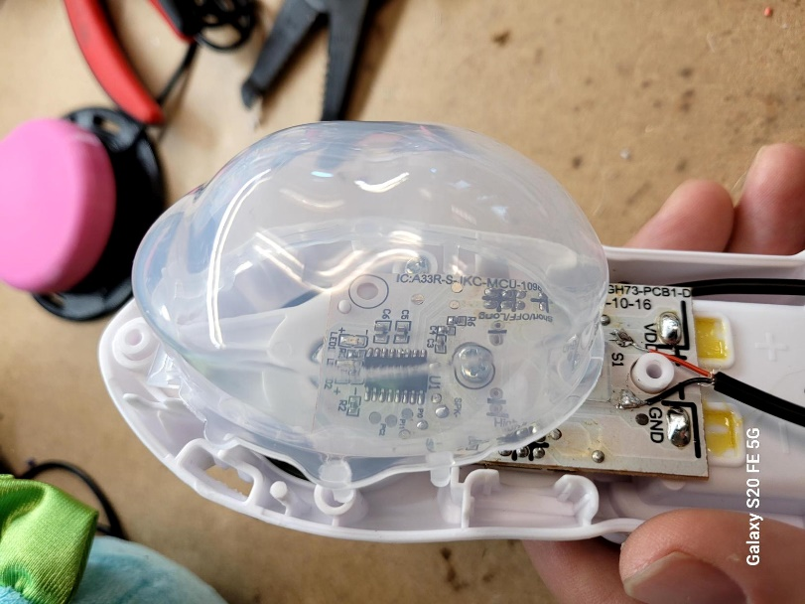
- Clip the white plastic cover back on top. You may need a slip-joint plier to help close the case (be careful to not accidentally crack the plastic) | 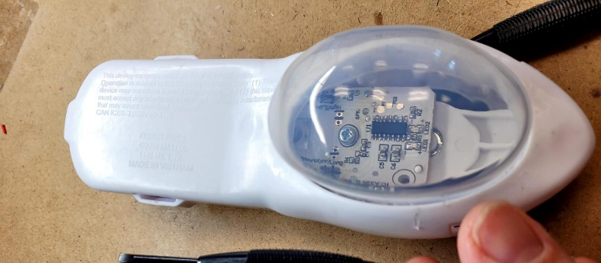
- Place the white plastic case back into the plushy toy.

