Introduction
The Switch Adapted Peppa Pig is an adapted “Peppa Pig Oink-Along Songs Singing Plush Doll” that can be used with a 3.5 mm assistive switch. This adaptation is intended for users that have difficulty activating the button inside of the Peppa Pig toy.

Research

Existing Commercial Options
Title | Peppa Pig Giggle & Snort - Switch Adapted Toy
Link | https://www.spectronics.com.au/product/peppa-pig-giggle-snort-switch-adapted-toy
Vendor | Spectronics Inclusive Learning Technologies
Cost | $120 plus shipping
Notes | Located in Australia

Title | Switch Adapted Peppa Pig Giggle
Link | https://www.merushop.org/product/switch-adapted-peppa-pig-giggle-and-snort/
Vendor | meru
Cost | £25.00 (Approximately $42 CAD) plus shipping
Notes | Located in the UK

DIY Designs
Title | SWITCHED Adapted Toys - Peppa Pig
Link | https://www.youtube.com/watch?v=008dOfm0GBU&ab_channel=SWITCHEDadaptedtoys
Author | SWITCHED Adapted Toys
License | Not stated
Notes | Toy is no longer available

Requirements

Goals
G01 | Make a Peppa Pig toy more accessible by adding the ability to use an assistive switch for operation.

Functional Requirements
F01 | The toy is operated with the use of a 3.5 mm assistive switch.

Non-functional Requirement
NF01 | Toy is relatively easy to adapt so that others can do it themselves with our assembly manual.

Constraints
C01 | Cost less than $50 so it is less expensive than commercial options.

Ideation
This Peppa Pig toy was chosen because there was a desire in the community for switch adapted Peppa Pig toys.
Originally, a mono jack was going to be used, but after opening up the electronics compartment it was found that there wasn’t much room for a mono jack. For this reason, a mono cable with a female (jack) end was chosen instead. This also allows the cable to stick out of the Peppa toy, which is easier for users to plug in and unplug their assistive switch, rather than having to open up the plush toy each time.
To provide strain relief, and prevent the solder joints from being broken if the cable were to be pulled, a zip tie was added near the hole where the cable exits the electronics compartment.

Detailed Design
In the photo below it can be seen where the mono cable needs to be soldered, where the hole was drilled for the cable, and the zip tie is also shown.
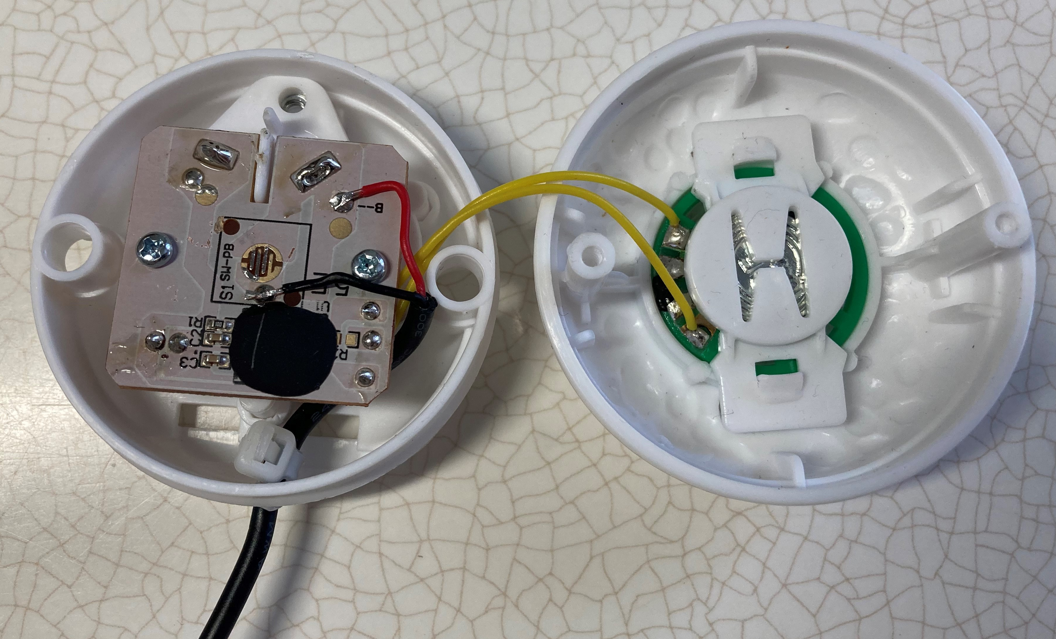
The below photo shows where the mono cable sticks out the back of the toy, easily accessible to plug in an assistive switch.
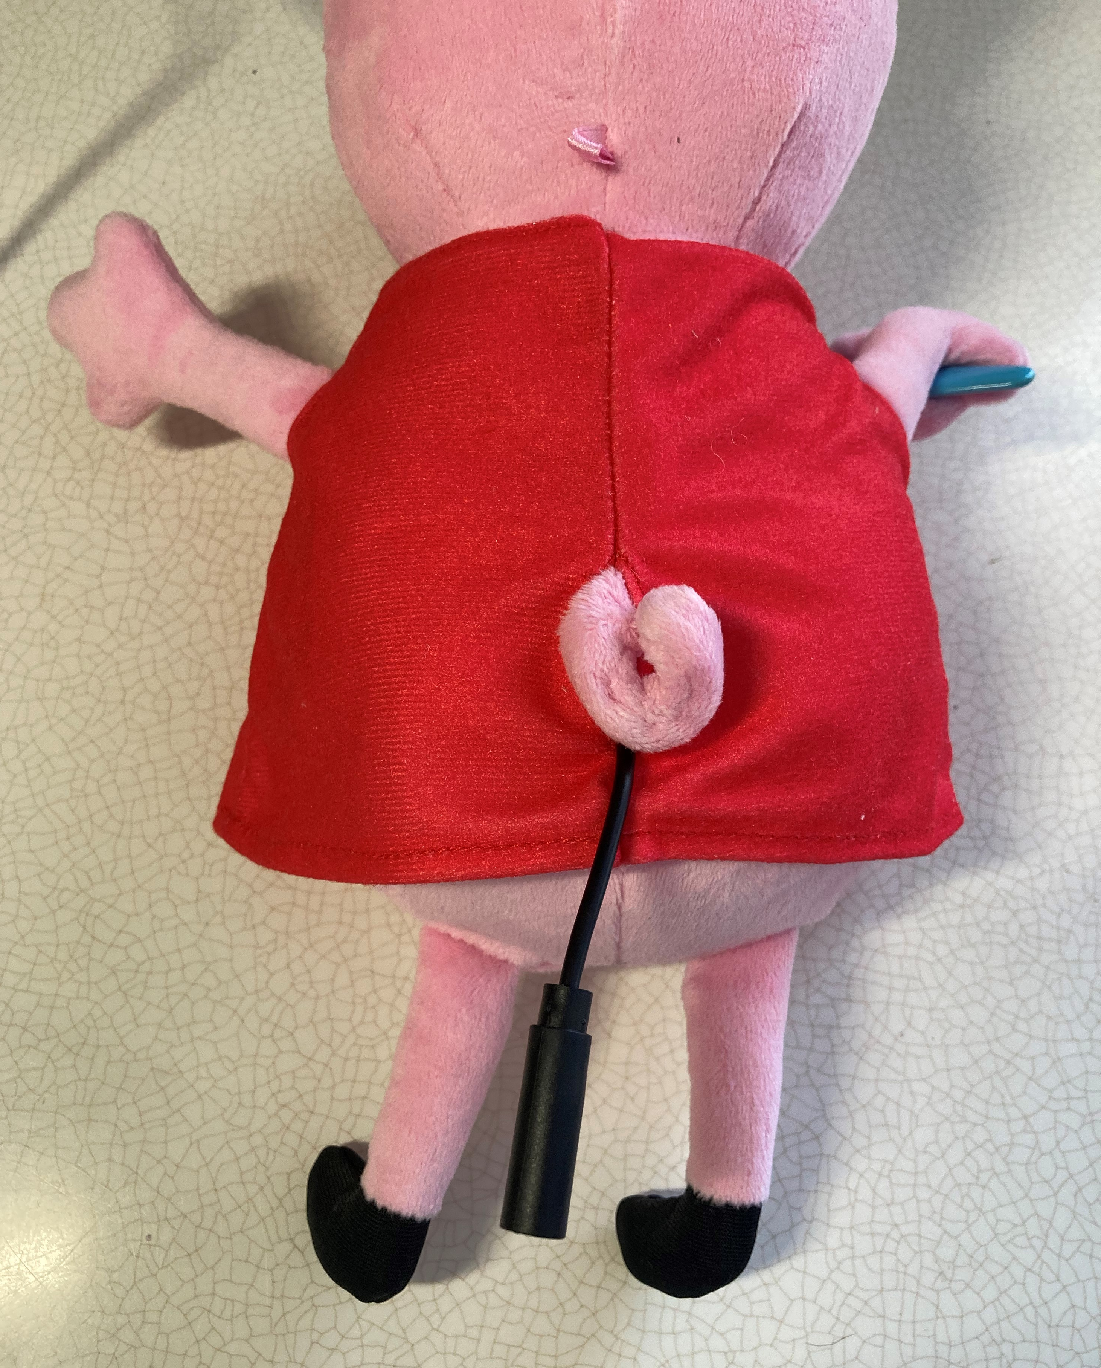
Below is a photo of the completed switch adapted Peppa Pig Oink-Along Songs Singing Plush Doll with an assistive switch plugged into it. The end cost of this switch adaption is less than $30.
