Introduction
This switch adapted Peppa Pig toy (“Peppa Pig Oink-Along Songs Singing Plush Doll”) is compatible with a 3.5 mm assistive switch. This device may be beneficial for someone with limited hand function that is interested in Peppa Pig toys, or for teaching cause and effect with assistive switches.

Usage
Plug in an assistive switch to the cable that comes out of the back of the Peppa Pig toy (circled in blue).
Activate the switch to use the toy. When the switch is activated, Peppa will make noises. There are a few different noises/songs that cycle through each time the switch is activated.
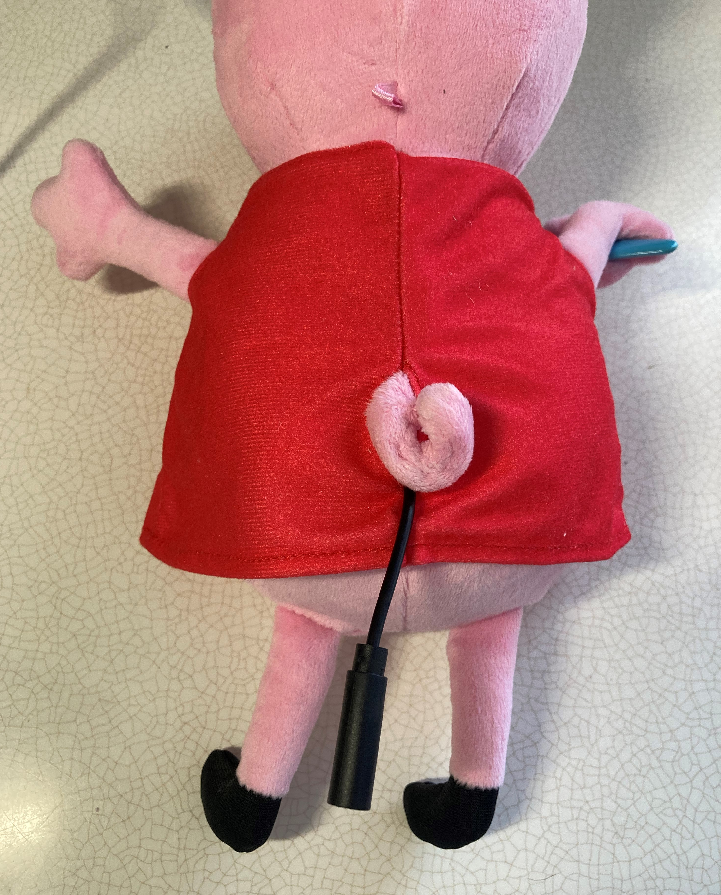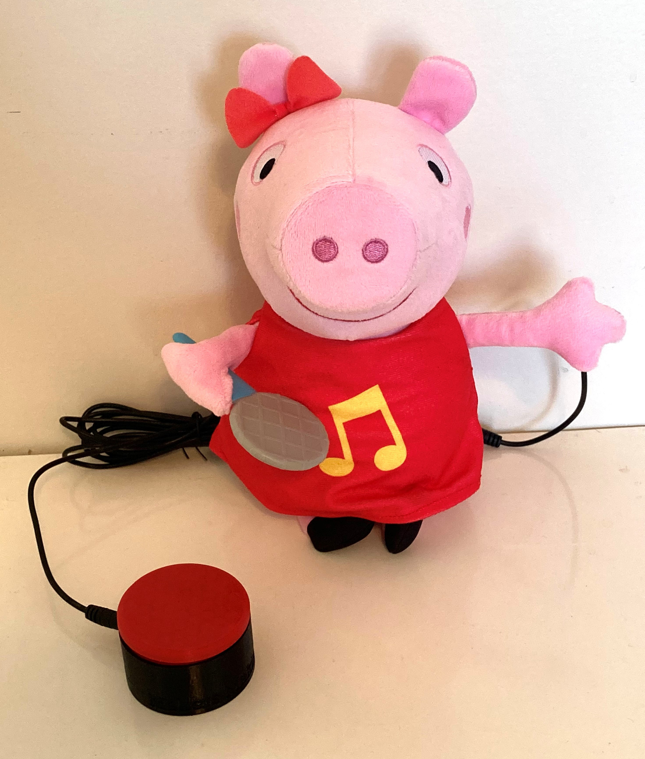

Compatibility
This adapted toy is compatible with assistive switches that have a 3.5 mm plug.

Cleaning
Do not wash the Peppa Pig plush toy with the electronics inside. If the plush toy needs to be washed, remove the electronics from the pouch on the back of the plush toy.

