Required Components
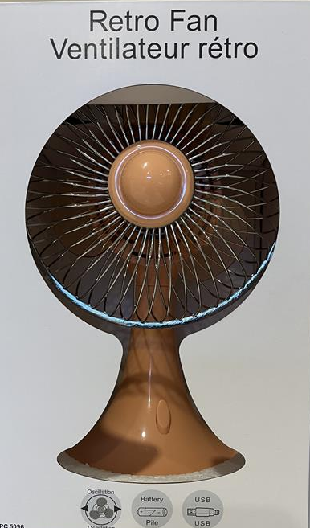  1. | 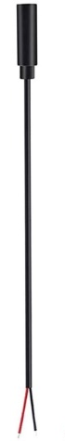  2. | BOM  - Shoppers Drug Mart Retro Fan  - 3.5 mm Female Mono Cable  - 3 AA Batteries  - Cable tie
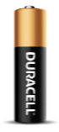 | 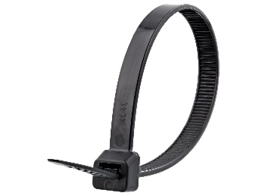

Required Tools
- Phillips Screwdriver
- Wire strippers
- Soldering iron and solder
- Drill and 1/8” drill bit
- Scissors / flush cutters

Required Personal Protective Equipment (PPE)
- Safety glasses

Assembly Instructions
- Carefully remove the toy from its packaging without damaging it. Remove the 3 white stickers and the 3 screws located under the stickers. Keep the stickers and screws in a safe location. | 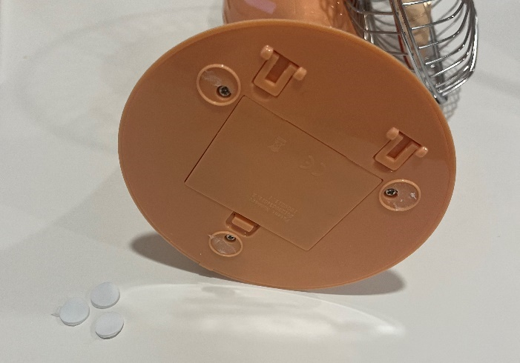
- Remove the cover from the base, being careful not to pull any wires from their soldered connection points. | 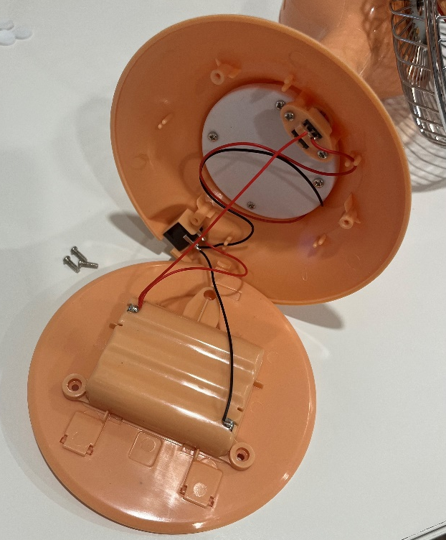
- Remove the USB jack from the base. This will give the wires more length and allow for more working space. | 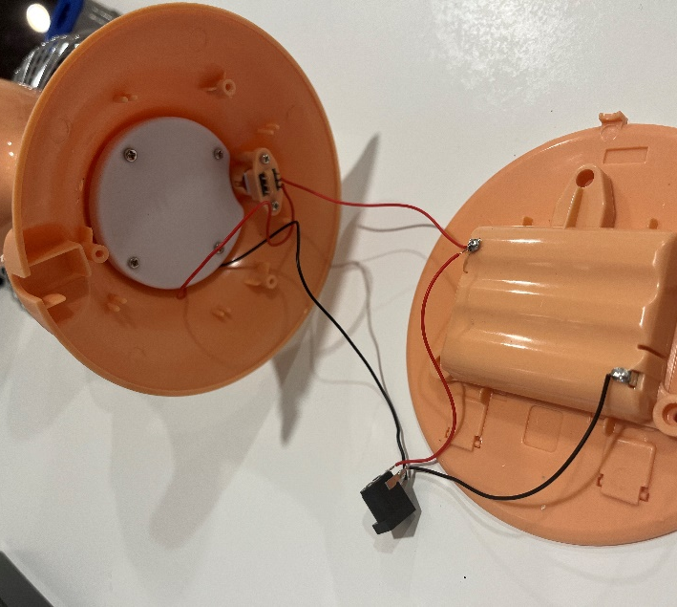
- Use wire strippers to strip approximately 2 cm off the outer wire casing, revealing two internal wires.  Skip this step if the two inner wires are already exposed. | 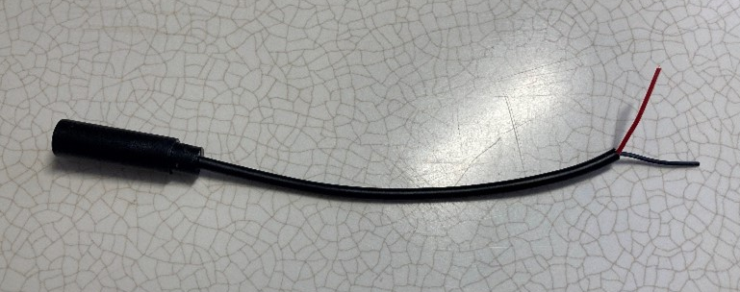
- If there are two internal wires, strip approximately 0.5 cm off each wire.  Skip this step if the metal is already exposed on the two inner wires. | 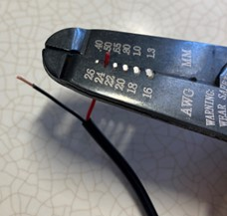
- If there are three internal wires (red, black, and exposed), strip off 0.5 cm of the red insulation and twist the red wire and exposed wire together. Strip 0.5 cm from the black wire. | 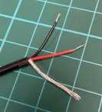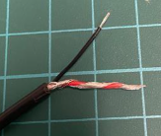
- Melt a small amount of solder over the two exposed ends of the wires. | 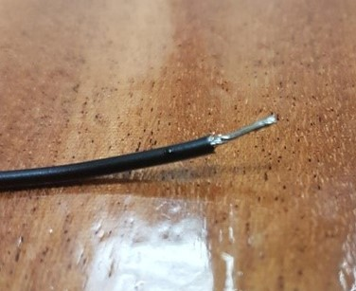
- Using a 1/8” drill bit, drill a hole in the back of the fan, near the USB port. Position the hole so that when the cable is inserted, it will be close to the white weight in the fan. Remove any loose plastic.  Insert the mono cable through the hole. | 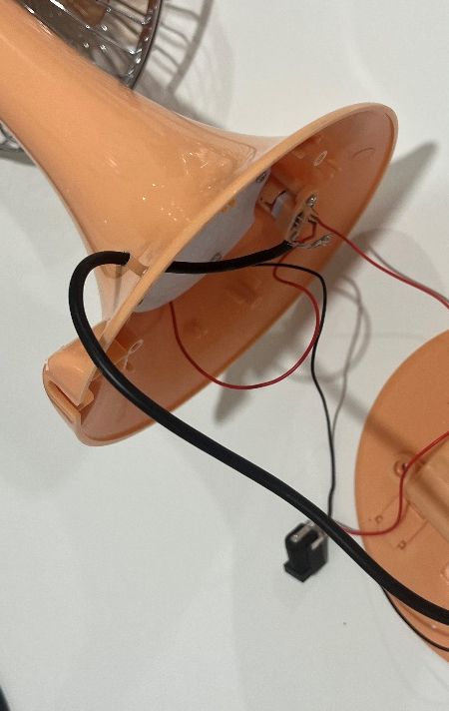
- Solder the two wires from the mono cable on top of the existing red wires connected to the original fan button.  Note: This step may be tricky, and the original wires may become de-attached. If this happens, try soldering the two wires together first, and then connect them back to the switch. | 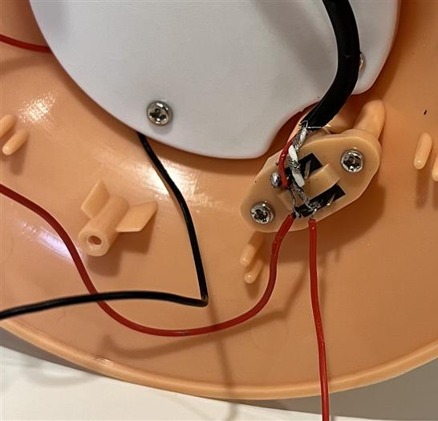

- It is now time to test the toy. Insert batteries into the battery compartment and an assistive switch into the mono jack. The toy will activate when the assistive switch is pressed and turn off when it is released. The original button should also still be able to control the toy.  Note: If the toy does not turn on, please check the soldered connections.  If the toy does not turn off when the assistive switch is released, please check the soldered connections. | 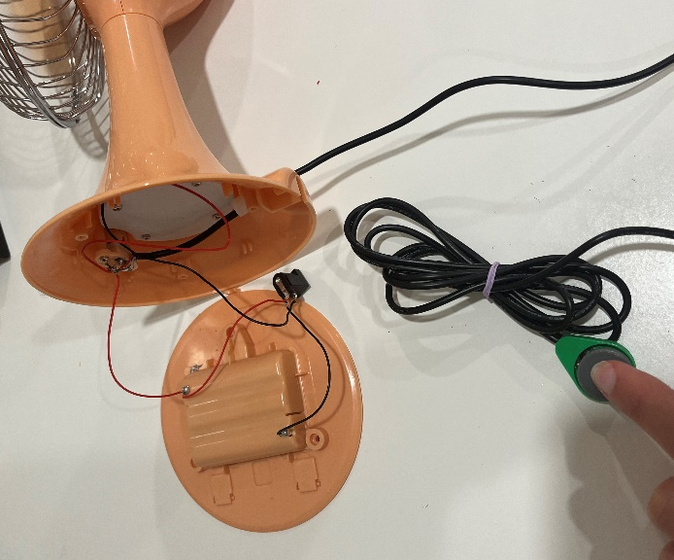
- Lightly pull the mono cable tight across the base and attach a cable tie to the wire, near the drilled hole. Make sure the cable tie is tightened all the way, as tight as you can with your hands, so that it cannot slide down the cable.  This will create strain relief, helping to make sure the cable cannot be pulled out of the fan. | 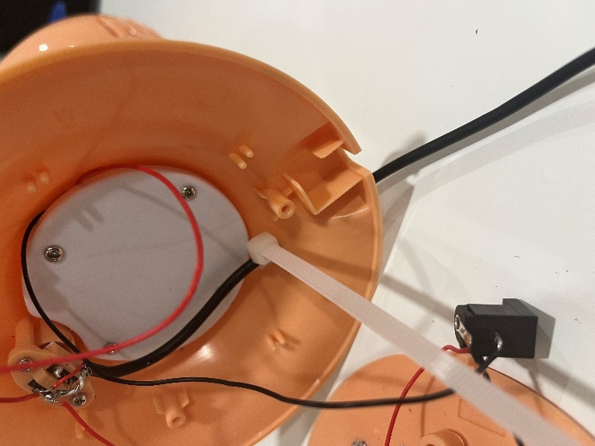
- Use scissors or flush cutters to cut the excess length off the cable tie. | 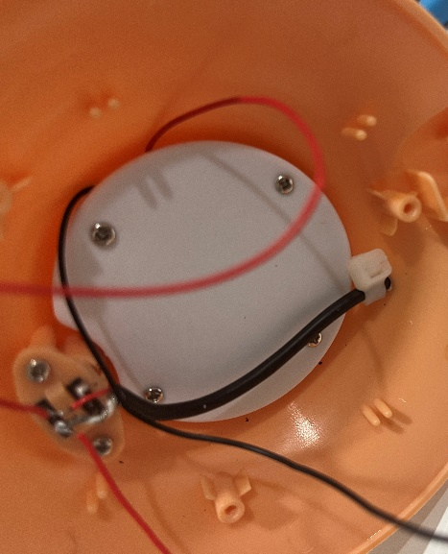
- Reassemble the toy using the 3 screws set aside earlier and replace the 3 stickers. | 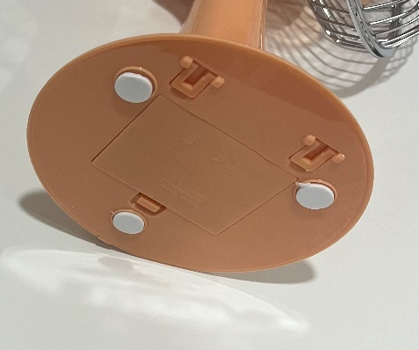
- Test the toy again. If it is still working properly, repackage the toy and the adapted toy is complete! | 