Required Components
 | 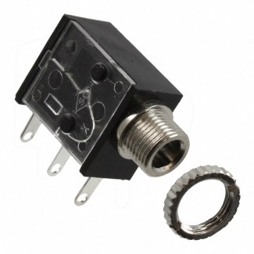 | BOM  - Nerf N-Strike Elite HyperFire Blaster  - 3.5 mm Mono jack  - Toggle switch  - 22 AWG wire
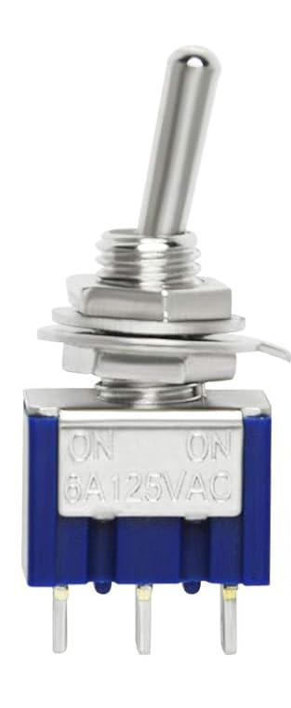 | 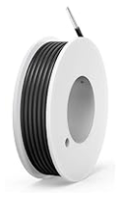

Required Tools
- Soldering Iron
- Solder
- Electrical Tape
- Wire Strippers
- Screwdriver
- Drill with ¼ inch bit

Required Personal Protective Equipment (PPE)
- Eye Protection

Assembly Instructions

Step 1
Remove all screw holding the two halves of the gun together and separate the gun into two halves.
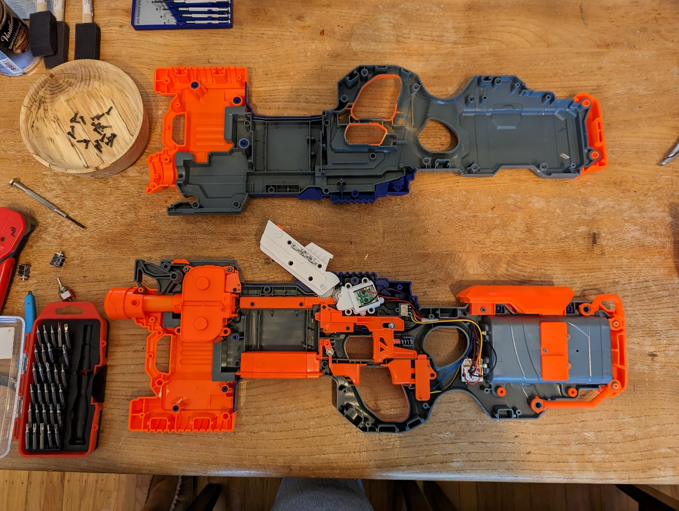

Step 2
Drill two quarter inch holes in the side of the shell with all the electronics. Test fit the toggle switch and mono jack before and after drilling to make sure there is enough space. Remove both after testing. (While the below photo has two mono jacks, only one was used in the final product) The location of the holes is not important, if there is room to route the wires from the jacks.
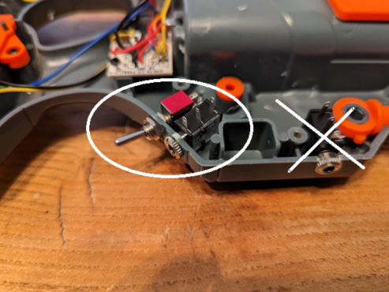

Step 3
Cut two lengths of wire. The lengths of the wires will change depending on where you put the mono jack. One length should be long enough to reach the positive terminal of the battery from the mono jack, the other should reach from the mono jack to the exposed circuit board on the white plastic. Strip both ends of each wire.
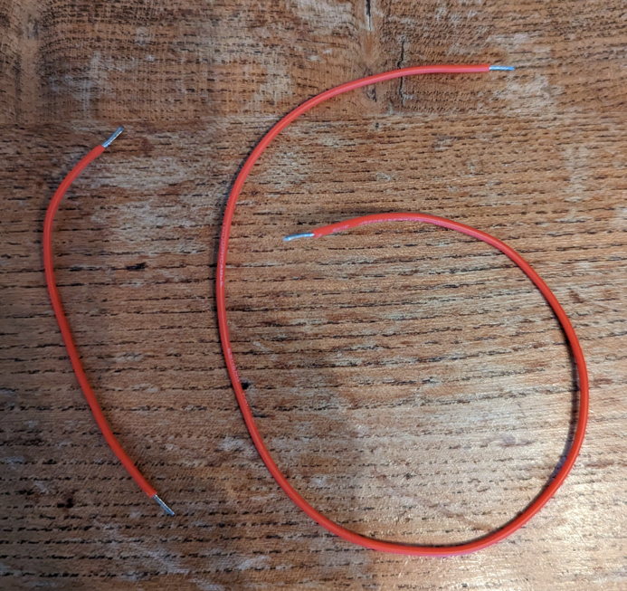

Step 4
Take the longer wire, and solder one end to the pin on the mono jack closest to the plug, and the other end on the red wire on the feed motor circuit board (in the top left of the picture). Take the shorter wire and connect one end to the red wire on the battery pack and the other to the middle pin on the mono jack.
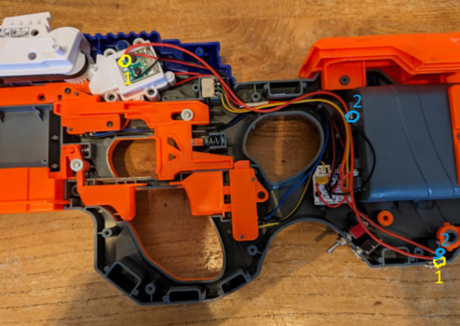

Step 5
Remove the orange cover from over the flywheel trigger sensor.
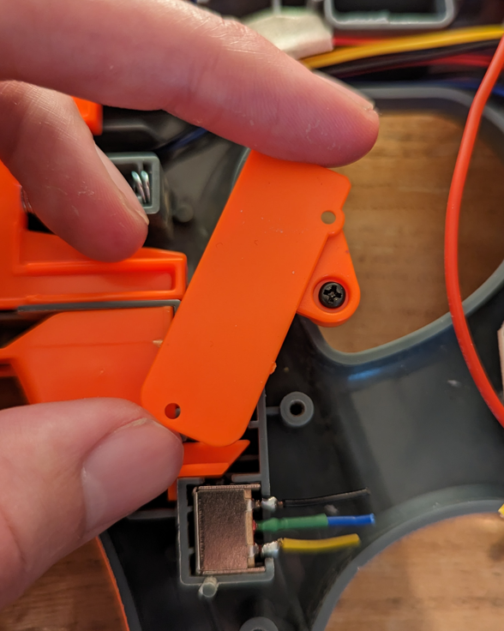

Step 6
Remove the C-shaped piece of plastic with the spring attached and discard. Replace the cover over the sensor.
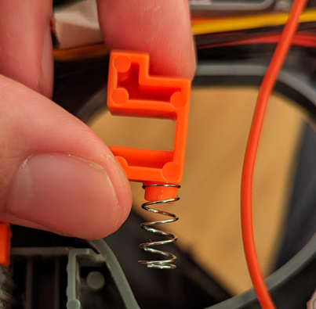

Step 7
Cut the three wires connected to the flywheel trigger sensor. This will render the original trigger inoperable.
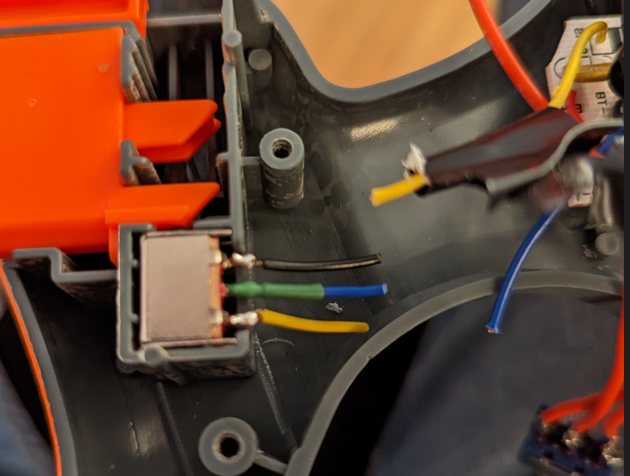

Step 8
Connect the wires that have just been cut to a three-pin toggle switch. Connect the middle wire to the centre pin of the toggle switch, with the other wires on either side. Depending on where you drilled your hole for the toggle switch, you may need to cut several lengths of wire to extend the original wires to reach the toggle switch.
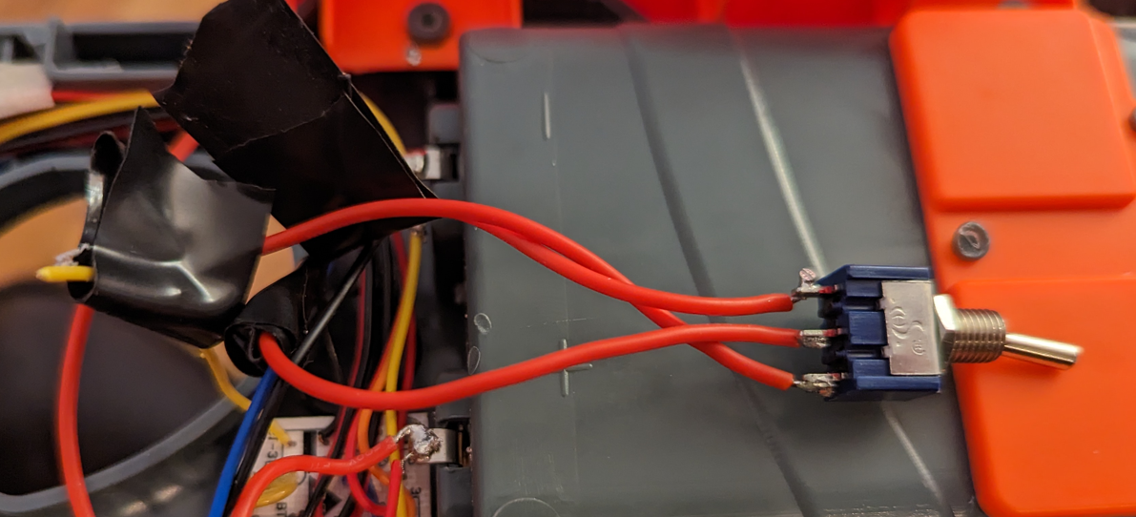

Step 9
Install both the toggle switch and the mono jack into the holes drilled into the housing. Secure them with the locking nuts they came with. Route all the wires with the existing wires to keep them from any pinch zones
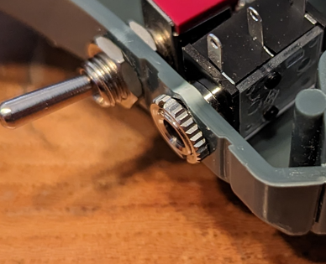

Step 10
Place the second half of the shell back on the gun and secure it in place with the screws
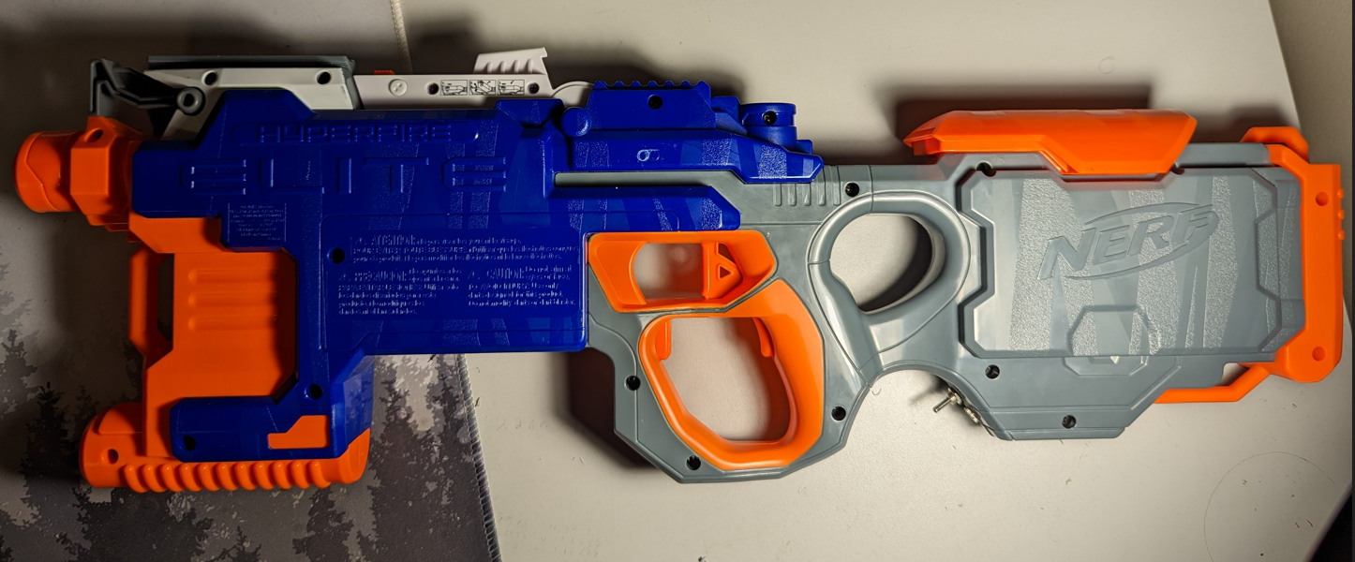

Step 11A
If using the gun with the desktop stand, after printing the stand, slide it onto the top attachment rail and flip the gun over. It will stand on the surface by itself.
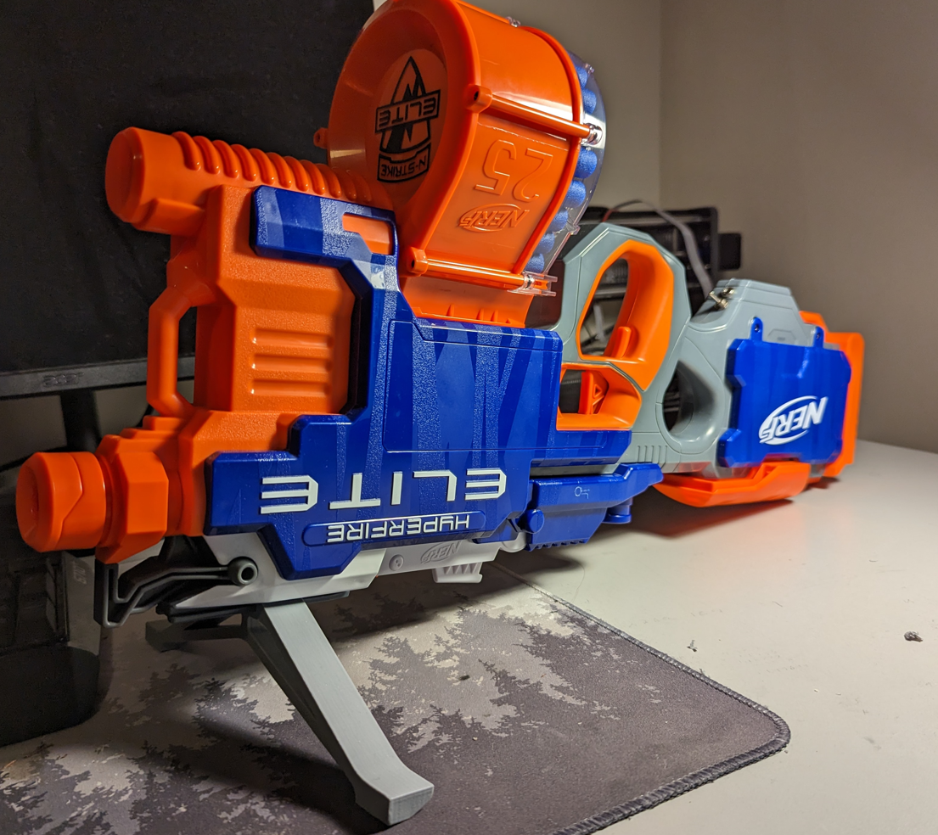

Step 11B
If using the Nerf gun with the bolt stand, after printing the stand, take 3 t-nuts and gently press them into the slots on the printed part. Use a bolt and tighten the nuts into position
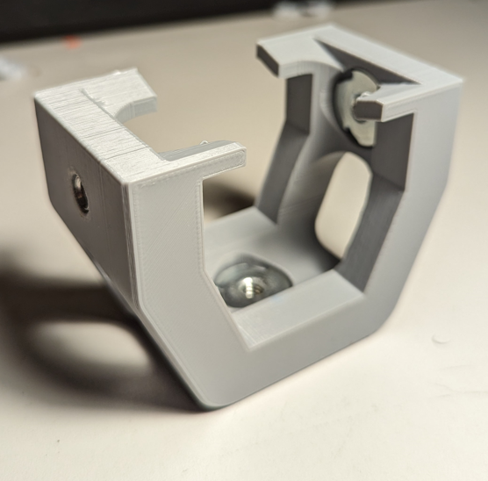

Step 12B
Attach two bolts to the side two nuts. Slide the assembly over the top section of the gun above the trigger as seen in the photos. When the stand is in place, tighten the two bolts to lock it in place. The nut on the bottom can be used to attach the gun to any ¼ - 20 bolt system.
