This is a list of commonly used components and tools that are used to switch adapt toys. Most items on this list can be purchased from different manufacturers for various prices. The tools are widely used and can be purchased from most local hardware stores. Note that not every tool and component listed is needed to adapt each toy, refer to the first page of the toy’s Maker Guide for more information.

Components
Device Type | Component | Purchase Link | Notes
 | 3.5 mm Rectangular Mono Jack  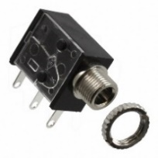 | DigiKey Link 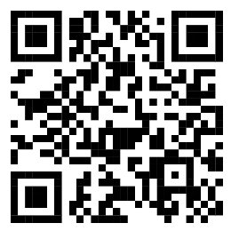 | Most used Mono Jack. Solder wires onto the two tabs closest to the cable input.  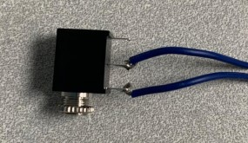
Mono Jack | 3.5 mm Square Mono Jack  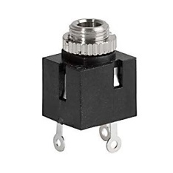 | DigiKey Link  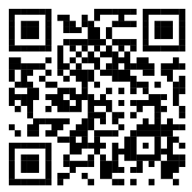 | Solder wires onto the two tabs directly across from each other.  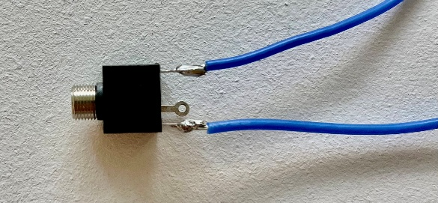
 | 22 AWG Wire  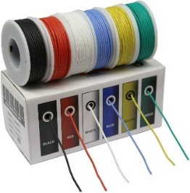 | Amazon Link  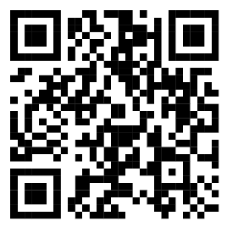 | Any 22 AWG silicone wire will work.
Cables | 3.5 mm F/Bare Mono Cable (1 ft)  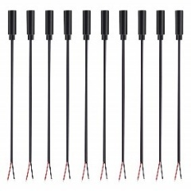 | Amazon Link  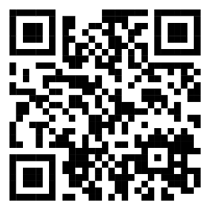 | 10 / $20.22.
 | 3.5 mm F/Bare Stereo Cable (1ft)  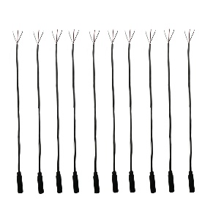 | Amazon Link  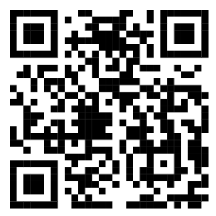 | To use as a mono cable:  Fully strip the insulation off the white wire and 0.5 cm from the red and black wires. Wrap the exposed wire around the red cable.  10 / $10.99  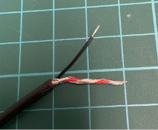
Battery Interrupter | Flex PCB  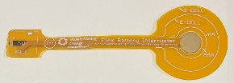 | Request from MMC  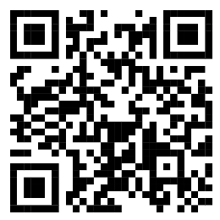 | -
 | 3.5 mm Mono Jack Flat Rectangular  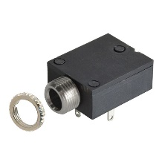 | Digikey Link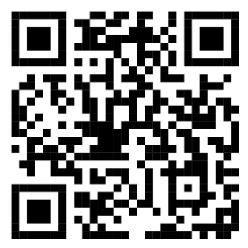 | Flex PCB is soldered onto the mono jack.
Additional Components | 10,000 pf (103) Capacitor  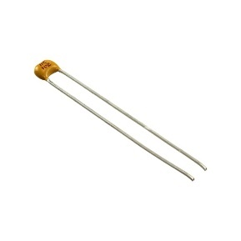 | Digikey Link  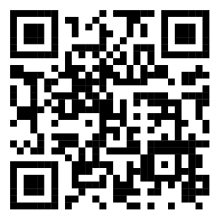 | Used for adapting multiple RC cars.  Amazon Dinosaur RC Car  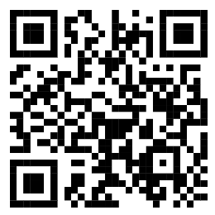  Prextex RC Race and Police Car  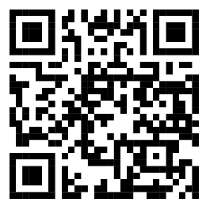  Prextex RC Truck and Tractor  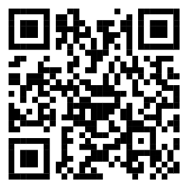
 | Toggle Switch  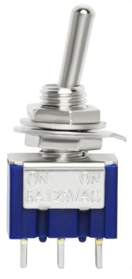 | Amazon Link  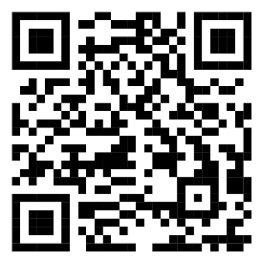 | Used in Nerf N-strike Elite Hyperfire Blaster. 10/$15.98.  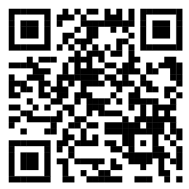

Tools
Tool | Purchase Link | Price  ($ CAD) | Notes
Soldering Kit  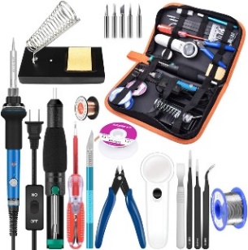 | Amazon Link  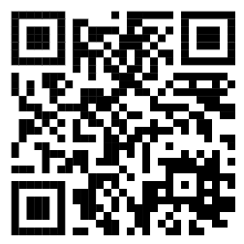 | 39.99 | Easy and cheap way to acquire a lot of tools.  Includes: Soldering iron, solder, soldering iron stand, sponge, Phillips and flathead screwdriver, flush cutter, tweezers, etc.
Wire Strippers  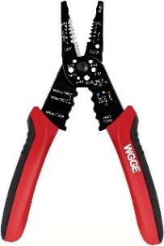 | Amazon Link  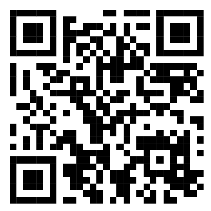 | 21.43 | Required for mono jack / cable toys.
Multi Head Screwdriver  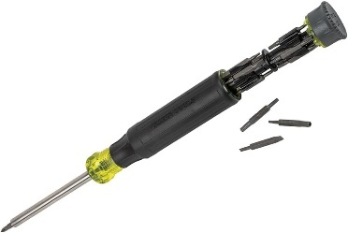 | Amazon Link  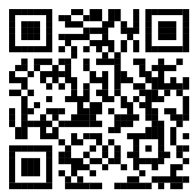 | 31.77 | Comes with 26 bits.  Helpful to have a few more screwdrivers than soldering irons for events.  Most toys use Phillips Screwdrivers.
Cable Tie  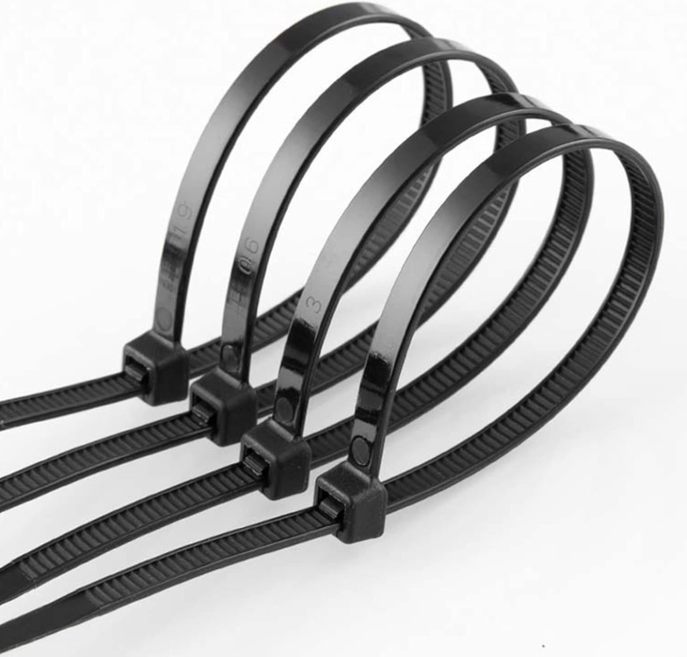 | Amazon Link  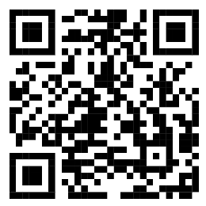 | 10.99 | Attach to mono cable on inside of toy for strain relief.  Pack of 150 cable ties:  50 - 10cm  50 - 20cm  50 - 30cm
Flush Cutter  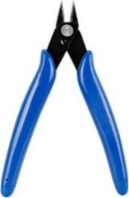 | - | - | Used to cut wires.  *Included in soldering kit*
Drill and Drill Bits  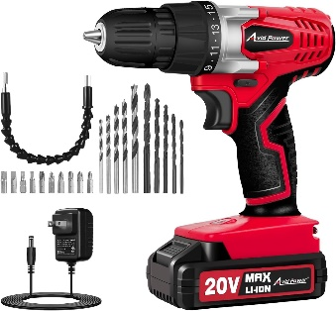 | Amazon Link  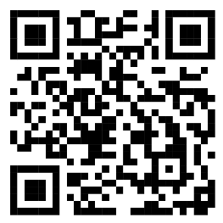 | 69.99 | Needed to create hole in hardshell toys for cable/jack. 1/8" drill bit for mono cable, 1/4" drill bit for mono jack.
Safety Glasses  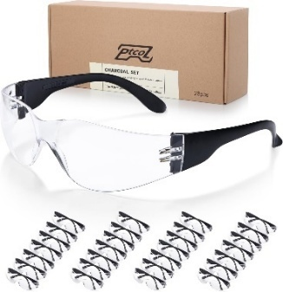 | Amazon Link  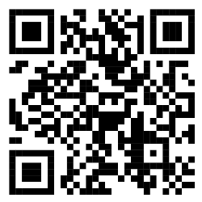 | 39.50 | Pack of 28.
Silicone Mat  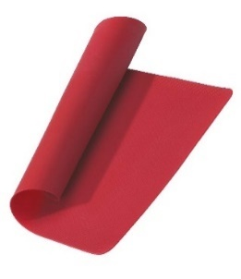 | Canadian Tire Link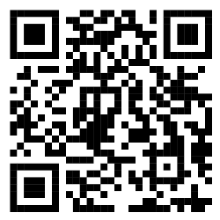 | 9.99 | Often goes on sale for $5.  Useful to have one with each soldering iron at events.
Silicone Mat  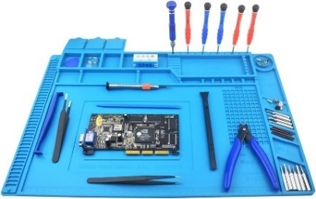 | Amazon Link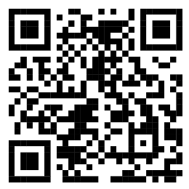 | 25.99 | Good for a personal workstation.
Pliers  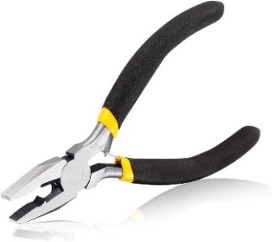 | Amazon Link  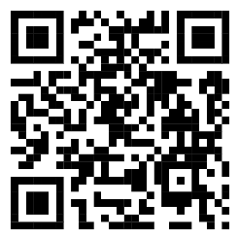 | 11.99 | -
Long Nose Pliers  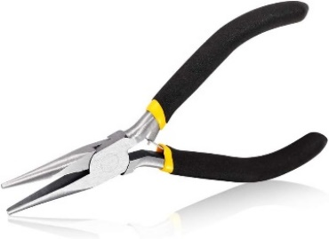 | Amazon Link  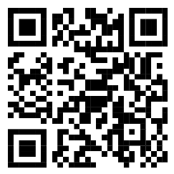 | 11.99 | -
Multimeter  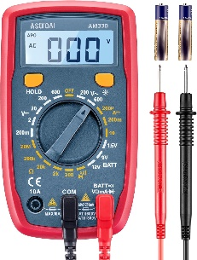 | Amazon Link  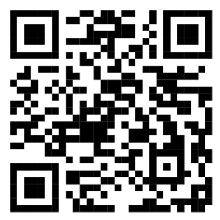 | 23.99 | Useful for deciding where to solder new wires onto a PCB.
Electrical Tape  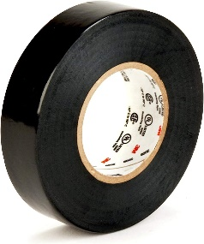 | Amazon Link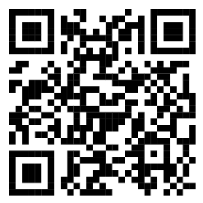 | 4.70 | Often required for toys adapted with a mono jack.
Helping Hands  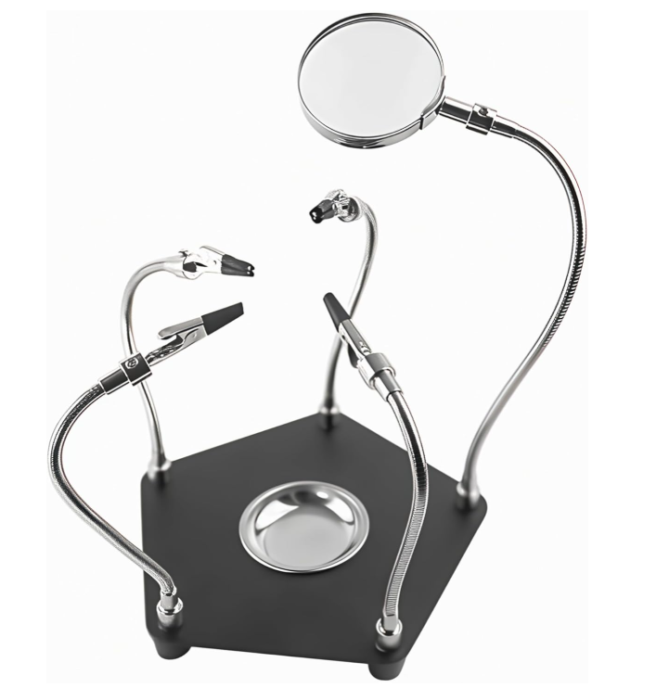 | Amazon Link  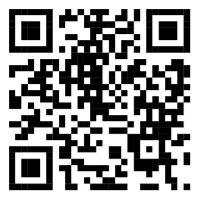 | 29.99 | Can be helpful when soldering.
Hot Glue Gun  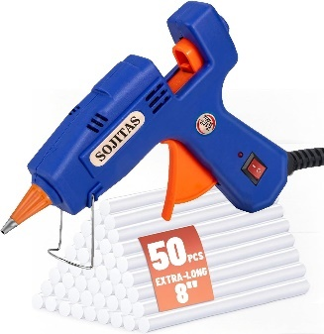 | Amazon Link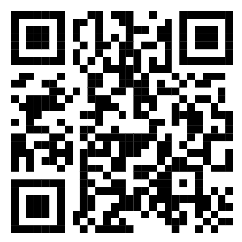 | 19.99 | -
Needle and Thread  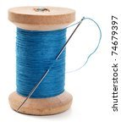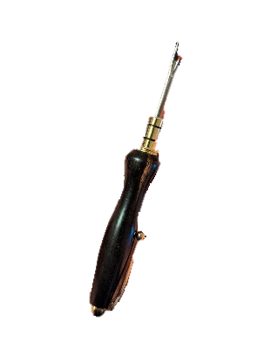 | - | - | Sometimes needed to close plush toys.

