Required Components
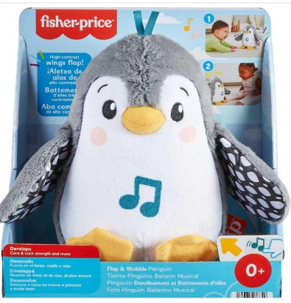 | 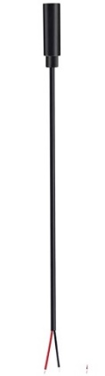 | BOM  - Fisher-Price Flap and Wobble Penguin Plush (Amazon, Walmart)  - Female mono cable (3.5mm)  - Small cable tie – about 10 cm  - Large cable tie – at least 45 cm or 18 in  Refer to the Tool and Component List for purchasing details.
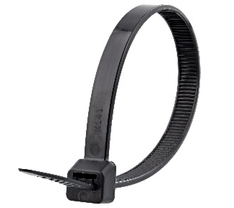 | 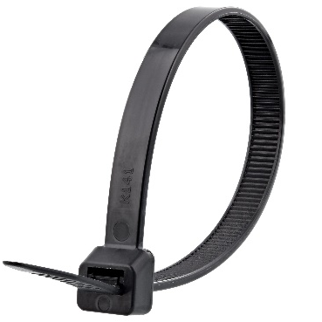

Required Tools
- Drill with 1/8” bit
- Small Phillips screwdriver
- Additional large screwdriver, preferably flathead
- Flush cutters
- Wire strippers
- Soldering iron and solder

Required Personal Protective Equipment (PPE)
- Safety glasses

Assembly Instructions

Step 1
- To start, locate the bottom of the penguin and the large plastic compartment. You will notice this compartment has a cable tie holding it in place  - Locate the cable tie. It will be in the seam of the fabric going around the plastic compartment.  - Find an opening (you may have to snip a bit of fabric) to then snip the cable tie. When this happens, the plastic will be free from the fabric. | 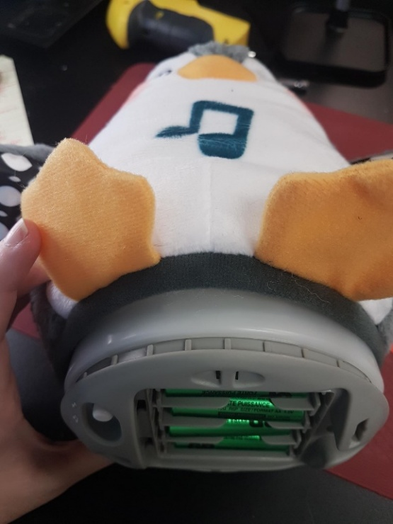

Step 2
- Gently pull the inside plastic compartment out as much as you can – the compartment will not come all the way out.  - Locate the 4 screws – circled in red – and loosen the screws. Set the screws aside in a safe place.  - This internal part of the toy will not come completely apart, but you can have the grey bottom come loose. | 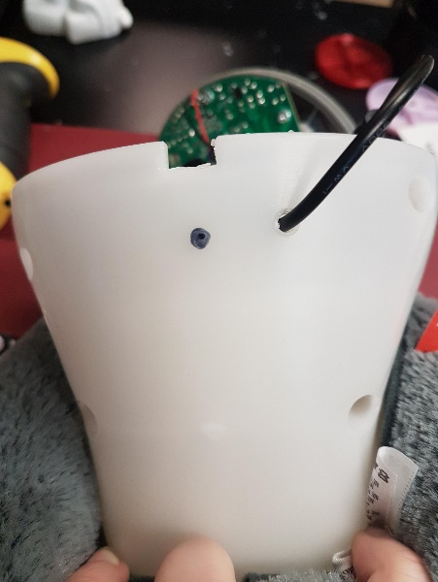

Step 3
- This part is difficult, as you will need to separate the grey bottom from the toy by prying the plastic apart.  - Using a screwdriver, you will wedge the screwdriver between the grey plastic bottom and white plastic compartment. While doing this, try to wiggle the grey plastic bottom free, moving the screwdriver around all sides. | 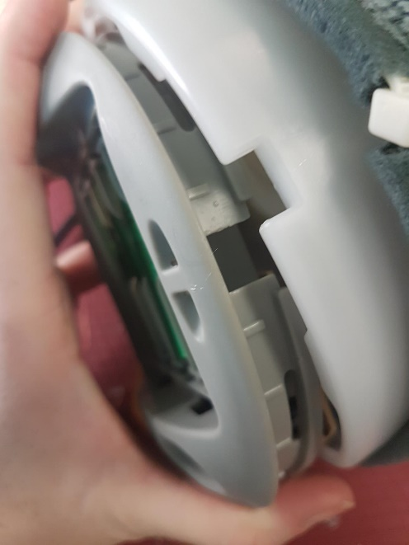

Step 4
- This toy is adapted by a cable, so must make an entry point for the cable and thread it through, before we solder it onto the board  - Drill a hole into the plastic to thread the cable through. The hole can be made at the back of the toy, just above and to the side of the square hole. Make sure to be about 2 cms from the bottom of the toy so the cable does not interfere with the plastic parts when reassembled | 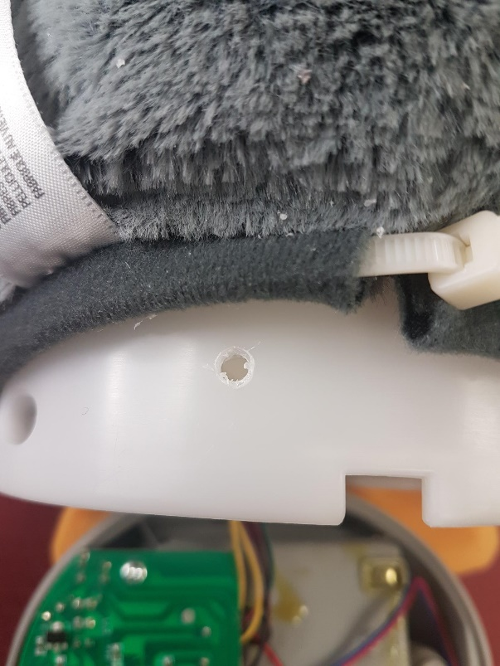

Step 5
- You can lay the penguin on its side, leaving the grey bottom flat on the table which will give you space to work with the circuit board.  - The cable is threaded through the hole, and you can now add some solder to the ends of your internal cable wires. This will make it easier to attach to the board | 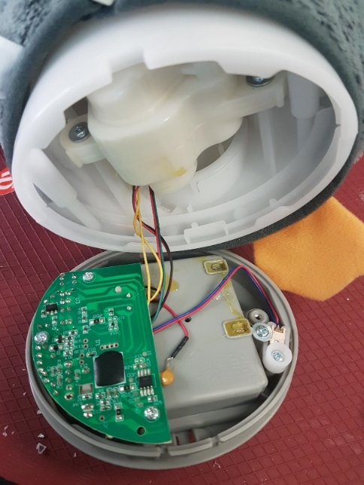

Step 6
- Your internal cable wires will now be soldered onto the board.  - Connect one wire to each spot on the board – circled in red.  - It does not matter what wire is attached to what spot but make sure the original wires also stay in that spot  - Each spot on the board – circled in red – will have one new wire from the cable and one original wire  - Make sure to keep the solder on each spot, and not to connect any of the spots on the board together  - When complete, use an assistive switch to test the toy (you will also need to add batteries for testing) | 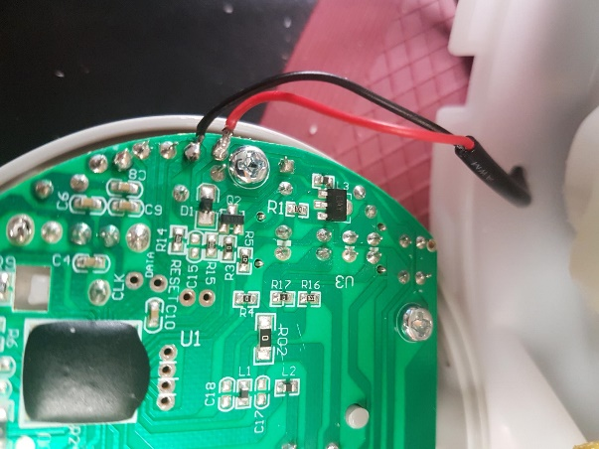

Step 7
- Before reassembling, secure the small cable tie around the cable inside the plastic compartment. This is to keep the cable from being pulled out and staying in place inside of the toy. | 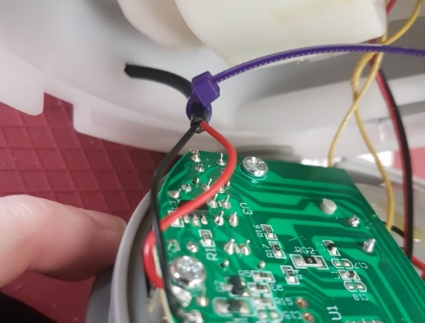

Step 8
- The toy can now be reassembled. The grey plastic bottom can be reattached to the main plastic compartment. If this is difficult, make sure you have the correct orientation of the grey part, and you can do this by lining up the square cut outs in the back of the toy. | 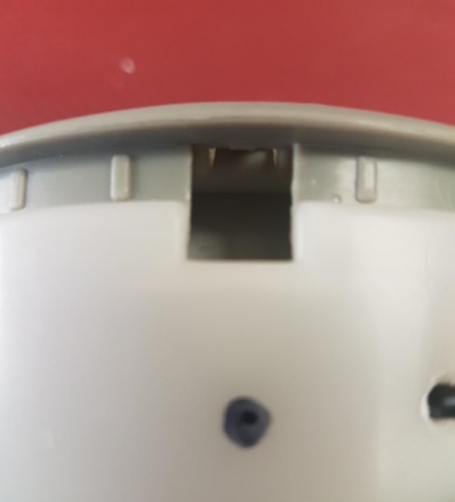

Step 9
- Secure the screws back in place  - Push the plastic compartment back inside the toy to the original position  - Use your new cable tie, thread the cable tie through the seam (if the original cable tie is still there, remove it) and secure it around the plastic compartment to hold it in place.  - Make sure you cable is able to be accessed and outside of the toy before securing the cable tie | 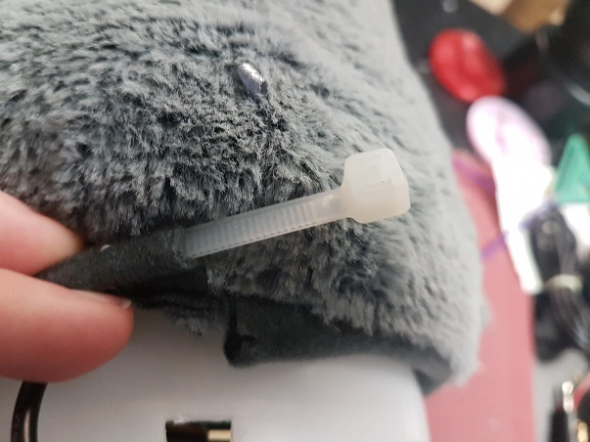

Step 10
- Test the toy again with an assistive switch. If it is still working properly, repackage the toy and the adapted toy is complete! | 