Completion Checklist (DELETE BEFORE POSTING)
- Download a copy of this template
  - Rename it Manufactuer_Name_Toy_Name_Maker_Guide
- Decide how the toy will be adapted
  - Choose from mono jack, mono cable and battery interrupter methods
  - Delete the highlighted headers, other two sets of instructions and Table of Contents
- Update <MONTH> and <YEAR> in header
- Update V<X.Y.Z> in header
- Update <TOY NAME> in header
- Update <YEAR> in footer
- Update <Author> in footer
- Update Required Components table
  - Add a photo of the toy from the manufacturer’s website
  - Add or remove component images as necessary
  - Add the toy’s manufacturer name and name to the BOM
  - Adjust the number of batteries in the BOM and image
- Add tools to Tool List
  - Specify screwdriver type
- Add Required PPE
- Complete Assembly Instructions
  - Edit and add steps as necessary
  - Add text to the left and images to the right
  - Add colored circles to the images to highlight what you’re referring to
- Delete Completion Checklist
- Before putting the toy back in the packaging
  - Take an image of the adapted toy with an assistive switch
  - This image will be used for the website

Download the template
File > Download > Word (.docx)

Contents
Mono Jack Instructions 2
Required Components 2
Required Tools 2
Required Personal Protective Equipment (PPE) 2
Assembly Instructions 2
Mono Cable Instructions 6
Required Components 6
Required Tools 6
Required Personal Protective Equipment (PPE) 6
Assembly Instructions 7
Battery Interrupter Template 9
Required Components 9
Required Tools 9
Required Personal Protective Equipment (PPE) 9
Assembly Instructions 10

Mono Jack Instructions

Required Components
- <Toy Image> | 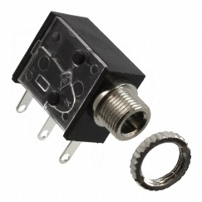 | BOM  - <Brand Name - Toy Name> (Store)  - 3.5 mm Mono Jack and Ring  - 22 AWG Wire  - Electrical Tape  - # and type of Batteries (please also adjust # of batteries in the photo)  Refer to the Tool and Component List for purchasing details.
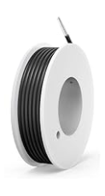 | 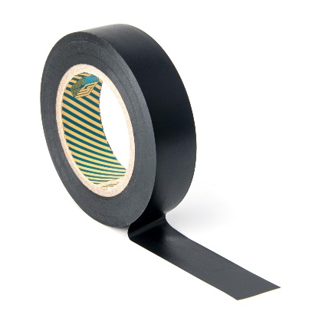 | 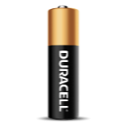  

Required Tools
- Small Phillips Screwdriver 3mm Diameter

- Ruler
- Wire strippers
- Soldering iron and solder
- Drill and 1/4” drill bit

Required Personal Protective Equipment (PPE)
- Safety glasses

Assembly Instructions
- Carefully remove the toy from its packaging without damaging it (we will be repackaging the toy after adapting). Locate and remove the screws along the body of the toy.  *Note: keep screws, and keep track of where they came from if there are multiple different sized screws | [Image]
- Carefully separate the two halves of the toy. | [Image]
- Cut 2 pieces of wire, each X cm long. | 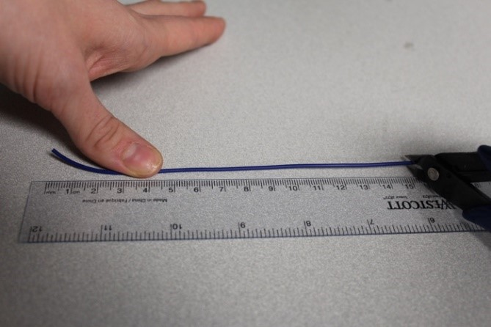
- Use wire strippers to strip approximately 0.5 cm off each end of the wires | 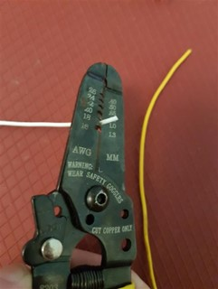
- Solder the two wires onto the front two tabs of the mono jack. | 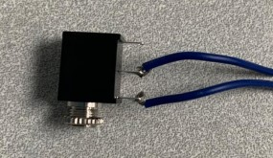
SELECT WHICH WAY THE TOY WILL BE ADAPTED AND DELETE THE OTHER SET
FOR TOYS ADAPTED IN PARALLEL
- Tin the other ends of the wires by adding a small amount of solder to each wire. | 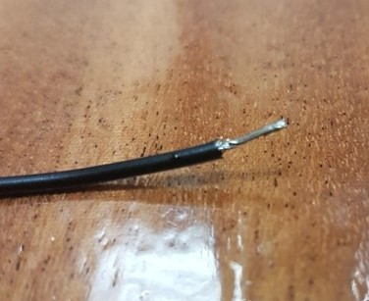
- Solder the new wires in parallel with the existing wires connected to the switch. Do this by carefully soldering the new wires on top of the existing wires, being careful not to break the original connection. | [Image]
- It is now time to test the toy. Insert batteries into the battery compartment and an assistive switch into the mono jack. Test to make sure that the toy can be controlled using the original switch and the assistive switch.  Notes:  - If the toy does not turn on, please check the soldered connections.  [Select one statement]  For Continuous Toys (singing for example)]:  - If the toy continuously repeats the song when the switch is released, the connection is shorted. Check for areas of touching solder and separate using a soldering iron.  For Press Activation Toys (release and stop)  - If the toy does not turn off when the switch is released, the connection is shorted. Check for areas of touching solder and separate using a soldering iron. | [Image]
FOR TOYS ADAPTED IN SERIES
- Locate a wire that connects from the battery compartment to the switch. Use the soldering iron to heat up the original solder and release the wire from the board. | [Image]
- Solder the end of the released wire to one end of the wire connected to the mono jack. | [Image]
- Wrap the exposed joint in electrical tape to ensure they stay connected. | [Image]
- Solder the end of the other wire connected to the mono jack to the board where the wire was removed. | [Image]
- It is now time to test the toy. Insert batteries into the battery compartment and an assistive switch into the mono jack. The toy will activate when the assistive switch is pressed.  Notes:  - If the toy does not turn on, please check the soldered connections.  [Select one statement]  For Continuous Toys (singing for example)]:  - If the toy continuously repeats the song when the switch is released, the connection is shorted. Check for areas of touching solder and separate using a soldering iron.  For Press Activation Toys (release and stop)  - If the toy does not turn off when the switch is released, the connection is shorted. Check for areas of touching solder and separate using a soldering iron. | [Image]
CONTINUE WITH THESE INSTRUCTIONS
- Using a ¼” drill bit, drill a hole into the position shown on the right. Remove any loose plastic. | [Image]
- Remove the retaining ring from the mono jack and push the mono jack through the hole from the inside. Reinstall the retaining ring on the outside of the toy and tighten to secure. | [Image]
- Reassemble the toy using the screws set aside earlier. | [Image]
- Test the toy again. If it is still working properly, repackage the toy and the adapted toy is complete! | [Image]

Mono Cable Instructions

Required Components
1. <Toy Image> | 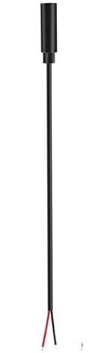  2. | BOM  - <Brand Name - Toy Name>  - 3.5 mm Female Mono Cable  - Cable Tie  - # and type of Batteries (please also adjust # of batteries in the photo)  Refer to the Tool and Component List for purchasing details.
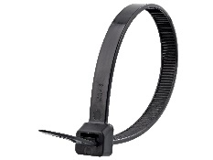 |   

Required Tools
- Screwdriver (Please specify screwdriver type)
- Wire strippers
- Soldering iron and solder
- Drill and 1/8” drill bit
- Slip joint pliers
- Flush cutters

Required Personal Protective Equipment (PPE)
- Safety glasses

Assembly Instructions
- Carefully remove the toy from its packaging without damaging it (we will be repackaging the toy after adapting). Locate and remove the screws along the body of the toy.  *Note: keep screws, and keep track of where they came from if there are multiple different sized screws | [Image]
- Carefully separate the two halves of the toy. | [Image]
- Use wire strippers to strip approximately 2 cm off the outer wire casing, revealing two internal wires. | 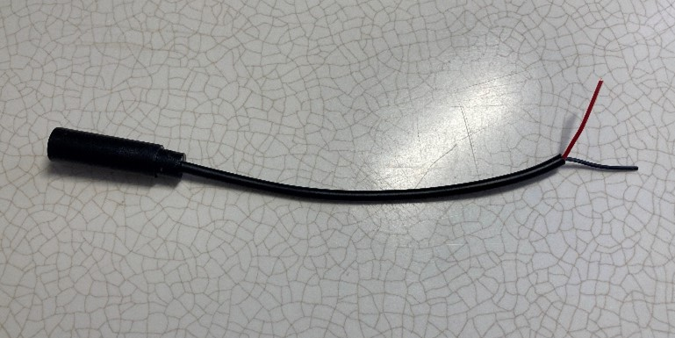
- If there are 2 internal wires, strip approximately 0.5 cm off each wire. | 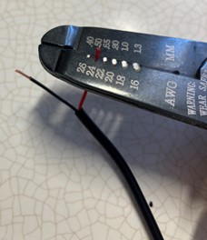
- If there are three internal wires (red, black, and exposed), strip off 0.5 cm of the red insulation and twist the red wire and exposed wire together. Strip 0.5 cm from the black wire. | 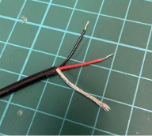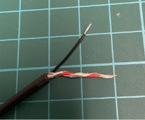
- Melt a small amount of solder over the exposed ends of the wire. | 
- Using a 1/8” drill bit, drill a hole into the position shown on the right. Remove any loose plastic and insert the mono cable through the hole. | [Image]
- Attach the mono cable to the toy. | [Image]
- It is now time to test the toy. Insert batteries into the battery compartment and an assistive switch into the mono jack. The toy will activate when the assistive switch is pressed.  Notes:  - If the toy does not turn on, please check the soldered connections.  [Select one statement]  For Continuous Toys (singing for example)]:  - If the toy continuously repeats the song when the switch is released, the connection is shorted. Check for areas of touching solder and separate using a soldering iron.  For Press Activation Toys (release and stop)  - If the toy does not turn off when the switch is released, the connection is shorted. Check for areas of touching solder and separate using a soldering iron. | [Image]
- Attach a cable tie to the cable on the inside of the case as close as possible to where it enters.

Tighten the cable tie as much as you can and snip the excess zip tie using the flush cutters.

The cable tie will serve as strain relief, so the soldered connections do not get pulled and break.
- Reassemble the toy using the screws set aside earlier. | [Image]
- Test the toy again. If it is still working properly, repackage the toy and the adapted toy is complete! | [Image]

Battery Interrupter Template

Required Components
- <Toy Image> | 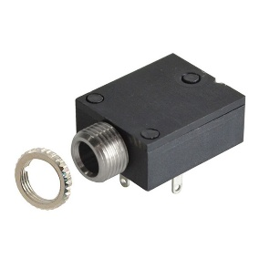 | BOM  - <Brand Name - Toy Name>  - 3.5 mm Square Mono Jack and Ring  - MMC Flex PCB  - # and type of Batteries (please also adjust # of batteries in the photo)  Refer to the Tool and Component List for purchasing details.
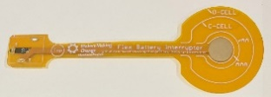 |   

Required Tools
- Screwdriver (Please specify screwdriver type)
- Soldering iron and solder
- Scissors

Required Personal Protective Equipment (PPE)
- Safety glasses

Assembly Instructions
- Locate your battery interrupter PCB and mono jack. The prongs from the mono jack match up with the holes in the PCB. Lay the battery interrupter on top of the mono jack, with the metal prongs sticking through the holes. | 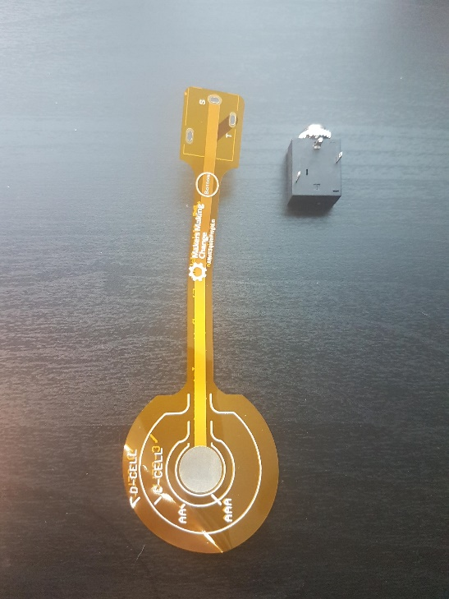
- At the base, add solder to the metal prongs so the PCB and mono jack are connected. Make sure the PCB is as flat against the mono jack as possible. The metal ring that is around the input of the mono jack can be removed and set aside. | 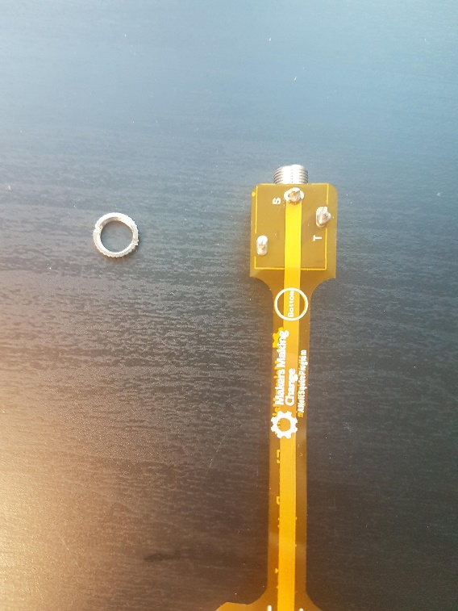
- Check what size the batteries are of the toy you wish to use the interrupter with. This toy uses AAA batteries. There are circles on the orange PCB indicating the battery size. Locate the circle labeled AAA and cut the PCB to that size. | 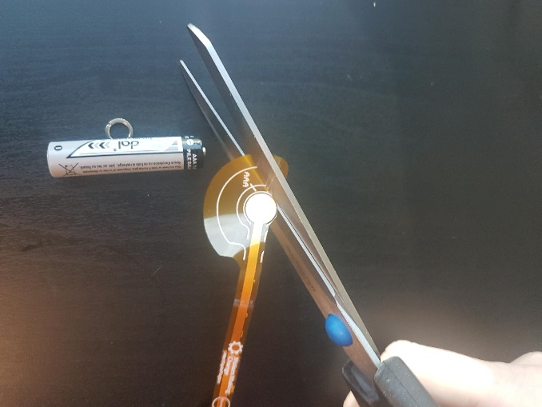
- Unscrew the battery cover from the toy. Match the circle that you just cut with the positive end of one of the batteries. Hold in place and replace the battery cover. Tighten the battery cover tightly to make sure the interrupter is pushed up against the battery.  *Note: When it is secure enough, the toy will not turn on with the original button. | [Image for step 4]
- The toy can now be paired with an assistive switch. When the switch is plugged in and activated, the toy should turn on. Repackage the toy and the adapted toy is complete!  *Note: If the toy does not work, make sure the original button is on, and check the position of the interrupter. | [Image of the completed toy]

