Required Components
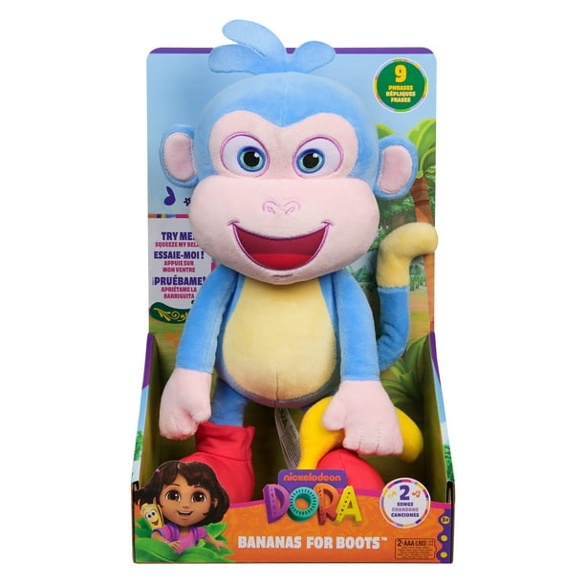  1. | 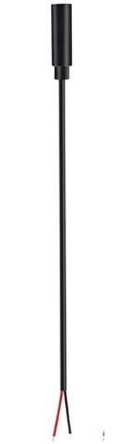  2. | BOM  - Dora The Explorer – Bananas For Boots Plush  - 3.5 mm Female Mono Cable  - 12’’ Cable Tie  - 4’’ (or smaller) Cable Tie  - 2 AA batteries (Included)  Refer to the Tool and Component List for purchasing details.
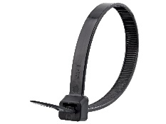 | 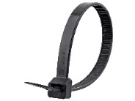 | 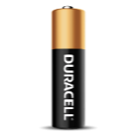  

Required Tools
- Phillips Screwdriver
- Wire strippers
- Soldering iron and solder
- Drill and 1/8” drill bit

Required Personal Protective Equipment (PPE)
- Safety glasses

Assembly Instructions
- Carefully cut the toy out of the packaging without damaging the box (we will be repackaging the toy after adapting). | 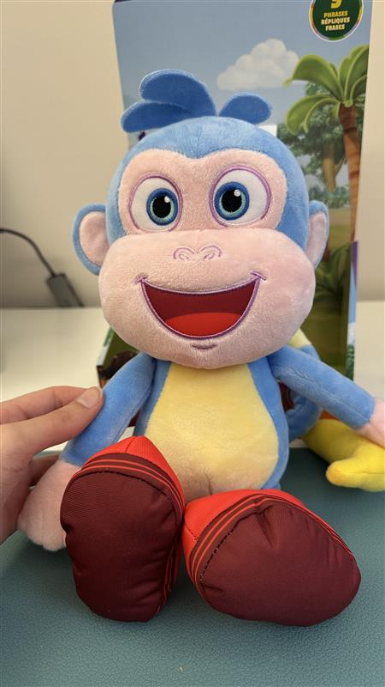
- Open the compartment on the back of the toy, revealing the inner plastic compartment. | 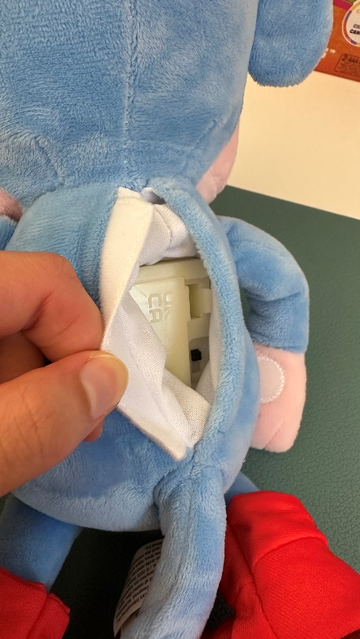
- Pull the plastic box out of the toy. The box is larger than the hole, so be careful not to rip the fabric. | 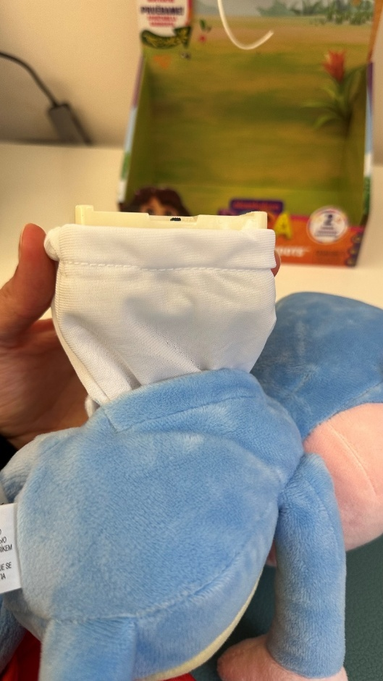
- Locate the seam of the white fabric. You should be able to slide the fabric around the side of the box as shown in the image. This will reveal a cable tie. Using scissors or flush cutters, cut through the cable tie (avoid cutting the fabric).  If needed, you can make the hole larger by cutting the thread (Not the fabric). | 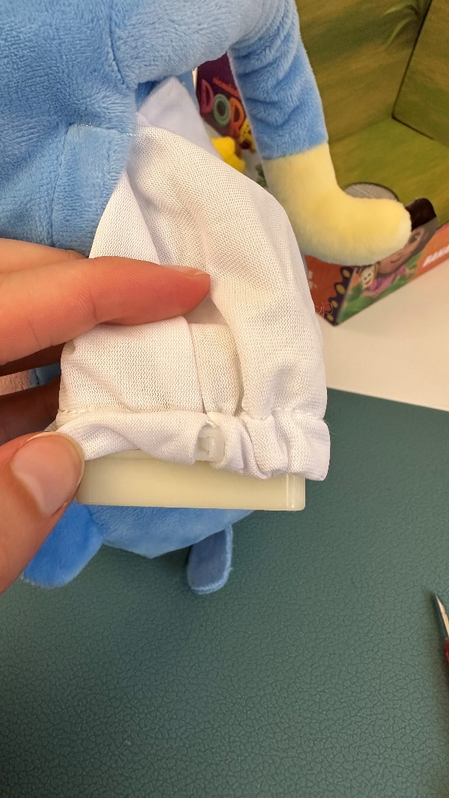
- You will now be able to pull the plastic box out of the fabric. | 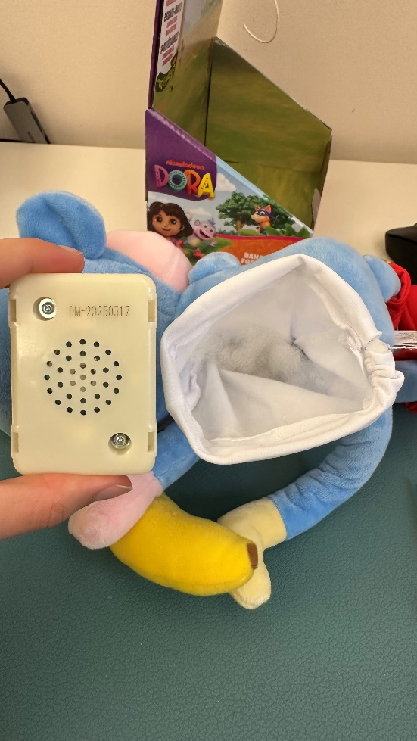
- Using a Phillips screwdriver, remove the two screws on the top. Then open the compartment by applying pressure to the sides. | 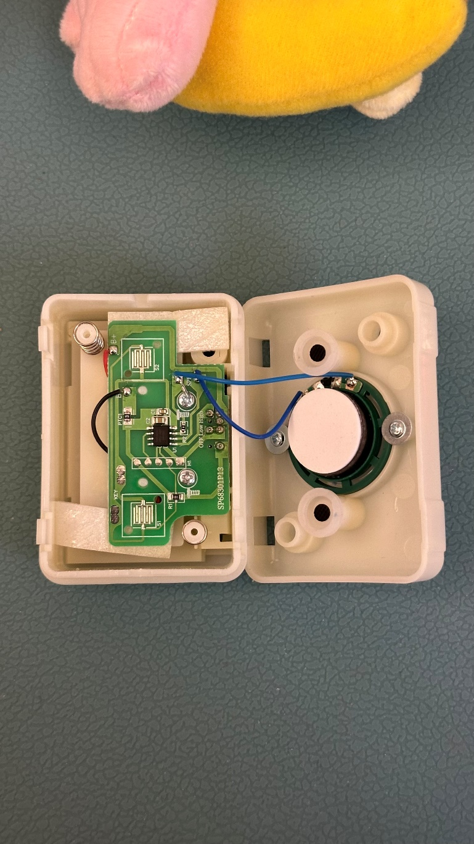
- Use wire strippers to strip approximately 2 cm off the outer wire casing, revealing two internal wires.  Note: If your mono cables come ready to solder, skip steps 7-9. | 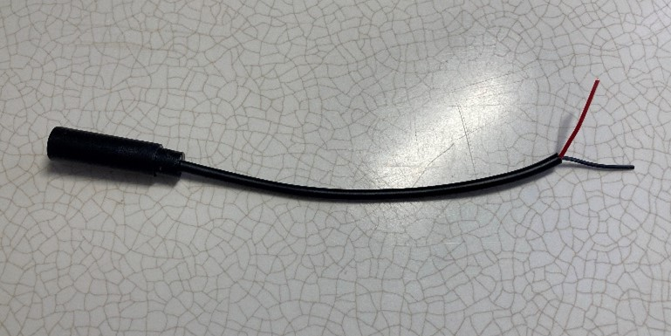
- If there are 2 internal wires, strip approximately 0.5 cm off each wire. | 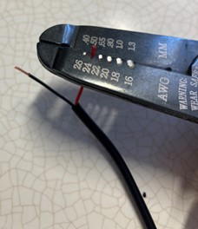
- If there are three internal wires (red, black, and exposed), strip off 0.5 cm of the red insulation and twist the red wire and exposed wire together. Strip 0.5 cm from the black wire. | 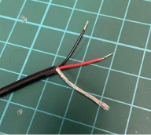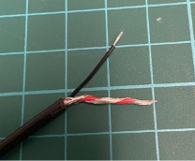
- Melt a small amount of solder over the exposed ends of the wire. | 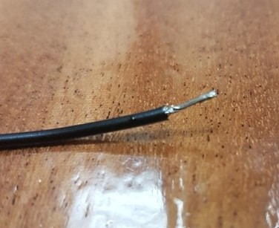
- Using a 1/8” drill bit, drill a hole into the position shown in the photo. Remove any loose plastic and insert the mono cable through the hole. | 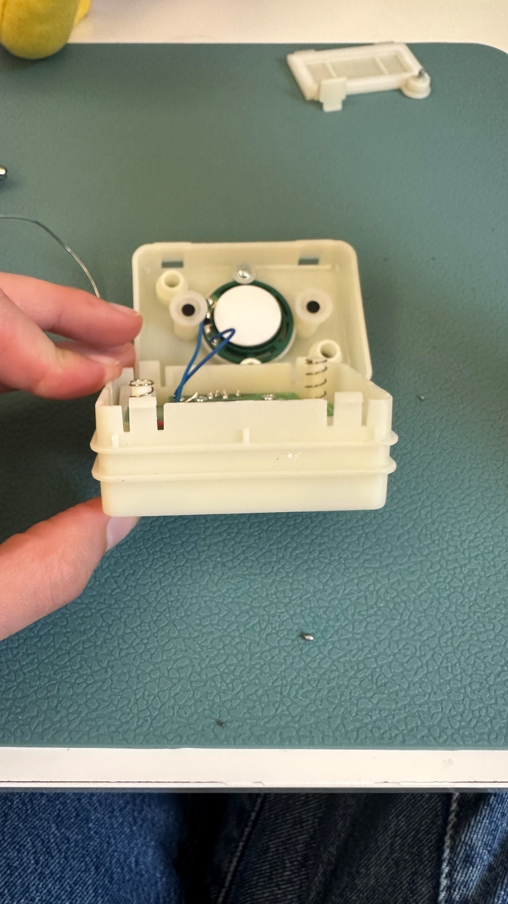
- Melt a small amount of solder on the two spots on the PCB that are circled in Red in the image. | 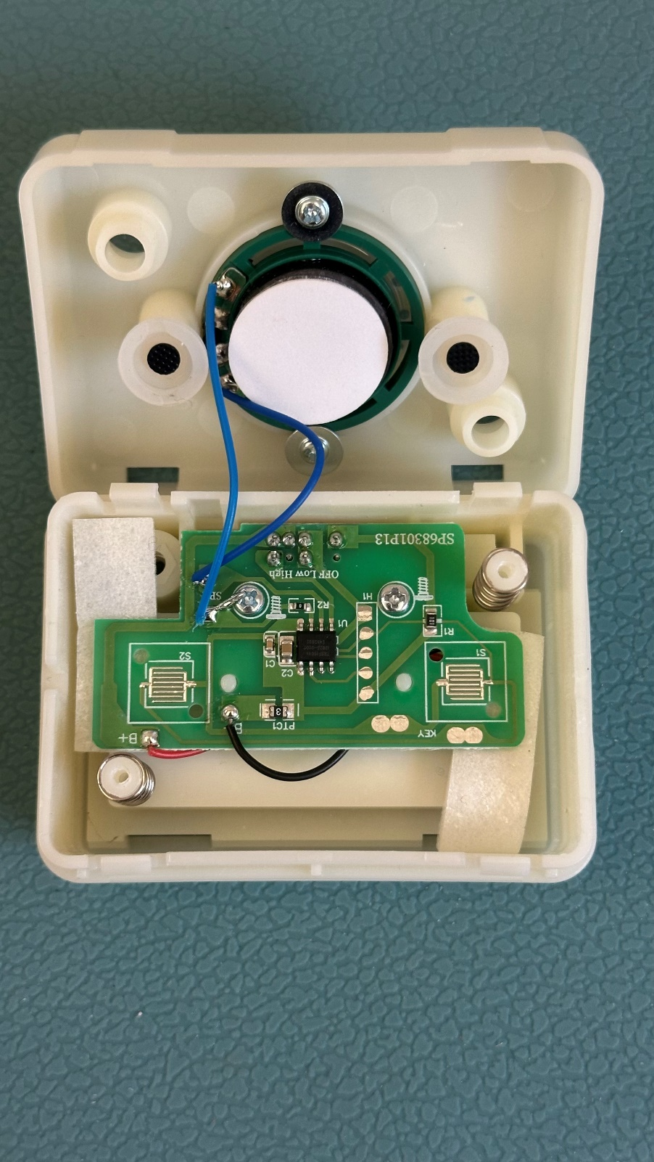
- Solder the mono cable to the two pre-soldered circles. | 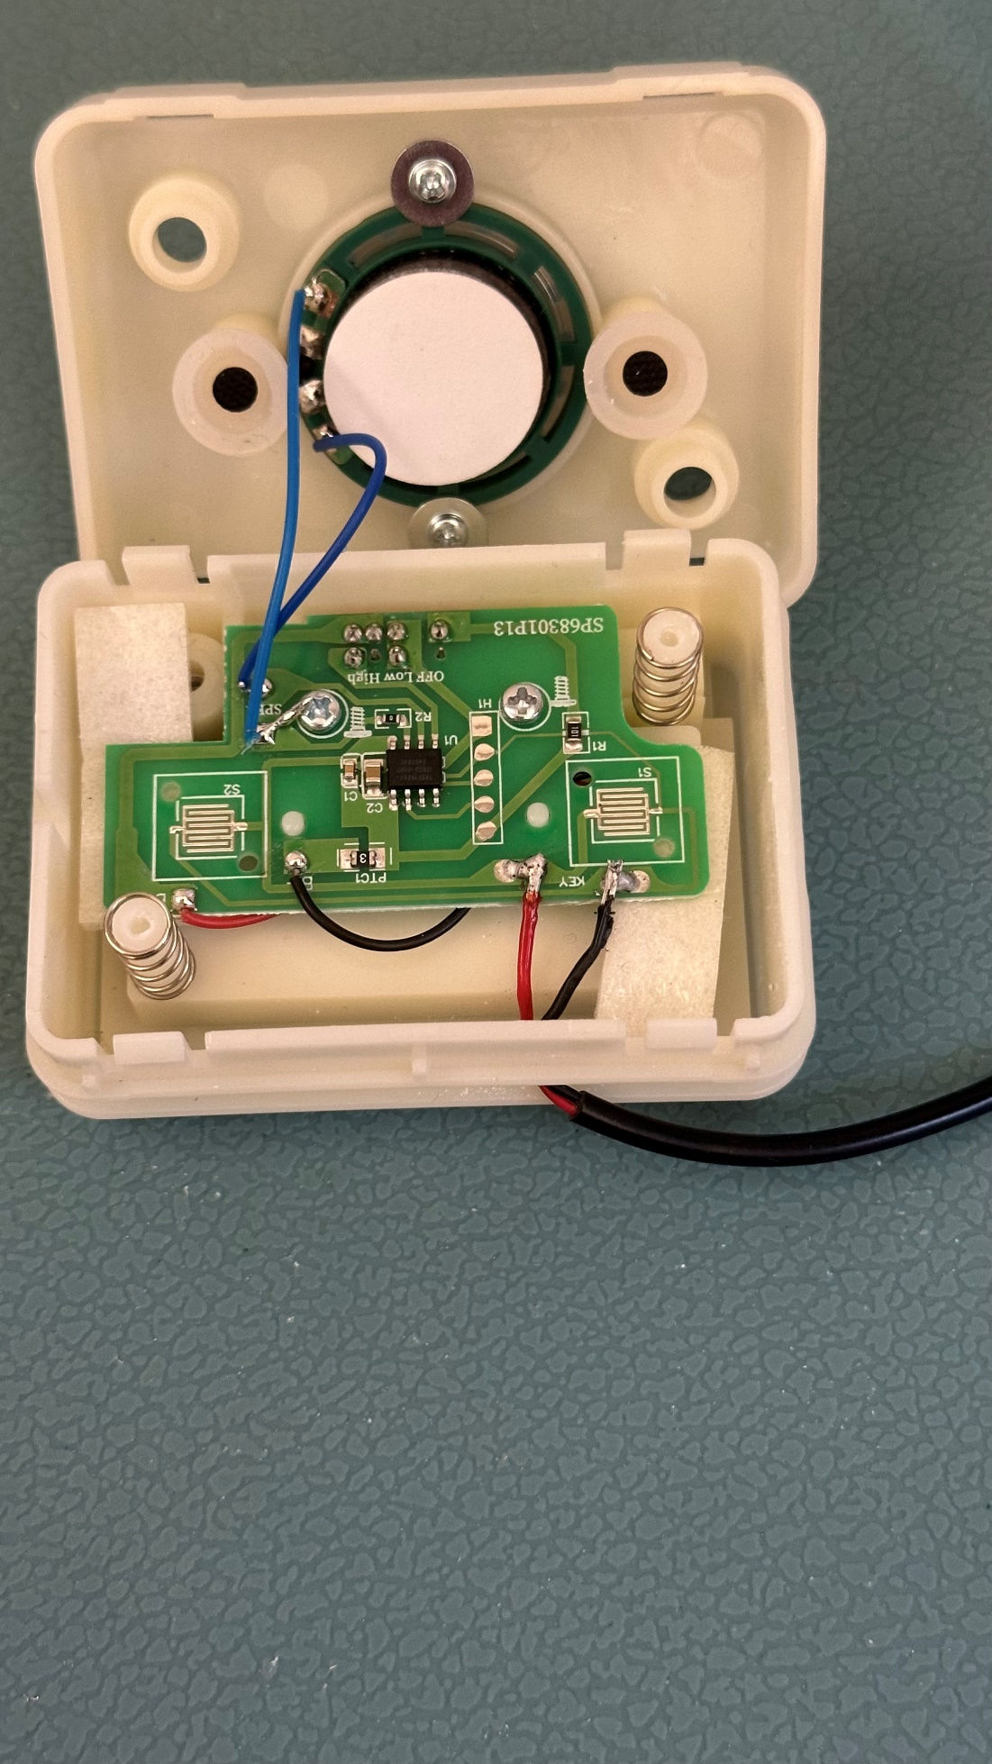
- It is now time to test the toy. Make sure the toggle switch on the back of the compartment is in the On position. Insert an assistive switch into the mono jack. The toy will activate when the assistive switch is pressed and turn off if the switch is pressed again.  Notes:  - If the toy does not turn on, please check the soldered connections.  - If the toy does not turn off, check the soldered connections. | 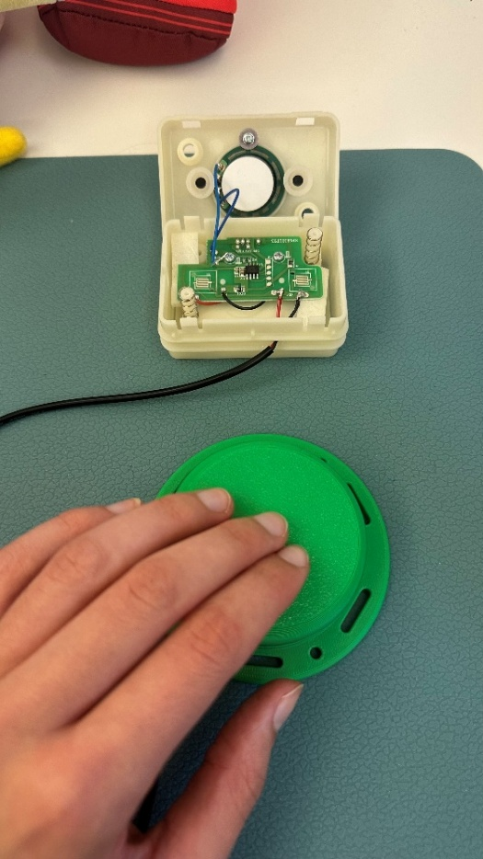
- Take the small cable tie and wrap it around the mono cable on the inside of the plastic compartment for strain relief. Make sure the cable tie is tightened all the way. | 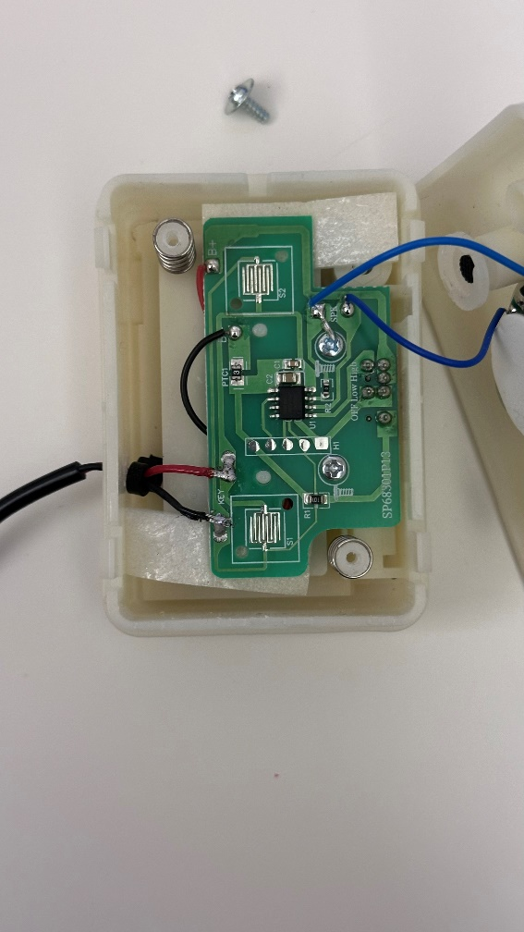
- Close the box and secure it with the two screws. Place it back into the fabric compartment in the back of the toy. | 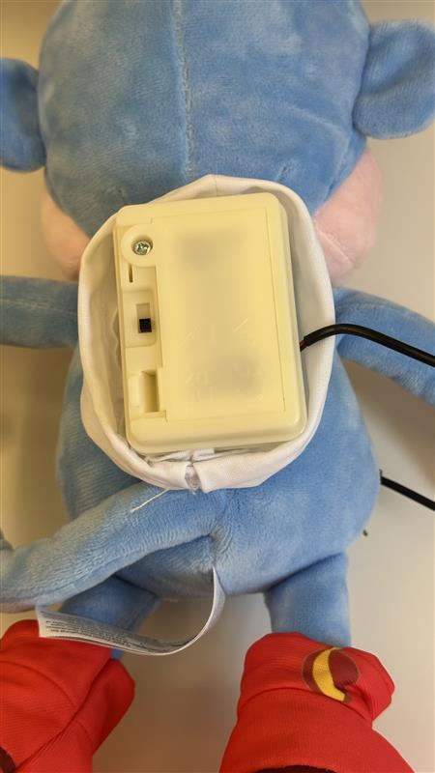
- Feed the longer cable tie through the hole in the fabric and fasten it tightly around the plastic case. Cut the end of the cable tie if it is too long. | 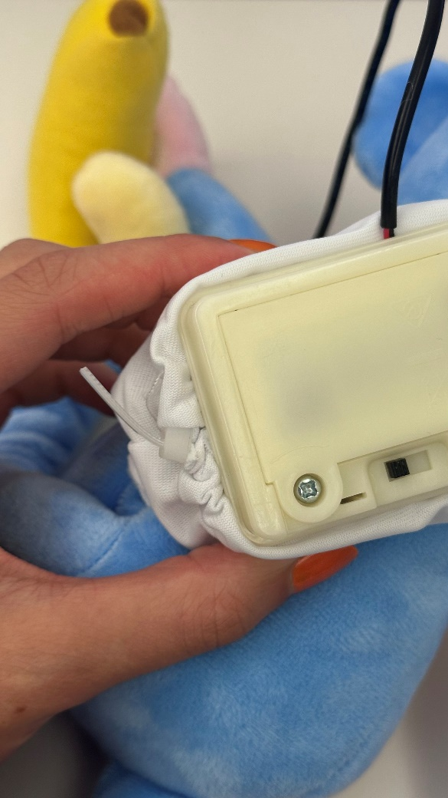
- Test the toy again with an assistive switch. If it is still working properly, repackage the toy and the adapted toy is complete! | 