Required Components
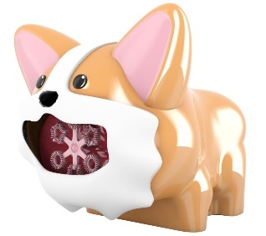 | 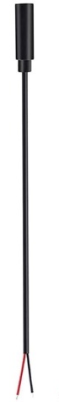 | 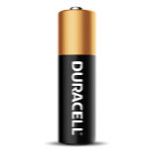 | BOM  - DanaPlay - Corgi Bubble Blower  - 3.5mm Female Mono Cable  - 2 AA Batteries

Required Tools
- Long Phillips screwdriver
- Wire strippers
- Soldering iron and solder
- Electrical tape

Required Personal Protective Equipment (PPE)
- Safety glasses

Assembly Instructions
- Remove the toy from its packaging. Locate and unscrew all screws on corgi (4 on body, 2 on ears, 1 under beard). | 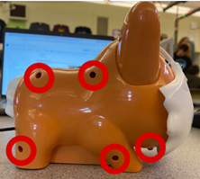  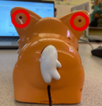
- Remove the ears from the body.  (This may be difficult) | 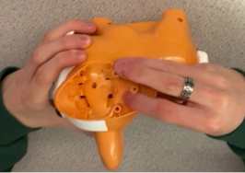
- Unscrew screw under right ear.  Pull apart two halves of the body. | 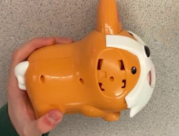
- Strip 2 cm of the cable using a wire stripper, revealing two internal wires.  (Skip this step if your wire already looks like this) | 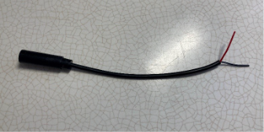  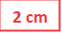
- Strip 0.5 cm of each internal wire, then twist the strands of wire. | 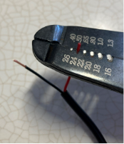  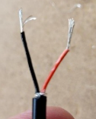
- Tin the wires by covering the exposed wire in solder.  (This preps the wire for soldering!) | 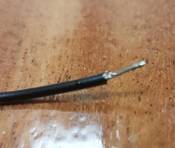
- Locate the switch.  Use wire cutters to cut it out of the circuit. | 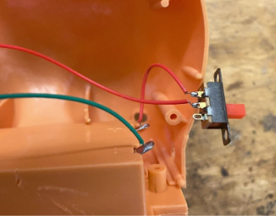
- Using wire strippers, strip 0.5 cm off the ends of the two wires that were previously connected to the switch. | 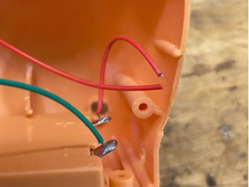
- Solder one of the mono cable wires to the wire coming from the battery pack.  Solder the second mono cable wire to the wire coming from the motor  Note: It does not matter which of the two wires. | 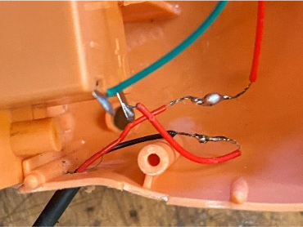
- Cover the soldered wires with electrical tape to prevent a short circuit inside the corgi. | 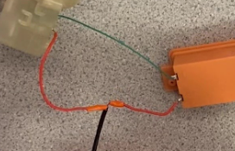
- Plug an assistive switch into the mono cable and test to ensure the motor turns on.  Note: If the motor does not turn on, check the soldered connections. | 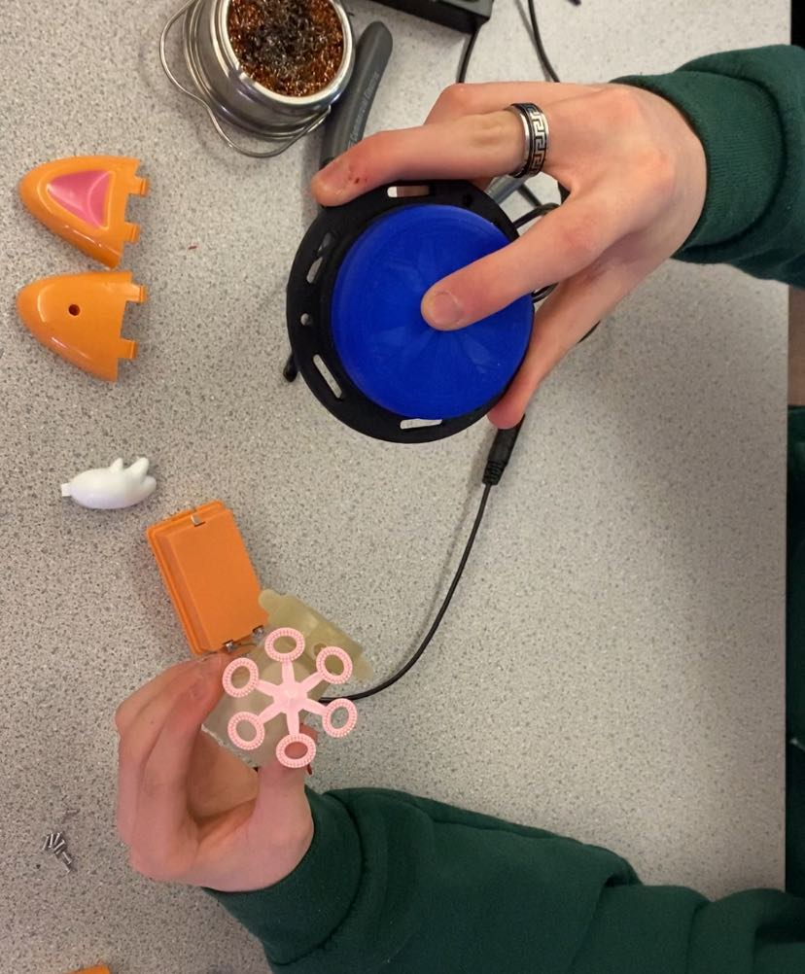
- Tie a knot in the mono cable for strain relief. | 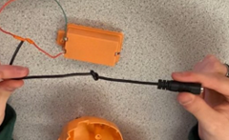
- Place the mono cable through the opening where the original switch was located (ensuring the knot is on the inside of the corgi, near the opening). | 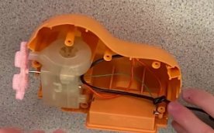
- Reassemble the corgi  Install screws on body, then snap ears back on, and install the final two screws on the ears.  Test the bubble machine again using an assistive switch. If it is working properly, re-insert the machine in its original packaging and the adapted toy is now complete. | 