Required Components
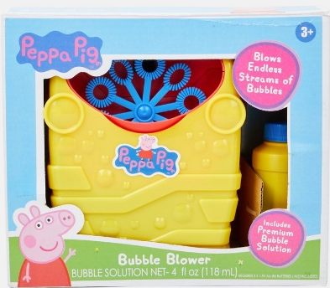 | 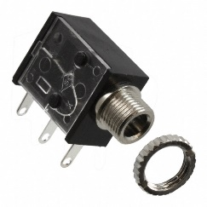 | BOM  - Peppa Pig Bubble Blower  - 3.5 mm Mono Jack and Nut  - 22 AWG Wire  - 3 AA Batteries
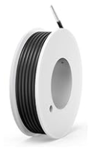 | 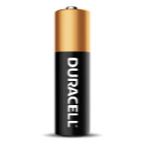  

Required Tools
- Screwdriver
- Ruler
- Wire strippers
- Soldering iron and solder
- Drill and 1/4” drill bit
Required Personal Protective Equipment (PPE)
- Safety glasses

Assembly Instructions
- Carefully remove the toy from its packaging without damaging it. Locate and remove the screws along the body of the toy.  *Note: keep screws, and keep track of where they came from if there are multiple different sized screws | 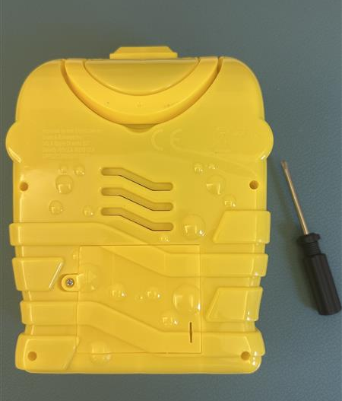
- Carefully separate the two halves of the toy. | 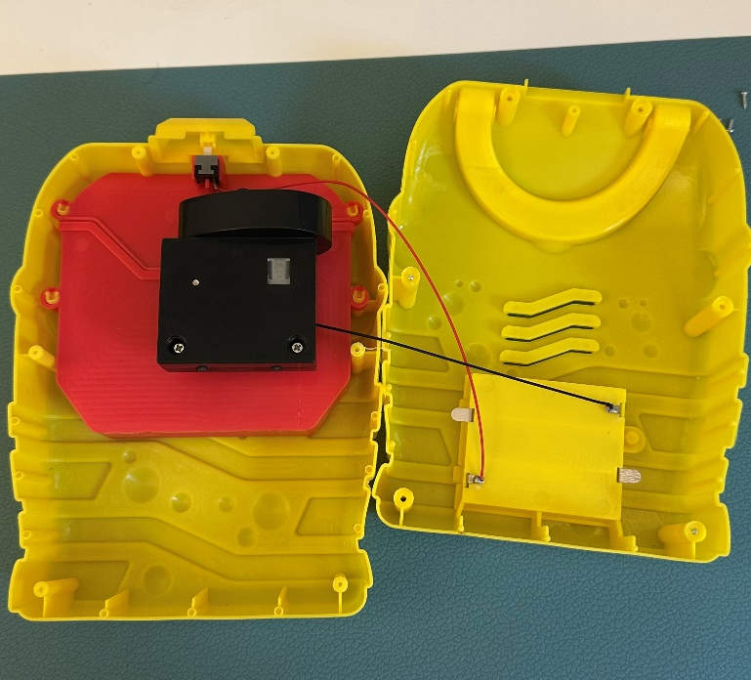
- Using the soldering iron, melt the solder on the middle prong of the switch and remove the wire | 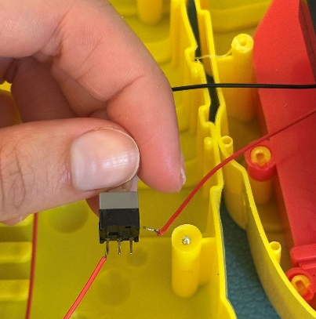
- Strip about 0.5 cm extra off the red wire from the toy. | 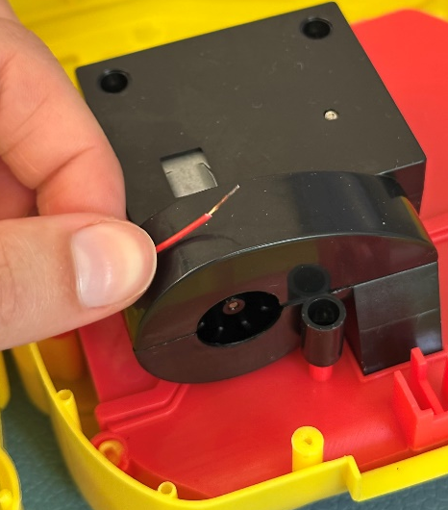
- Cut four pieces of wire approximately 6 cm long. Strip the ends of all wires.
- Take two of the wires and twist the ends together. Then twist the end of the red wire from the toy. Solder this connection | 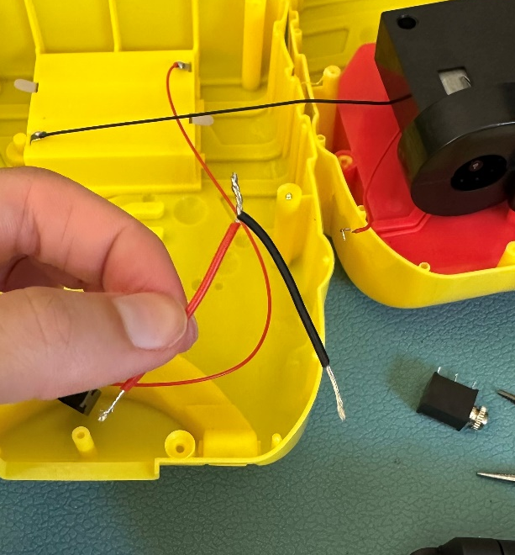  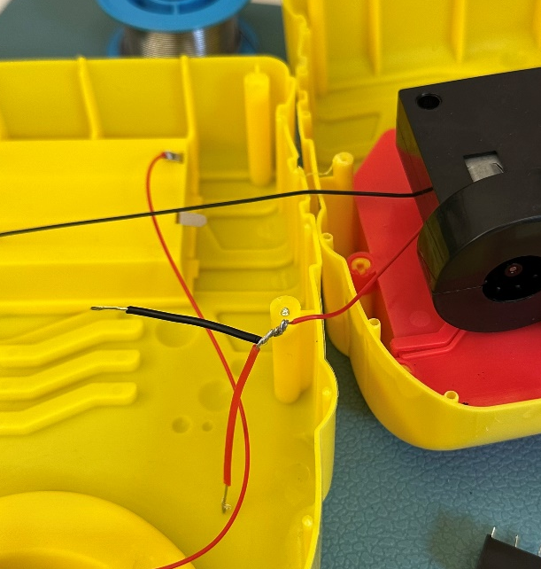
- Take one of the free wire ends, and solder it to the middle prong of the switch. It helps to wrap it around the prong before soldering | 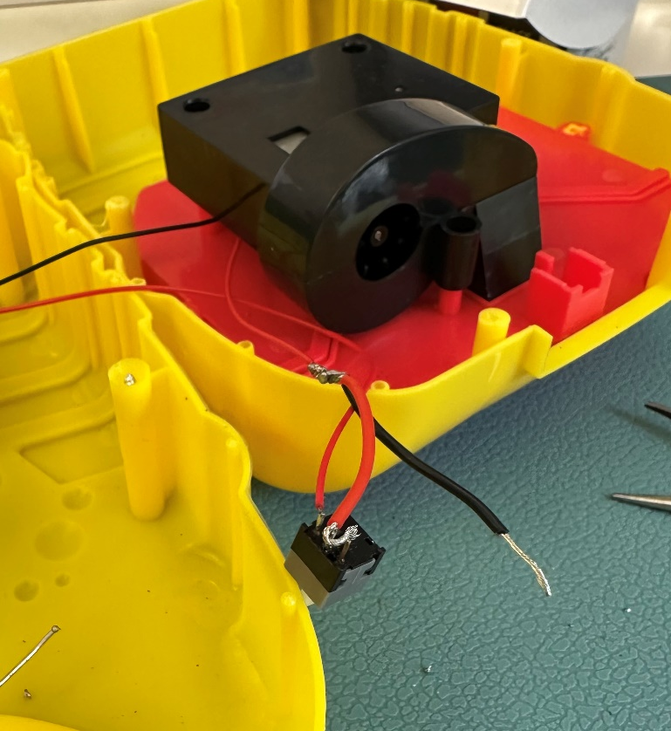
- Take the other free wire end and loop it through the first prong of the mono jack (closest to the jack as shown in the image). Solder this connection | 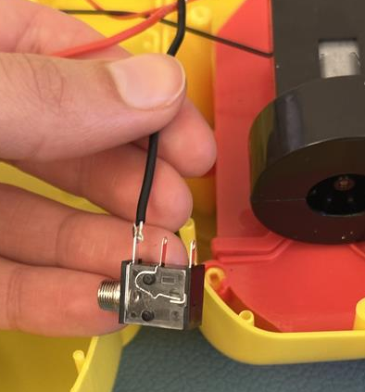
- Repeat this process for the other cable. This time, solder the wire to the middle prong of the mono jack, and to the original spot on the switch | 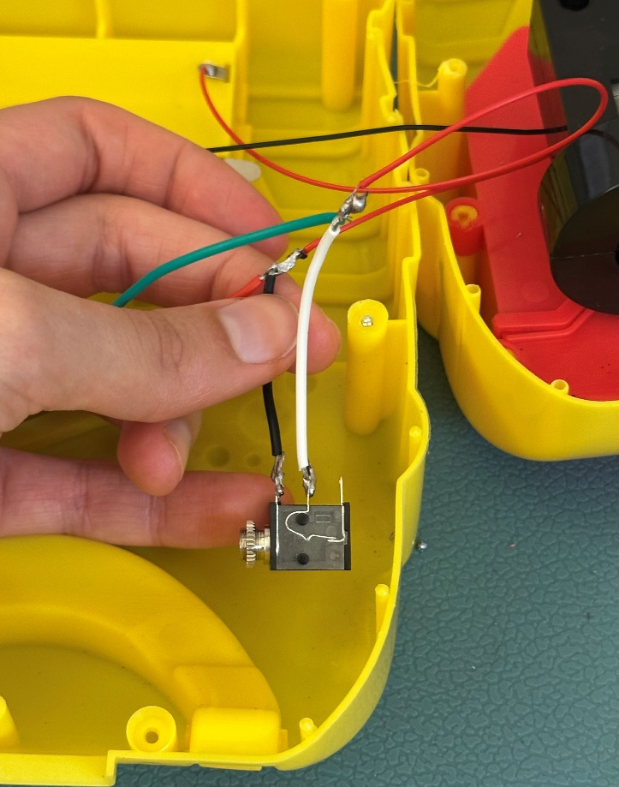
- It is now time to test the toy. Insert batteries into the battery compartment and an assistive switch into the mono jack. Test to make sure that the toy can be controlled using the original switch and the assistive switch.  Note: If the toy does not turn on, please check the soldered connections. | 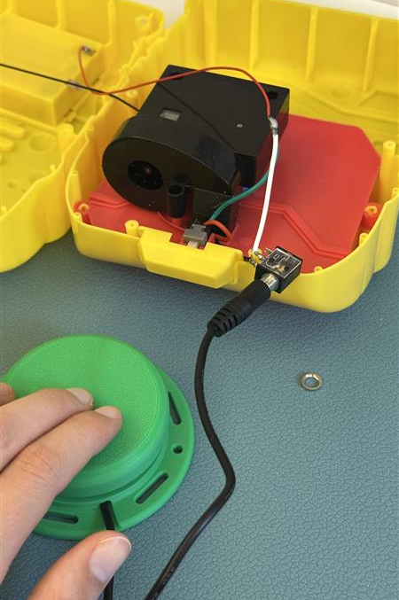
- Using a drill and ¼’’ drill bit, drill a hole into the top of the toy, to the left of where the original button is located. | 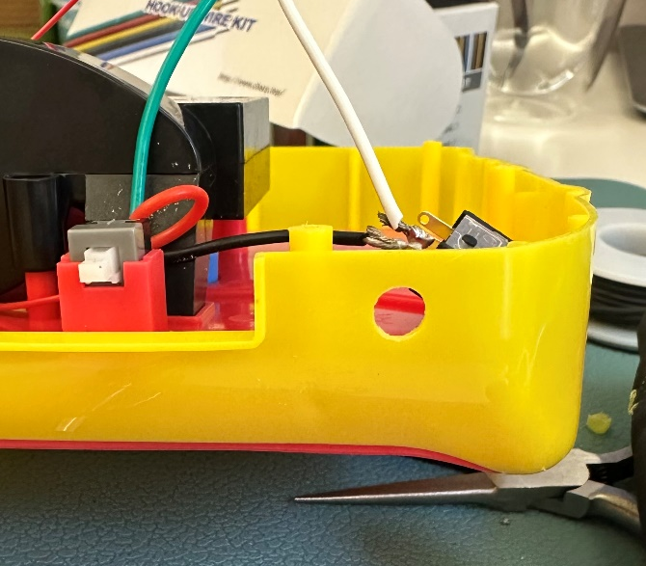
- Remove the retaining ring from the mono jack and push the mono jack through the hole from the inside. Reinstall the retaining ring on the outside of the toy and tighten to secure. | 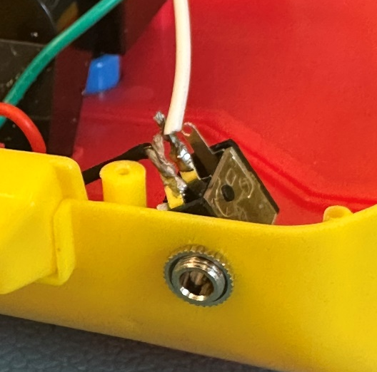  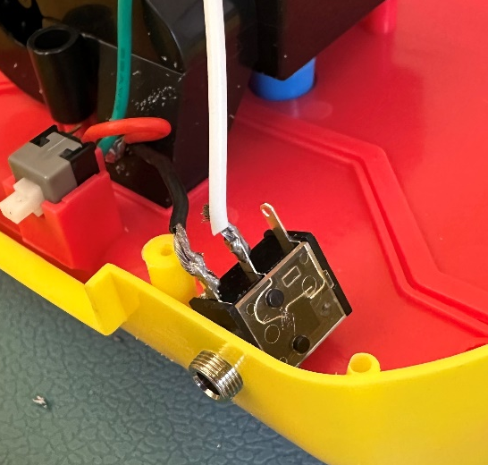
- Wrap the exposed joint in electrical tape to ensure that the exposed wires do not touch inside the toy. Make sure all exposed wire and solder is covered. | 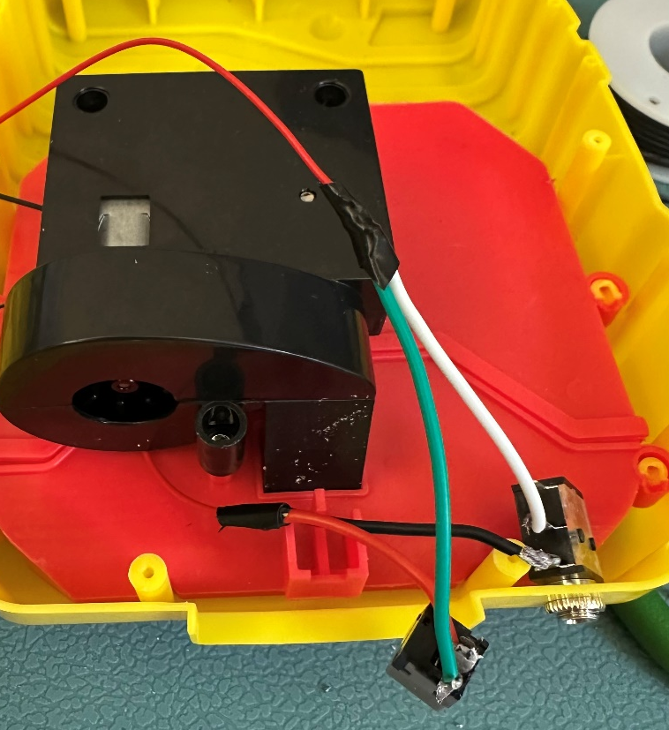
- Place the original switch back where it was, and place the button cover on top. | 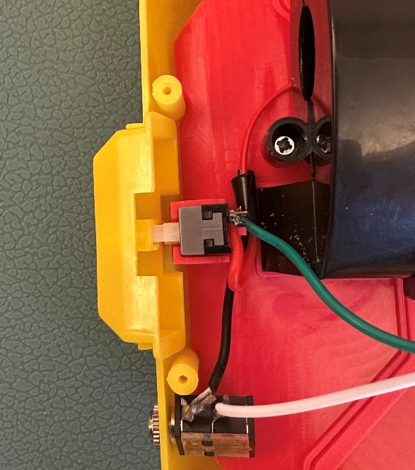
- Reassemble the toy using the screws set aside earlier. | 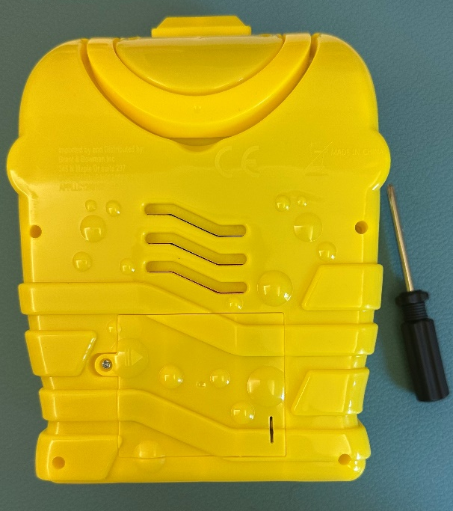
- Test the toy again. If it is still working properly, repackage the toy and the adapted toy is complete! | 