Required Components
 | 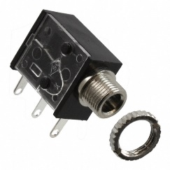 | BOM  - Play Day – Light-Up Bubble Blaster  - 3.5 mm Mono Jack and Nut  - 22 AWG Wire  - 4 AA Batteries
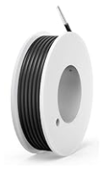 | 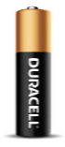

Required Tools
- Screwdriver
- Ruler
- Wire strippers
- Soldering iron and solder
- Drill and 1/4” drill bit

Required Personal Protective Equipment (PPE)
- Safety glasses

Assembly Instructions
- Please remove the clear plastic from around the bubble container and keep the red tag on the toy.  Using a screwdriver, remove the 10 screws from one side of the toy. | 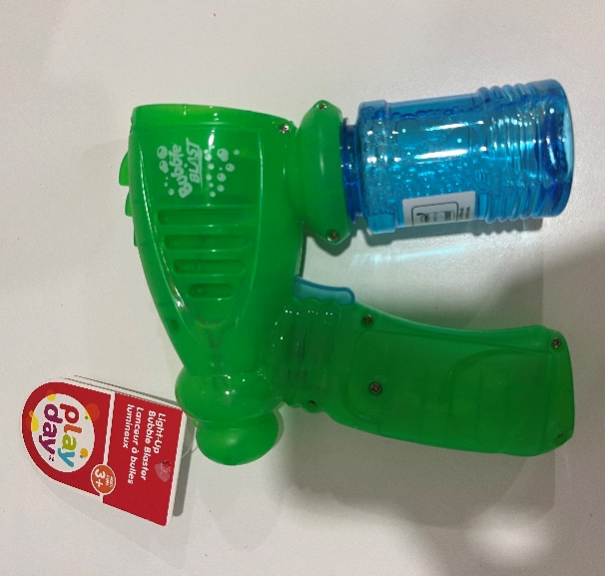
- Separate the two halves of the toy. You can remove the PCB board from its position to allow both halves of the toy to lay flat on the table. | 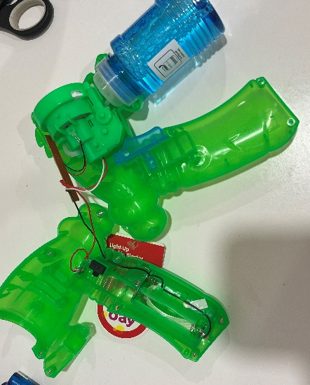
- Cut two pieces of wire, each about 8 cm long. | 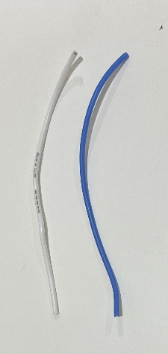
- Strip approximately 0.5cm off the end of each wire. | 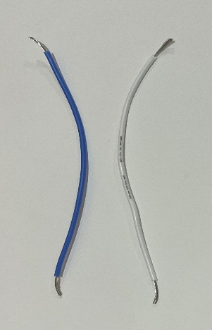
- Solder the wires onto the legs of the mono jack closest to where the cable is inserted. | 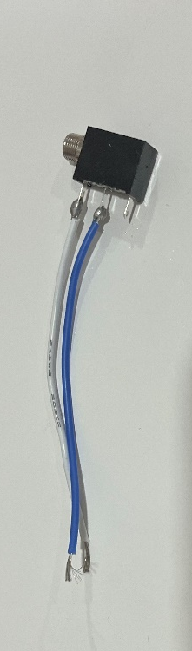
- Tin the other ends of the wires by covering them in a small amount of solder. This will make the next steps easier. | 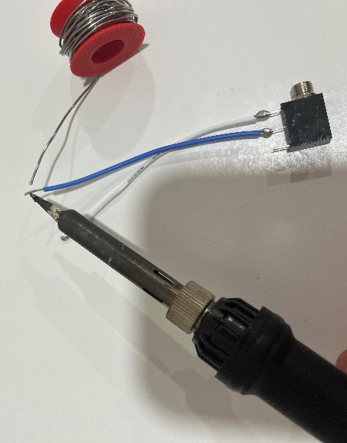
- Locate a wire that connects from the battery compartment to the switch. Use the soldering iron to heat up the original solder and release ONE wire from the switch. | 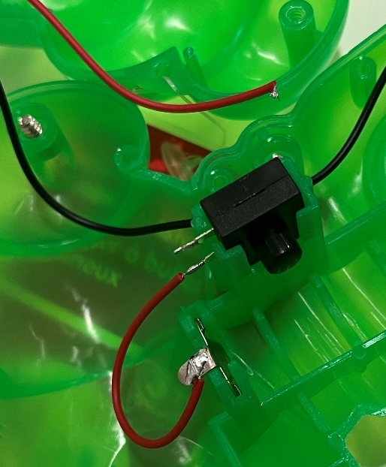
- Solder the end of the released wire to one end of the wire connected to the mono jack. | 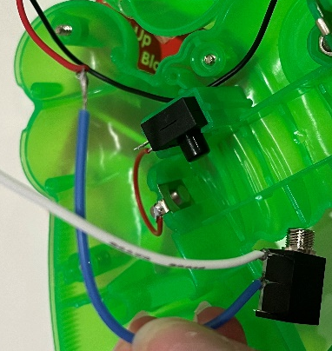
- Wrap the new connection with electrical tape to secure the connection. | 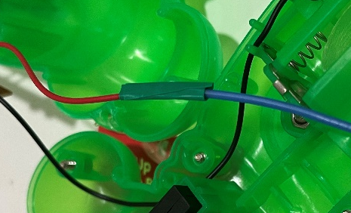
- Solder the end of the other wire connected to the mono jack to the board where the wire was removed. | 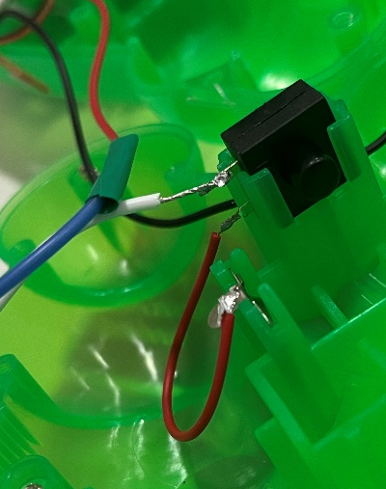
- It is now time to test the toy. Insert batteries into the battery compartment and insert an assistive switch into the mono jack. When the switch is pressed, the bubble motor and light will turn on and you can move onto the next step. You may need to click the original button for the adapted switch to work.  Note: If the toy does not turn on, please check the soldered connections. | 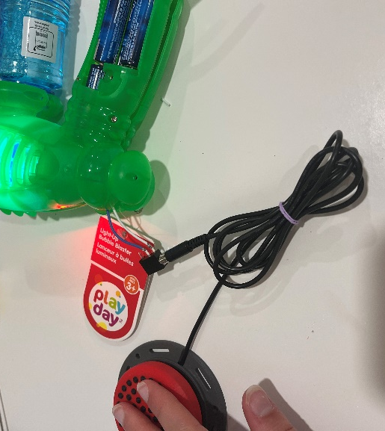
- Using a ¼” drill bit, drill a hole into the side of the bubble blower. Cut away any loose plastic. | 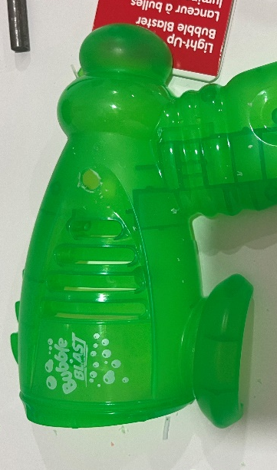
- Remove the nut from the mono jack and push the mono jack through the hole from the inside. | 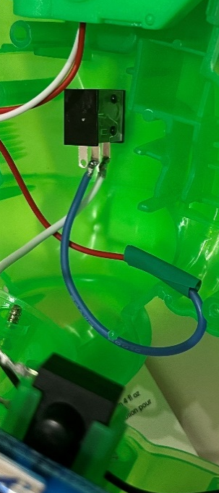
- Reinstall the nut on the outside of the toy and tighten to secure. | 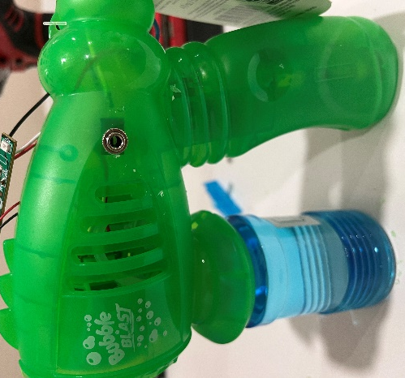
- Reinstall the PCB and reassemble the toy halves. Be careful the wires are not pinched when put back together and the original switch is in the correct position. Re-install the 10 screws. | 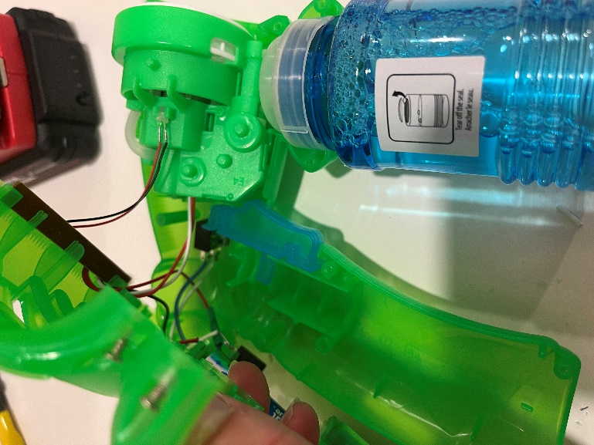
- Test the toy again. If it is still working properly, remove the batteries and re-install the battery cover.  The adapted toy is now complete! | 