Required Components
    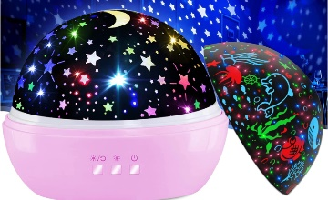   |  | BOM  - DQMOON Butterfly Light Projector / KEVAP Ocean Light Projector / KEVAP Moon and Stars Projector  - 3.5 mm female mono cable (x3)  - 4 AAA batteries
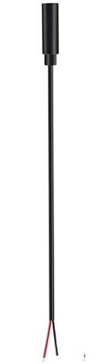     | 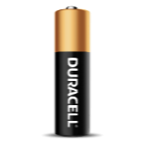      

Required Tools
- Soldering iron and solder
- Wire strippers
- Hot glue gun
- Phillips head screwdriver

Required Personal Protective Equipment (PPE)
- Safety glasses

Assembly Instructions
- Remove cover and projector shades.

- Unscrew the two screws in the white plate.
- Lift the white plate off. There should be a pink plate underneath.
- Unscrew the four screws in the corners of the pink plate. Ensure that you keep these separate from the screws you took out in step 2, they are different sizes.
- Remove the small silver balls from their little indents in the pink plate.
- Take the circuit board out of its slot by the side of the bottom of the toy. Notice that it has three buttons, one that turns it on/off, one that controls the light colour, and one that turns on/off the rotation motor.
- Strip 2 cm off of the cable using a wire stripper, revealing small wires inside. | 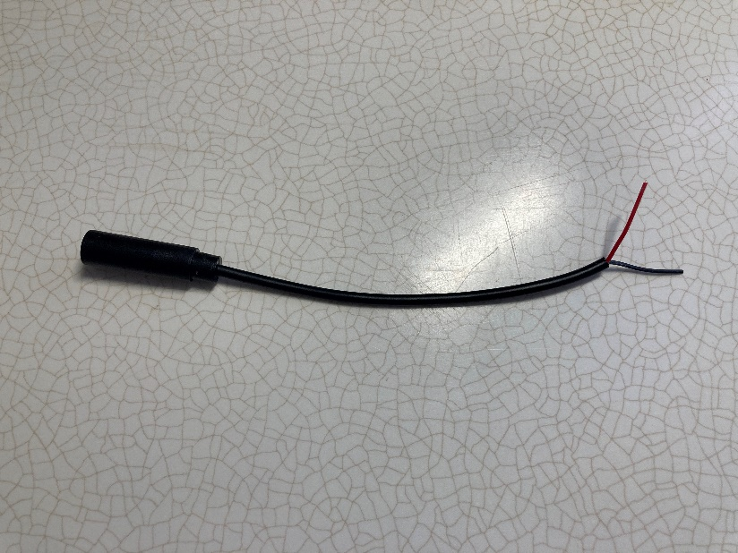  2 cm
- Strip approximately 0.5cm off of the small wires.  Note: if there are 3 wires, strip all the wires first then twist the ends of the Tip and Ring wires together. | 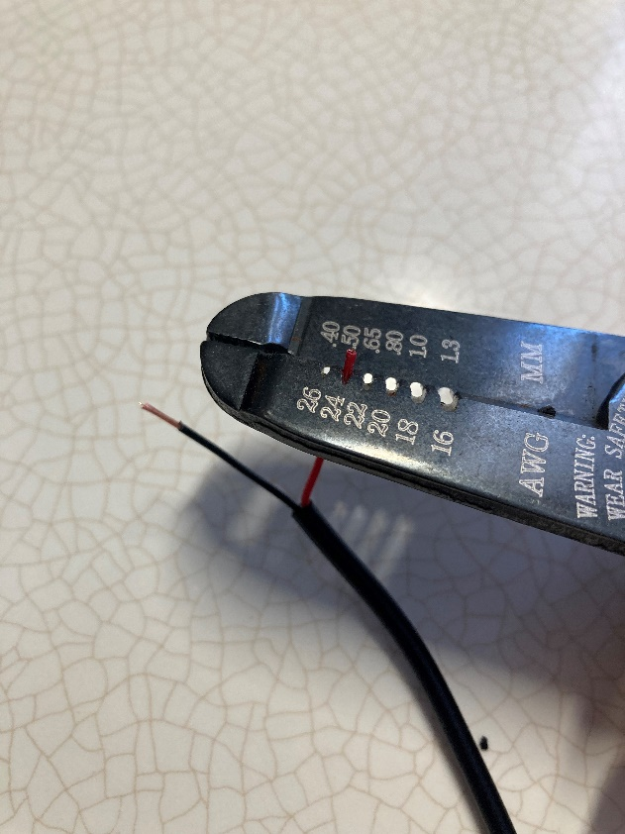  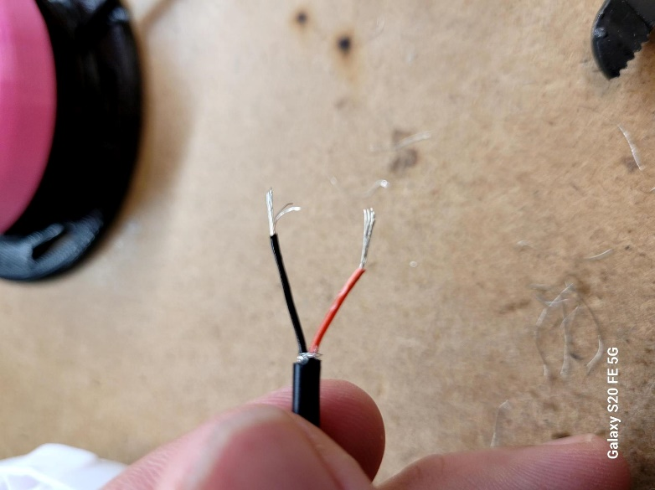
- Prior to soldering to the device, tin your wire. The best way to do this is cover the exposed wire end in solder. | 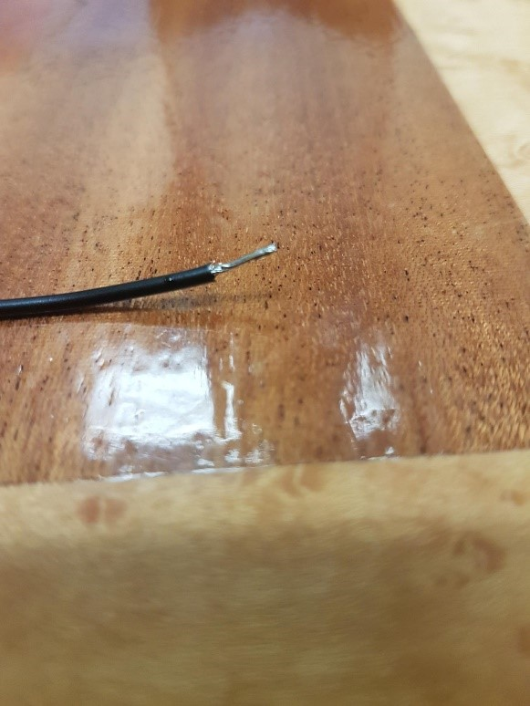
- Take the plastic buttons out of the holes on the side of the projector.  Feed the stripped ends of the wires through the button holes from the outside so that the mono jack is on the outside of the projector. | 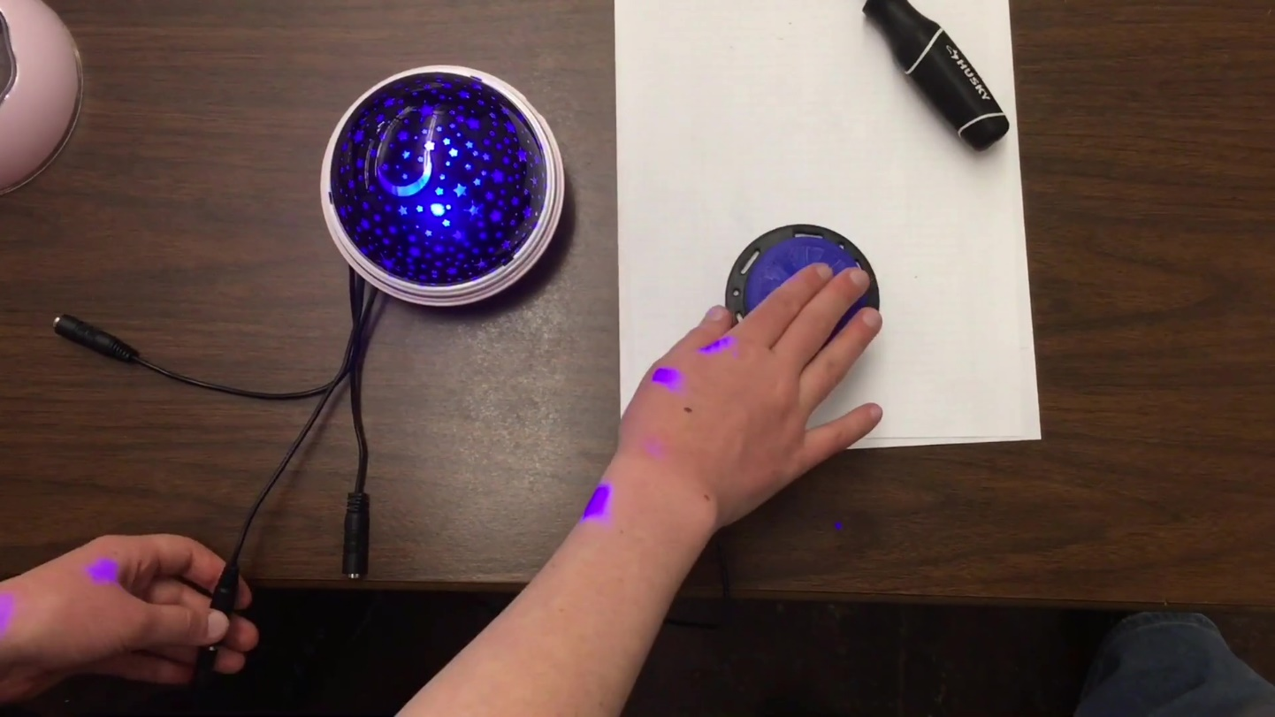
- Leave about 10cm of cable inside the toy. Then, tie knots in the cable inside the projector to prevent tug damage.
- Solder the two wires to the two bottom legs of the switch (as highlighted in red).  Repeat for the two other buttons with the other mono cables. | 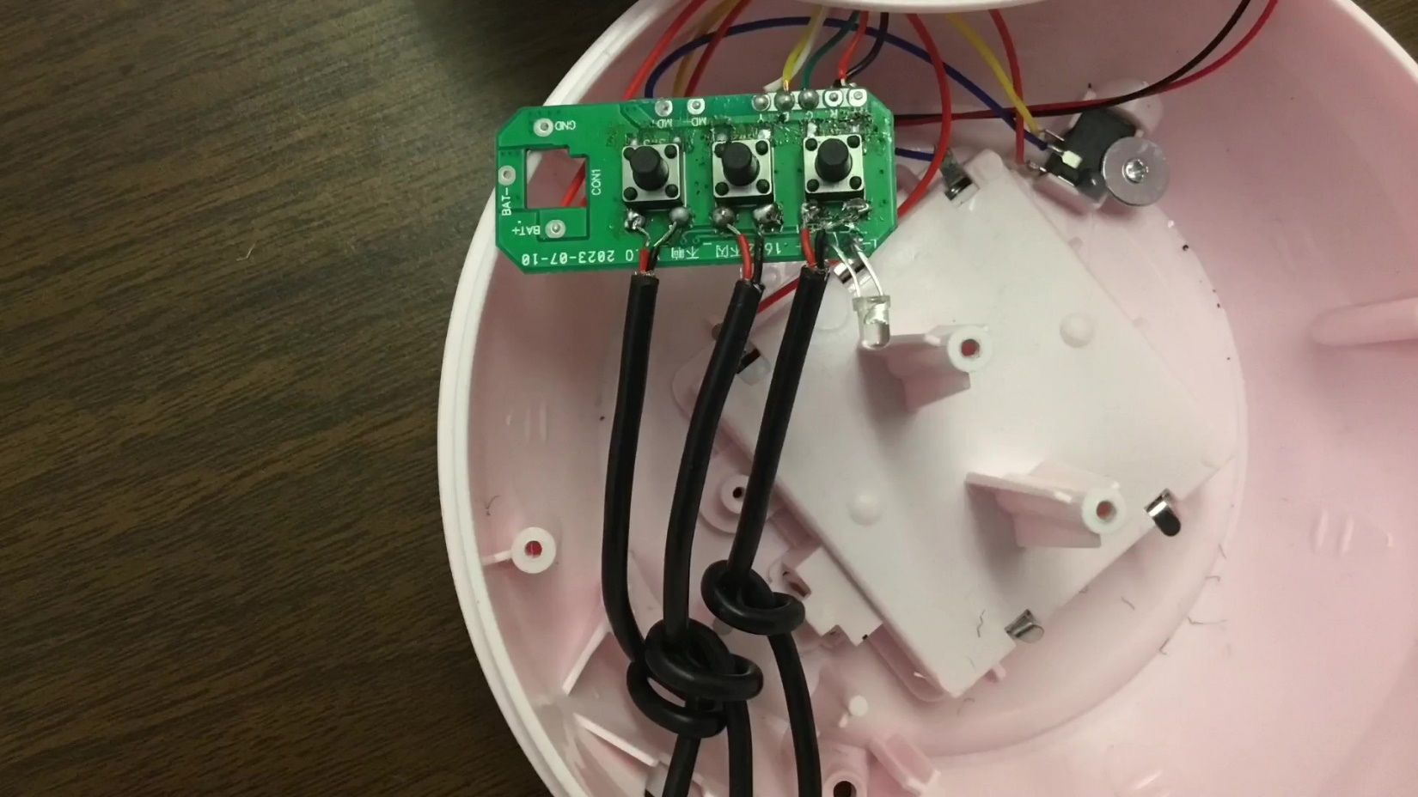
- Test your projector. You can do this by plugging your assistive switch into the end of the mono jack. You will need to press the on button before you will be able to test the motor or light buttons.  If it does not work, recheck your soldering job for any place where the two wires may be touching. | 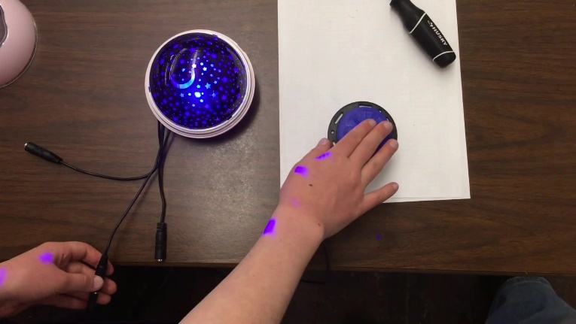
- Put a small dab of hot glue on the bottom of the pink bowl and resecure the circuit board to the bottom of the case. | 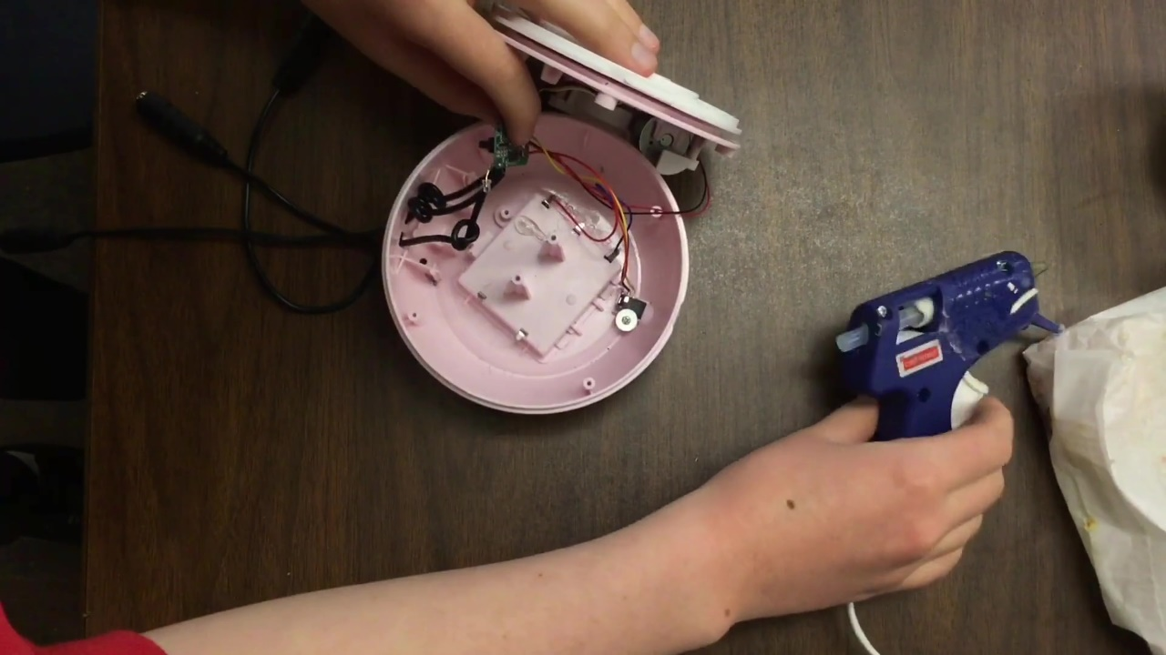
- Screw the pink plate back into the main base.
- Return the silver balls to their indents
- Screw the white plate back on top.
- Put projector shade back on.

