Required Components
  1. | 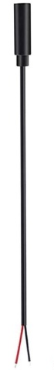  2. | BOM  - Pretex RC Truck and Tractor  - Female Mono Cable (x2)  - 10k pF Capacitor (x2)  - AA Batteries (x5)  Note: This toy comes in a pack of 2. Component quantities listed are for one RC car.
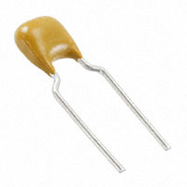 | 

Required Tools
- Phillips screwdriver
- Wire strippers
- Soldering iron and solder
- Drill and 1/8” drill bit

Required Personal Protective Equipment (PPE)
- Eye protection
- Ear protection

Assembly Instructions
- Assemble materials and tools according to the materials list | 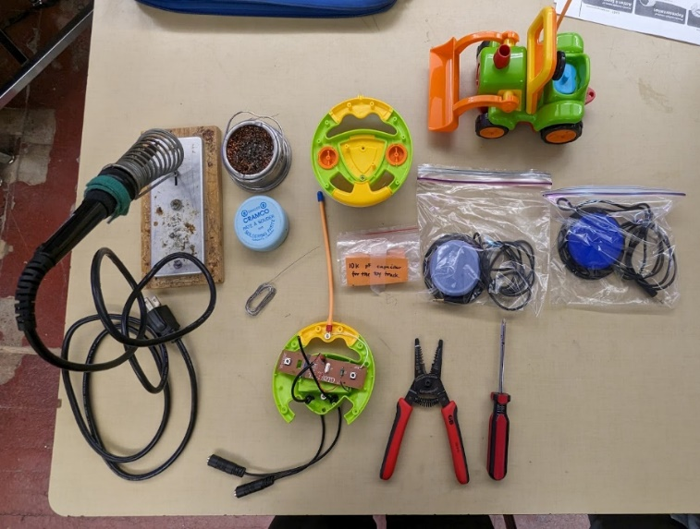
- Remove the six screws that hold the controller together and remove the back. | 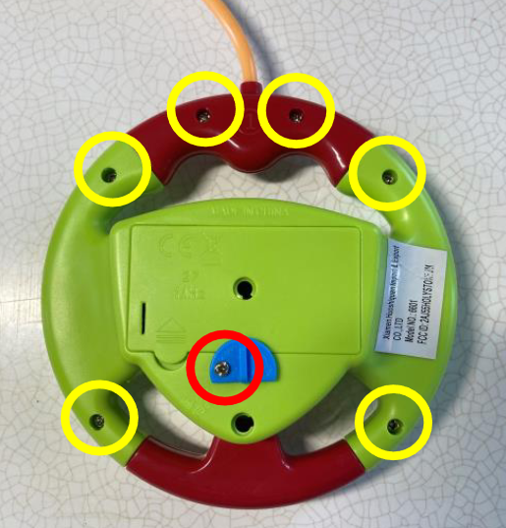
- Drill two small holes in back of the controller with an 1/8’’ drill bit.  Ensure the holes have a diameter that matches the size of the mono cable you are using. | 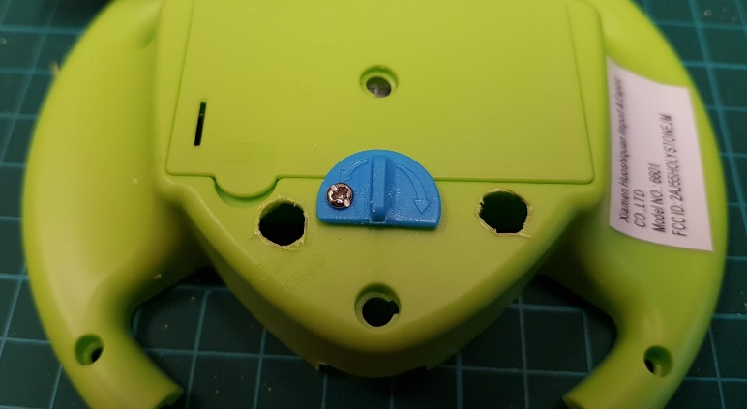
- Slide the end of the mono cable into the hole such that the mono jack end is sticking outside of the controller.  Leave around 6 centimeters of the cable inside the controller and tie a knot in the cord to prevent it from sliding out. | 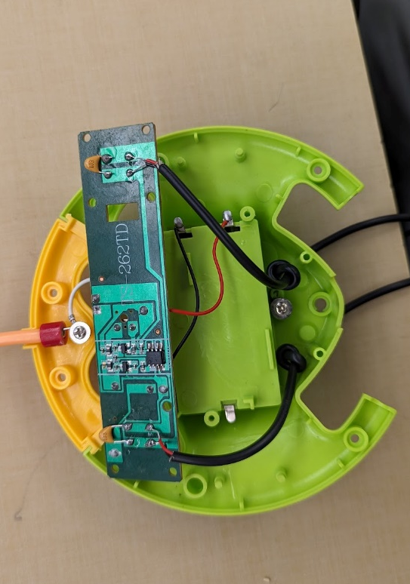
- Strip 1.5 cm off the outside insulation of the mono cable.  If there are three internal wires, cut the additional silver wire leaving only the red and black wire.  Repeat for both cables | 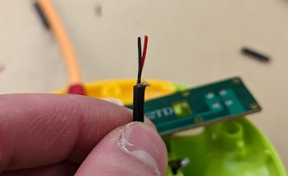
- Strip 1 cm off the red and black wires.  Repeat for both cables. | 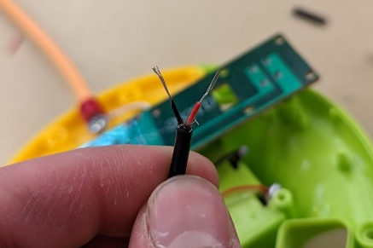
- Remove the circuit board and identify the pins for the original buttons that control the toy. | 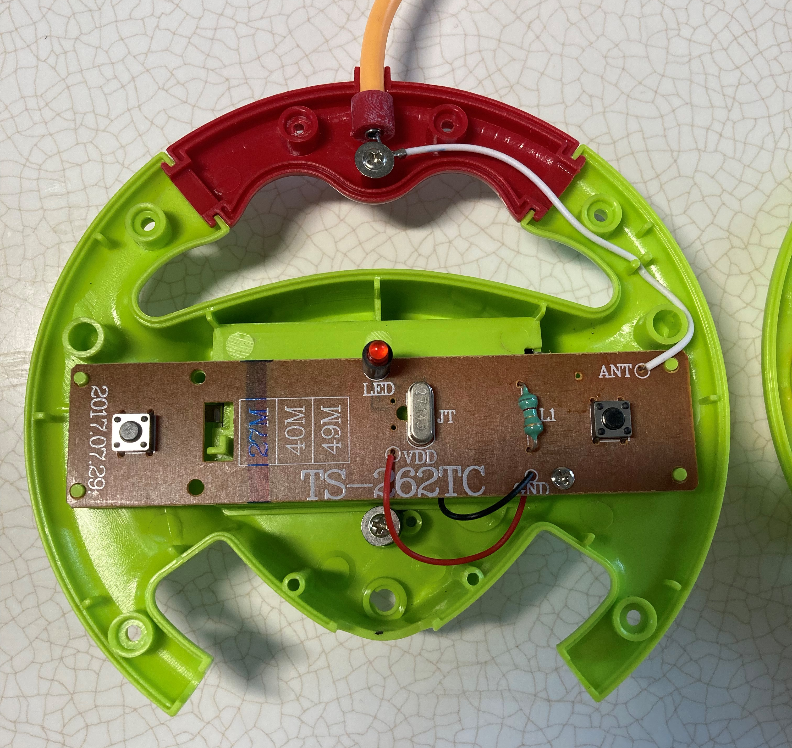
- Solder the mono cable to the lower two pins (highlighted in red).  Solder the capacitor to the upper to pins (highlighted in yellow). | 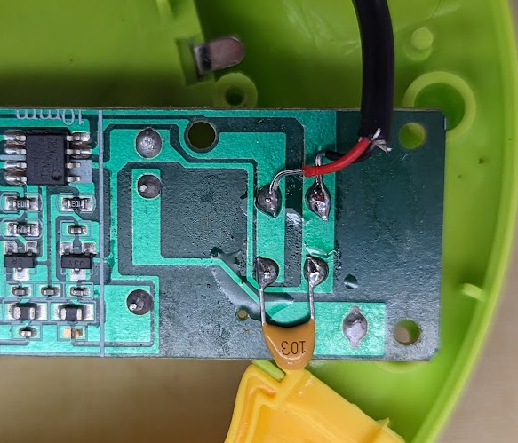
- Repeat step 8 for the other button. | 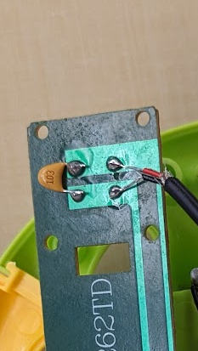
- Reassemble the toy with the six original screws.

- Label the female ends of each mono jack with the corresponding button they control. | 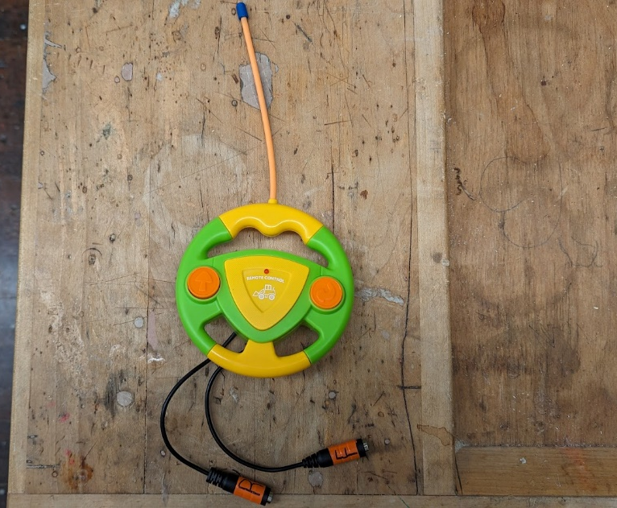
- Add batteries, attach switches and test the toy.  If it does not work, check solder connections and retest.  If the toy works, repackage the toy and it is complete! | 