Required Components
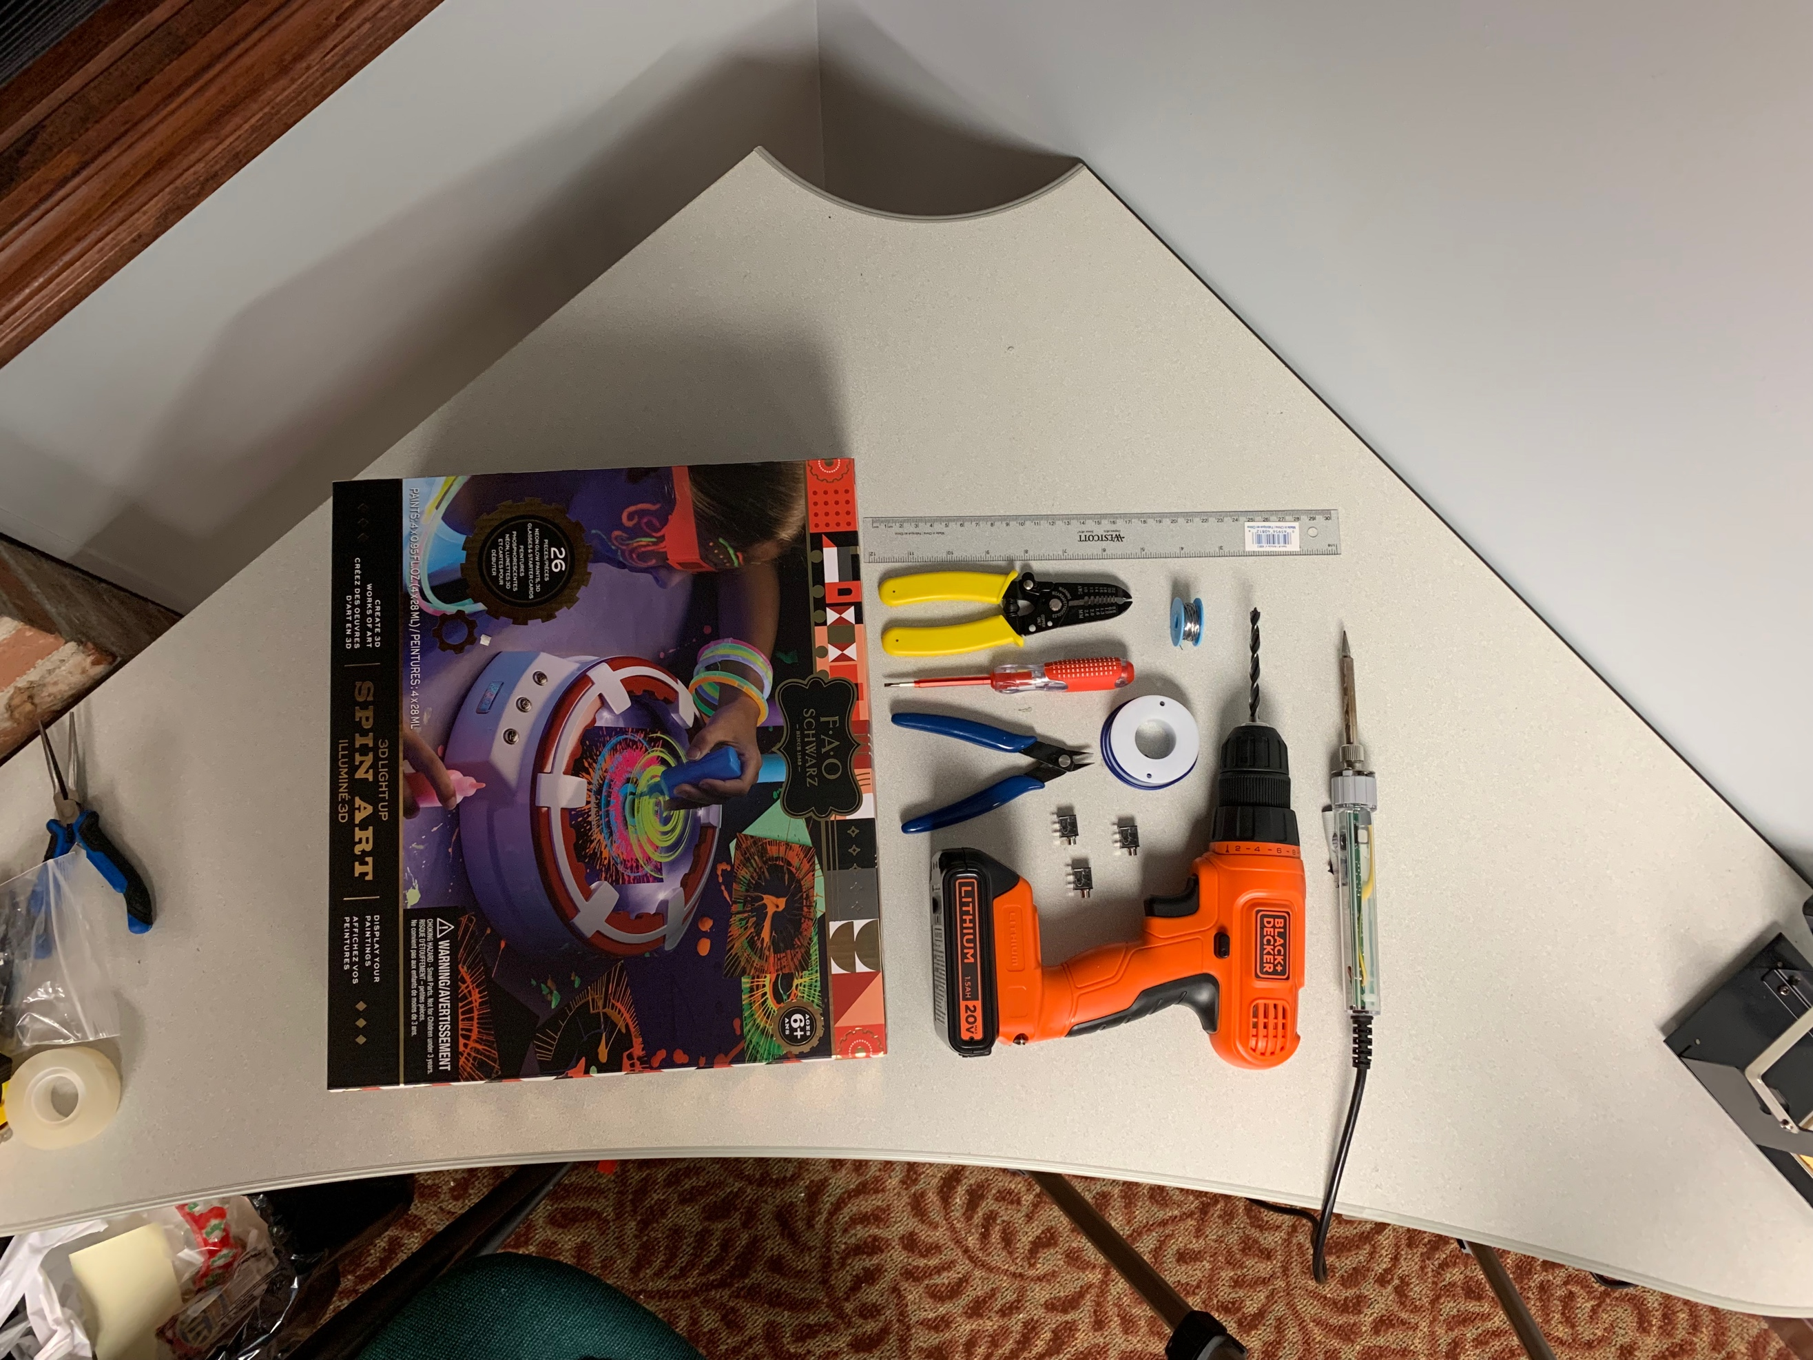  6  5  8  9  7  11  10  2  3  1  4 | BOM  - Soldering iron  - Ruler  - 1/4” Drill bit  - Drill  - Solder  - Wire  - Mono jacks  - Screwdriver  - Flush cutters  - Wire strippers  - Spin art toy

Required Tools
- Soldering iron
- Ruler
- 1/4” Drill bit
- Drill
- Solder
- Wire
- Screwdriver
- Flush cutters
- Wire strippers

Required Personal Protective Equipment (PPE)
- Safety glasses

Assembly Instructions

Step 1
Carefully unpack the toy being careful to preserve the packaging.
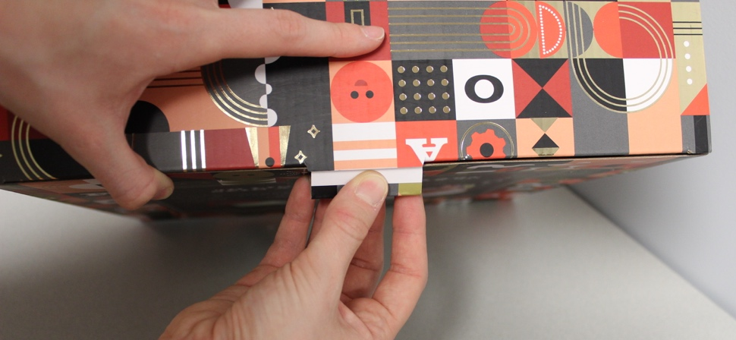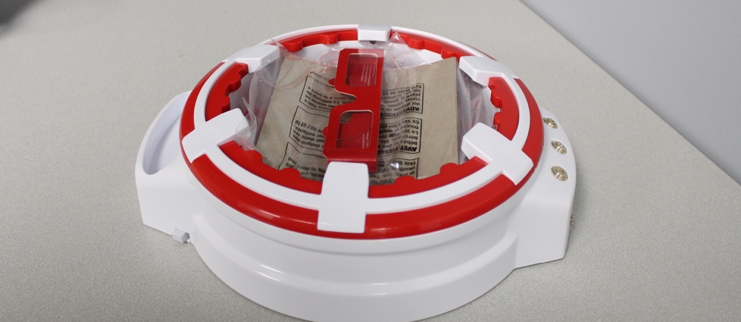

Step 2
Remove any batteries from the back of the toy.
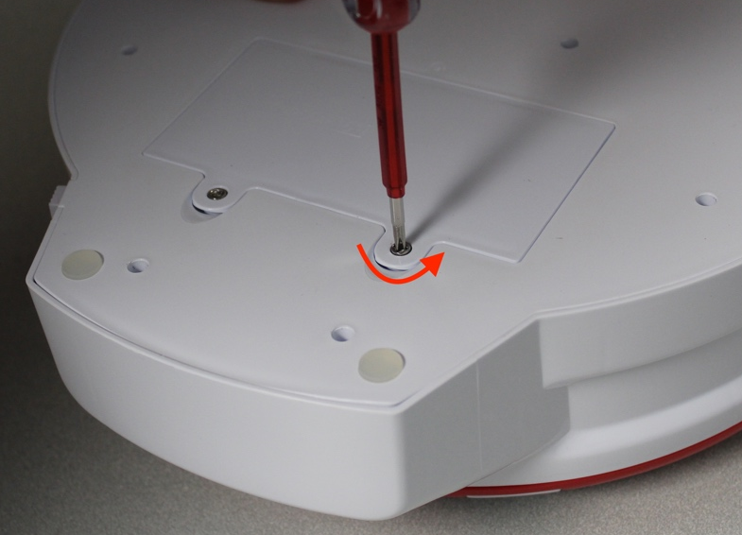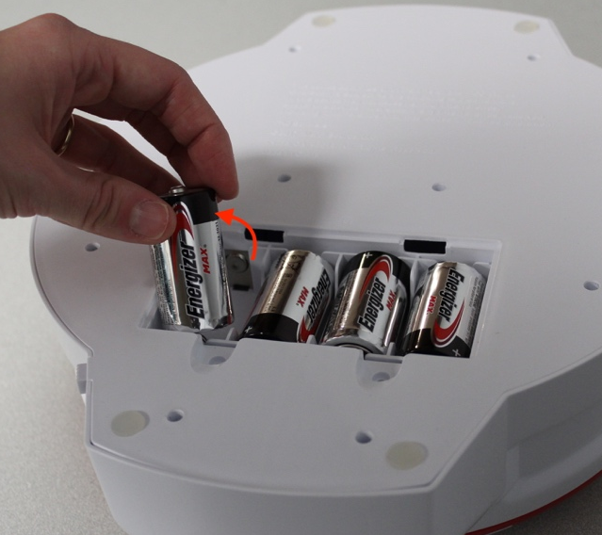

Step 3
Identify the ten screws securing the two halves of the toy together and remove them.
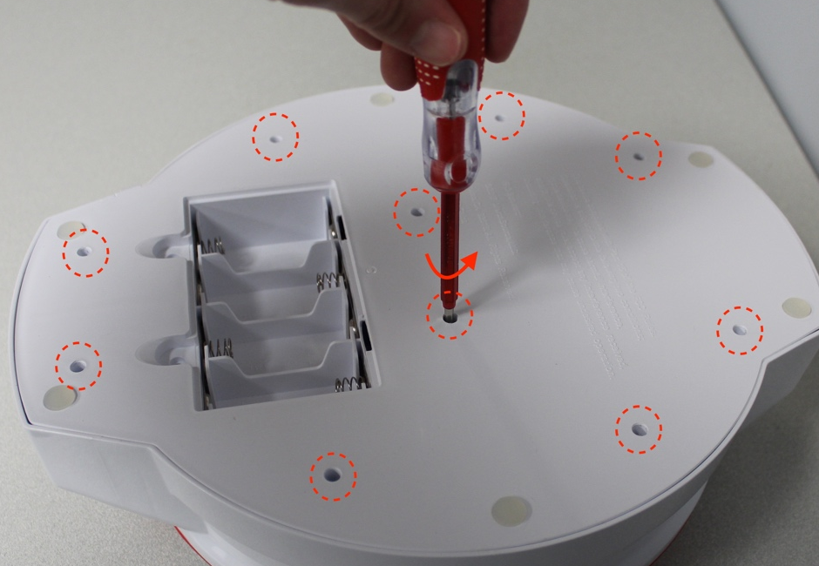

Step 4
Gently pry the back of the toy off with the screwdriver.
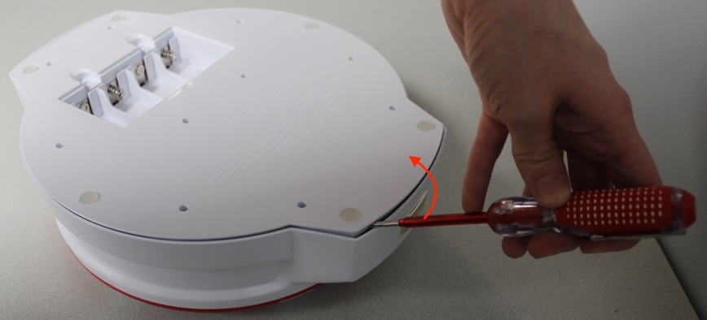
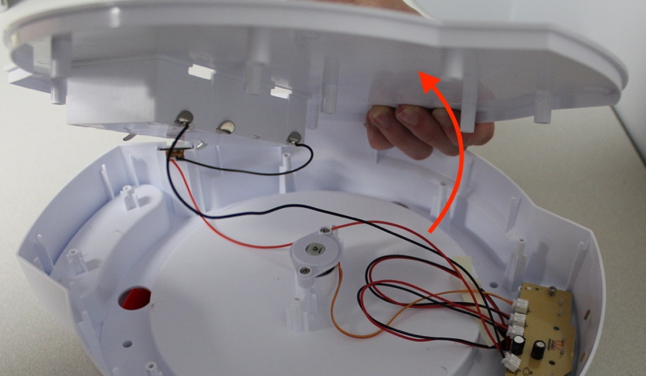

Step 5
Remove the on/off slider switch from its resting place and remove its plastic cover. This will allow you to move the bottom half of the toy more freely.
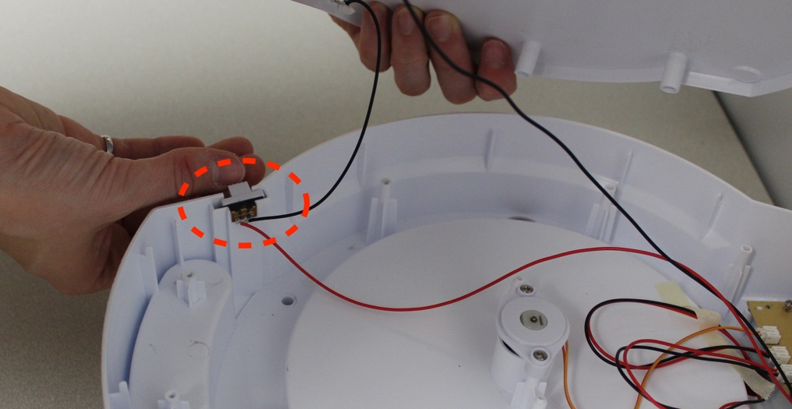

Step 6
Mark three places for the mono jacks to be installed. A good place is underneath the original buttons so the user will still know which switch controls which control. Drill ¼” holes in these three locations marked with permanent marker.
Note: Not all spin art machines have three buttons. You only need to drill one hole if there is one button, two holes if there are two buttons, etc.
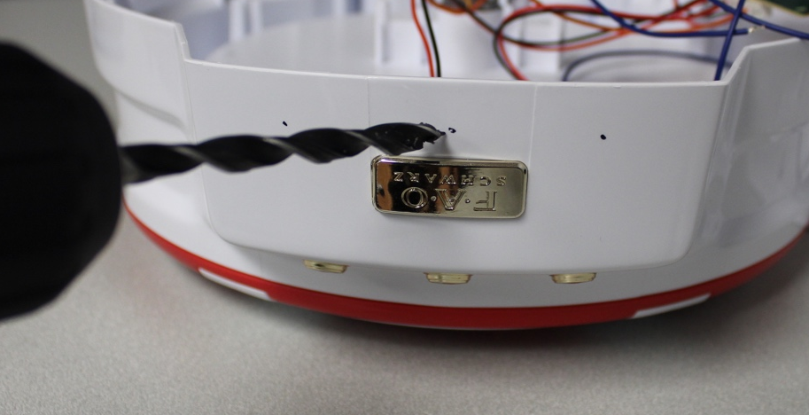

Step 7
Use a craft knife to remove any excess plastic to clean up the holes.
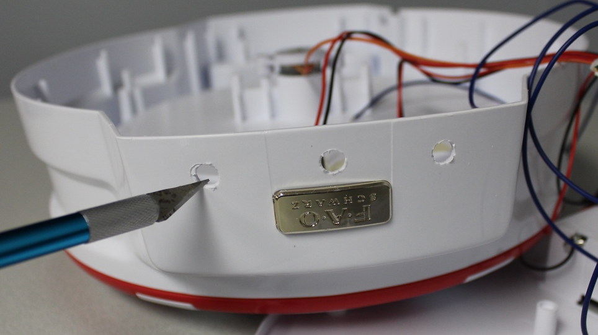

Step 8
Cut 6 pieces of wire about 10cm in length and strip 0.5cm of insulation off each end.
Note: You need 2 pieces of wire per button (3 buttons x 2 wires = 6 wires total). If your spin art machine has 1 button you need 2 pieces of wire, 2 buttons is 4 pieces of wire, etc.
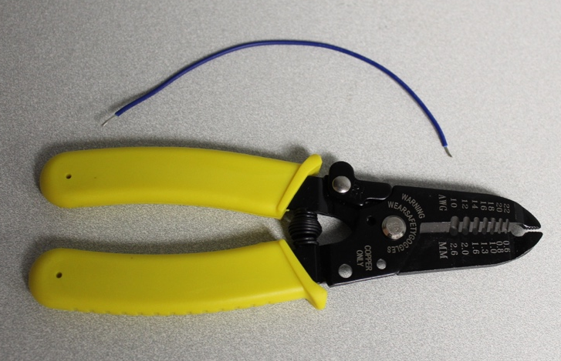
x 6

Step 9
Remove the four screws securing the circuit board to the toy.
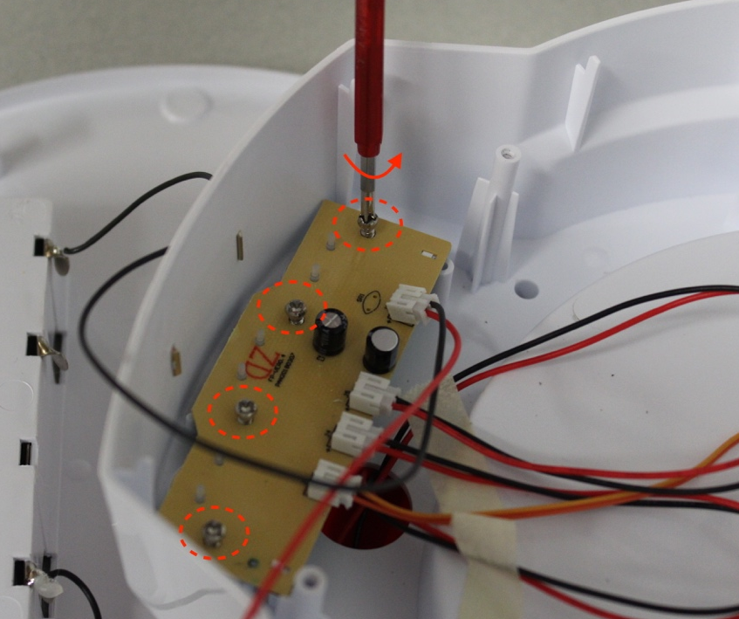

Step 10
Flip the circuit board over and remove the three soft plastic button pads.
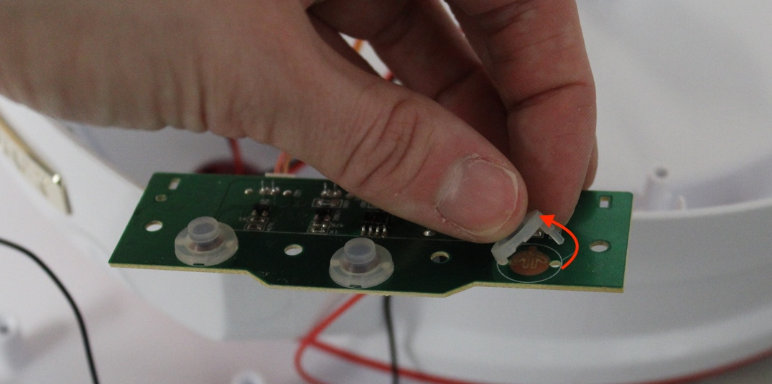

Step 11
Identify the copper circles located underneath the plastic pads just removed. A wire will be soldered to the small dot beside each circle, and a wire will be soldered to the opposite side of the circle. These locations are identified by arrows in the picture.
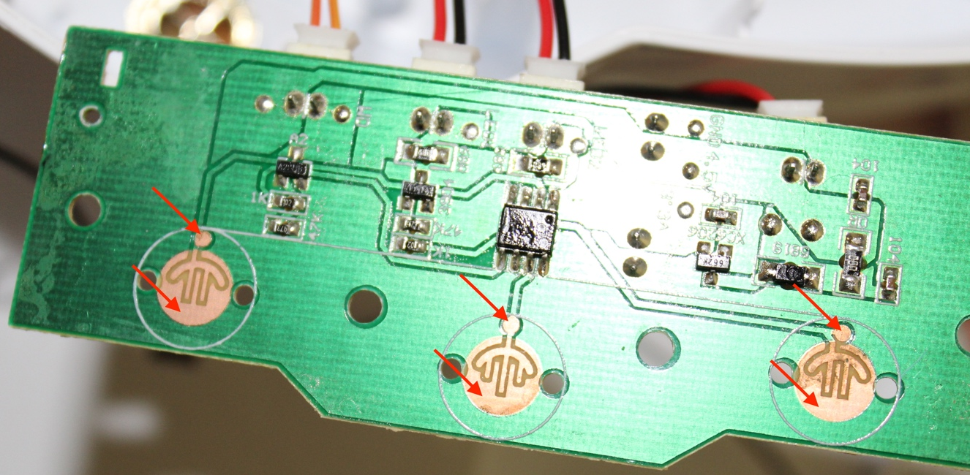

Step 12
Solder one end of each wire to each of the identified points. Ensure that no solder or wire crosses the lines running throughout the circle. It may help to melt a drop of solder onto the board on the identified points, and then melt some solder onto the tip of the wires. Next, hold the wire to the dot of solder on the board and melt it so the wire becomes secured to the board.
Note: You will have less connections to solder if you have fewer buttons on your toy.
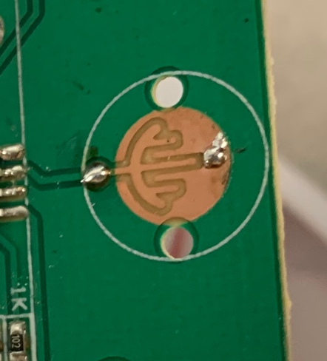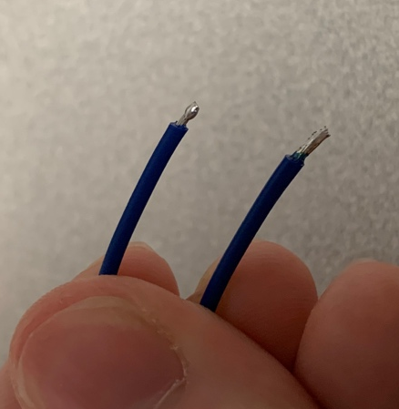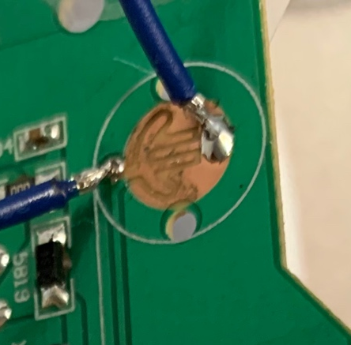
3
2
1
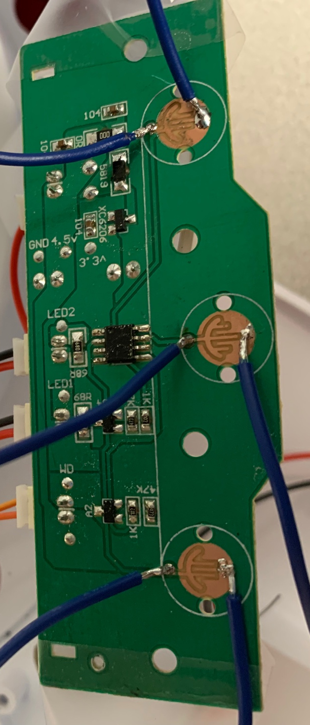

Step 13
Solder a wire from the first circle to the first leg of a mono jack. Solder the second wire from the circle to the middle leg of the mono jack.
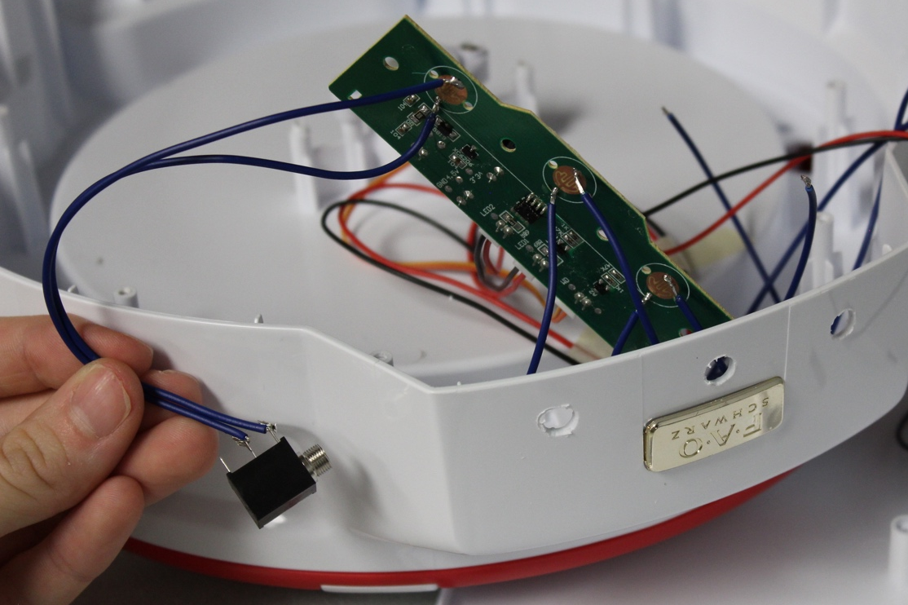

Step 14
Repeat Step 13 for the other two circles. Three mono jacks should now be installed.
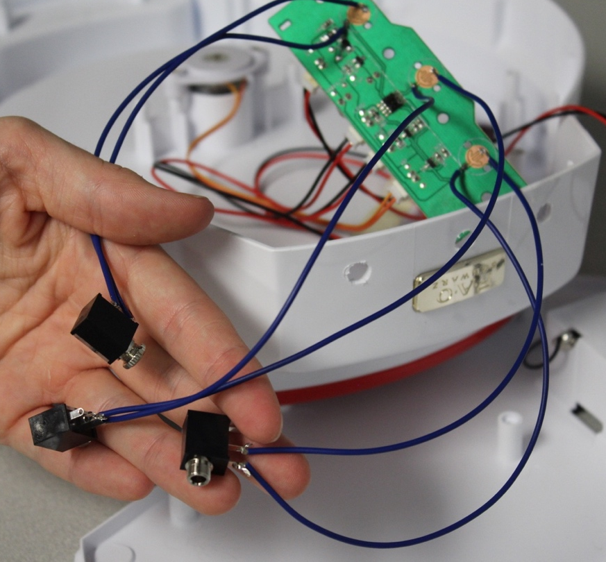

Step 14
Flip the circuit board back over ensuring the mono jack’s wires are free to wrap around the board.
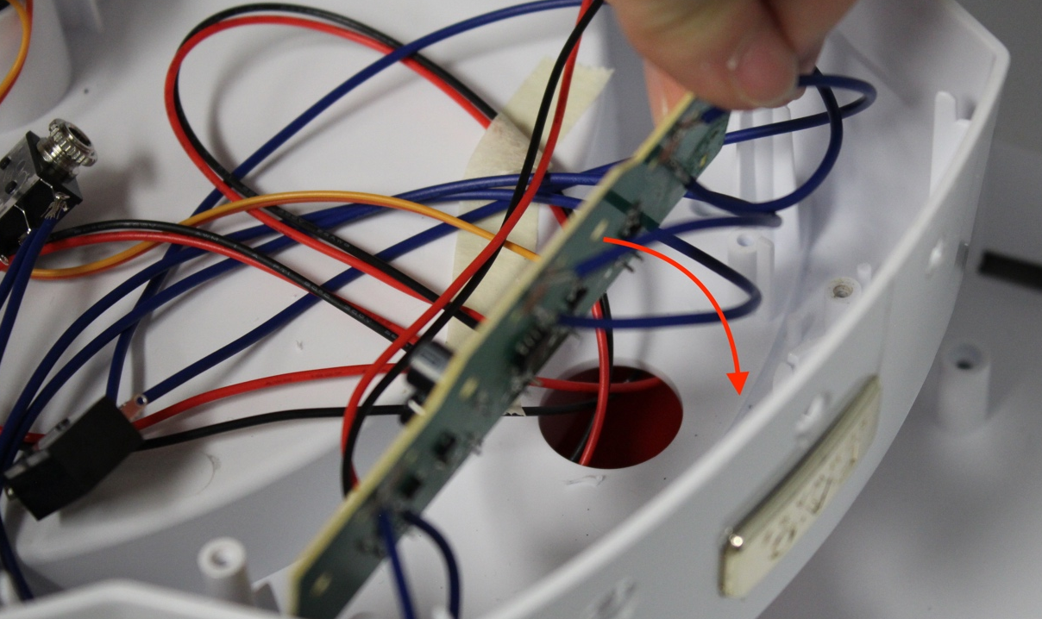

Step 15
Secure the board to the toy with the four screws removed in Step 9.
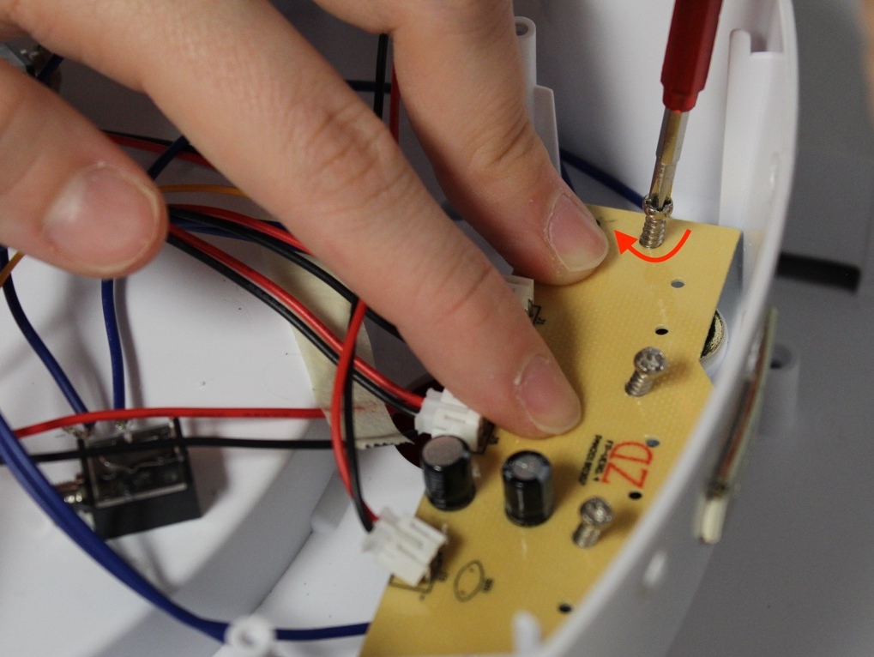

Step 16
Remove the nut from the mono jack on the left side of the board, and push the threaded component through the hole on the left. Rethread the nut onto the jack to secure it in place.
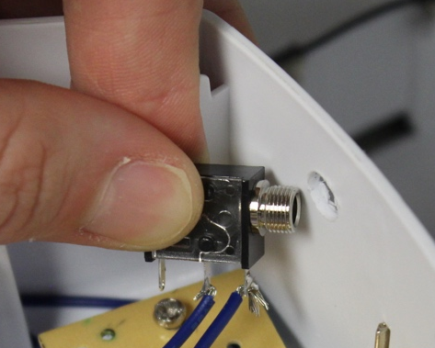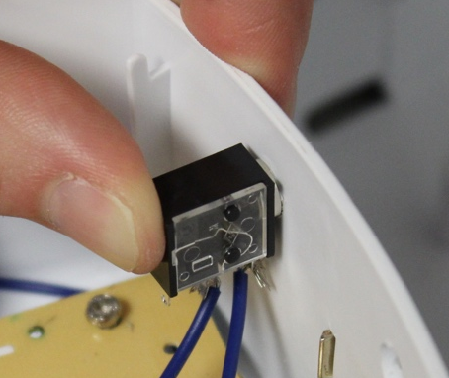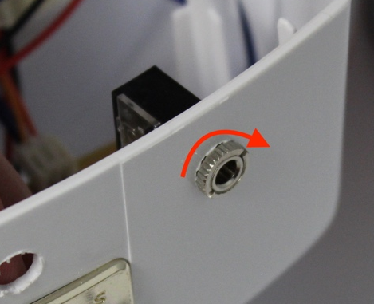

Step 17
Repeat Step 16 for the other two mono jacks so all three are secured. Install the mono jacks in the holes that are in line with the area of the board they are soldered to.
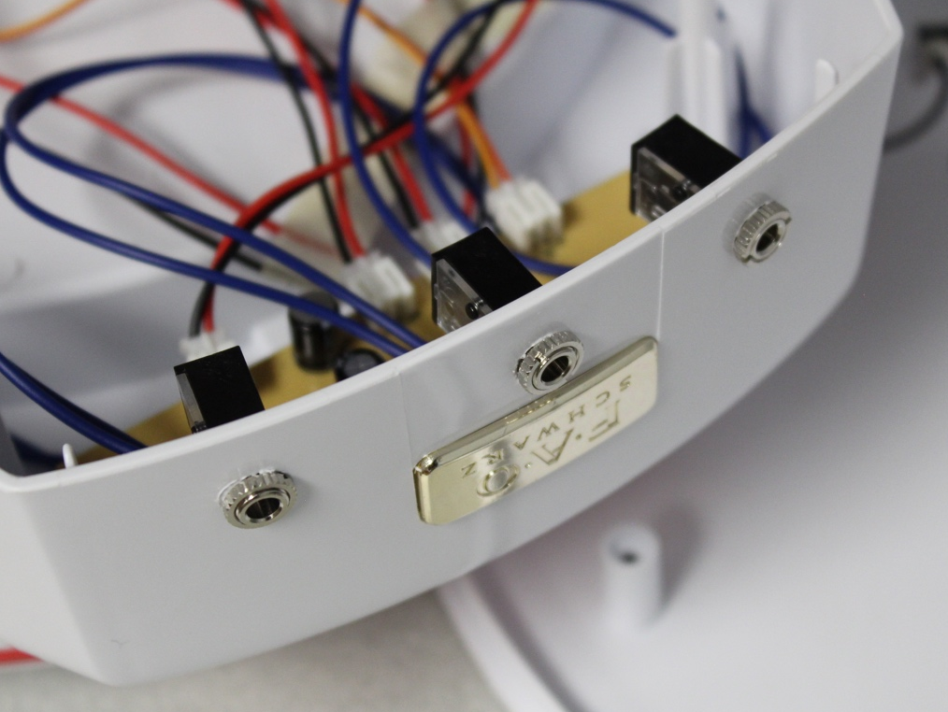

Step 18
Reinstall the slider on/off switch and its plastic cover in its original place.
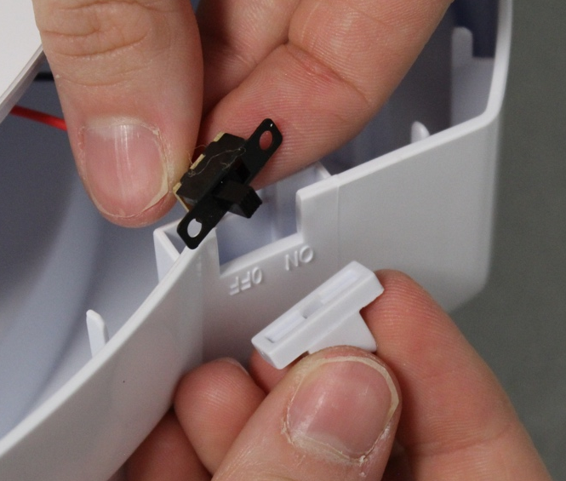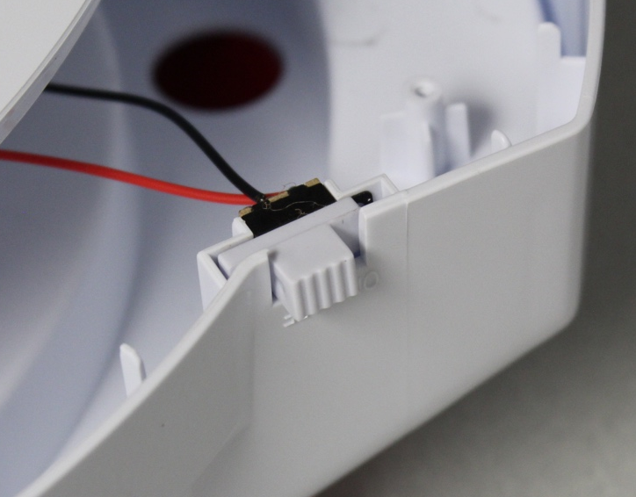

Step 19
Place the toy’s base back onto the toy and reinstall the screws to secure the halves together.
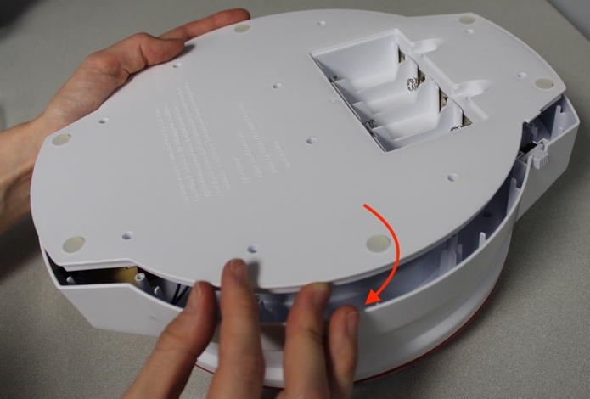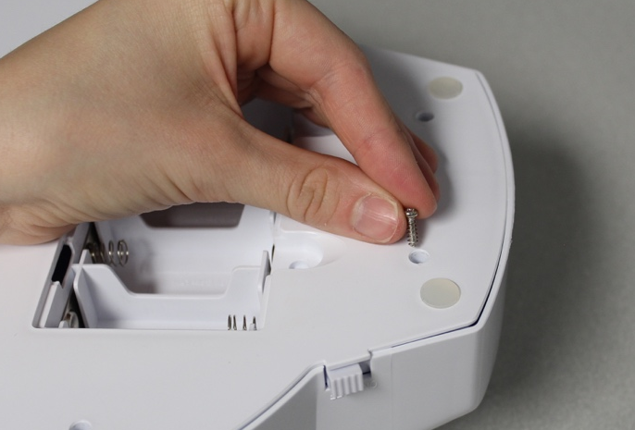

Step 20
Reinstall the batteries and test the toy with switches.
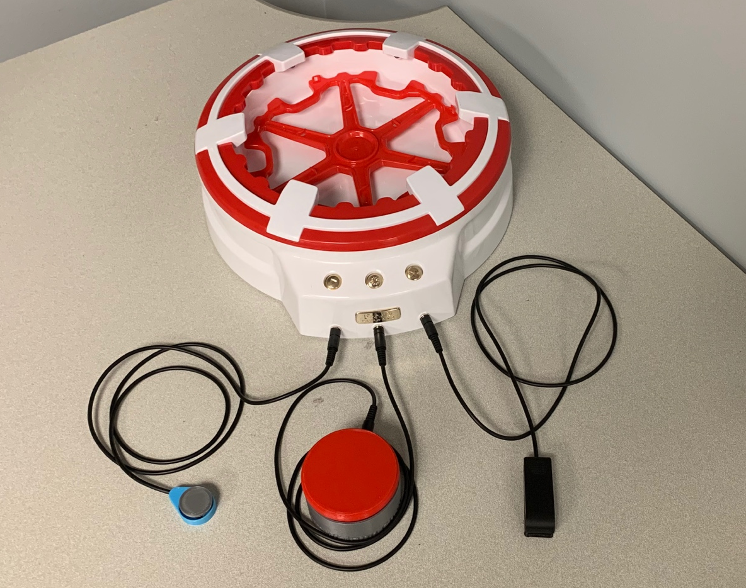

Step 21
Repackage the toy in its original packaging.
