Required Components
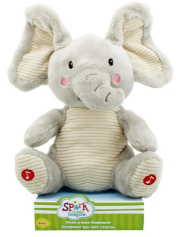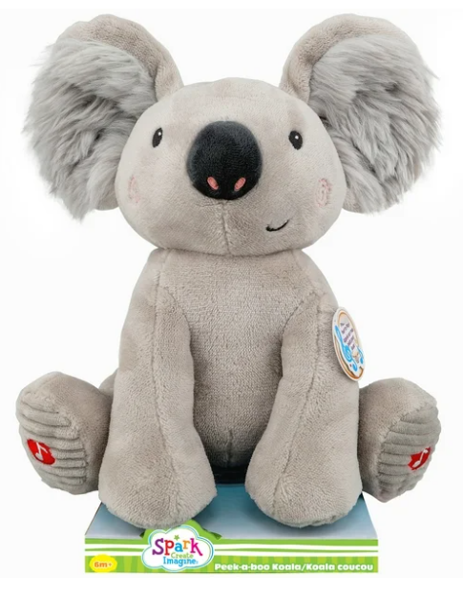 | 2.  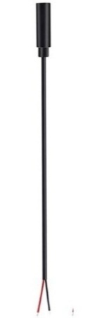   | BOM  - Spark Peek-a-Boo Elephant or Koala  - (2x) 3.5 mm Female Mono Cable  - Cable Tie (at least 25 cm)  - (2x) Small cable ties (10-15 cm)  - (3x) AA batteries (included with toy)
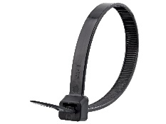 |  | 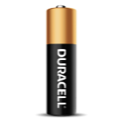    

Required Tools
- Phillips Screwdriver
- Wire strippers
- Soldering iron and solder
- Drill and 1/8” drill bit
- Scissors
- Flush cutters

Required Personal Protective Equipment (PPE)
- Safety glasses

Assembly Instructions
- Using Scissors, carefully remove the toy from its packaging without damaging it.  (we will be repackaging the toy after adapting) | 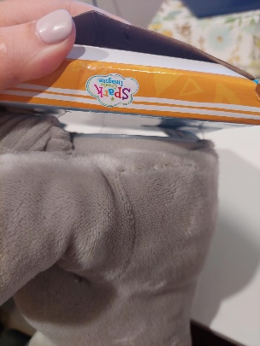
- Locate the thread at the back of the toy. Using scissors, cut the thread. Avoid cutting the fabric of the toy. | 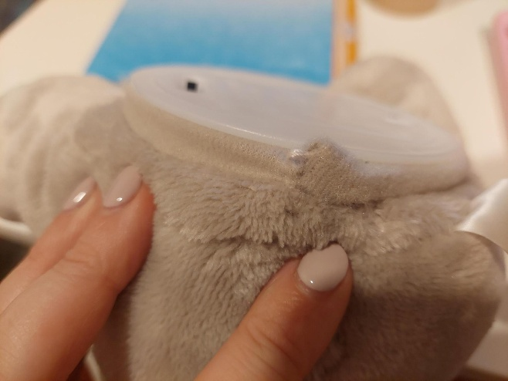
- Use flush cutters to remove the current cable tie and pull it through the fabric. Then pull the internal component out of the toy. | 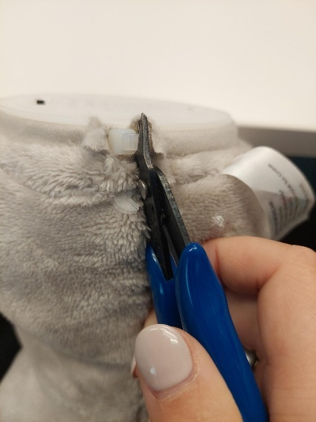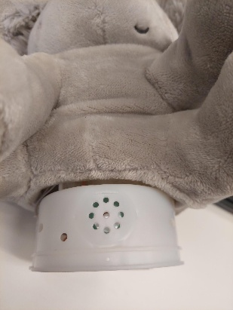
- Locate and remove the two screws as shown in the photo along the body of the toy.  *Note: keep screws, and keep track of where they came from if there are multiple different sized screws | 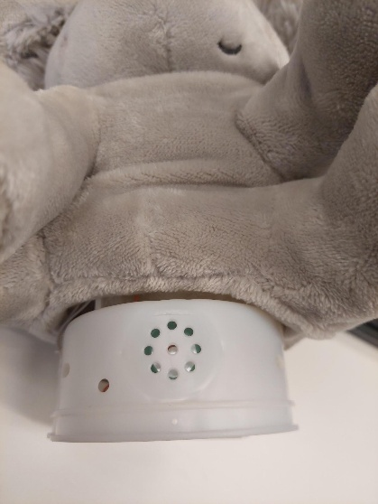
- Carefully separate the two halves of the toy. Right beside the current cables, use your 1/8” drill bit to create your new holes for the female cables. Repeat on each side, drilling 2 holes total. | 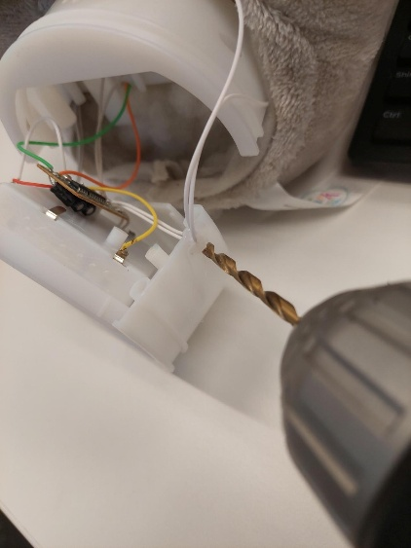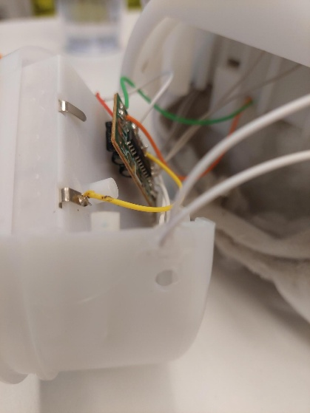
- Use wire strippers to strip approximately 2 cm off the outer wire casing, revealing two internal wires.  Skip this if the two internal wires are already showing. | 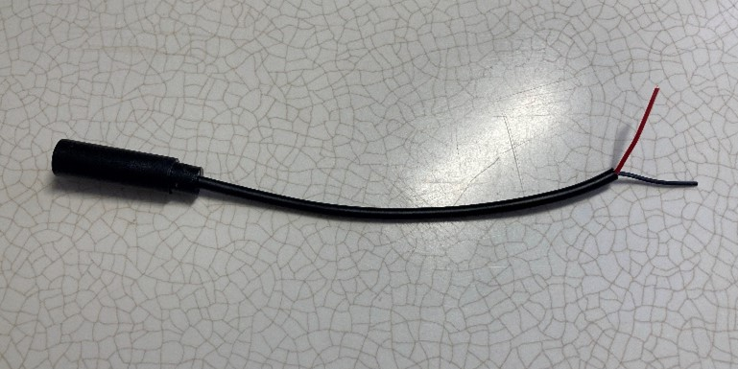
- If there are 2 internal wires, strip approximately 0.5 cm off each wire.  Skip this step if the internal wires have already been stripped, and the metal is exposed. | 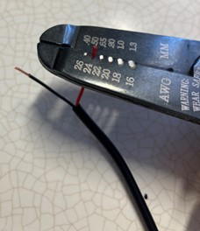
- If there are three internal wires (red, black, and exposed), strip off 0.5 cm of the red insulation and twist the red wire and exposed wire together. Strip 0.5 cm from the black wire. | 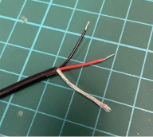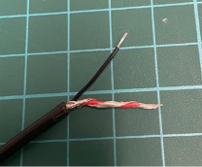
- Melt a small amount of solder over the exposed ends of the wire. | 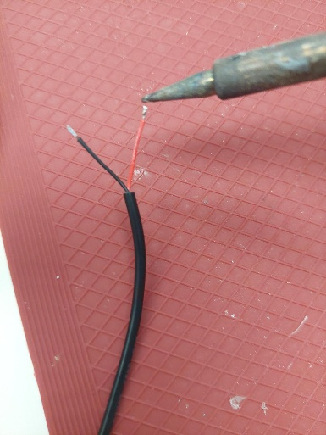
- Feed each of the two female cables through the two separate drilled holes. | 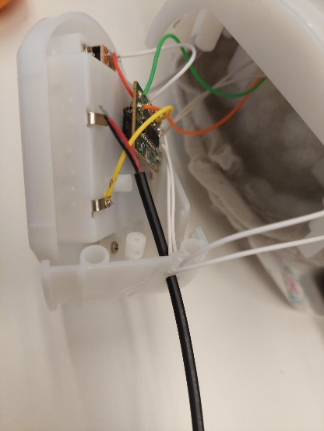
- Looking at the board the four solder points are all in a line on one side of the board. Follow the two grey wires to their connection on the PCB board outlined by the red circle in the photo as they are right beside each other. Then follow the two white wires that come from the toy’s arm to their connection on the board, outlined in yellow in the photo. One is beside the two greys and the other is at the end of the board. | 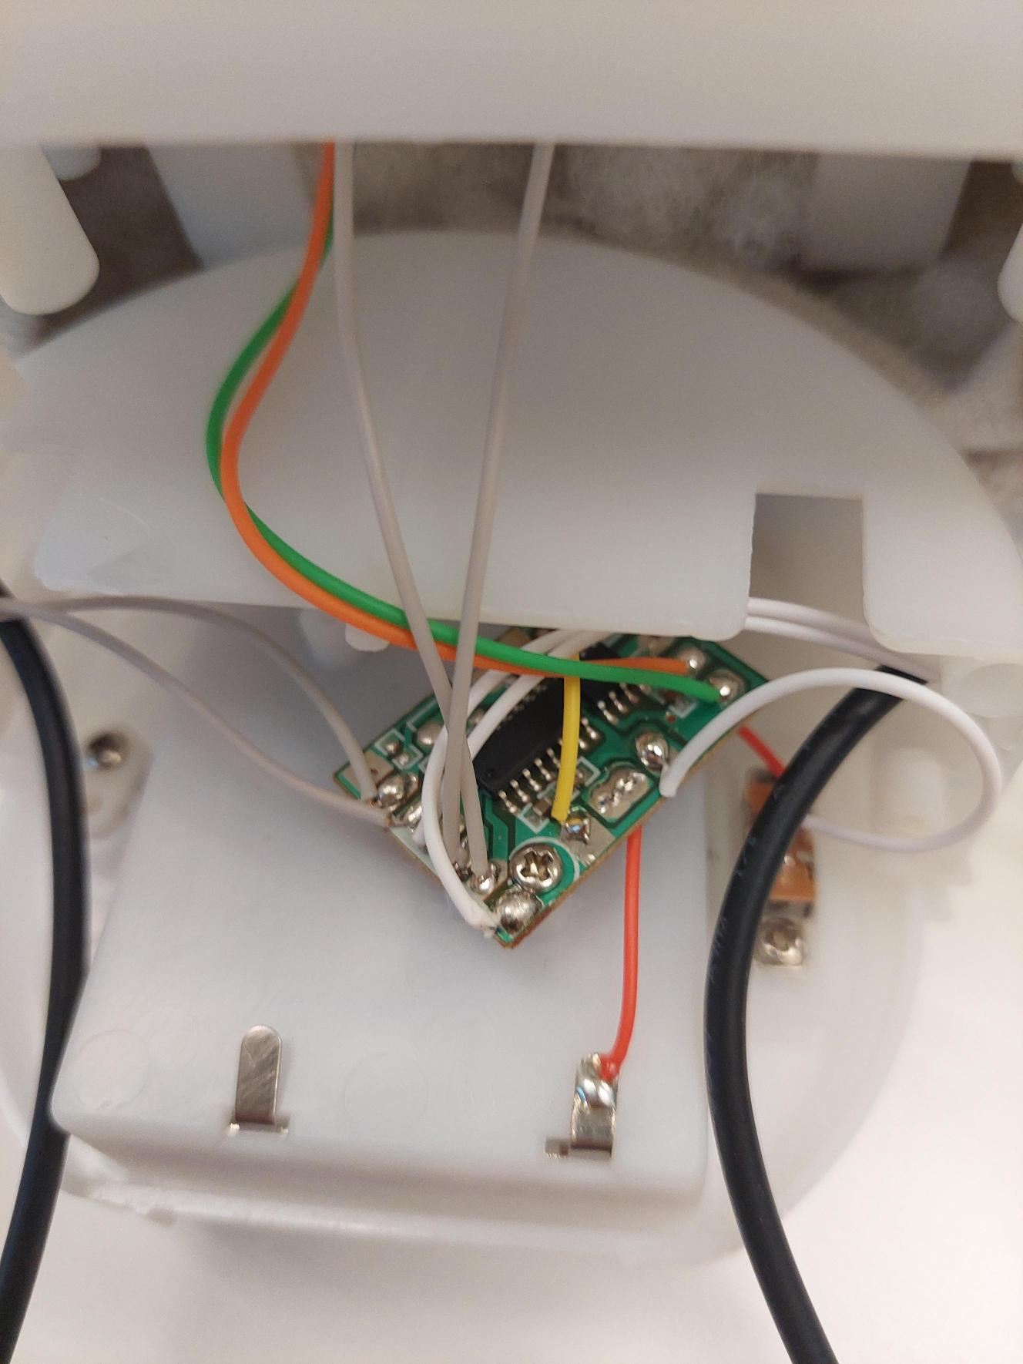
- Take one mono cable and solder to the two points where the grey wires are soldered to the board, shown circled here. | 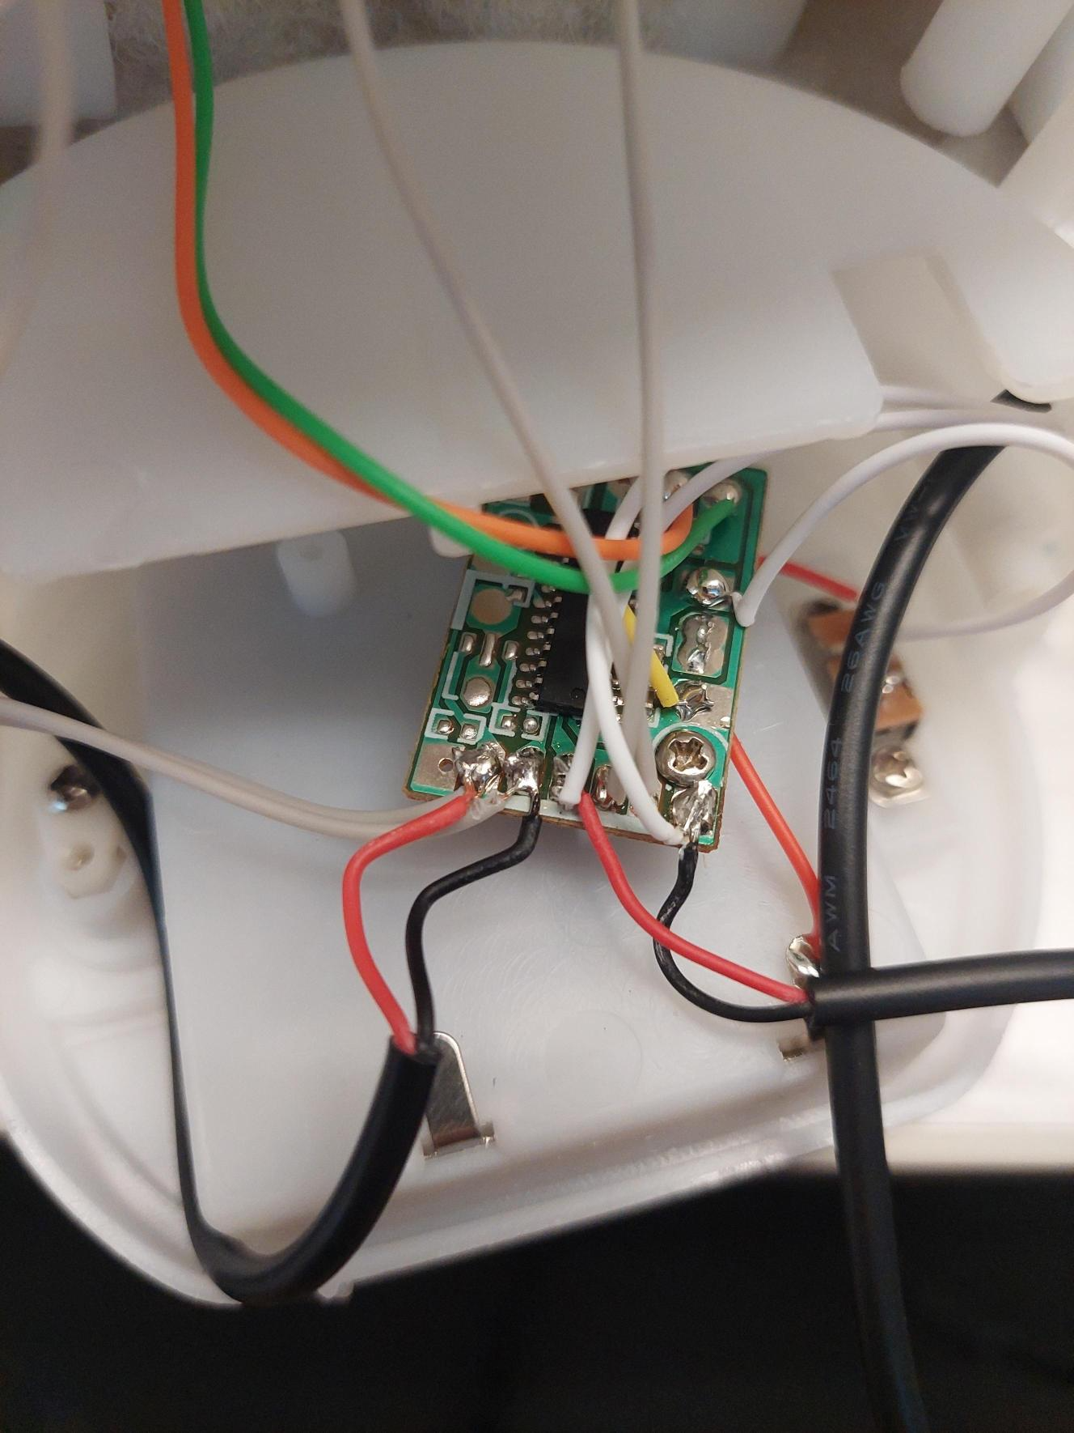
- Take the second mono cable and solder to the two points where the white wires are soldered to the board, shown circled here. | 
- It is now time to test the toy. Insert the batteries and plug in an assistive switch into the each of the mono cables. The toy will activate when the assistive switch is pressed.  Notes:  - If the toy does not turn on, please check the soldered connections. As well, check if the batteries are working.  - If the toy continues to repeat when the switch is not pressed, check the connections for touching solder. | 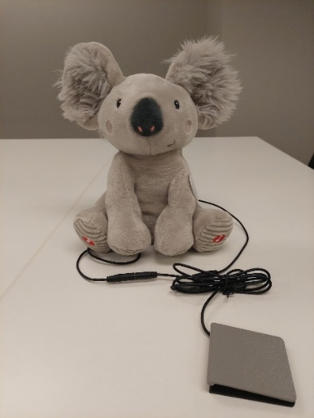
- Add a small cable tie around the mono cable on the inside of the enclosure for strain relief support. Make sure the cable tie is tightened all the way. Repeat for both cables. | 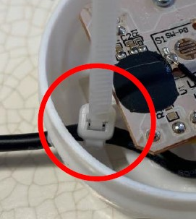
- Reassemble the toy using the two screws set aside earlier. | 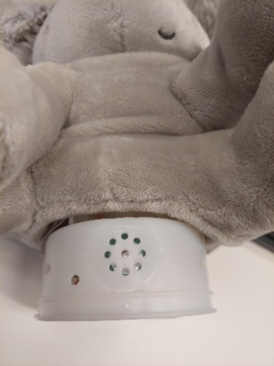
- Reposition the internal component inside the toy, with the fabric around it. Feed a new cable tie through the fabric and tighten, ensuring your two new cables of the toy come out this hole in the fabric and don’t interfere with how the toy sits. | 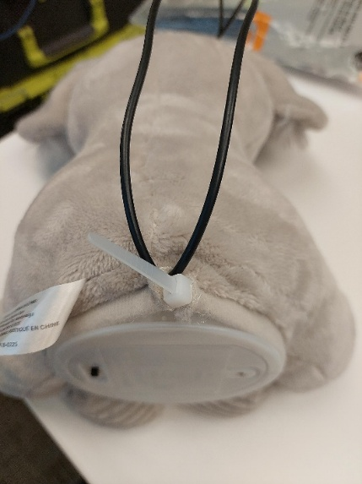
- Test the toy again. If it is still working properly, repackage the toy and the adapted toy is complete! | 