Required Components
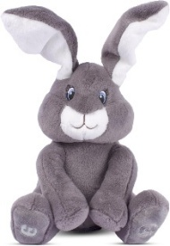  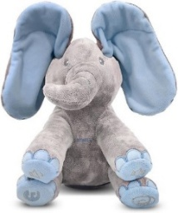 | 2.  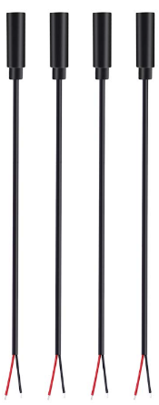 | 3.  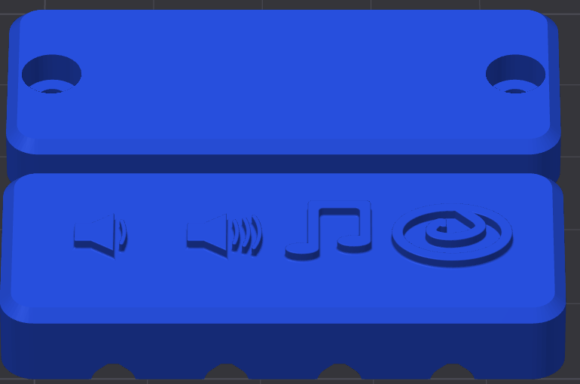 | BOM  - Dimple Peek-A-Boo Elephant or Bunny stuffed animal  - (x4) Female mono cables  - 3D printed cable clamp  - (x2) #4x3/8 sheet metal screws  - Cable tie (at least 35 cm long and only 4 mm wide.)  - (x3) AA batteries
4.  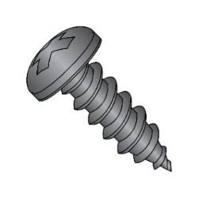 | 5.  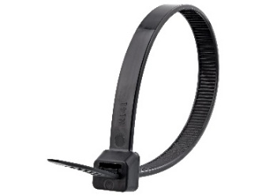 | 6.  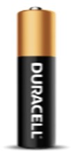
Note: the instructions show the elephant Dimple Peek-A-Boo toy, but the steps to switch adapt the toy are the same for other versions of the toy (bunnies and other elephant colour).

Required Tools
- Precision Philips screwdriver (included with toy)
- Utility/hobby knife, or scissors
- Soldering iron
- Painting/masking tape (or other tape that can be written on)
- Marker
- Hot glue gun
- Wire stripper (optional)

Required Personal Protective Equipment (PPE)
- Safety Glasses

Assembly Instructions

Step 1: Unbox the toy
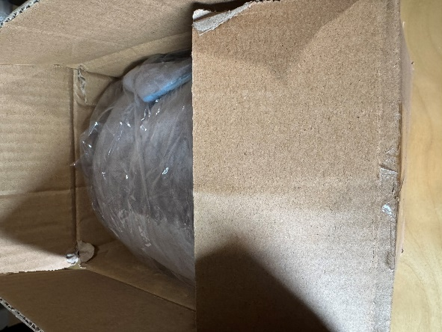 | - Carefully open the box the toy came in. The toys are packed very tightly, so it is easy to damage the toy if you are not careful when cutting the tape on the box.  - Remove the toy from the plastic.  - Remove the included screwdriver.

Step 2: Test the toy
- Follow the instructions included with the toy to install the three AA batteries.
- Turn the toy on and test that all four buttons (one in each paw) are working properly. If the toy is not working properly, return it.
- If the toy is working properly, remove the batteries and continue switch adapting.

Step 3: Access the Cable Tie
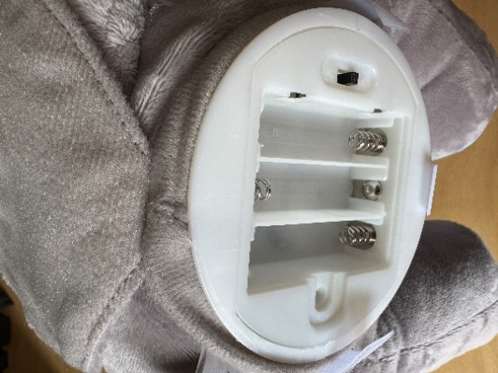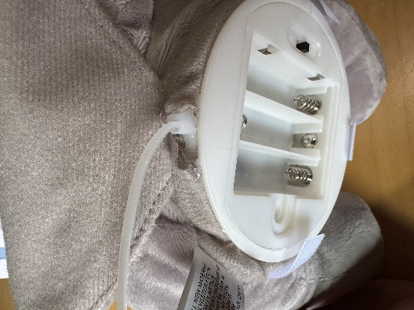 | - Cut the stitching at the back of the battery compartment, where shown circled in the photo. Avoid cutting the fabric of the toy.  - Pull the end of the cable tie out of the opening you created, and expose the head of the cable tie.

Step 4: Remove the cable tie
 | - Cut and remove the cable tie

Step 5: Pull out the electronics enclosure
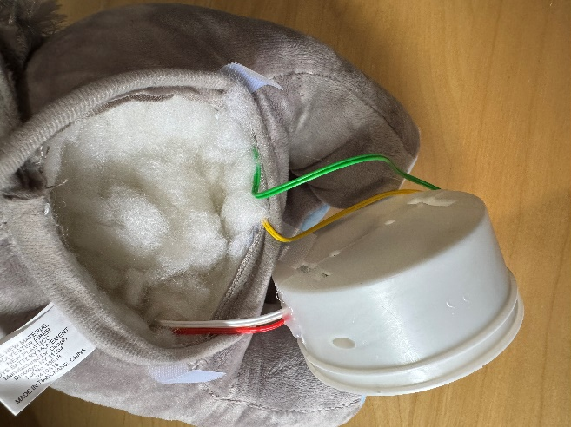 | - Pull the plastic piece that houses the electronics out of the body of the toy. Be sure to keep the wires running from the enclosure to the body of the toy attached.

Step 6: Open the electronics enclosure
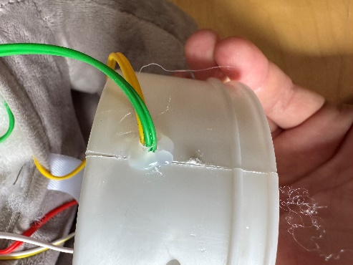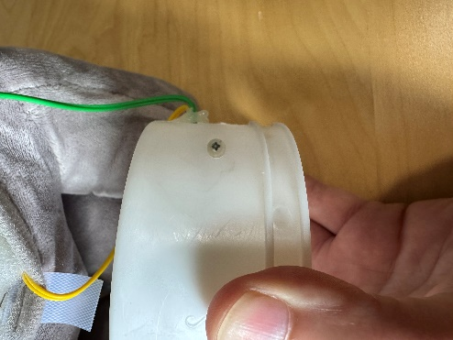 | - Remove the hot glue that is holding the wires to the sides of the enclosure. Make sure you avoid damaging the wires while doing so.  - Remove the two screws which hold the halves of the enclosure together.  - Place the screws some place safe so you do not lose them.

Step 7: Remove hot glue from wires on PCB
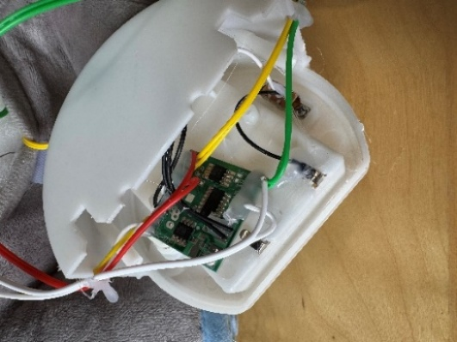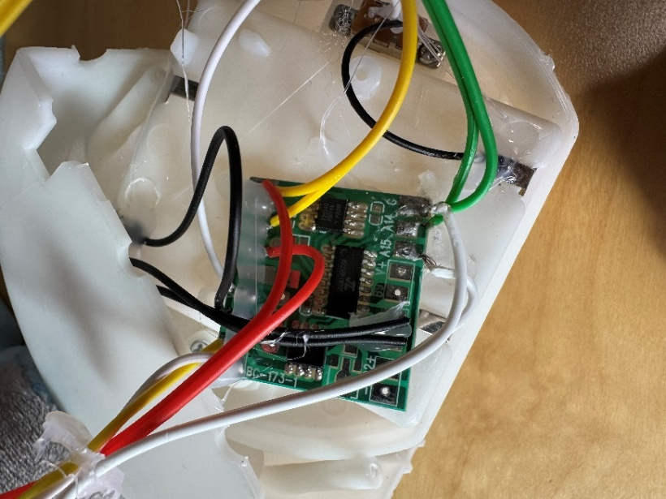 | - The wires in the toy connect to a printed circuit board (PCB), and the wires are glued to the board after soldering.  - Remove the hot glue from the four pairs of wires that go to the toy’s paws.  - The images only show the glue removed from one side of the board. You will need to remove glue from both sides.  - Six solder pads (shiny metal areas with wires attached) should be exposed. They are labelled A1, A2, A14, A15, and two are labelled G.

Step 8: Prepare the female mono cables
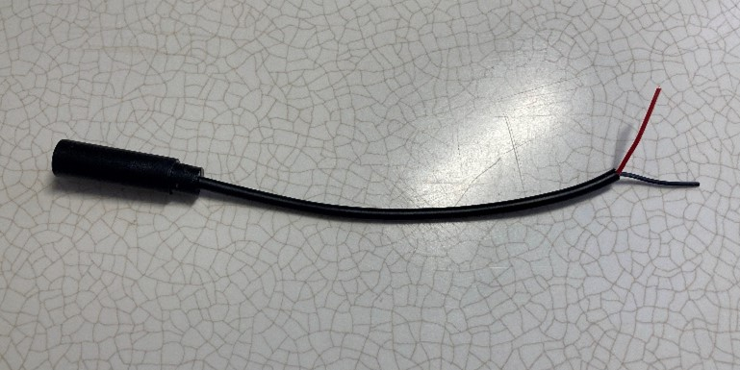 | - Take the mono cables, using the wire strippers, strip approximately 2 cm of the outer wire casing, revealing the internal wires.  Skip this if the two internal wires are already showing.
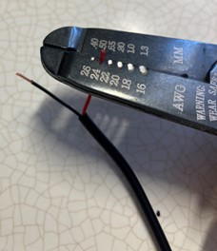 | - If there are 2 internal wires, strip approximately 0.5 cm of each wire.  Skip this step if the internal wires have already been stripped, and the metal is exposed.
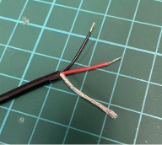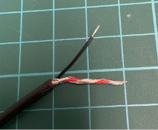 | - If there are three internal wires (red, black, and exposed), strip off 1.5 cm of the red insulation and twist the red wire and exposed wire together. Strip 0.5 cm from the black wire.
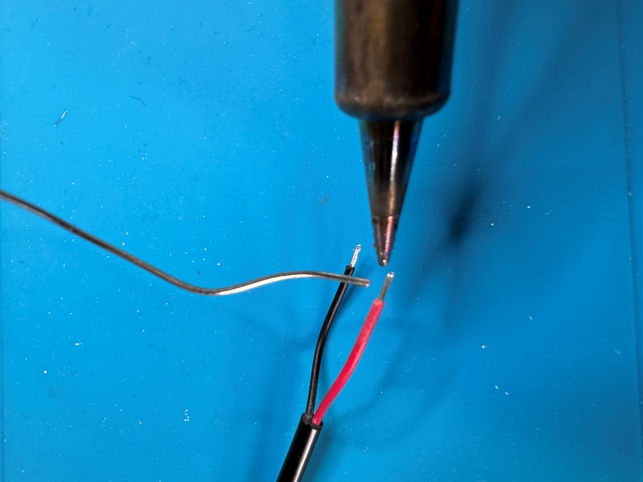 | - Add solder to both exposed ends of wire on each mono cable.  - Repeat this step for all four mono cables.

Step 9: Solder mono cables to PCB
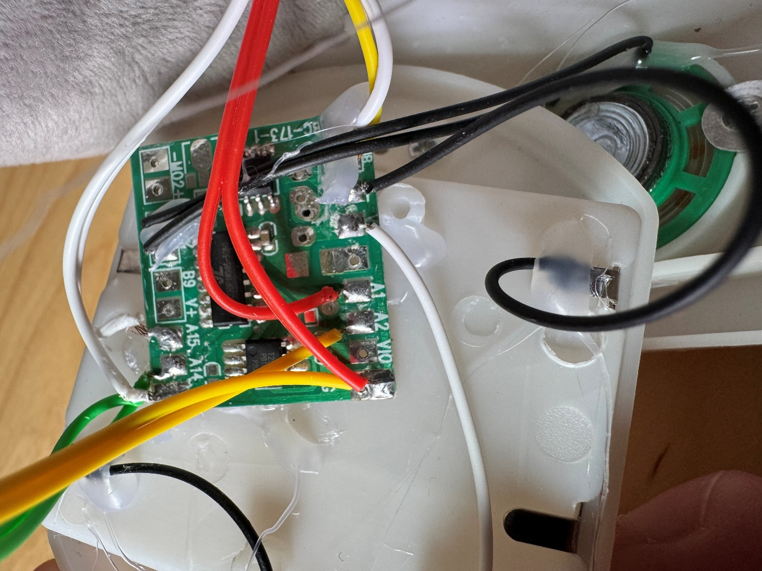  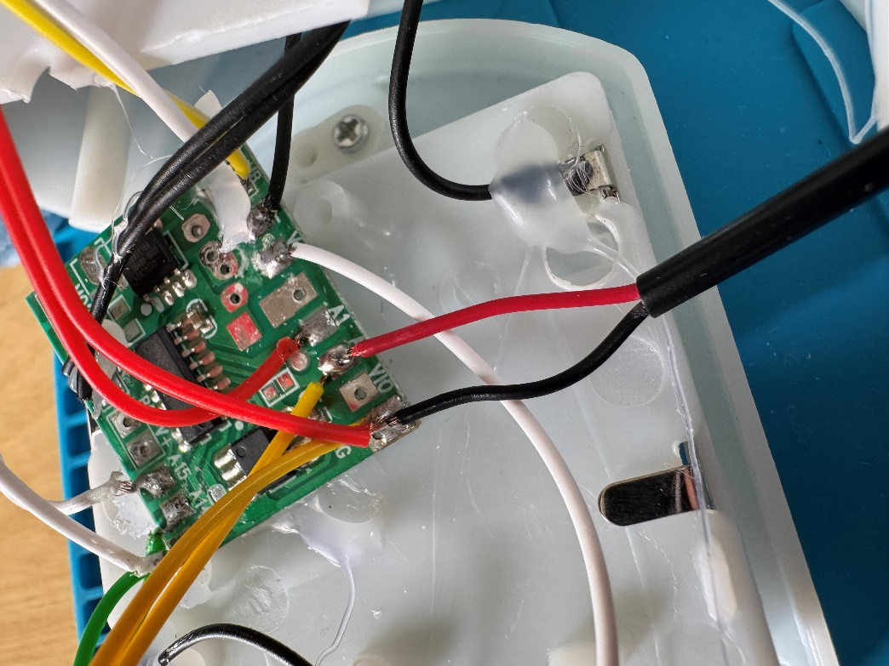 | - Solder the two wires from the first mono cable to the two points circled in the top image. These points should be labelled “G” or “GND” and “A2”. Once the cable is soldered it will look like the image below.  Note: if the wire colours or labels on the PCB change, follow the pairs of wires that come from each paw and solder a mono cable to those two points, with one mono cable per paw.
 | - Solder the two wires from the second mono cable to the two points circled in the image. These points should be labelled “G” or “GND” and “A1”.
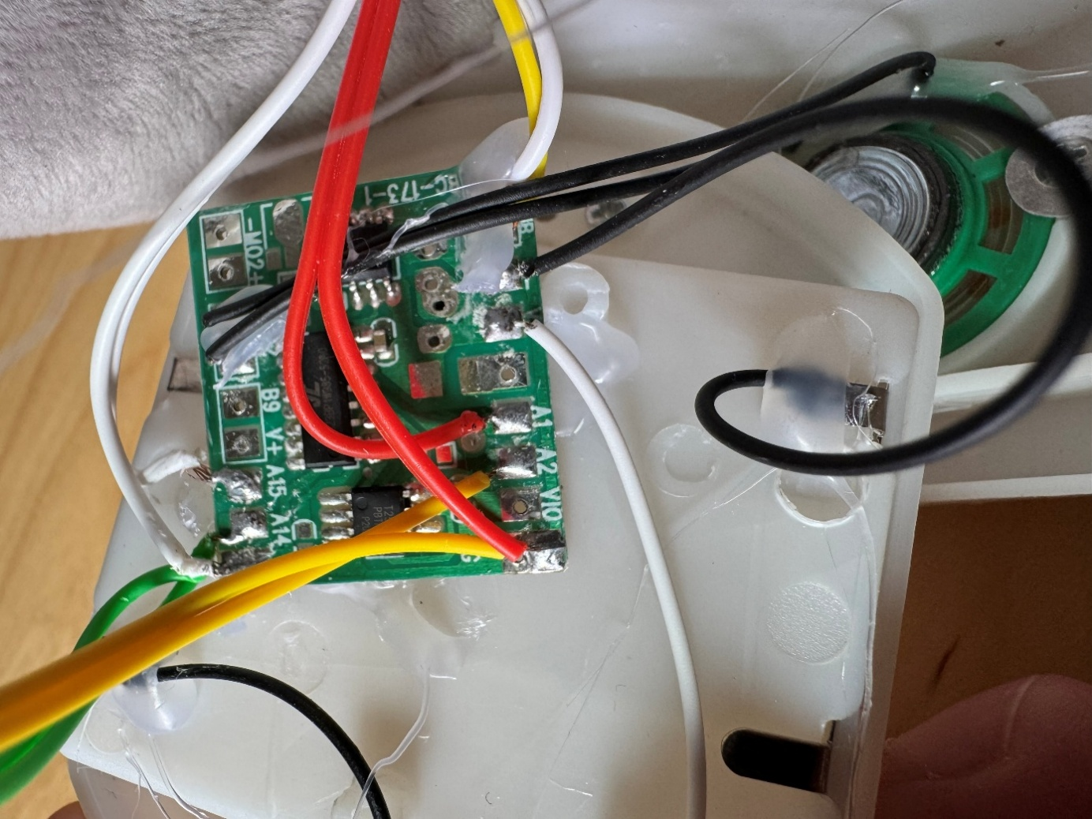 | - Solder the two wires from the third mono cable to the two points circled in the image. These points should be labelled “G” or “GND” and “A14”.
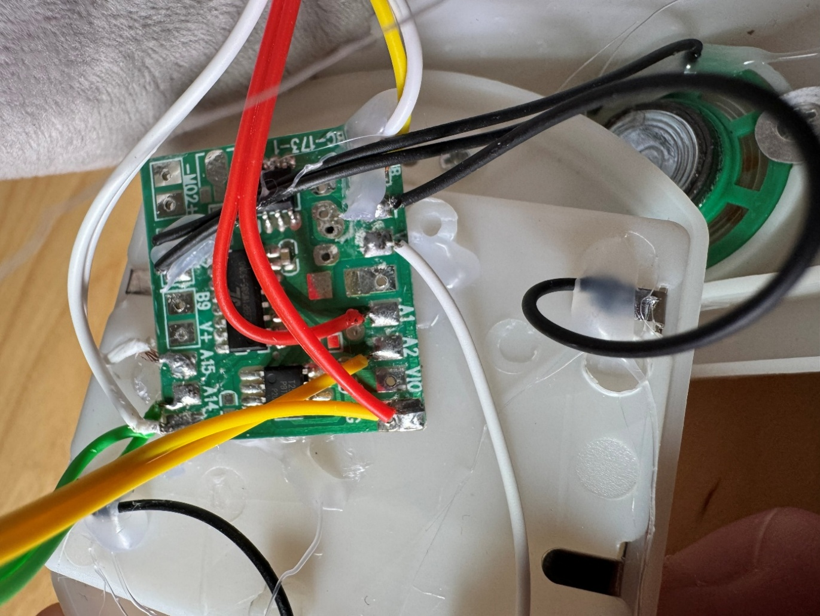 | - Solder the two wires from the fourth mono cable to the two points circled in the image. These points should be labelled “G” or “GND” and “A15”.

Step 10: Test toy and label mono cables
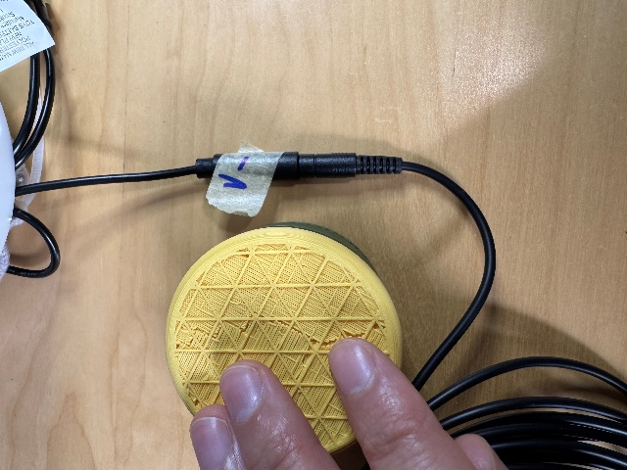 | - Replace the batteries in the toy and turn it on.  - Double check each of the 4 original buttons in the paws work as before.  - Use an assistive switch to test that each of the 4 mono cables you added work properly. They should perform the same function as the associated switch in the paw (ex. Turn volume up or down).  - As you test the cables, use the tape and marker to note which cable performs which function.  Notes:  - If the toy does not turn on, please check the soldered connections.  - If the toy continuously repeats the actions when the switch is released, the connection is shorted. Check for areas of touching solder and separate using a soldering iron.

Step 11: Glue wires to PCB
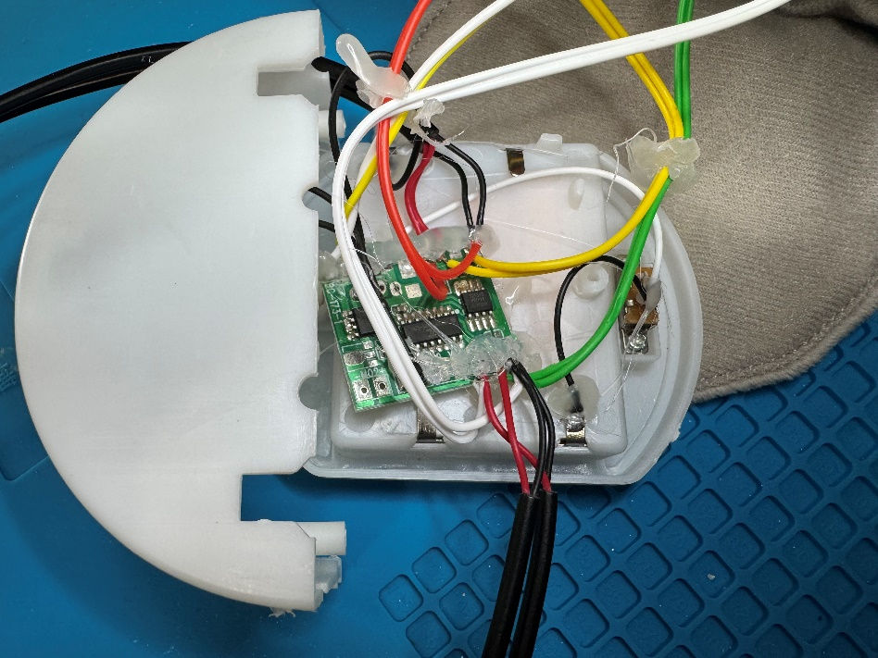 | - Once you have confirmed the toy works, add hot glue across all the connections you soldered.  - The hot glue should connect the wires to the board, adding strength to your soldered connection.

Step 12: Close electronics enclosure
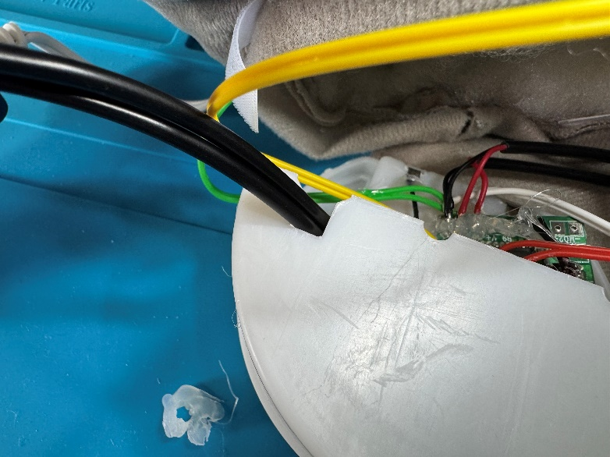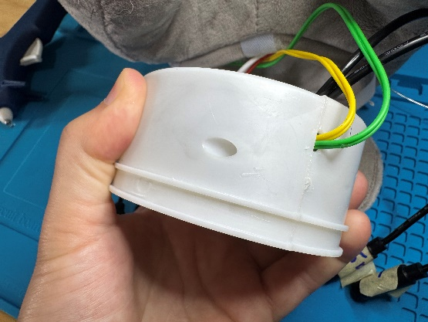 | - Line the wires up with the holes they were originally coming out of, and line the mono cables up with the large slots on the top of the enclosure.  - Push the two sides of the enclosure back together, making sure the wires and cables aren’t pinched, and that the battery compartment is held between the sides.  - Put the screws back in to connect the sides together.

Step 13: Glue wires and cables to enclosure
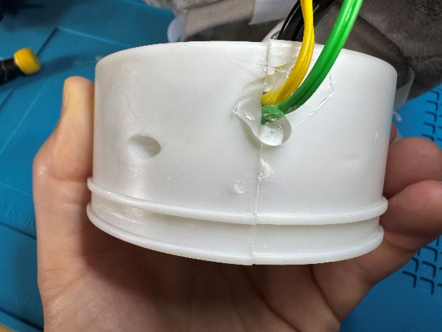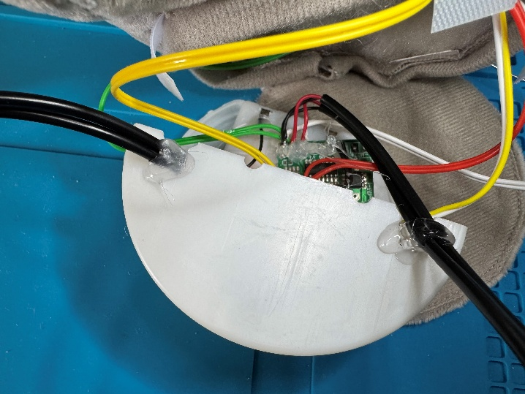 | - Add hot glue to where the wires come out of the enclosure, like there was when you first opened the toy.  - Also add glue to where the mono cables come out of the enclosure to hold them in place.  - Wait for the glue to cool and harden before proceeding to the next step.

Step 14: Put enclosure back into toy
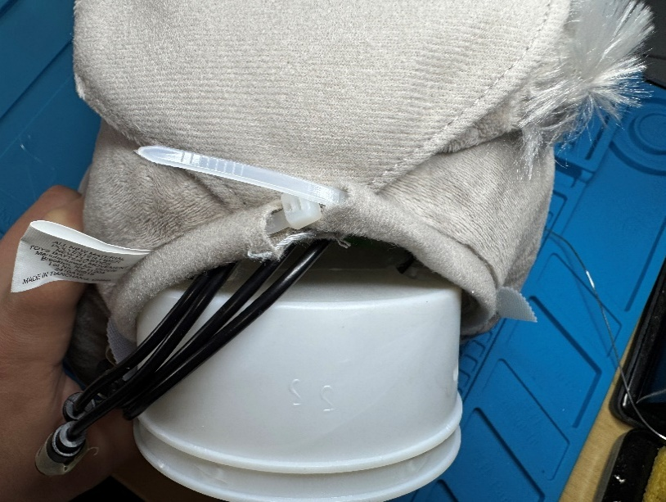 | - Feed the cable tie back through the pocket in the toy fabric.  - Push the electronics enclosure back into the bottom of the toy.  - Make sure the mono cables stick out of the fabric of the toy near where the cable tie was attached.

Step 15: Cable Tie the toy closed
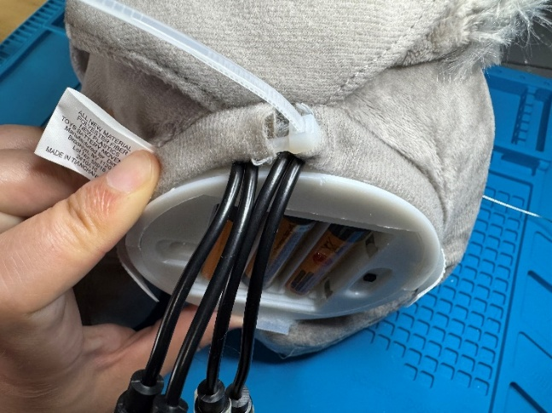 | - Make sure the cable tie lines up with the slot on the plastic enclosure, so it holds tightly.  - Partially close the cable tie, but do not tighten it down fully yet. You may need to adjust the mono cables in the next step, and if the cable tie is fully tightened this will be difficult.

Step 16: Add 3D printed cable clamp
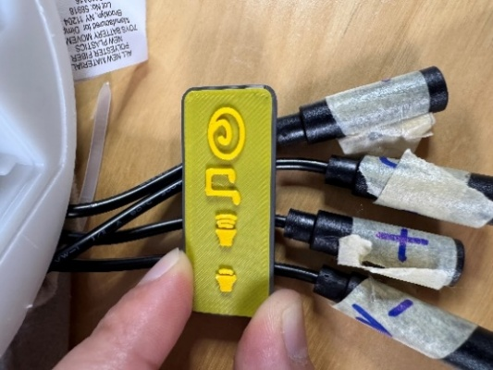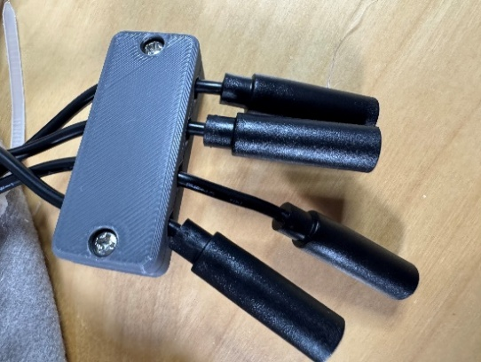 | - Line the female mono cables up in the top of the 3D printed cable clamp, making sure each cable is under the correct label. The labels on the clamp match the labels on the paws of the toy.  - Use the #4 screws to connect the bottom half to the top half of the 3D printed clamp to hold the cables in place.  - Remove the tape labels from the cables.

Step 17: Finish cable tie and close toy
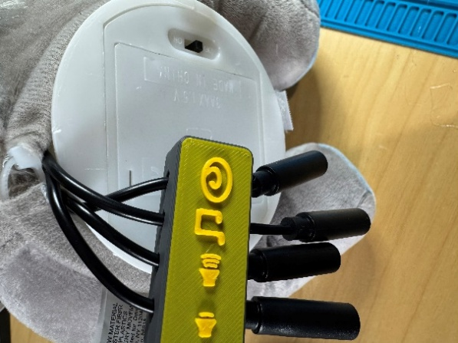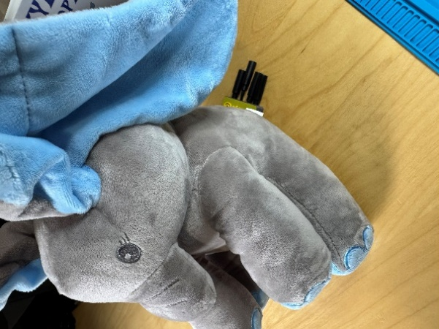 | - Once the cables are in the clamp, finish tightening the cable tie.  - Push the end of the cable tie back into the fabric of the toy, like it was when you first opened it.  - Screw the battery compartment closed and turn off the toy.  - Put the toy and screwdriver that came with it back into the box with the instructions.  - The toy is now complete.

