Required Components
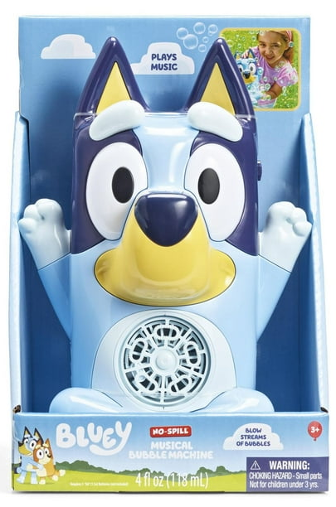 | 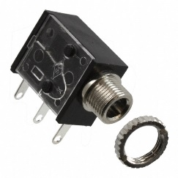 | BOM  - Bluey – No-Spill Musical Bubble Machine  - 3.5 mm Mono Jack and Nut  - 22 AWG Wire  - Electrical Tape  - 3 AA Batteries  Refer to the Tool and Component List for purchasing details.
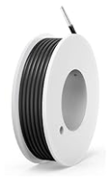 | 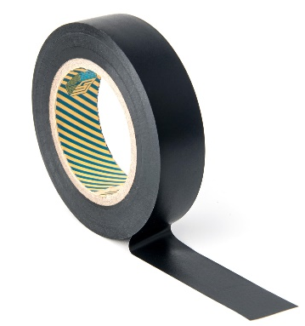 | 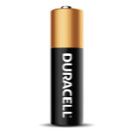

Required Tools
- Phillips Screwdriver
- Ruler
- Wire strippers
- Soldering iron and solder
- Drill and 1/4” drill bit

Required Personal Protective Equipment (PPE)
- Safety glasses

Assembly Instructions
- Remove the toy from its original packaging, please keep the original packing in good shape, the toy will be repackaged once completed. | 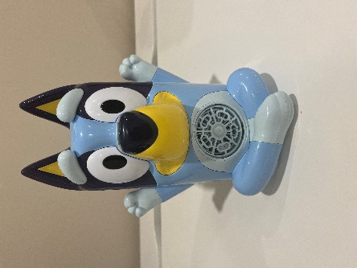
- Remove the cover on the back side, and the bubble container. | 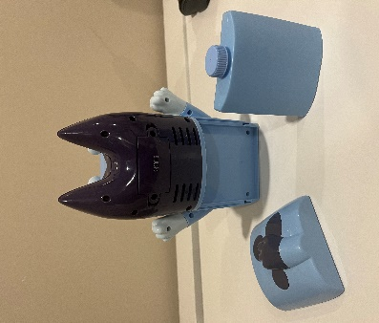
- Remove the 4 screws from the lighter blue cover and keep in a safe location. | 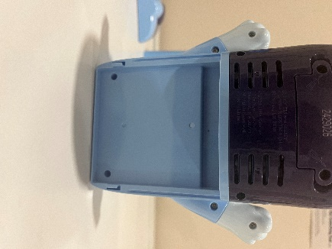
- Remove the lighter blue cover. | 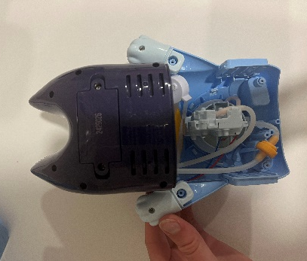
- Remove the 6 screws on the darker blue cover, store in a safe location and remove the darker blue cover. | 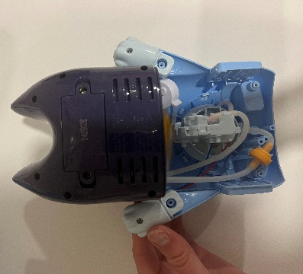
- Locate the switch on the side of the toy. | 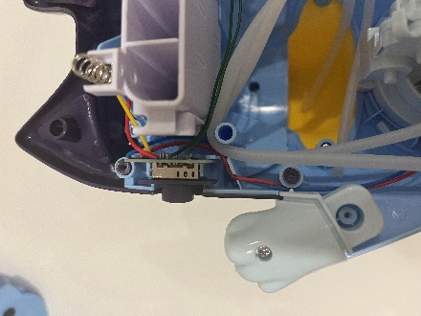
- Remove the circuit board and switch cover. | 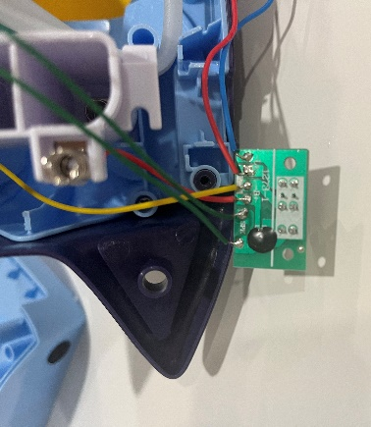
- Cut two pieces of wire, each about 10 cm long. | 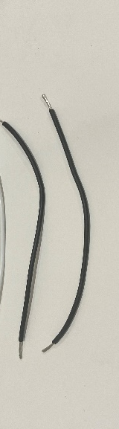
- Strip approximately 0.5cm off the end of each wire. | 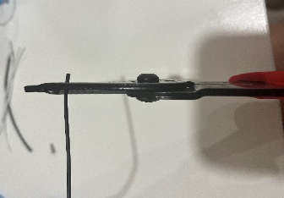
- Solder the wires onto the legs of the mono jack closest to where the cable is inserted. | 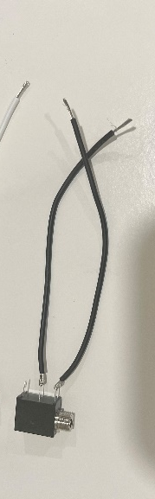
- Locate the wire that connects from the battery compartment to the circuit board. Use the soldering iron to heat up the original solder and release the wire from the board. | 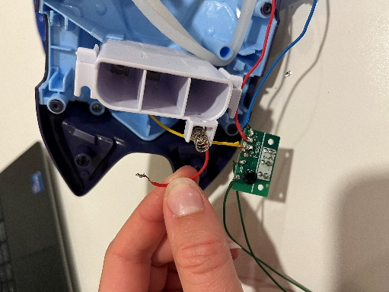
- Solder the end of the released wire to one end of the wire connected to the mono jack and wrap with electrical tape. | 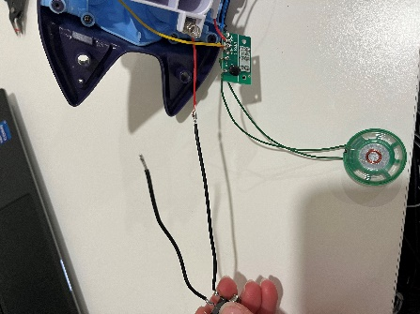
- Solder the end of the other wire connected to the mono jack to the board where the wire was removed. | 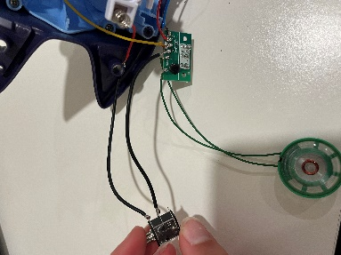
- It is now time to test the toy. Insert batteries into the battery compartment and insert an assistive switch into the mono jack. When the switch is pressed, the toy will turn on and you can move onto the next step. You’ll need to place the darker blue cover over the toy to connect the batteries.  Note: If the toy does not turn on, please check the soldered connections. | 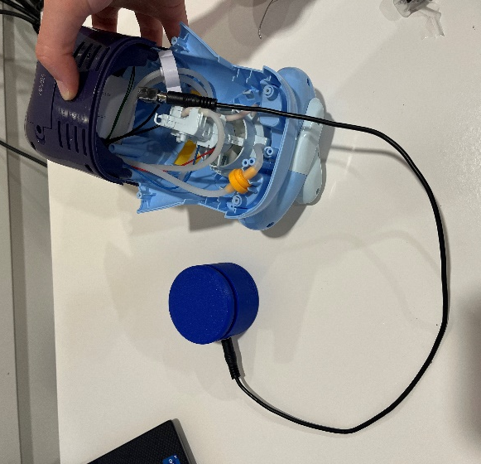
- Using a ¼” drill bit, drill a hole into the dark blue cover. Cut away any loose plastic. | 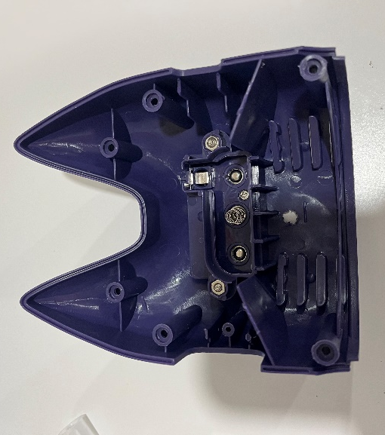
- Remove the nut from the mono jack and push the mono jack through the hole from the inside. Reinstall the nut on the outside of the toy and tighten to secure. | 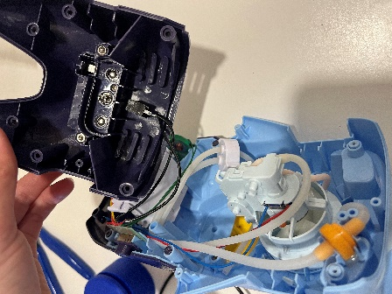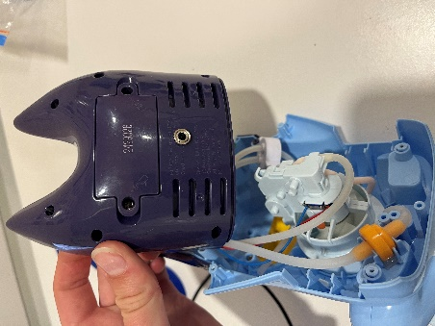
- Reassemble the toy, being careful the wires and tubes are not pinched when put back together. | 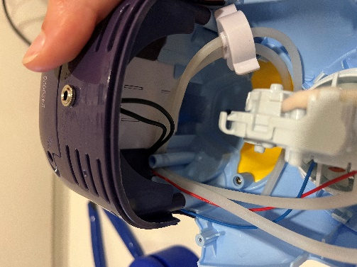
- Test the toy again. If it is still working properly, repackage the toy and the adapted toy is complete! | 