Required Components
1.  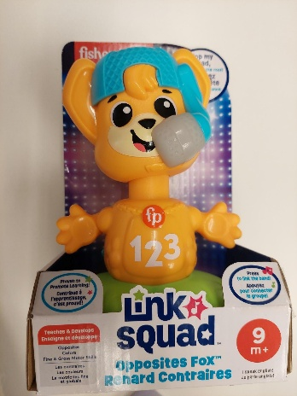 | 2.  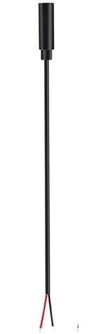 | BOM  - Fisher Price Link Squad Opposites Fox  - 3.5 mm Female Mono Cable  - Cable Tie (optional) (10-15 cm)  - (3x) AA batteries (included with toy)
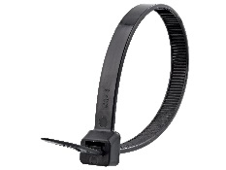 |     

Required Tools
- Phillips Screwdriver
- Flush Cutters or Scissors
- Wire strippers
- Soldering iron and solder
- Drill and 1/8” drill bit

Required Personal Protective Equipment (PPE)
- Safety glasses

Assembly Instructions
- Carefully remove the toy from its packaging without damaging it (we will be repackaging the toy after adapting). Cut away the cable tie with flush cutters or scissors and turn the plastic piece to remove the toy from packaging. | 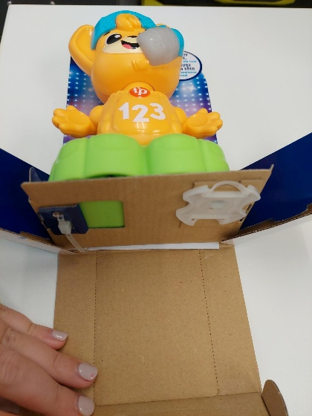
- Locate and remove the 4 screws along the body of the toy.  *Note: keep screws, and keep track of where they came from if there are multiple different sized screws | 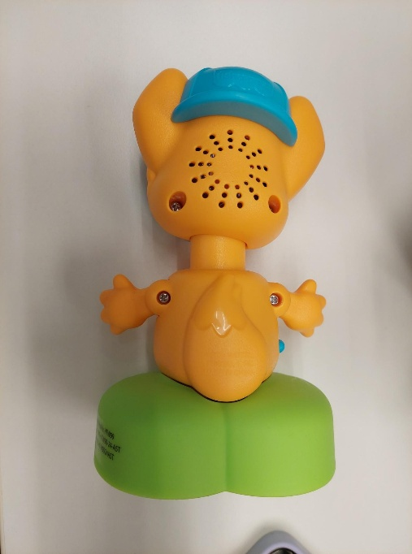
- Locate and remove the 4 screws along the base of the toy.  *Note: keep screws, and keep track of where they came from if there are multiple different sized screws | 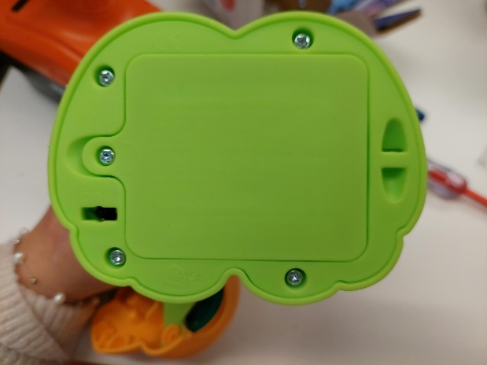
- Once you have removed the battery base you will locate two more screws to remove.  *Note: keep screws, and keep track of where they came from if there are multiple different sized screws | 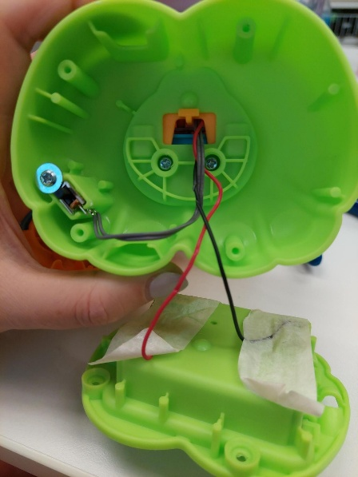
- Remove the yellow body of the toy from the green base. There are two slots for screws, if there are two screws, remove both; if there is only one screw (as shown in the image) remove it. | 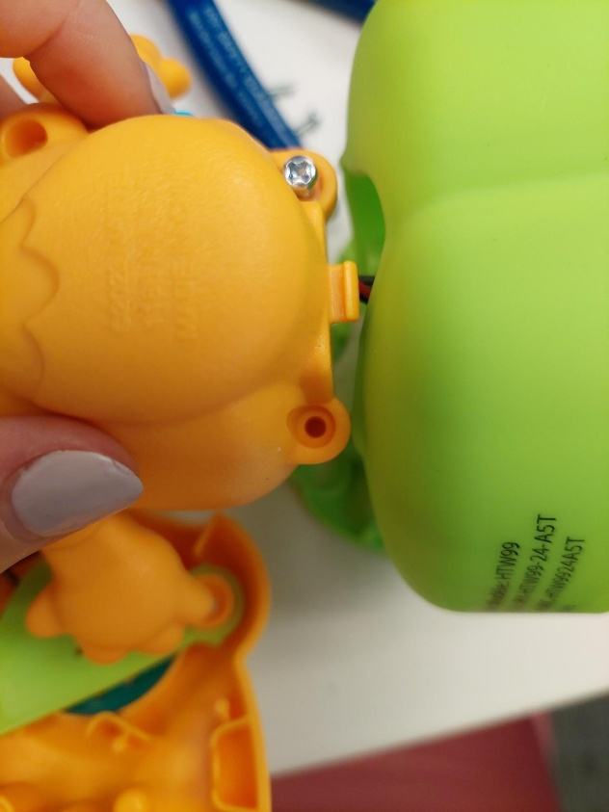
- There can be a hidden screw in the fisher price hat. Using your 1/8” drill bit, drill a hole inline with the letter “p” on the logo on the hat.  Note: some of the toys come without a screw in this slot. You can try taking the toy apart before you drill the hole. | 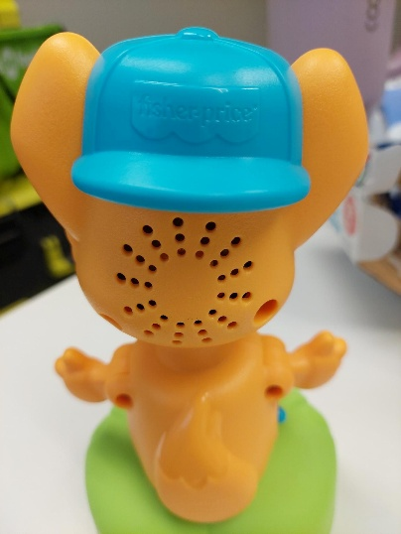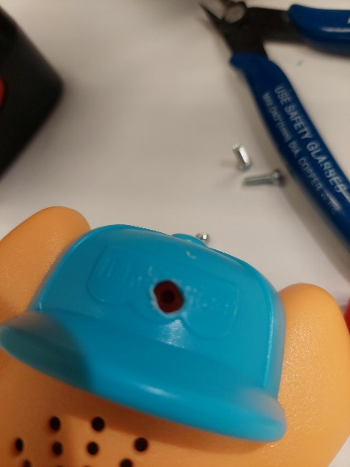
- Carefully separate the two halves of the toy. Remove the screw as shown circle in blue in the image. | 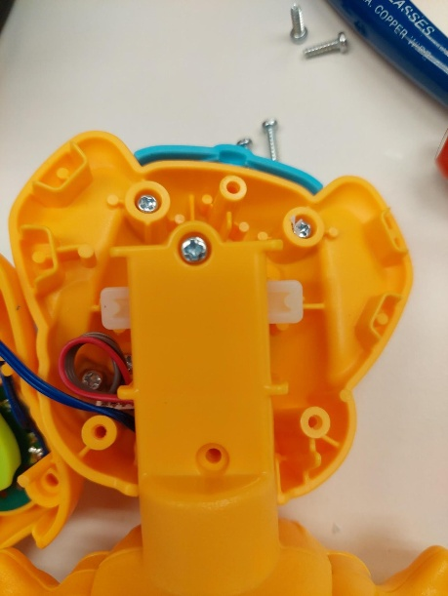
- Use wire strippers to strip approximately 2 cm off the outer wire casing, revealing two internal wires.  Note: If your mono cables come ready to solder, skip steps 7-9. | 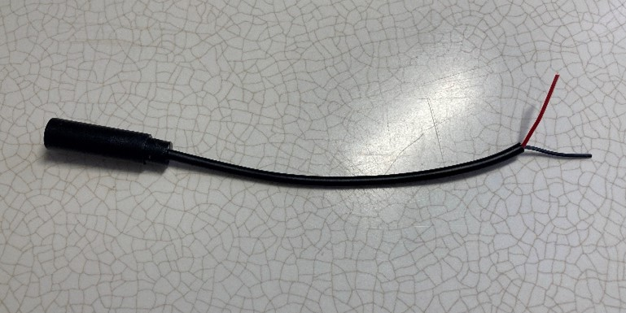
- If there are 2 internal wires, strip approximately 0.5 cm off each wire. | 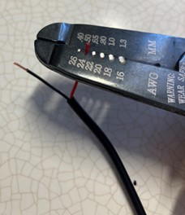
- If there are three internal wires (red, black, and exposed), strip off 0.5 cm of the red insulation and twist the red wire and exposed wire together. Strip 0.5 cm from the black wire. | 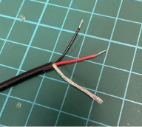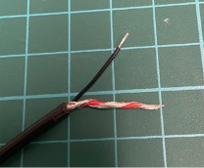
- Melt a small amount of solder over the exposed ends of the wire. | 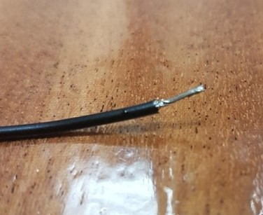
- Using a 1/8” drill bit, drill a hole into the position shown on the right. Remove any loose plastic and insert the mono cable through the hole. | 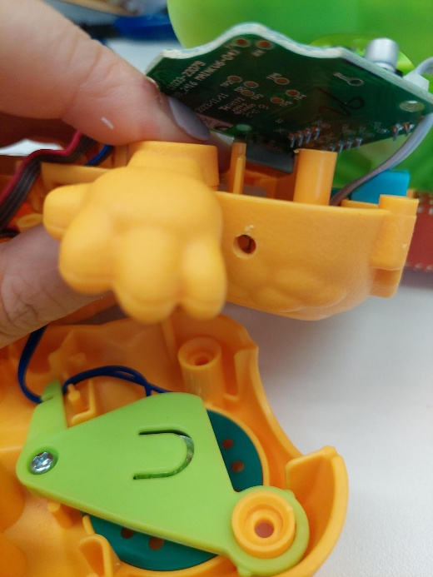
- Remove the final screw holding the green circuit board in the toy. | 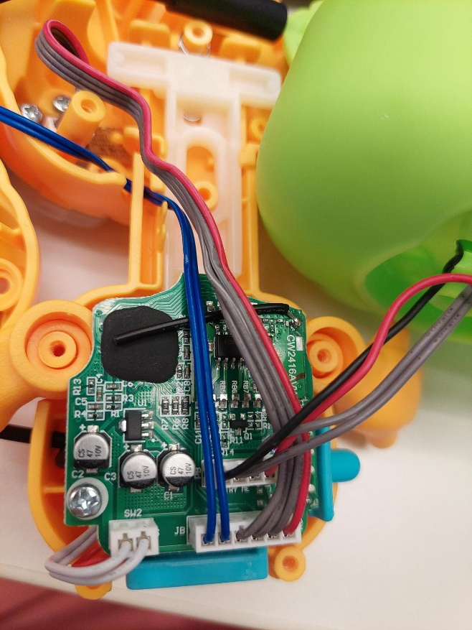
- Flip the circuit board over. The two spots to solder to are shown in the photo, circled in red. | 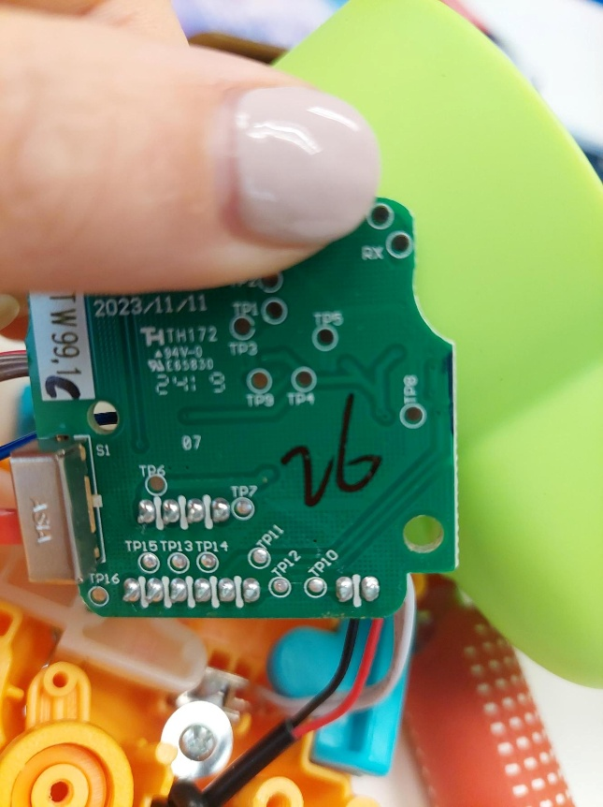
- Solder the two wires onto the board. | 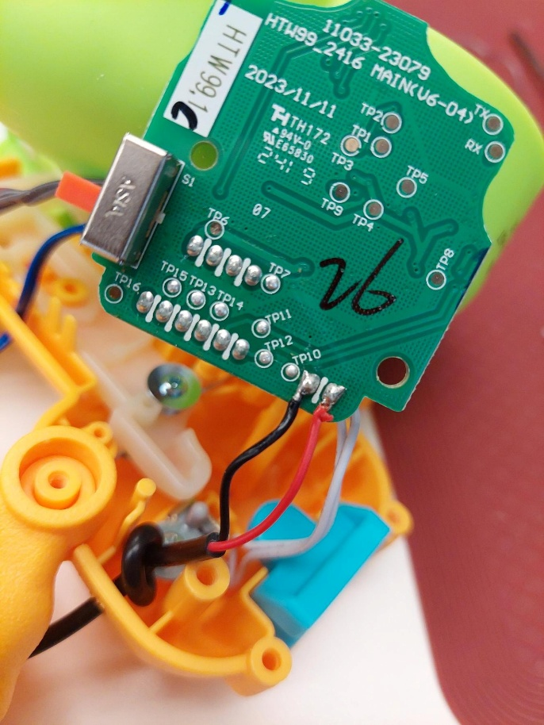
- It is now time to test the toy. Insert batteries into the battery compartment and an assistive switch into the mono jack. The toy will activate when the assistive switch is pressed. If the toy does not turn on, please check the soldered connections. This toy will sing through its whole song before you can activate it to move through its other actions.  Note: The blue switch may fall off when flipping the board over. Please put back before moving to further reassembly. | 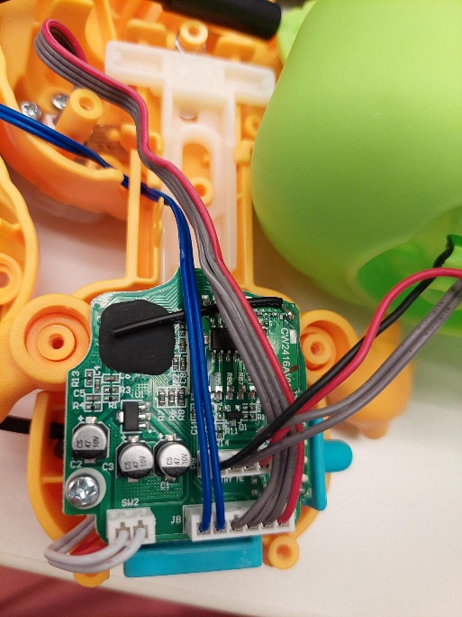
- Add a small cable tie around the mono cable on the inside of the enclosure for strain relief support. Make sure the cable tie is tightened all the way. | 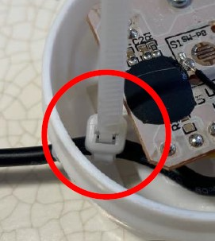
- Reassemble the toy using the screws set aside earlier. It may be helpful to review the instructions to ensure you do not miss a step in the reassembly process.  Note: The toy has a slot built into the design to help with cable management. Please feed the wires through this slot. | 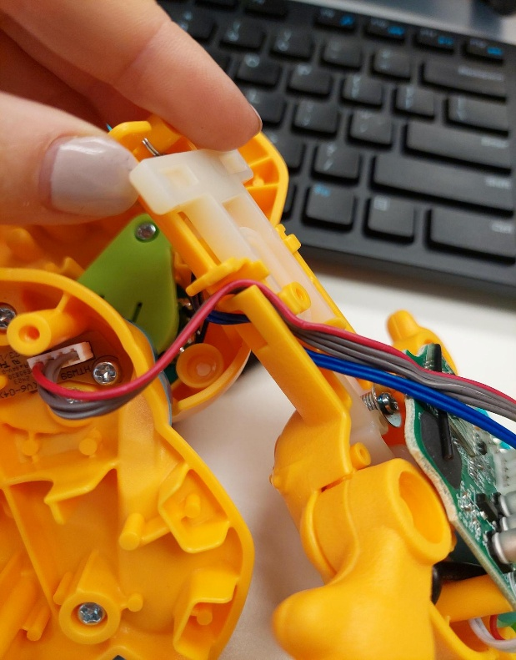
- Test the toy again. If it is still working properly, repackage the toy and the adapted toy is complete! | 