Required Components
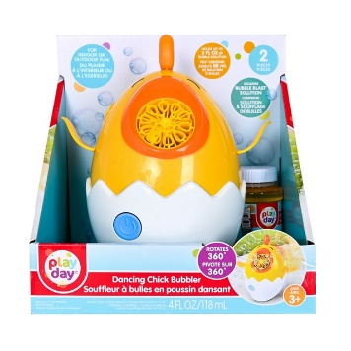 | 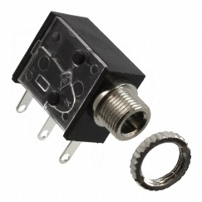 | BOM  - Play Day Dancing Chick Bubble Blower  - 3.5 mm Mono Jack and Nut  - 22 AWG Wire  - 4 AA Batteries  Refer to the Tool and Component List for purchasing details.
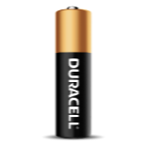  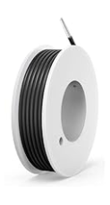 |     

Required Tools
- Phillips Screwdriver
- Soldering iron
- Wire stripper
- Flush cutter
- Drill and ¼” drill bit

Required Personal Protective Equipment (PPE)
- Safety Glasses

Assembly Instructions
- Carefully remove the toy from the packaging. The toy will be put back in after it is adapted.  Use a screwdriver to turn the 7 screws indicated in the red circles to open the toy.  Set screws aside in a safe place. | 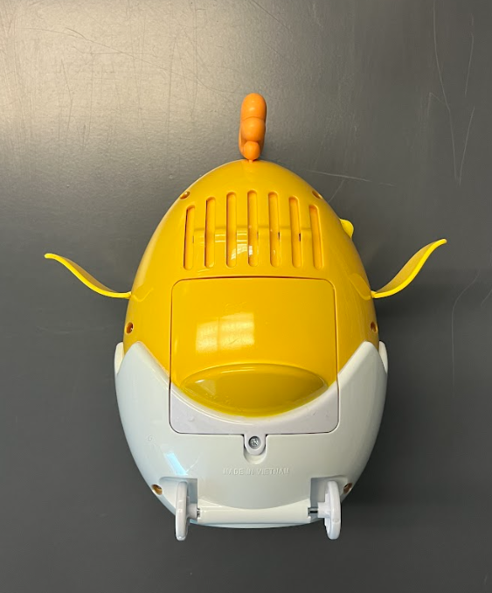
- Separate the two halves of the toy. Be very careful while doing this to prevent accidentally pulling off any existing wires or connections. | 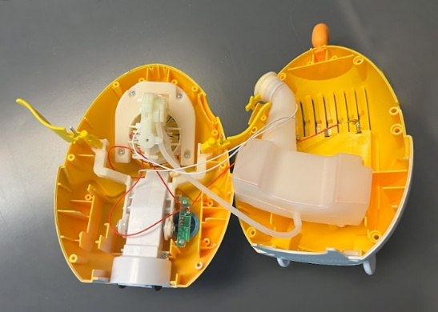
- Set aside the bubble solution container (but don’t detach the silicone tubing). | 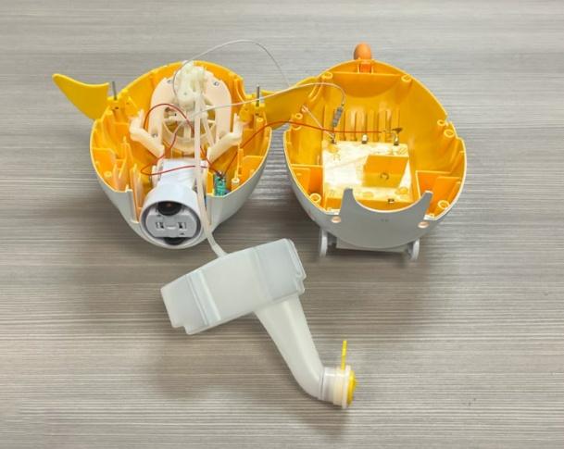
- With ¼ inch drill bit, drill a hole in the toy marked in the red circle. Do not drill where the X are. | 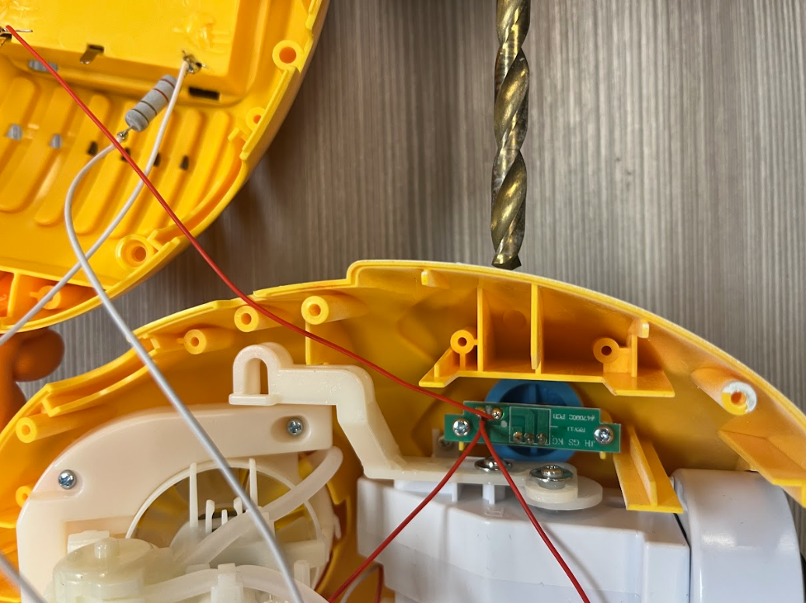  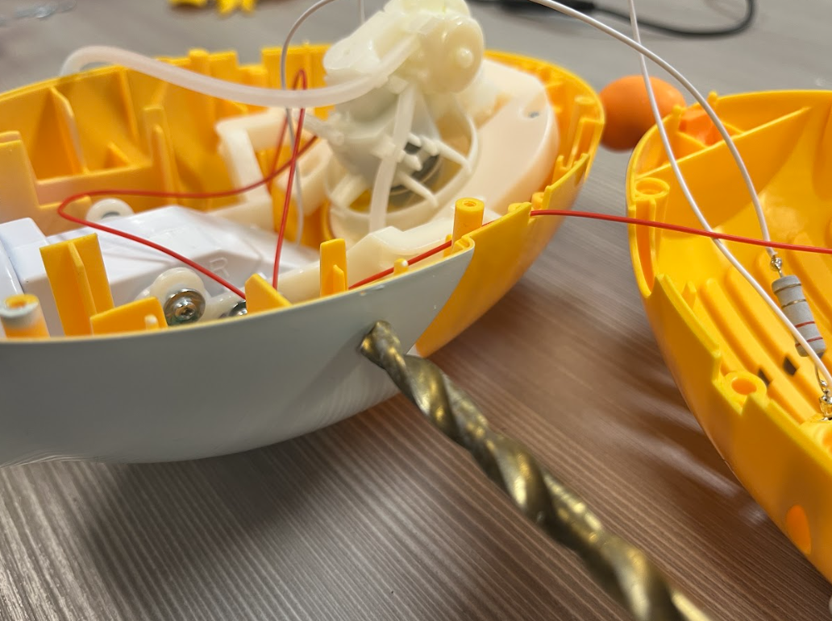
- Next, we will prepare the mono jack and wires.  Cut 2 pieces of wire each 5 cm in length. | 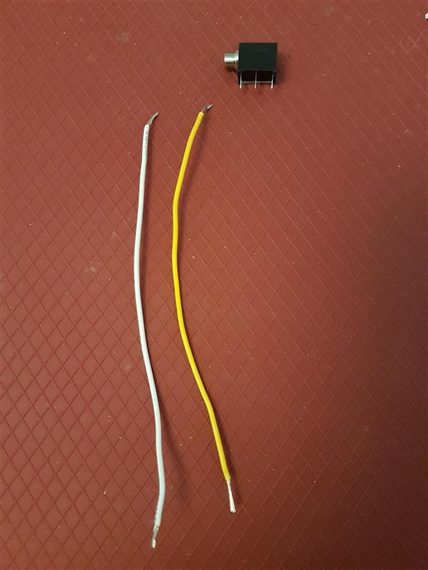  5 cm
- Use wire strippers to strip approximately 0.5 cm off each end of the wires. | 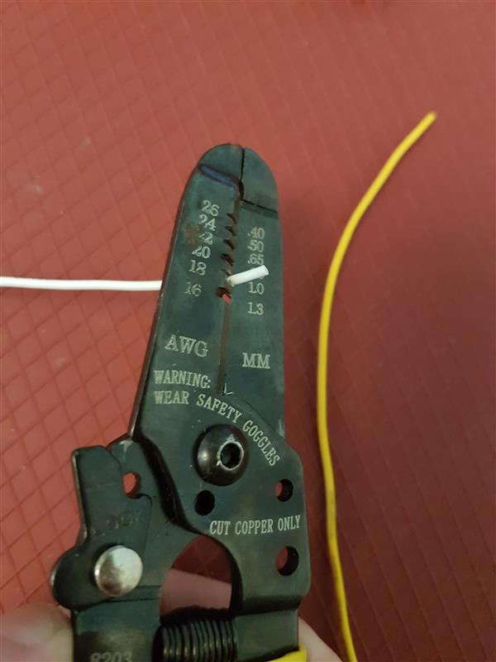
- Pick one wire and slide the exposed wire into first metal arm on mono jack (closest to the jack end).  With the second wire, slide one end of exposed wire into the middle metal arm on mono jack.  Solder the wires to mono jack.  Please note: Check that you have the correct metal arms of mono jack, refer to picture. | 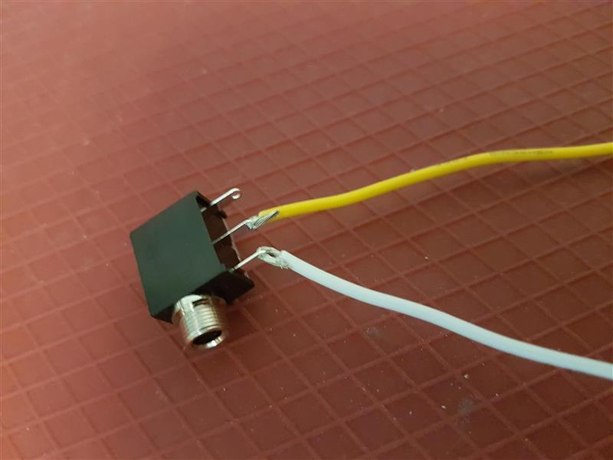
- Locate the green PCB. There are 3 wires soldered to it. The top solder point has 2 wires attached to it (circled in white), the bottom has 1 wire attached.  Detach the 2 top wires by placing the tip of the soldering iron to the solder joint. | 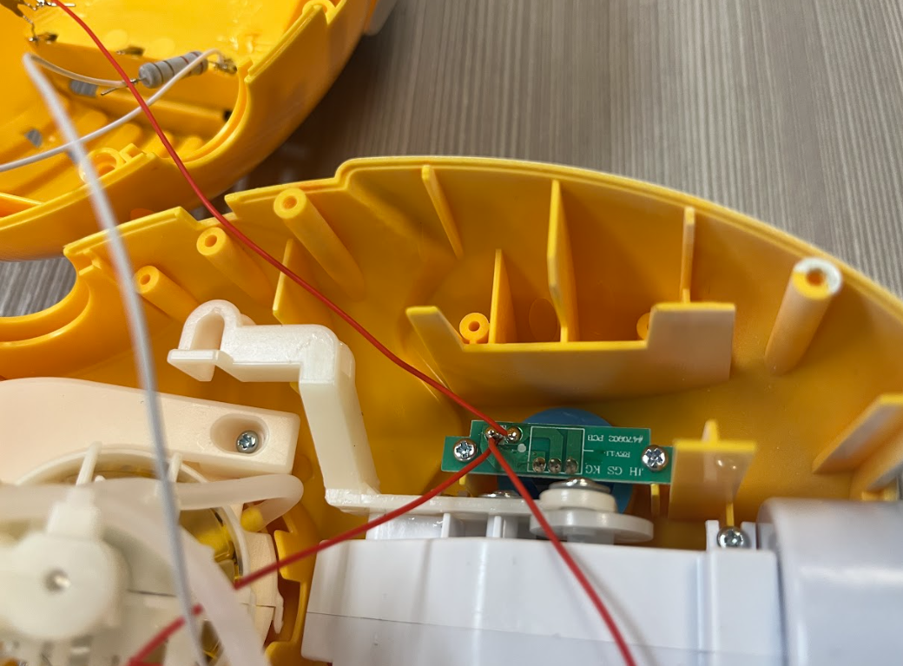  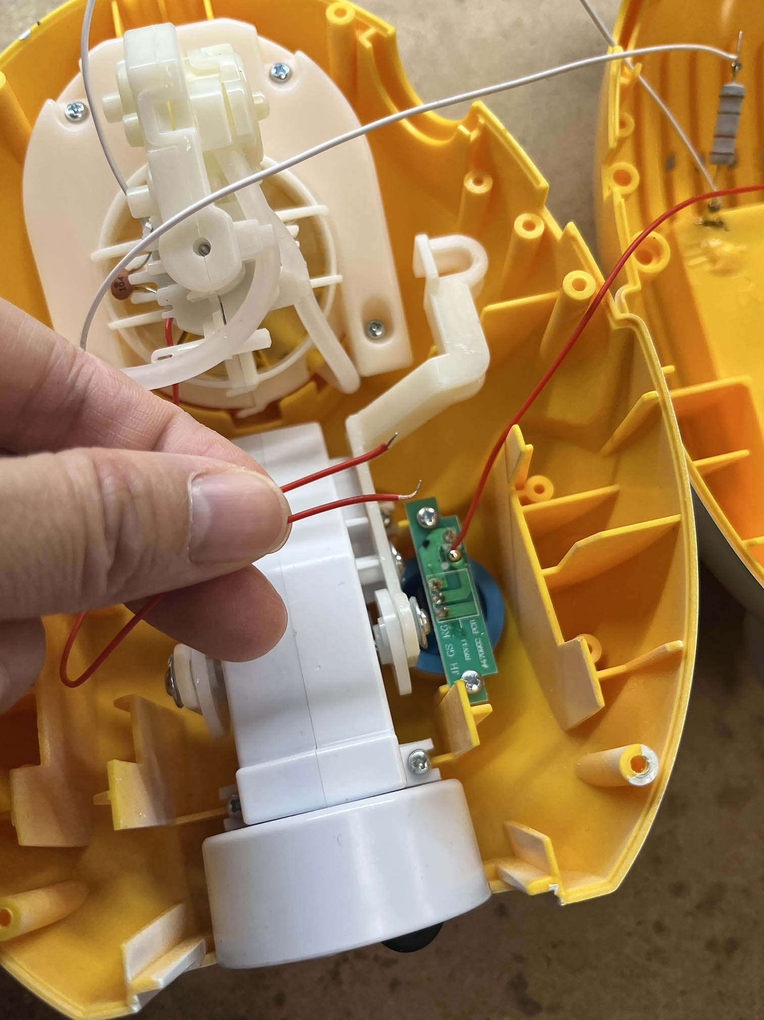
- Strip the 2 detached wires by 0.5cm to expose more wire.  Twist together the 2 detached wires and 1 wire from the mono jack assembly from Step 5 (any wire). | 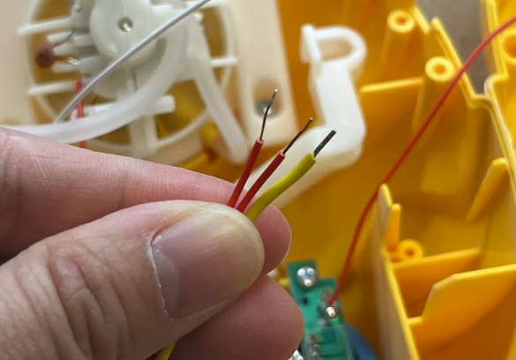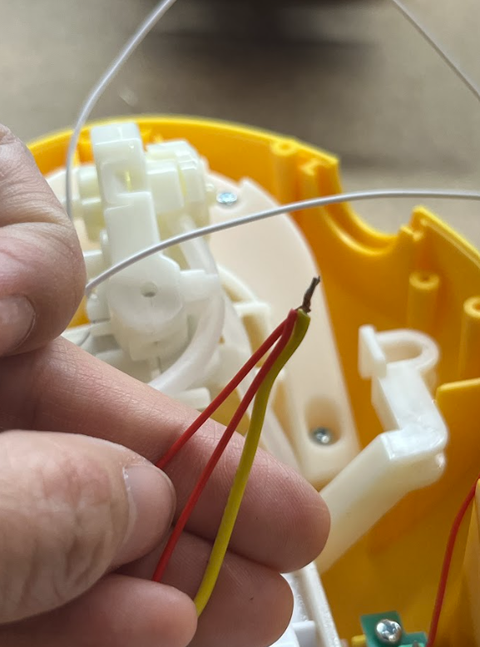
- Solder the 3 wires together. | 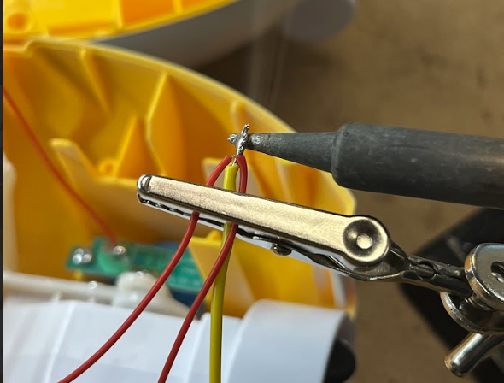
- Solder the 3 wires to the top solder joint. | 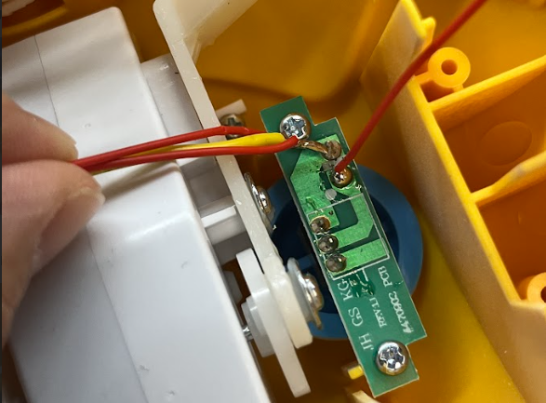
- Detach the bottom single wire by placing the tip of the soldering iron to the solder joint. |   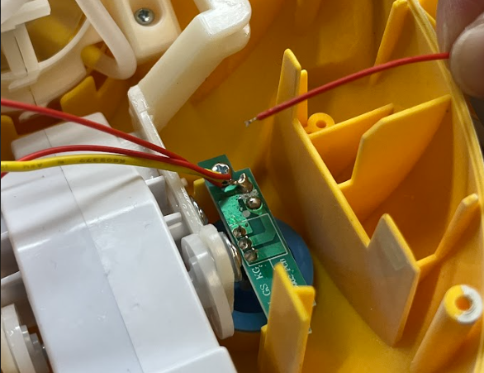
- Strip the detached wire by 0.5cm to expose more wire.  Twist together the detached wire and the remaining wire from the mono jack assembly from Step 5 (any wire). | 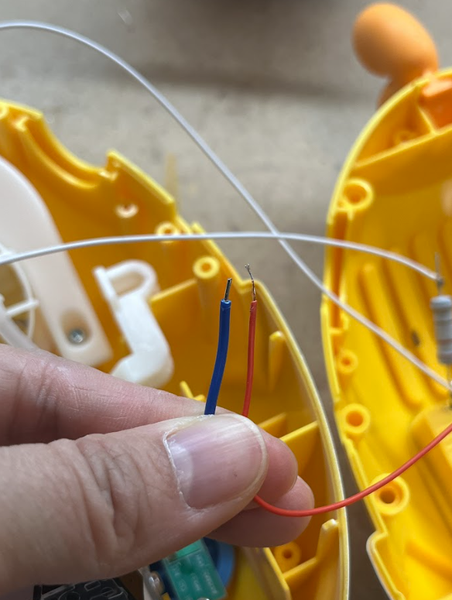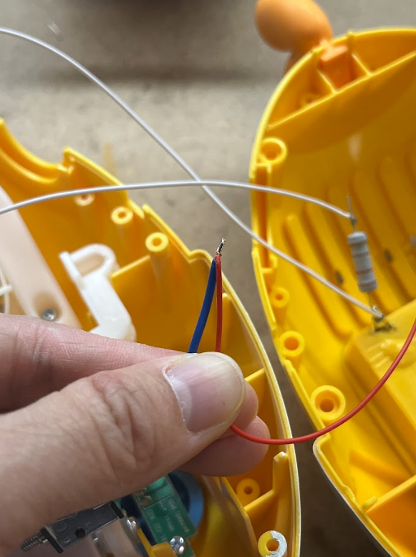
- Solder the 2 wires together. | 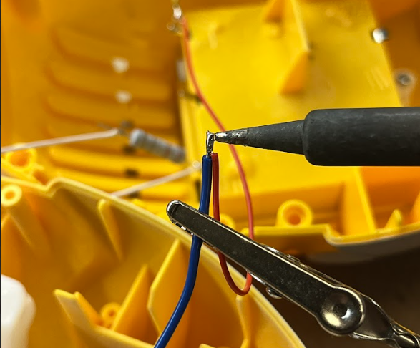
- Solder the wires to the bottom solder joint. | 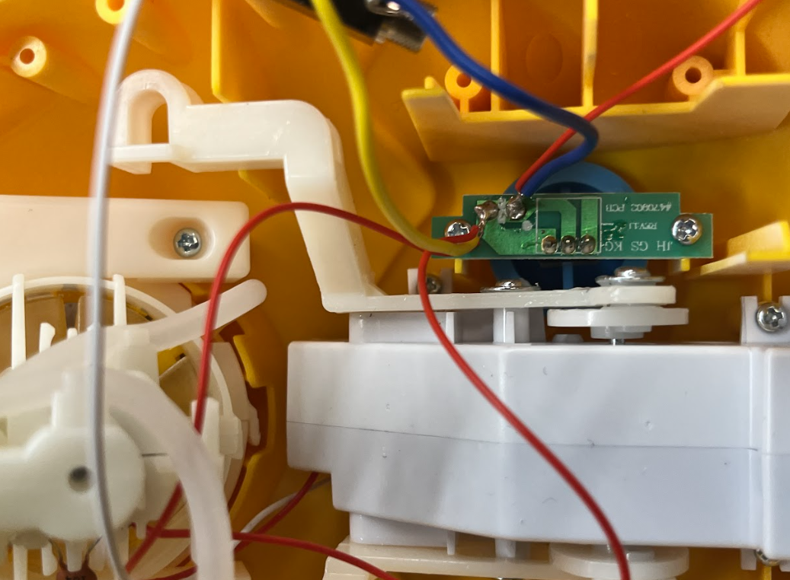
- Check that the connections were soldered correctly. Insert 4 AA batteries into the toy and plug an assistive switch into the mono jack. When the switch is pushed, the toy motor should be activated, and when the switch is not pushed, the toy motor should stop.  If the motor does not whirr, check that the soldered connections are secure, if the motor does not stop when the switch is not pressed, check for accidental bridging (excess solder connecting to the two solder joints together). | 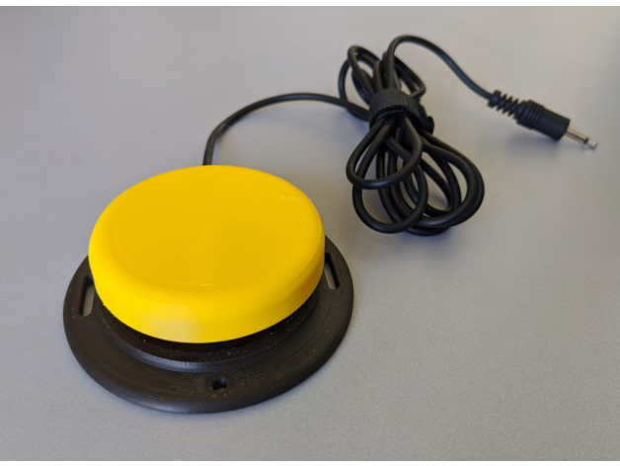
- Insert the mono jack through the previously drilled hole and secure in place by twisting the metal ring onto the jack from the outside of the toy. | 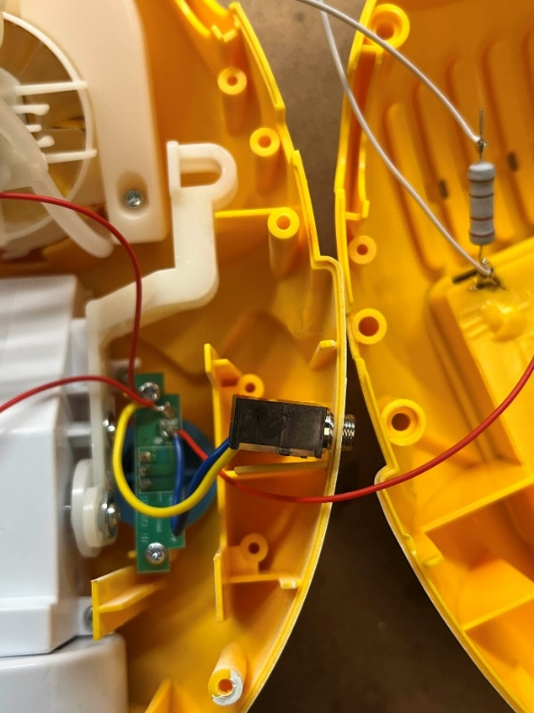  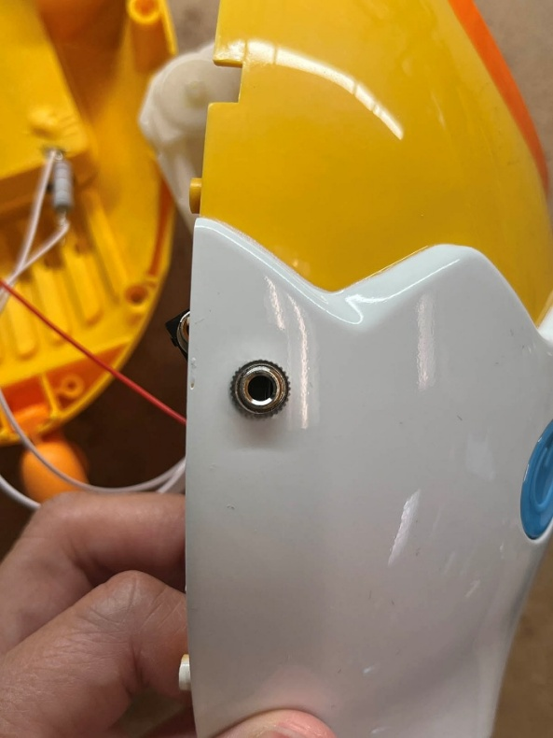
- Begin reassembling the toy by inserting the bubble solution container back in place. | 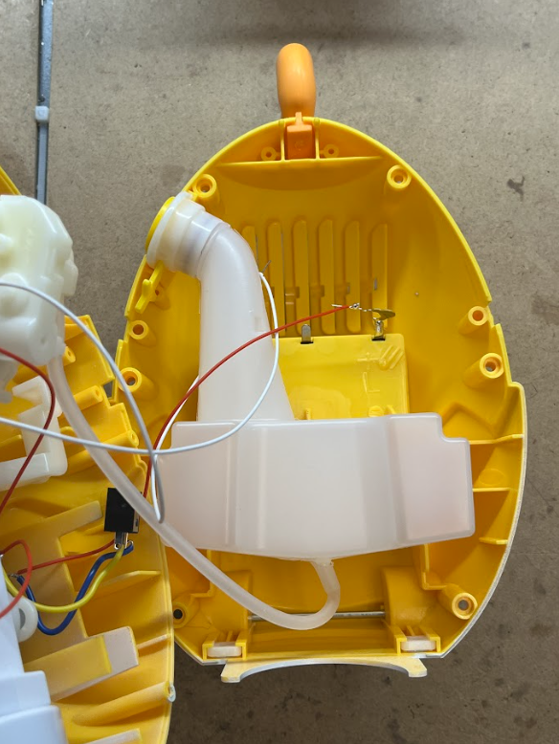
- Put back the two halves of the toy and screw the 6 screws back in place. | 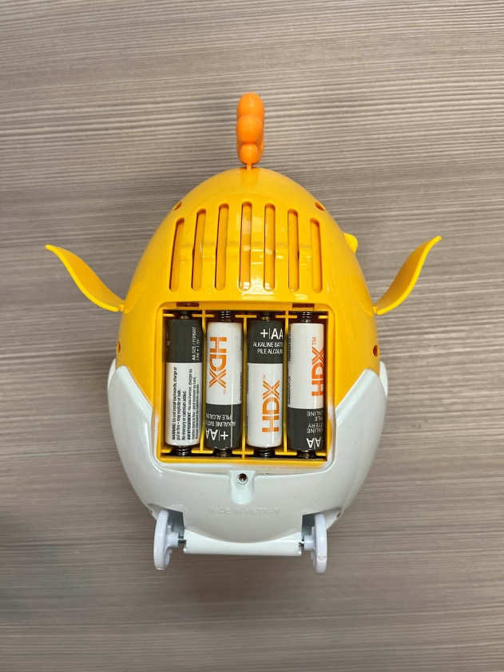
- Put the battery cover back on and secure it with a screw. | 
- You can check the toy again with an assistive switch to make sure it works once it is reassembled. If it does not work, check the connections inside. This includes looking at where wires may have been pinched when the toy was reassembled. | 

