Required Components
1. 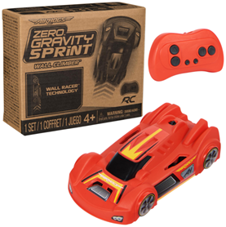 | 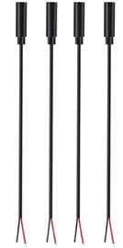  2. | BOM  - Air Hogs Zero Gravity Sprint RC Car  - (4x) 3.5 mm Female Mono Cable  - 3D Printed Cable Clamp  - (2x) #4 3/8” Screws  - (4x) Mini cable ties  - (2x) AAA Batteries  Refer to the Tool and Component List for purchasing details.
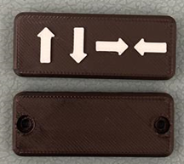  3. | 4.  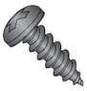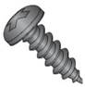 | 5.  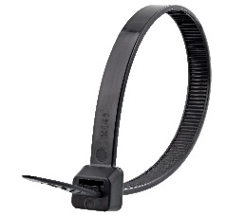
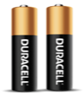

Required Tools
- Small Phillips Screwdriver 3mm Diameter
- Wire strippers
- Soldering iron and solder
- Drill and 1/8” drill bit

Required Personal Protective Equipment (PPE)
- Safety glasses

Assembly Instructions
- Carefully remove the car and controller from its packaging without damaging it (we will be repackaging the toy after adapting). Locate and remove the screws along the body of the controller.  *Note: keep screws in a safe place | 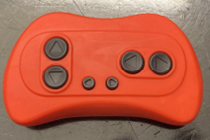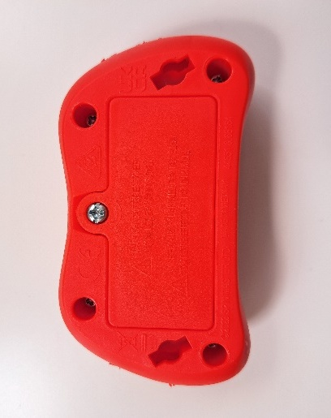
- Carefully separate the two halves of the toy. | 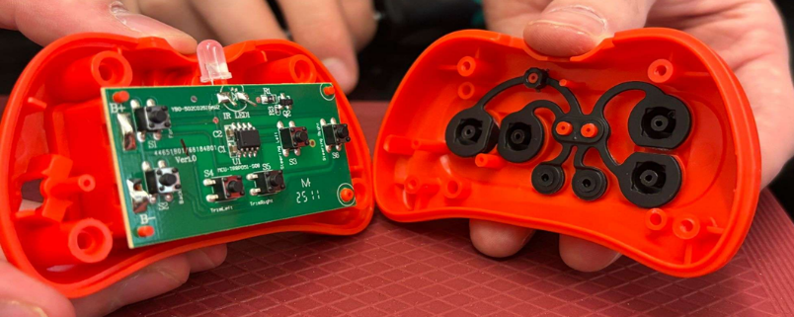
- To prepare the mono cable, use wire strippers to strip approximately 2 cm off the outer wire casing, revealing two internal wires. Repeat for all four mono cables.  Note: your mono cables may come prepped and ready to solder, with both wires revealed and metal on the ends exposed (skip steps 3-5). | 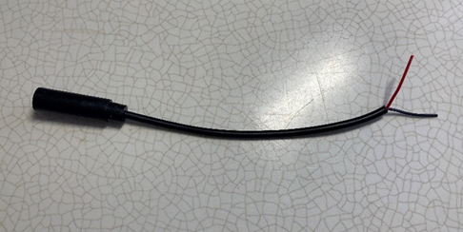
- If there are 2 internal wires, strip approximately 0.5 cm off each wire. | 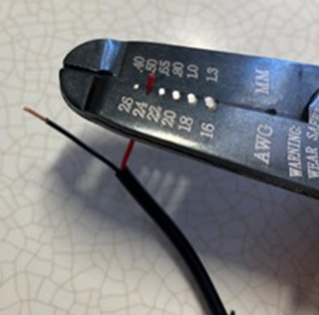
- Tin the other ends of the wires by adding a small amount of solder to each wire. | 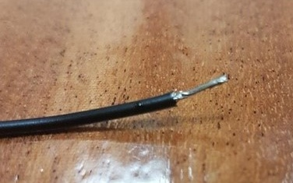
- Using a 1/8” drill bit, drill 4 holes in the top half of the case into the positions shown on the right. Remove any loose plastic. | 
- Insert the mono cables through the holes.  For each mono cable solder the two leads to the two matching circles shown on the image, on the bottom two contacts of each button. Make sure to not get solder on a prong that is not meant to be soldered. | 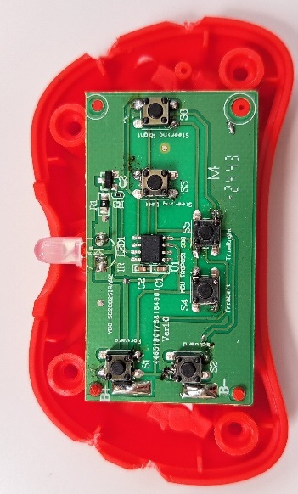
- When you have soldered all four cables, the PCB will look like this: | 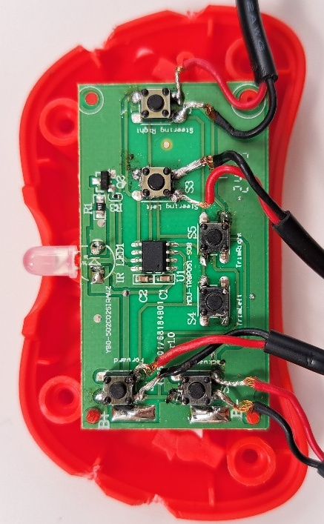
- Next, test the toy. Make sure both the remote and car have batteries inserted and that the car is turned on. Plug in an assistive switch. When you activate the switch, the car should perform the function of the button you soldered the cable to (Forward, Backward, Left, Right).  If the car does not move, make sure the batteries are pressed in fully and check the solder connections.  If the car does not stop moving when you release the switch, check the solder connections.  Repeat this for each cable. | 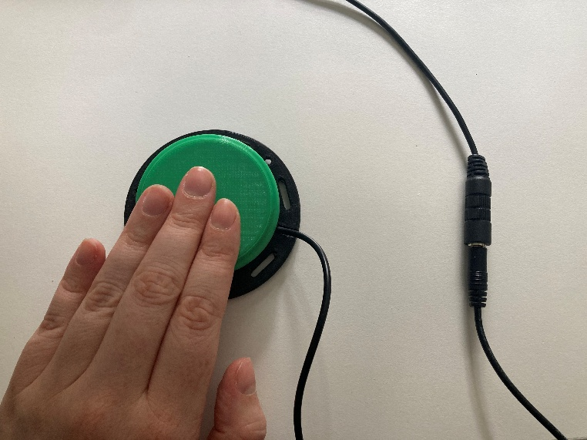
- Once the wires are connected, attach zip ties to the cable on the inside of the case as close as possible to where it enters.  Tighten the zip tie as much as you can and snip the excess zip tie.  The zip ties will serve as strain relief, so the soldered connections do not get pulled and break. | 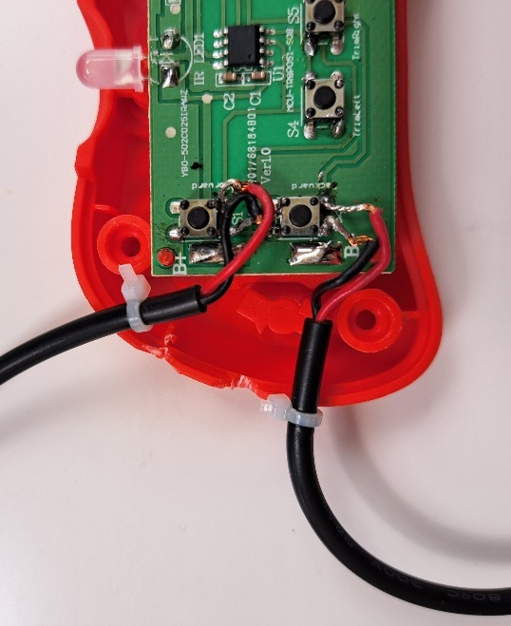
- Reassemble the toy using the screws set aside earlier. | 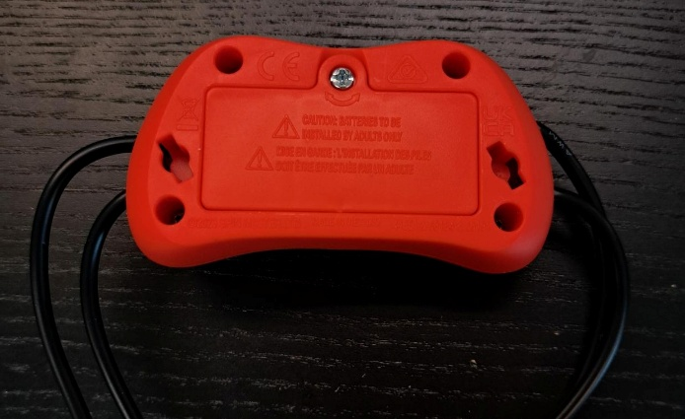
- Gather the mono cables, and put the cable clamp on, ensuring that each wire is lined up with the proper symbol on the clamp.  Insert the screws into the four holes on the back, and tighten to fasten the cable clamp. | 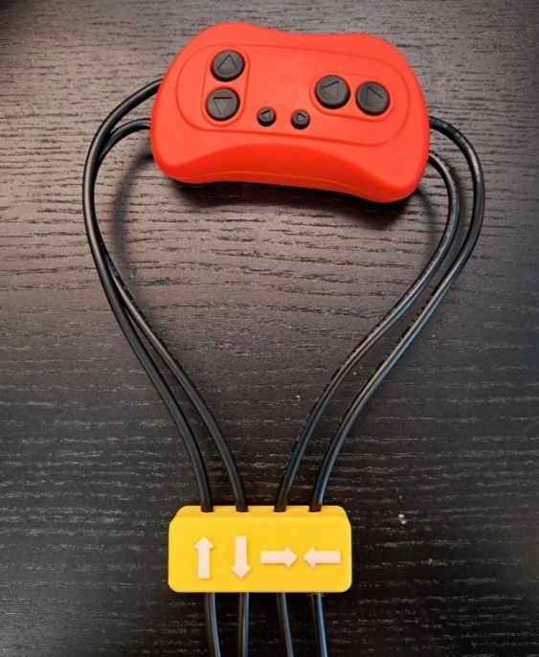
- Test the toy again. If it is still working properly, repackage the toy and the adapted toy is complete! | 