Required Components
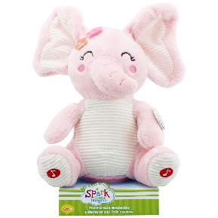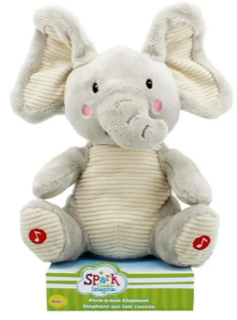 |  | 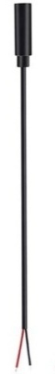 | BOM  - Spark Peek-a-Boo: Elephant, Pink Elephant, or Koala (Walmart)  - (2x) 3.5 mm Female Mono Cable  - Cable Tie (at least 25 cm)  - (2x) Small cable ties (10-15 cm)  - (3x) AA batteries (included with toy)  - Electrical Tape  Refer to the Tool and Component List for purchasing details.
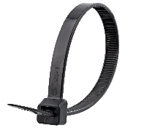 |  |  | 

Required Tools
- Phillips Screwdriver
- Wire strippers
- Soldering iron and solder
- Scissors
- Flush cutters
- Electrical Tape
- Hot Glue

Required Personal Protective Equipment (PPE)
- Safety glasses

Assembly Instructions
- Using scissors, carefully remove the toy from its packaging without damaging it.  (we will be repackaging the toy after adapting) | 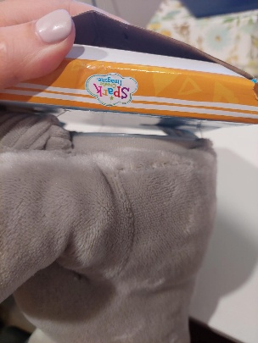
- Locate the thread at the back of the toy. Using scissors, cut the thread. Avoid cutting the fabric of the toy. | 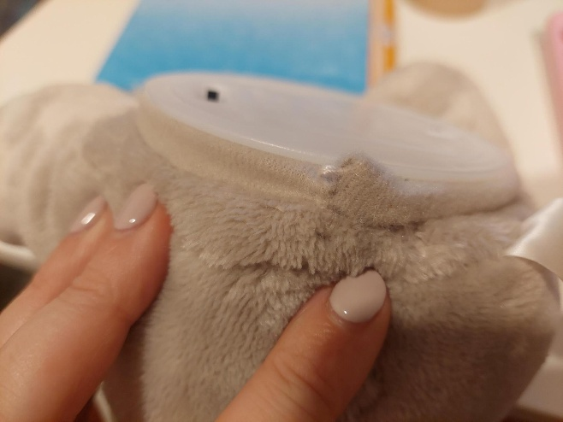
- Use flush cutters to remove the current cable tie and pull it through the fabric. Then pull the internal component out of the toy. | 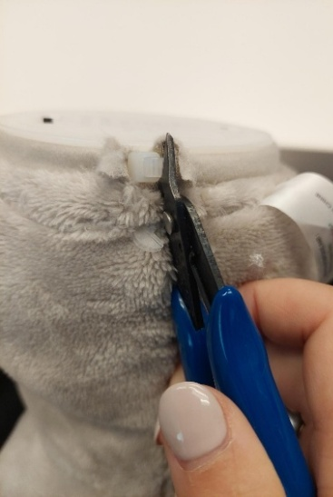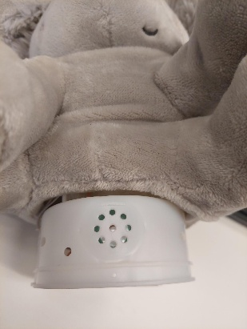
- Pull the white base out to reveal the white wires. | 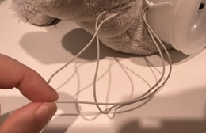
- Take the female mono cable and use wire strippers to strip approximately 2 cm off the outer wire casing, revealing two internal wires.  Skip this if the two internal wires are already showing. | 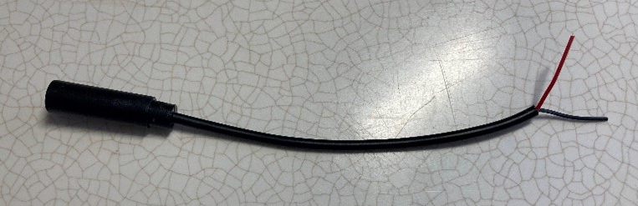
- If there are 2 internal wires, strip approximately 0.5 cm off each wire.  Skip this step if the internal wires have already been stripped, and the metal is exposed. | 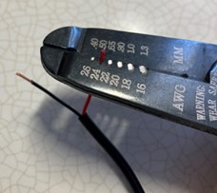
- If there are three internal wires (red, black, and exposed), strip off 0.5 cm of the red insulation and twist the red wire and exposed wire together. Strip 0.5 cm from the black wire. | 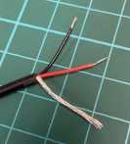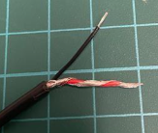
- Melt a small amount of solder over the exposed ends of the wire. | 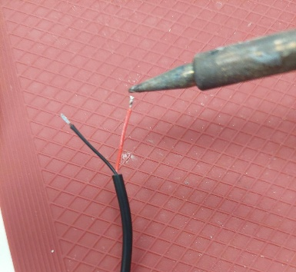
- Carefully cut one of the cables in half.  *Note: it’s important to cut only one wire at a time to ensure you do not mix up the cables when resoldering | 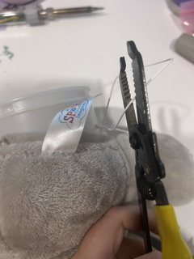
- Use wire strippers to strip away approximately 0.5 cm to reveal the wire and remove the white casing. Repeat on each side. | 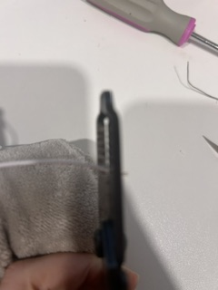
- Solder together the two stripped white wires and one of the wires from the female mono cable. | 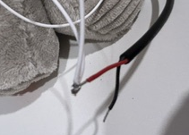
- Taking the other white wire that is coming out of the same side of the toy, repeat the process of cutting the second wire in half and use your wire strippers to remove 0.5 cm off each side. | 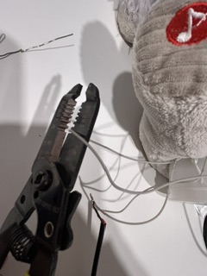
- Solder the two exposed wires together with the other wire from the female mono cable. | 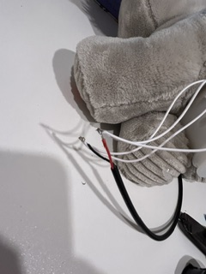
- It is now time to test the toy. Insert the batteries and plug in an assistive switch into the mono cable you just soldered. Keeping the two wires you just soldered apart, press the assistive switch, which should activate the toy.  Notes:  - If the toy does not turn on, check that the batteries work, and then check the soldered connections.  - If the toy continues to repeat when the switch is not pressed, check the connections for touching solder. | 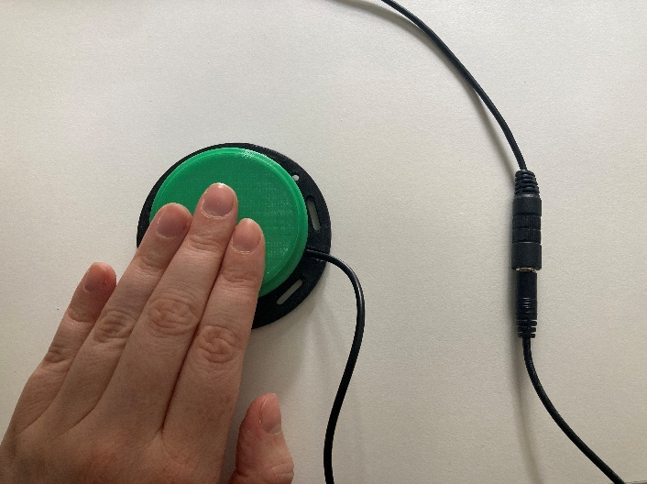
- Cover your exposed solder in hot glue and wrap electrical tape on the solder. | 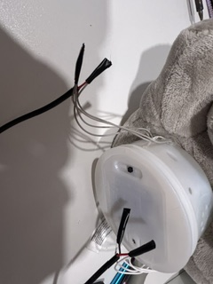
- Using a small cable tie, wrap around the female mono cable and the two white wires, for added strain relief. Ensure your cable tie is as tight as possible to protect your solder joints. | 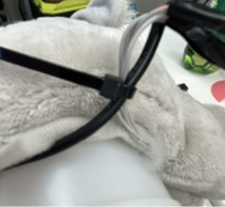
- Repeat steps 5 – 16 with the white wires coming out of the other side of the toy, that go to the toy’s second button.
- Reassemble the toy by ensuring all the cables and stuffing are pushed back inside the belly of the toy. | 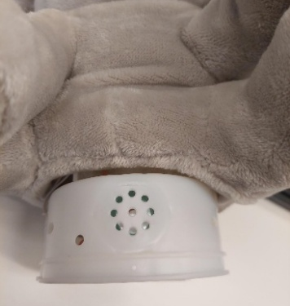
- Reposition the internal component inside the toy, with the fabric around it. Feed a new cable tie through the fabric and tighten, ensuring your two new cables of the toy come out this hole in the fabric and don’t interfere with how the toy sits. | 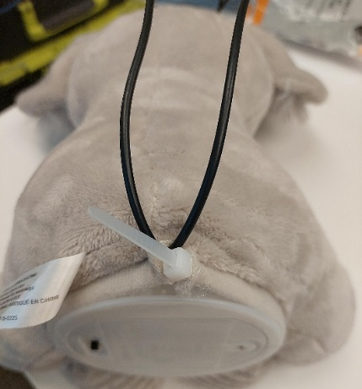
- Test the toy again. If it is still working properly, repackage the toy and the adapted toy is complete! | 