Required Components
   | 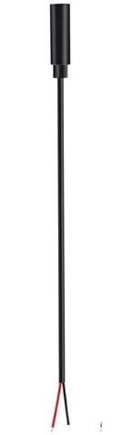 | 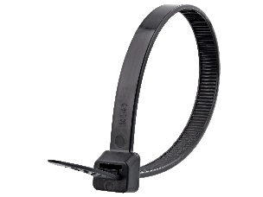  - 1 | BOM  - Fisher Price – Calming Vibes Hedgehog, Walrus, or Puppy Toy (Amazon, Walmart)  - 3.5mm mono cable with female jack  - Cable tie  Batteries included  Refer to the Tool and Component List for purchasing details.

Required Tools
- Phillip screwdriver
- Wire strippers
- Flush cutter
- Soldering iron and solder
- Drill and 1/8” drill bit

Required Personal Protective Equipment (PPE)
- Safety glasses

Assembly Instructions

- To start, pull the battery pack outside of the toy and remove the 2 screws noted in the photo. | 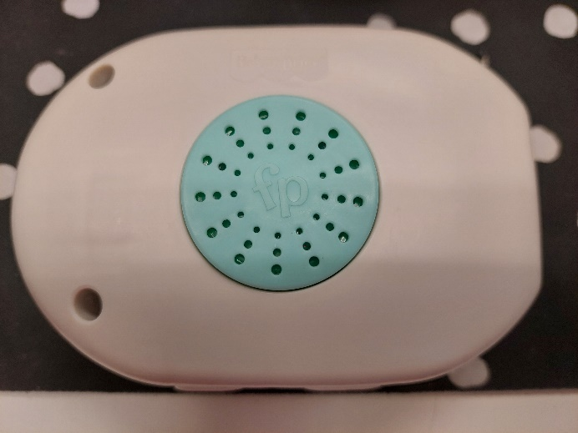
- Open the toy and set aside the blue piece. There are no screws holding it in place.  Note the motor is loose be cautious that everything is back in place before closing the toy | 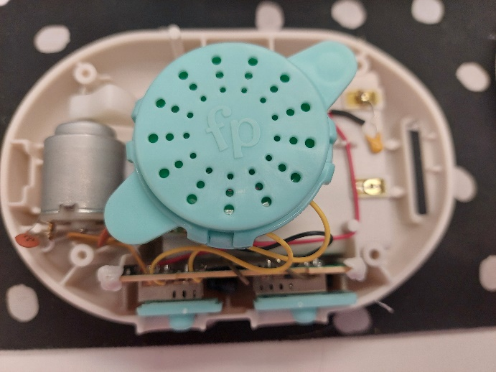
- Strip 2 cm off of the cable using a wire stripper, revealing 3 small wires inside. | 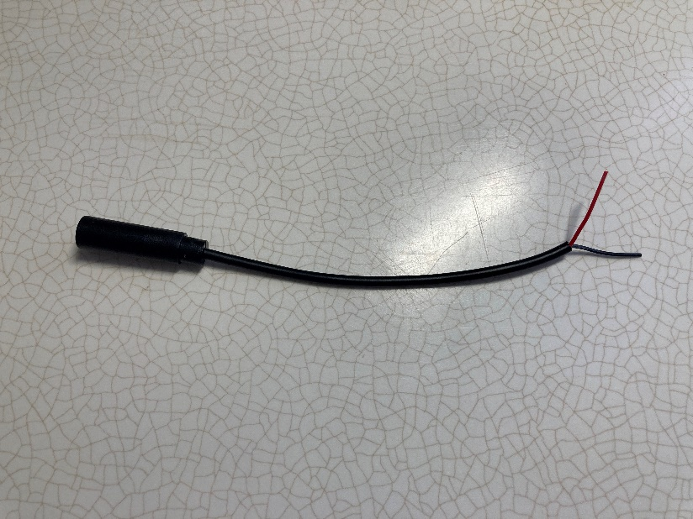  2 cm
- Strip approximately 0.5cm off of each of the small wires. | 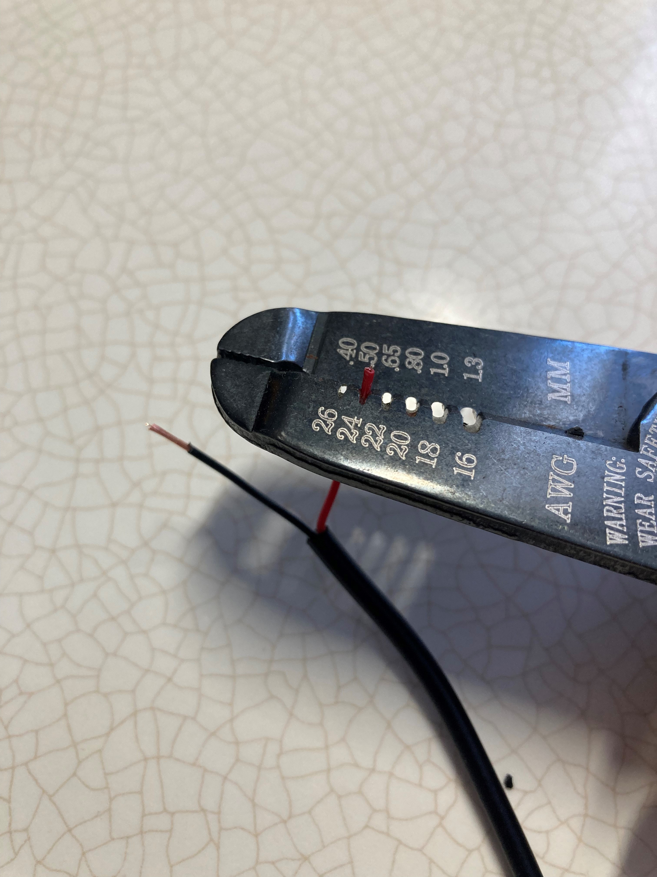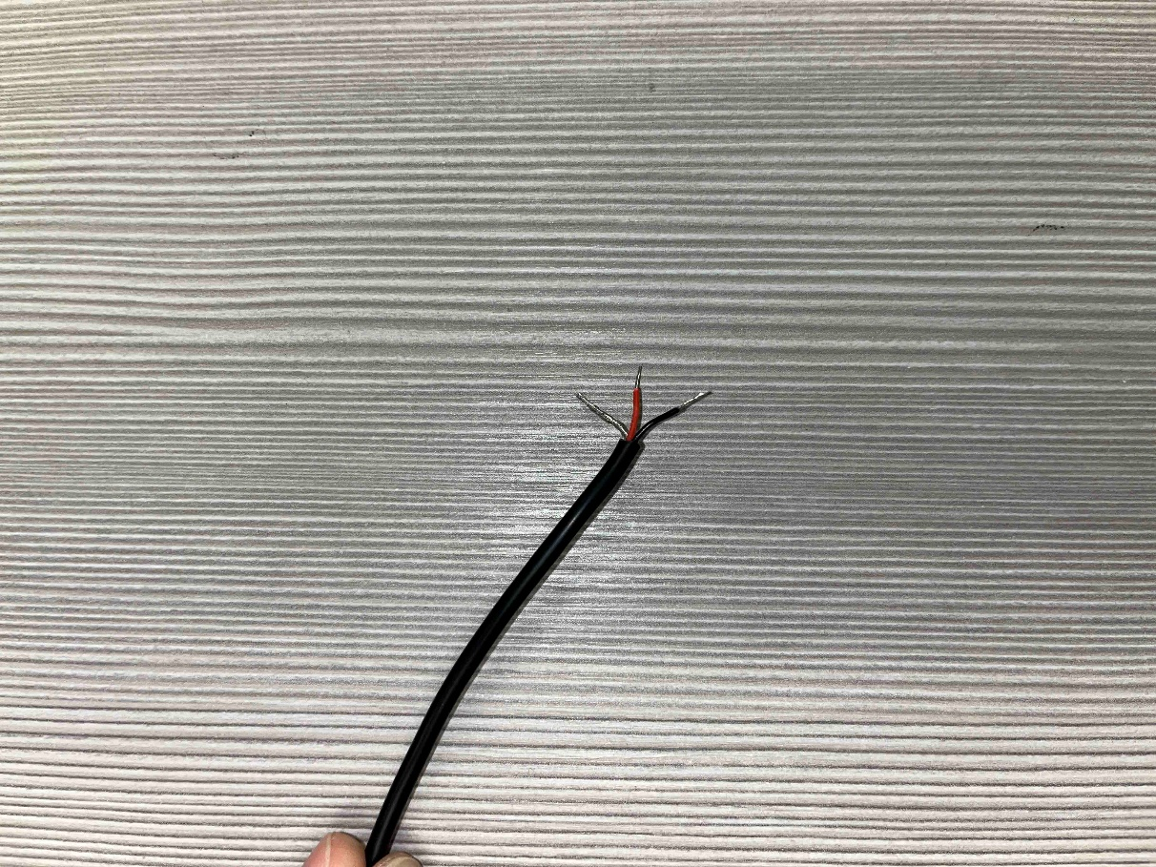
- Twist the bare wire and red wire together. | 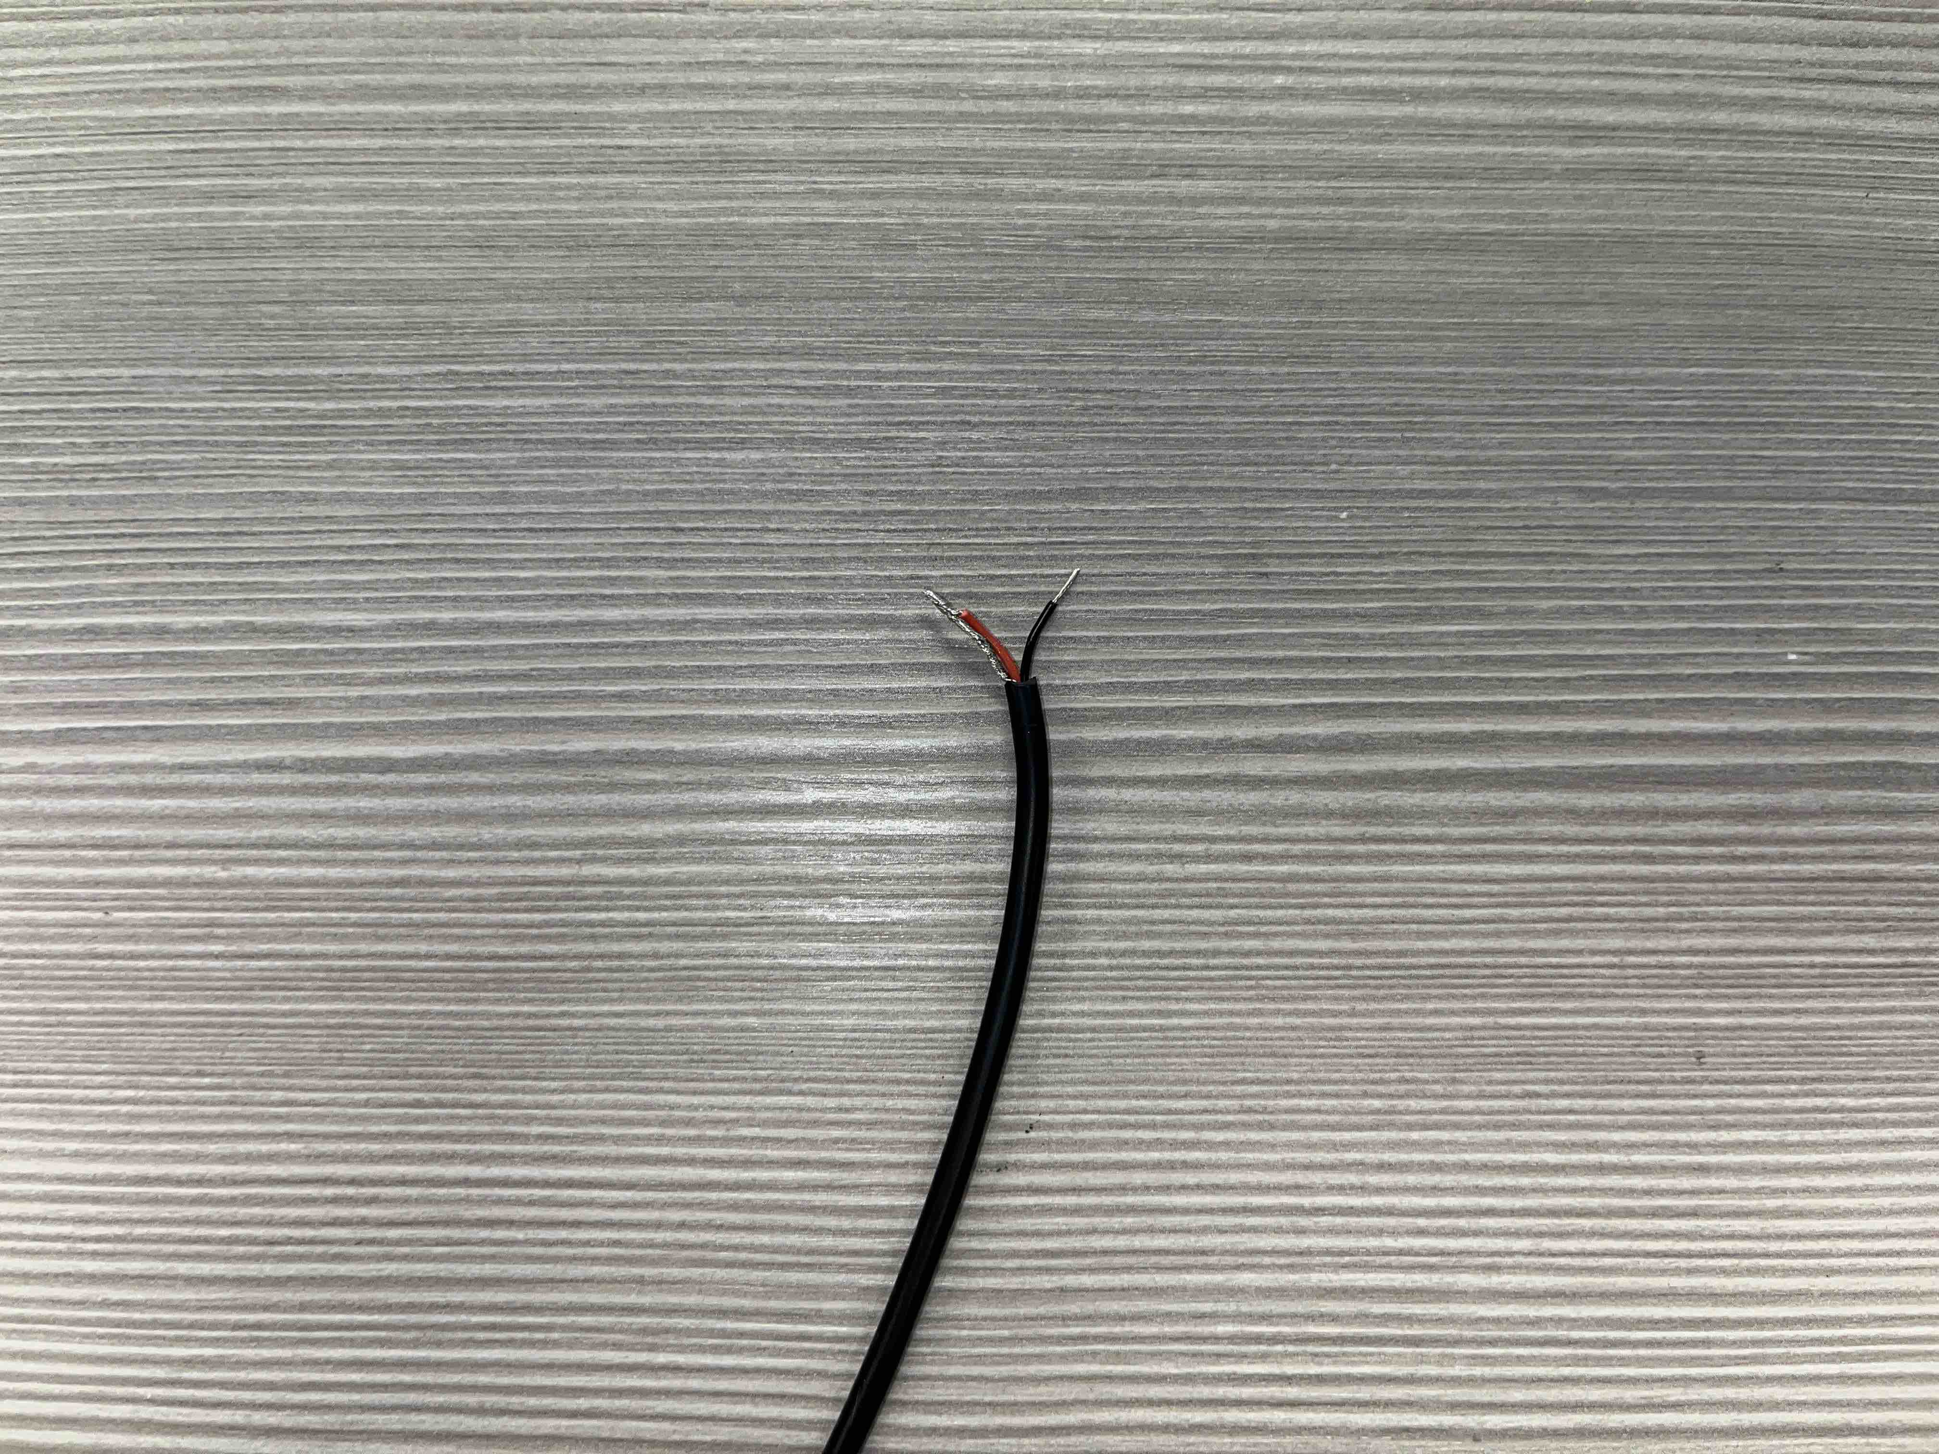
- Prior to soldering to the device, tin your wires. The best way to do this is cover the exposed wire end in solder. | 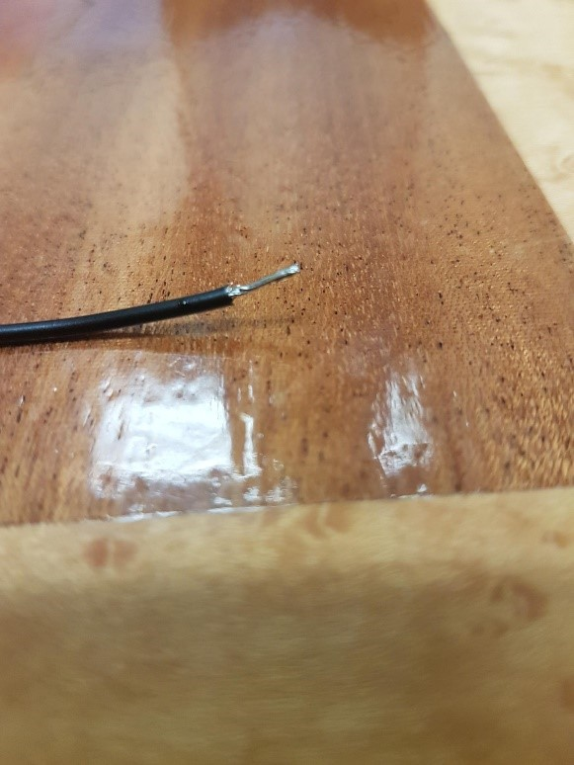
- Use the drill to make a hole in the toy casing.  Note: Choose a drilling spot that won’t interfere with the spinning plastic arm on the motor. | 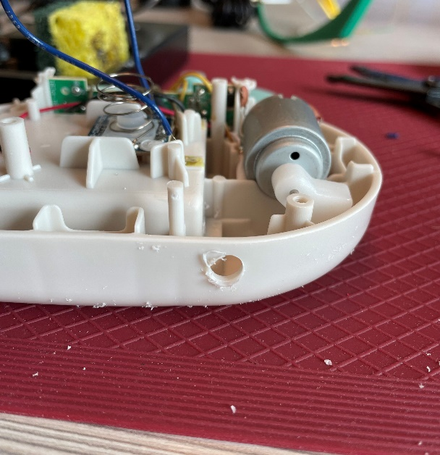
- Feed the stripped wire end of the cable into the white plastic case from the outside.  The female jack end will sit on the outside of the case when it’s put back together. | 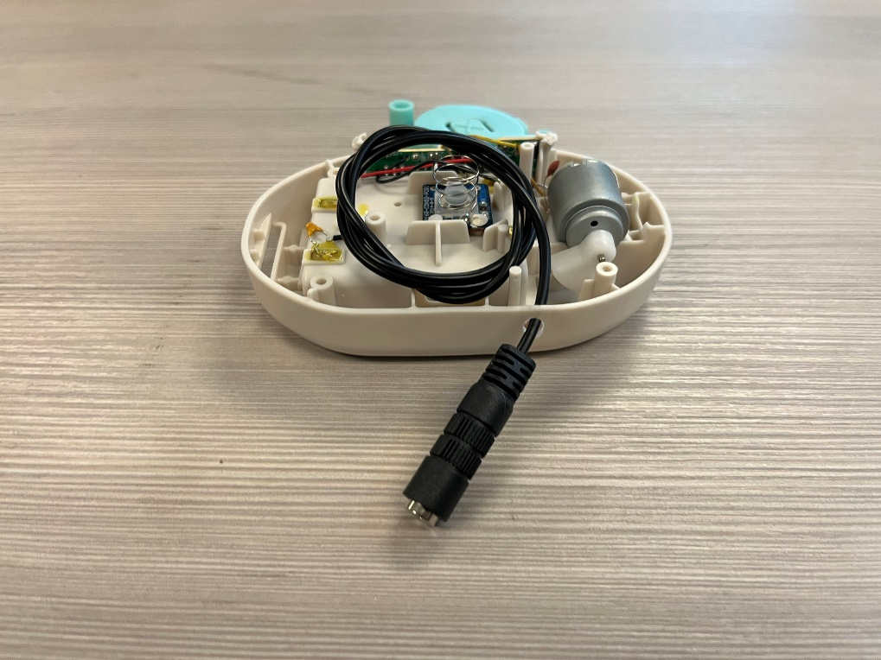
- Solder the first wire to one of the joints noted in red.  Solder the second wire the remaining joint on the board.  Note: Either wire will work. | 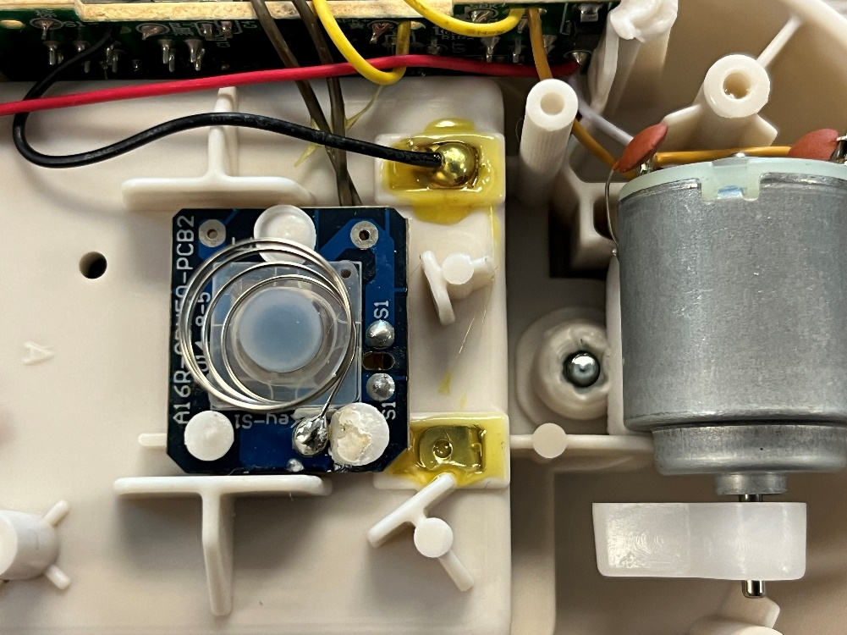
- Once the wire is connected, attach a zip tie to the cable on the inside of the white case as close as possible to where it enters.  Tighten the zip tie as much as you can and snip the excess zip tie.  This zip tie will serve as strain relieve. | 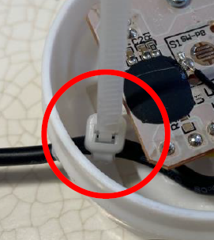
- Reassemble all materials into the toy. Using the screw driver, put the two screws back into the toy.  Note: Ensure nothing is in the way of the white spinning component off the motor. | 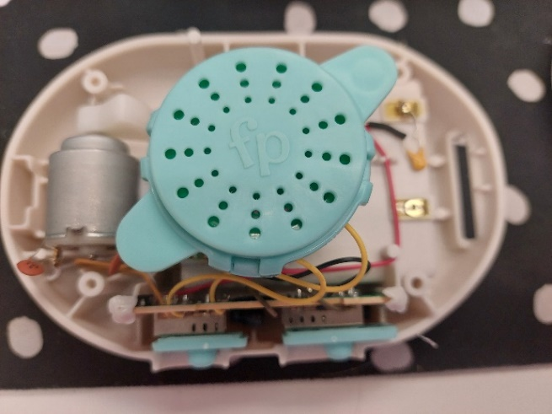
- Test the toy with an assistive switch. | 