Required Components
 | 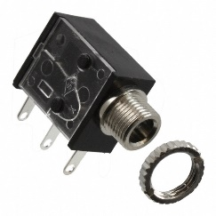 | BOM  - Fubbles Light-Up Mini Bubble Machine  - 3.5mm Mono Jack and Ring  - 22 AWG Wire  - 3 AA Batteries  Refer to the Tool and Component List for purchasing details.
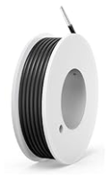 | 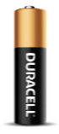

Required Tools
- Phillip screwdriver
- Ruler
- Wire strippers
- Soldering iron and solder
- Drill and ¼” drill bit

Required Personal Protective Equipment (PPE)
- Safety glasses

Assembly Instructions
- Carefully remove the toy from its packaging without damaging it. Locate and remove the 4 screws from the bottom of the toy. Separate the toy into two halves. | 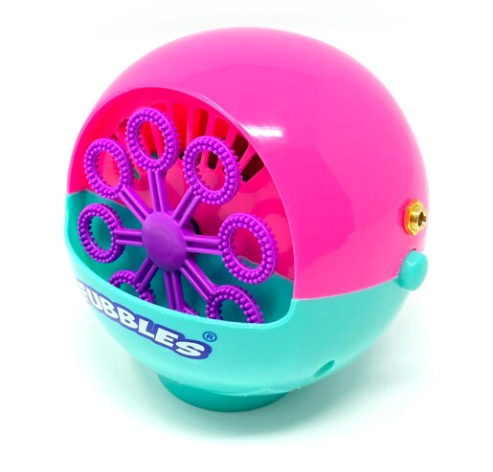
- Remove the motor from the base. | 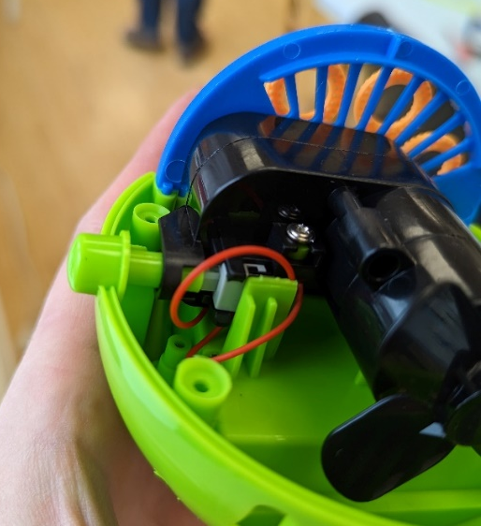
- Cut both the red wires using wire cutters. | 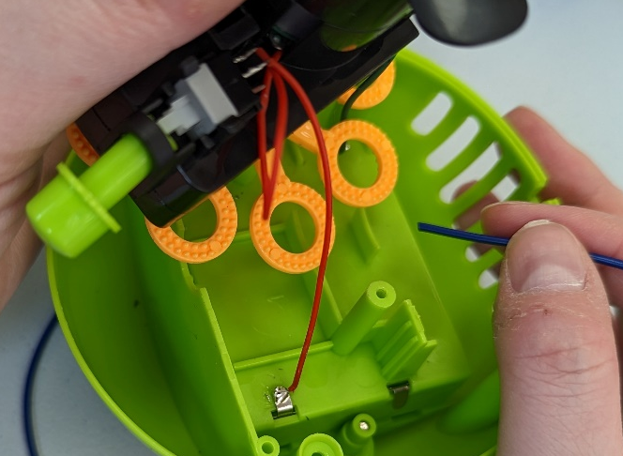
- Cut 2 pieces of wire, each approximately 4 cm long. | 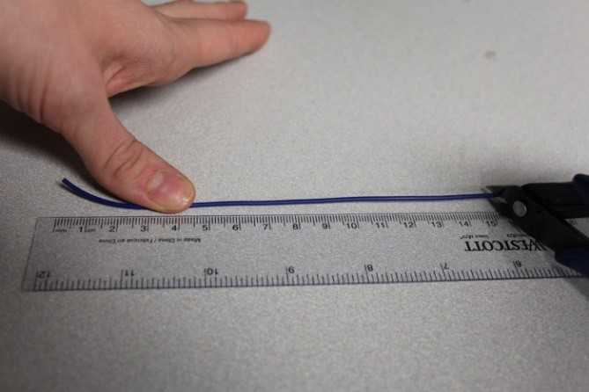
- Strip approximately 0.5cm off the end of each wire. | 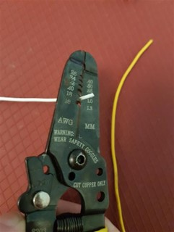
- Solder the two wires onto the front two tabs on the mono jack. | 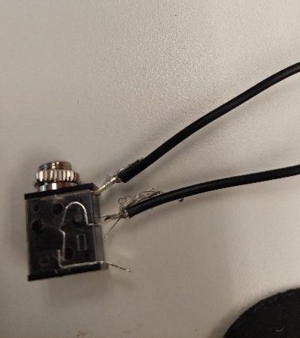
- Tin the other two ends of the wires by adding a small amount of solder to each wire. | 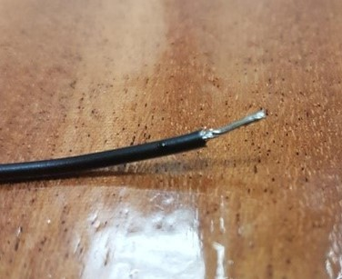
- To ‘close the loop,’ solder a wire to an existing red wire and solder the second wire to the second red wire. | 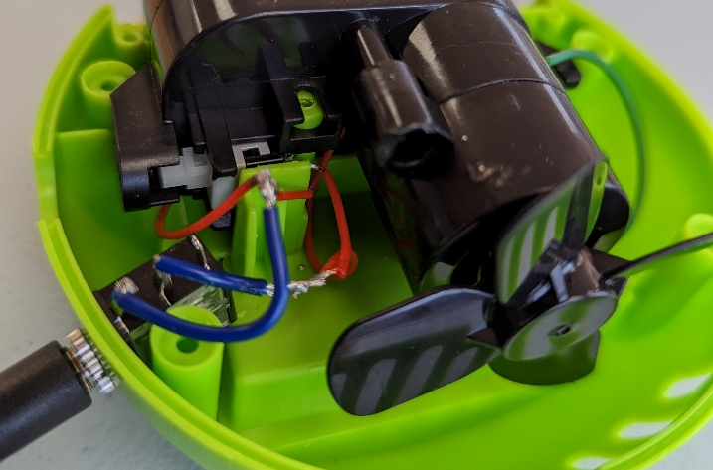
- Using a ¼” drill bit, drill a hole into the side of the toy. Remove any loose plastic.  Secure the mono jack to the case by screwing on the mono jack ring from the outside. | 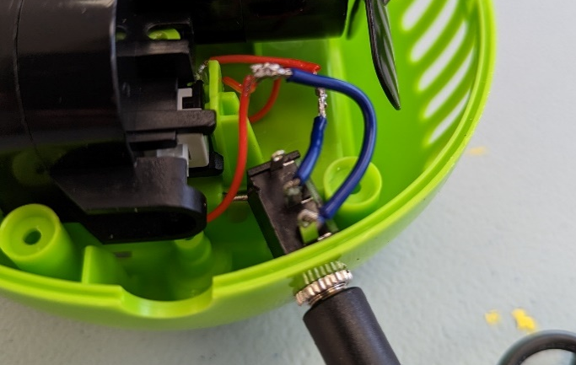
- Test the toy by installing batteries and plugging an assistive switch into the mono jack.  Note: If the toy does not turn on, please check the soldered connections. | 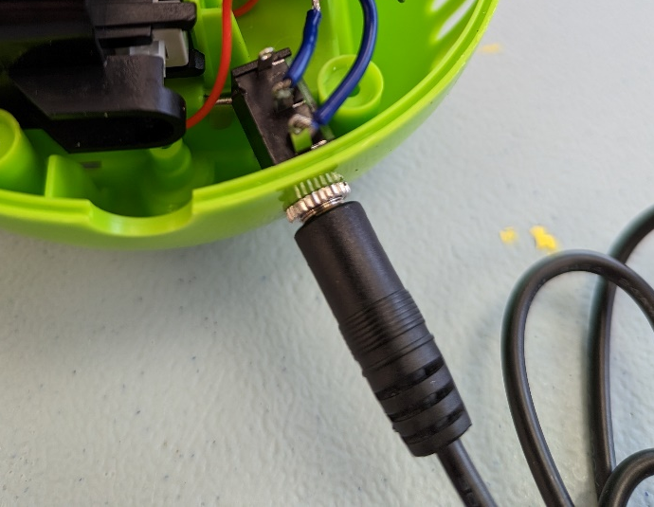
- Reassemble the toy by placing the motor back and reattaching the toy shell.  Re-test the toy with the assistive switch. If it still works properly, re-install the toy into its original packaging. | 