Required Components
 | 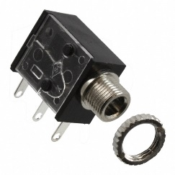 | BOM  - Gazillion Hurricane Bubble Machine  - 3.5 mm Mono Jack and Ring  - 22 AWG Wire  - 6 AA Batteries  Refer to the Tool and Component List for purchasing details.
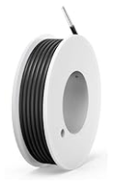 | 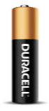

Required Tools
- Triangle screwdriver
- Ruler
- Wire strippers
- Soldering iron and solder
- Drill and 1/4” drill bit

Required Personal Protective Equipment (PPE)
- Safety glasses

Step 1: Partially Unbox the Gazillion  Open the top of the box, but keep the toy on the cardboard base. This will make it easier to reassemble after modification | 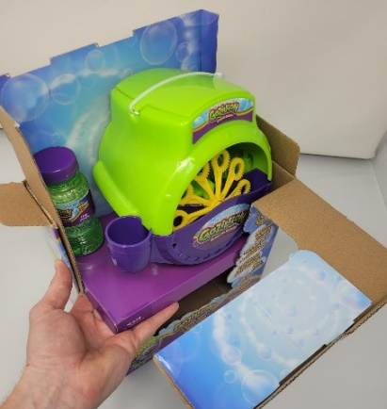
Step 2: Cut the Battery Cover Nylon Strap  Using the flush cutters cut the nylon strap, and discard it.  Set the Battery cover aside. | 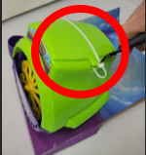
Step 3: Open the Battery Case  Make sure to keep the screws together. | 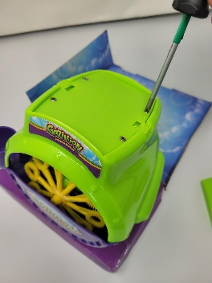
Step 4: Remove The Battery Tray  Using the 2 mm Triangle Screwdriver (or 2.4 Flathead screwdriver) unscrew the 4 screws holding the battery tray in place.  Be careful not to break the wires  attached to the back of the battery tray. | 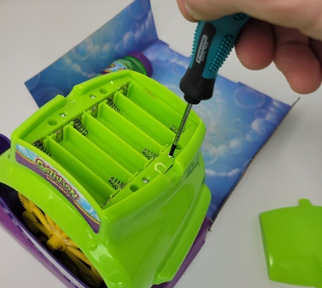
Step 5: Remove the Switch  Lift the switch out of the toy, and using the flush cutters, cut the wires | 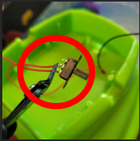
Step 6: Strip the Wires  Using the wire strippers, strip the insulation from the switch leads so about 1 cm of the metal wire is exposed. | 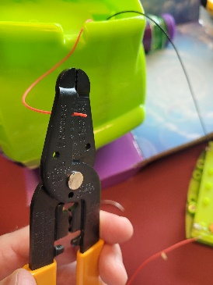
Step 7: Solder the Wires to the Switch Jack  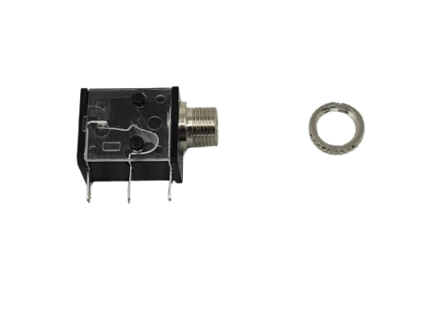  Solder the wires to the 2 legs closest to the threaded end. | 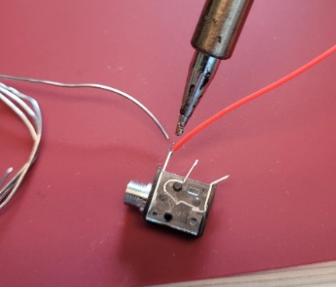
Step 8: Test the Toy  Insert batteries into the Battery Tray and insert a switch into the Mono Jack  Press the Switch: You should hear the motor turn on  Remove the batteries and the switch | 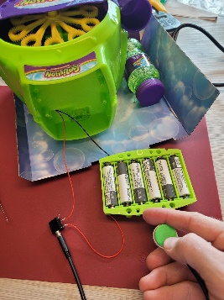
Step 9: Insert Jack into Switch Hole  Insert the mono jack into the hole where the switch was originally located. Use flush cutters to clear any plastic that might block the jack. | 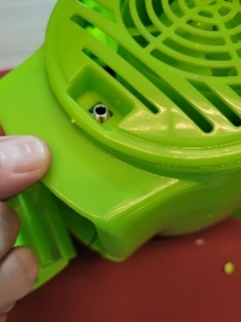
Step 10: Install the Jack Nut  Using the edge of a flathead screwdriver turn the nut until tight. Use the slots cut into the Jack Nut to tighten. | 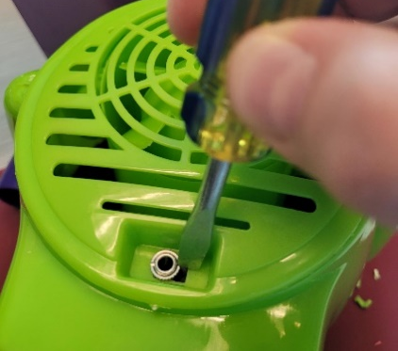
Step 11: Install the Battery Tray  Using the 2 mm Triangle Screwdriver (or 2.4 Flathead screwdriver), install the battery tray screws | 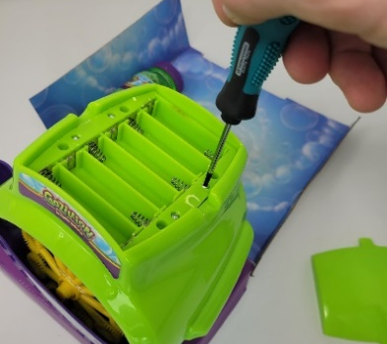
Step 12: Install the Batteries and Battery Cover | 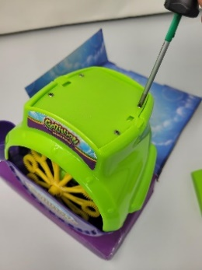
Step 13: Replace & Tape the Top Cover  Place a strip of electrical across the Top Cover to keep in place during shipping.  This also helps us know that the toy is ready for delivery. | 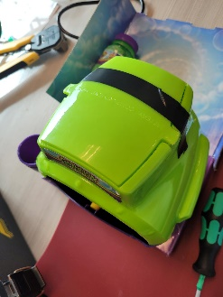
Step 14: Replace it in the Box  Carefully re-box the toy into its original packaging, and secure the top flap with Clear Tape. | 