Required Components
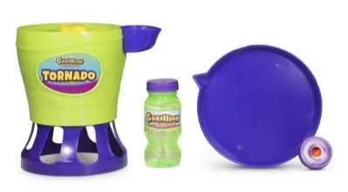 | 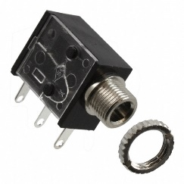 | BOM  - Gazillion Tornado Bubble Machine  - 3.5 mm Mono Jack and Nut  - 22 AWG Wire  - 4 AA Batteries  Refer to the Tool and Component List for purchasing details.
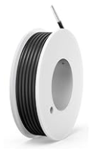 | 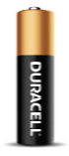

Required Tools
- Narrow flat headed screwdriver (the screws are triangle, but a flat head should work)
- Ruler
- Wire Strippers
- Flush Cutters
- Soldering iron and solder
- Drill with ¼” drill bit
- Hot glue gun

Required Personal Protective Equipment (PPE)
- Safety Glasses

Assembly Instructions

Step 1
Carefully take the bubble machine out of the box without damaging it. The toy will be put back in the packaging once adapted.
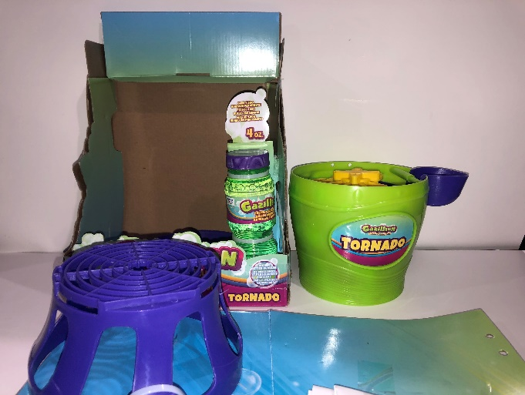

Step 2
Remove and set aside the 5 screws from the sides of the bubble blower. There are two on the other side not shown in the picture.
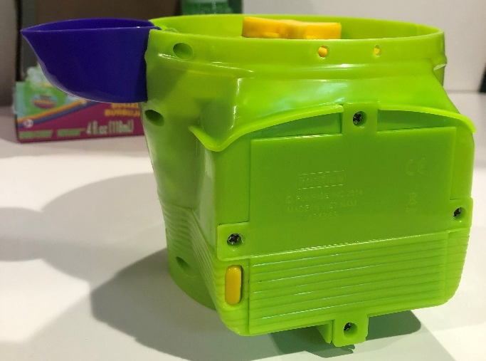

Step 3
Separate the two halves of the outside of the bubble blower and set the front half aside.
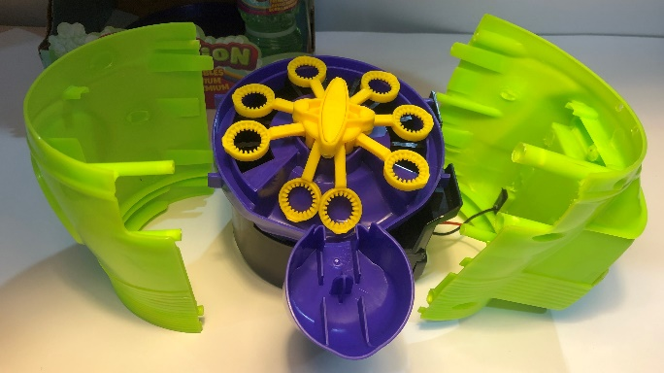

Step 4
Locate the switch.
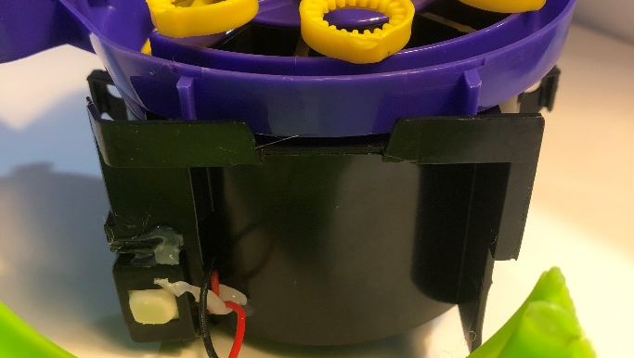

Step 5
Gently wiggle the switch and slide it downward until it is free.
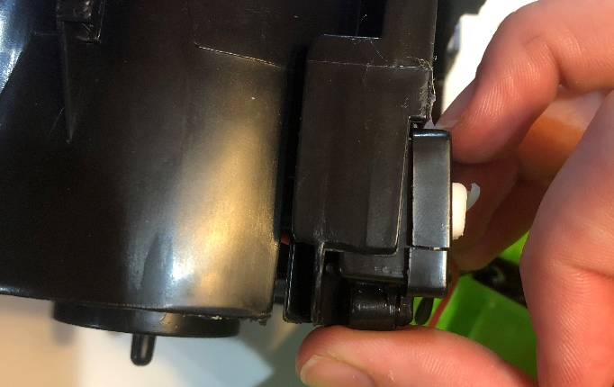

Step 6
Lay the bubble blower on its side.
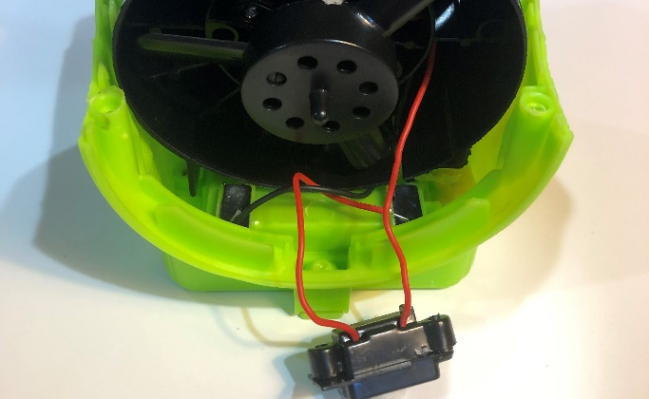

Step 7
Cut 2 pieces of wire 8 cm long. Use wire strippers to strip 1cm off each end of the wires.
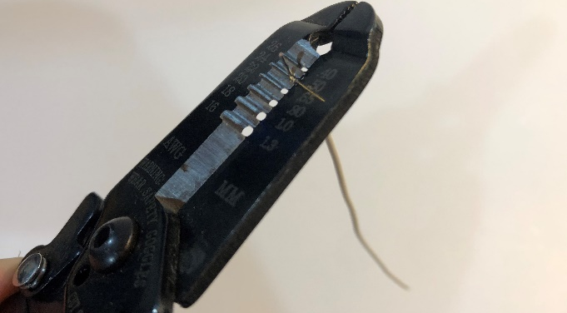

Step 8
Locate the two red wires. Carefully cut a small slit in the one shown above. You can peel off the rubber as needed.
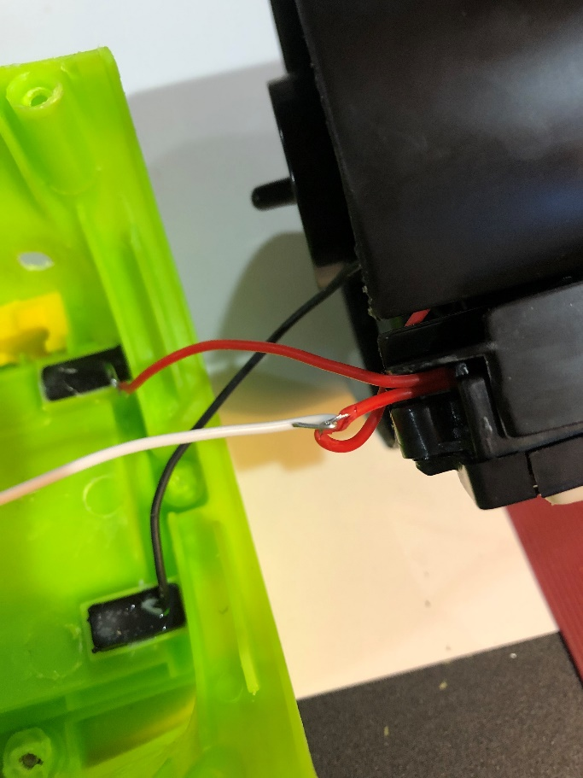

Step 9
Next, wrap one of the new wires around the newly exposed wire and solder them together. Once cooled, add tape over the joint.

Step 10
Solder one end of your second wire to the same location as this red wire shown below.

Step 11
Slide the switch back in the holder.

Step 12
Insert the yellow button back into the back of the machine.
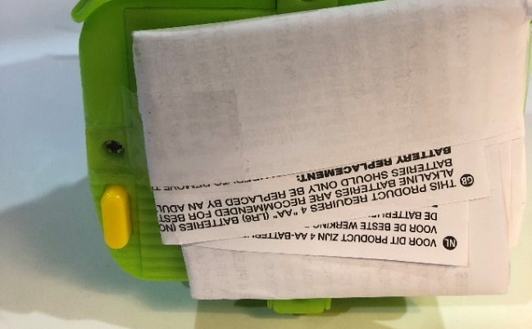

Step 13
Reattach the back green half of the bubble machine.
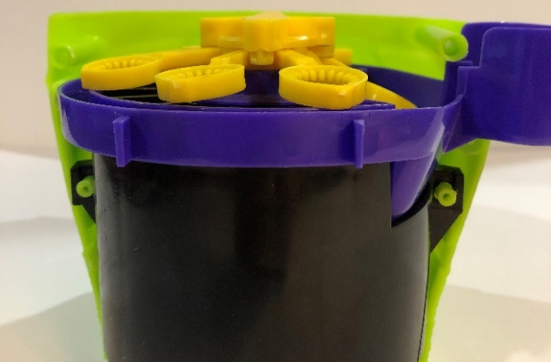

Step 14
Glue the previously existing red and black wires to the wall to keep them out of the way.
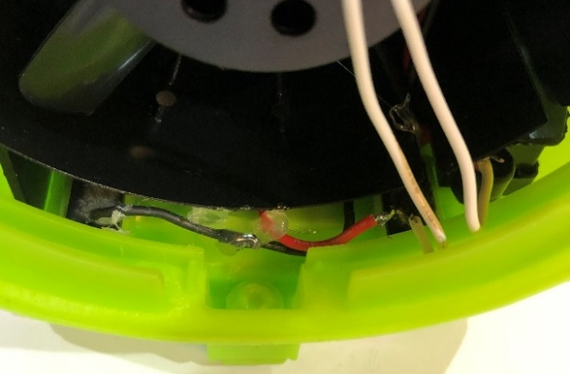

Step 15
Reattach the purple base. Once aligned, feed the two wires through the base.
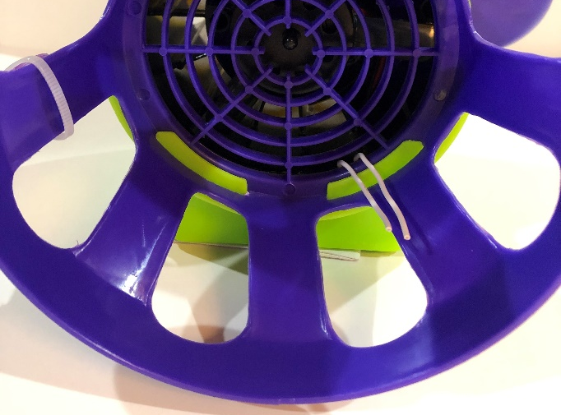

Step 16
Solder the two wires onto the two legs of the jack closest to the mono jack hole.
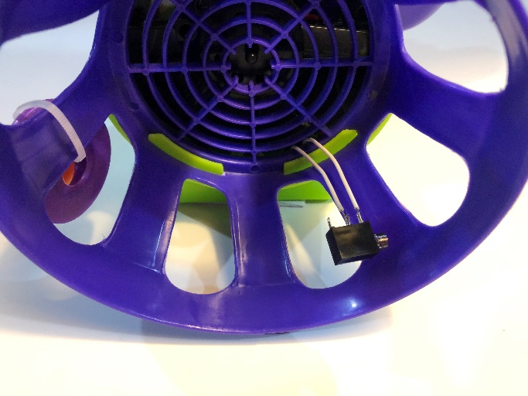

Step 17
Using a 1/4" drill bit, drill a hole in the base that can be reached by the mono jack. Cut away any loose plastic.
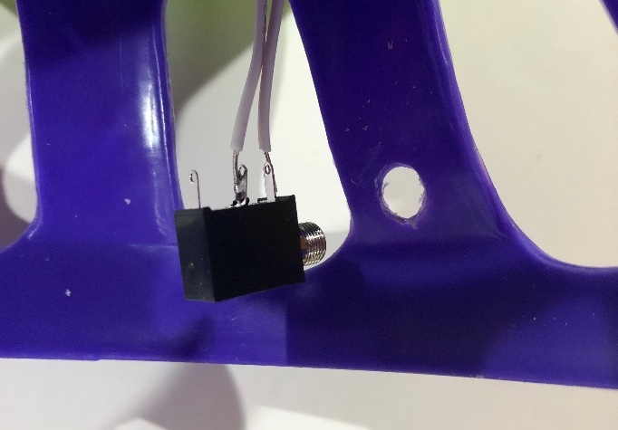

Step 18
Remove the nut from the mono jack and push the mono jack through the hole. Reinstall the nut and tighten to secure.
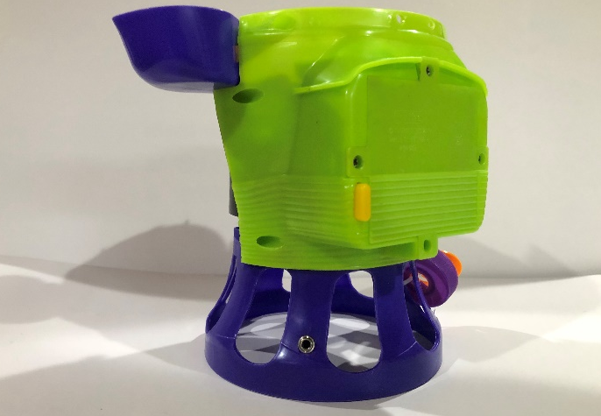

Step 19
Glue wires to the leg of the stand.
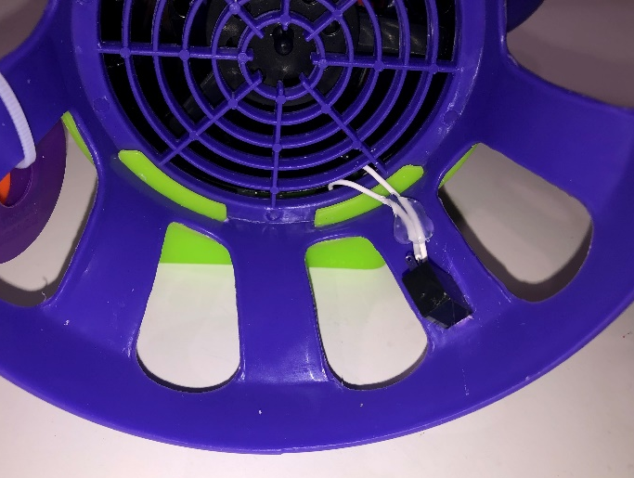

Step 20
Reattach the front side of the bubble machine using the 5 screws.

Step 21
Remove 4 screws on the back of the machine to add 4 AA batteries. Then put the screws back in.
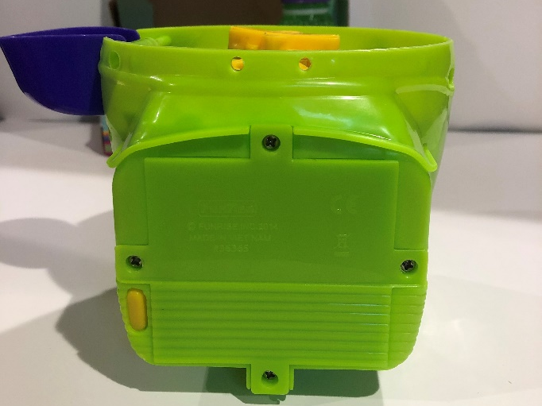

Step 22
Test the bubble blower. Then, repackage the device.
