Required Components
 | 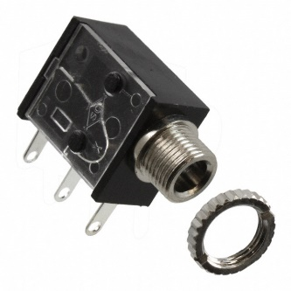 | BOM  - Little Kids - CoComelon Musical Bubble Machine  - 3.5 mm Mono Jack  - 22 AWG Wire  - 3 AA Batteries  Refer to the Tool and Component List for purchasing details.
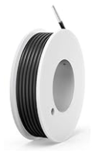 |   

Required Tools
- Phillips Screwdriver
- Soldering iron
- Wire stripper
- Flush cutter
- Drill and ¼ drill bit

Required Personal Protective Equipment (PPE)
- Safety Glasses

Assembly Instructions

Step 1
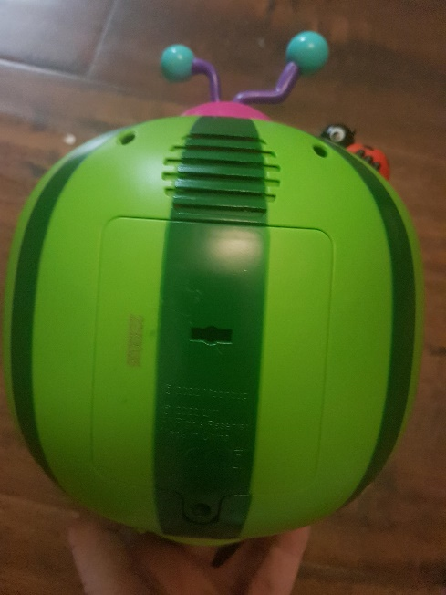 | - Carefully remove toy from cardboard, the toy will be put back in cardboard (if possible) after it is adapted  - Utilizing a screwdriver, turns screws indicated in the red circles to open the toy.  - Set screws aside in a safe place

Step 2
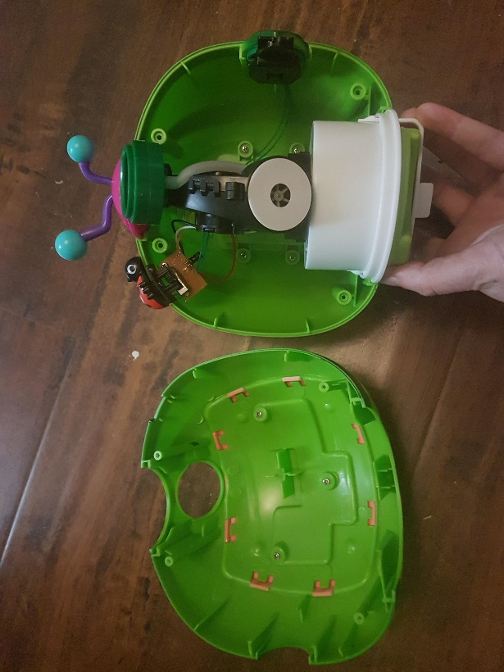 | - After screws are undone, gently pull the melon into two halves. Be very careful while doing this as to not pull off any existing wires or connections  - If some pieces move, like the speaker or ladybug, just take notes of how everything fits together but they can also be set aside while you work on the toy.

Step 3
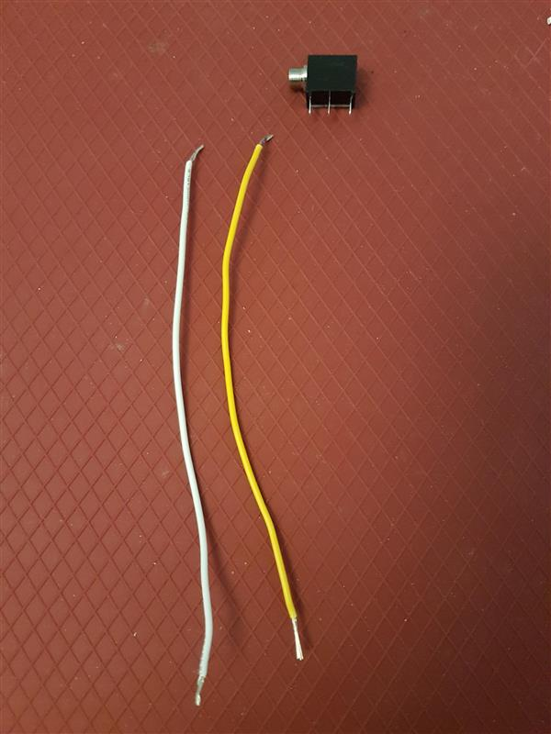  5 cm | Next we will prepare the mono jack and wires.  Cut 2 pieces of wire each 5 cms in length  Strip both ends of both wires, leaving about .5 cm of exposed wire on each end | 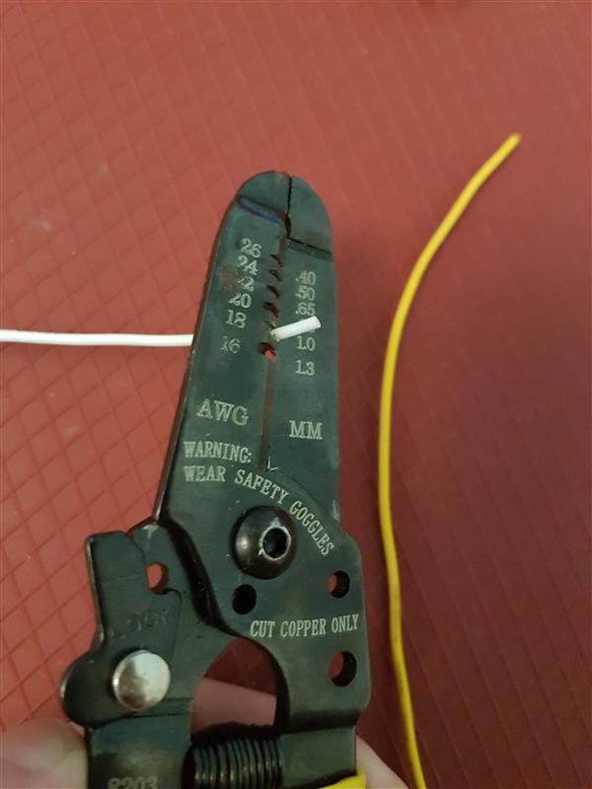

Step 4
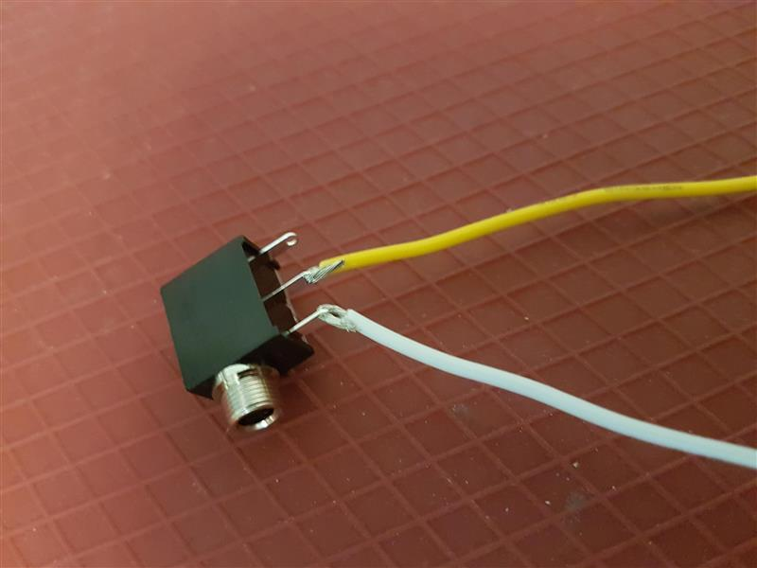 | - Pick one wire, slide exposed wire into first metal arm on mono jack  - With second wire, slide one end of exposed wire into the middle metal arm on mono jack  - Solder wire to mono jack  Please Note: Check that you have the correct metal arms of mono jack, refer to picture

Step 5
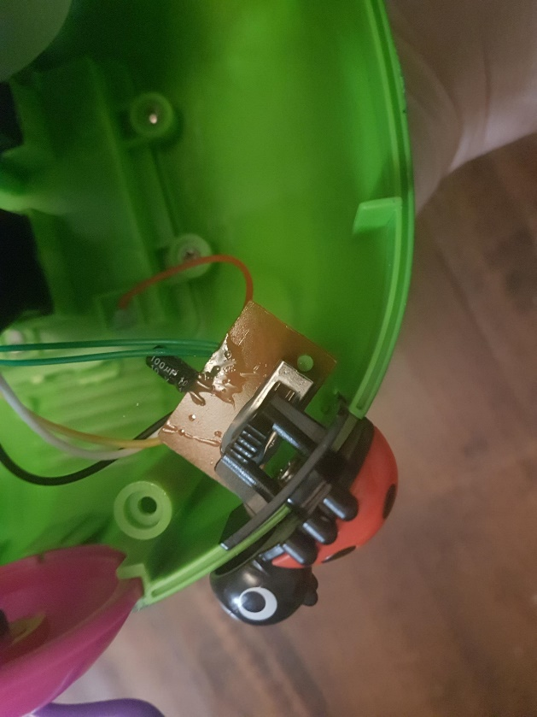 | - Locate where the switch is located. The ladybug can be removed. There is a small screw, circled in red, holding the board down. Remove screw and set aside in safe place.

Step 6
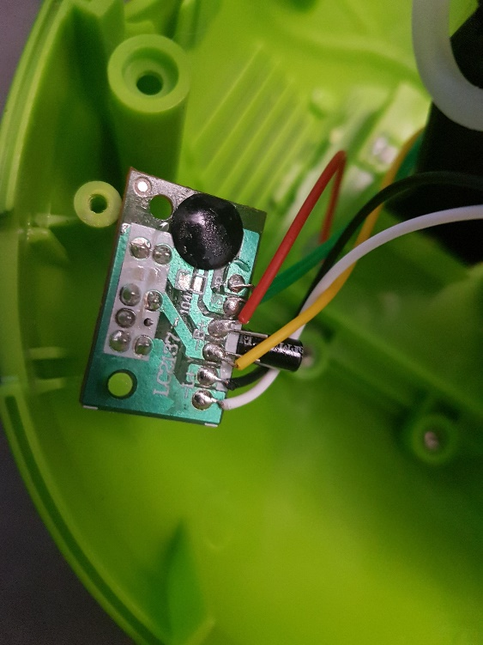 | - With the screw removed, the board can be flipped over to show the wires and solder joints. To hold the board in place while you work, you can the slide the board onto the post indicated by the arrow.  - Locate the red wire on the board. This wire goes from the board to the battery compartment

Step 7
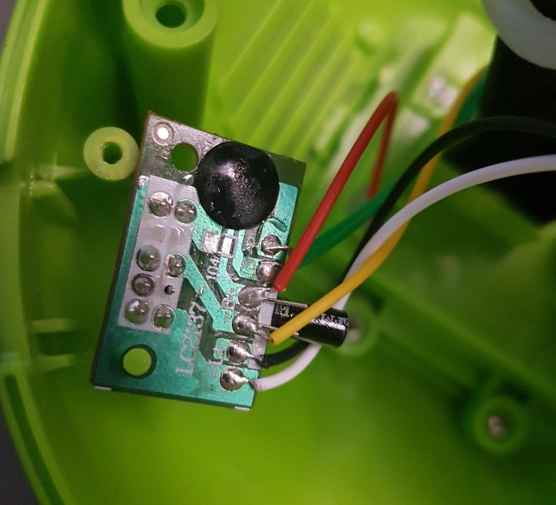 | - You are going to remove the red wire from the board – but only the red wire  - You will use your soldering iron to heat up on the solder on that spot, and then gently pull the red wire from that spot.

Step 8
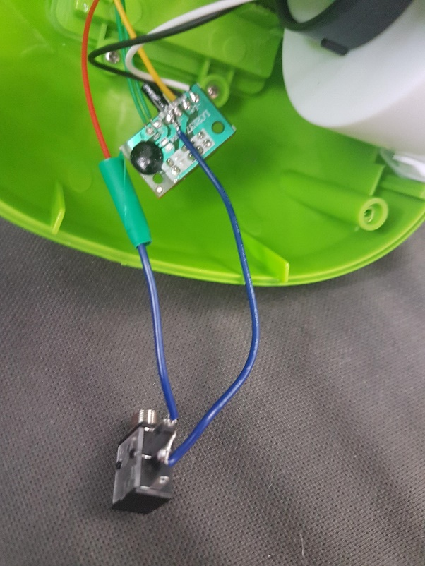 | - Using the mono jack and wires you previously made, solder one wire to the red wire that you just removed from the circuit board. The red wire will now be connected one of the new wires which leads to the mono jack.  - Once the wires are soldered, wrap electrical tape around the area where the wires are now connected. This will just help secure the connection

Step 9
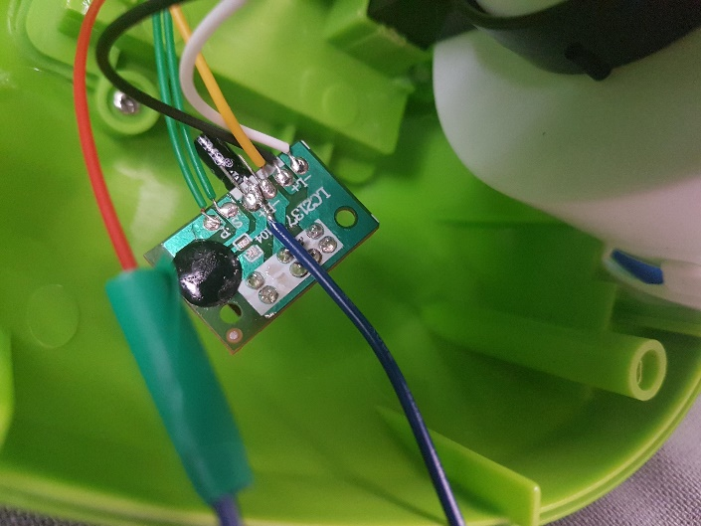 | - Using the previous prepared mono jack and wires, connect the second wire (the first one was connected to the red wire) to the spot on the board where the red wire was previously  - To solder the wire to the board, you may want to first add solder to the exposed part of the wire. Then, you will hold the wire on the connection point and use the soldering iron to heat up the solder that is already there  - Once both wires are connected, you can also check the connections by using an assistive switch to test. Plug the switch into the input, slide the original switch to either music, or music + bubbles. The toy will be activated when the switch is pushed.

Step 10
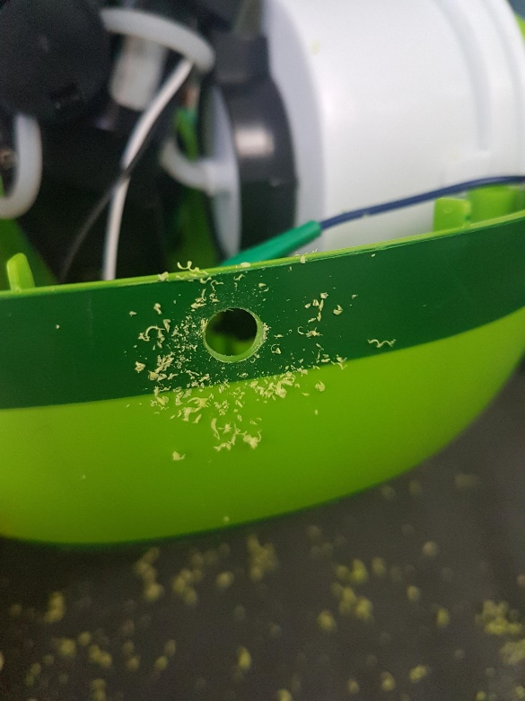 | - With ¼ inch drill bit, you will drill hole in the plastic of the toy. This is so the mono jack, or input, can be accessed and a switch can be plugged it.  - Before drilling, make sure your mono jack will reach the drilled hole. The hole can be drilled about 2 cms below where the original switch is on the side of the toy  - Check that mono jack out end can fit through the hole to be accessed from outside

Step 11
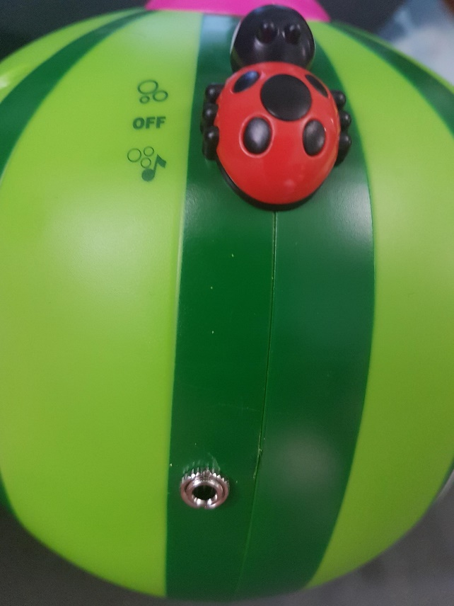 | - Twist ring onto input on the outside of lamp to secure the mono jack in place  - You will now reassemble the toy  - The circuit board can now be screwed back in it’s original spot  - Make sure to add the lady bug in it’s original spot. Check that the sliding function still works.  - With everything in place, put the two halves of the toy together and add screws.

Step 12
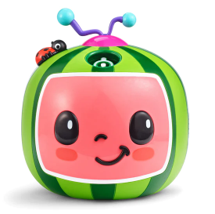 | - You can check the toy again to make sure it works with an assistive switch once it is reassembled. If it does not check connections inside – this includes looking at where wires may have be pinched when the toy is reassembled.

