Required Components
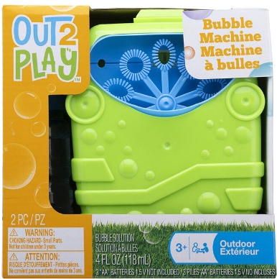 | 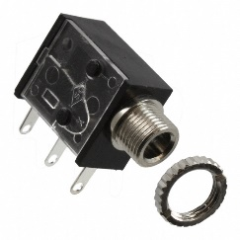 | BOM  - Out 2 Play Bubble Machine  - 3.5 mm Mono Jack and Nut  - 22 AWG Wire  - 3 AA Batteries  Refer to the Tool and Component List for purchasing details.
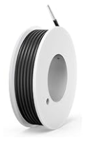 |   

Required Tools
- Long Philips Screwdriver
- Ruler
- Wire strippers
- Soldering iron and solder
- Drill and 1/4” drill bit

Required Personal Protective Equipment (PPE)
- Safety glasses

Assembly Instructions
- Carefully remove the toy from its packaging without damaging it. Locate and remove the screws along the body of the toy.  *Note: keep screws, and keep track of where they came from if there are multiple different sized screws | 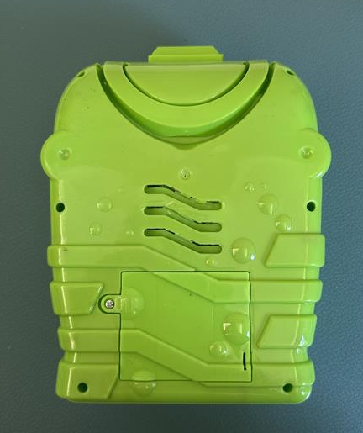
- Carefully separate the two halves of the toy. | 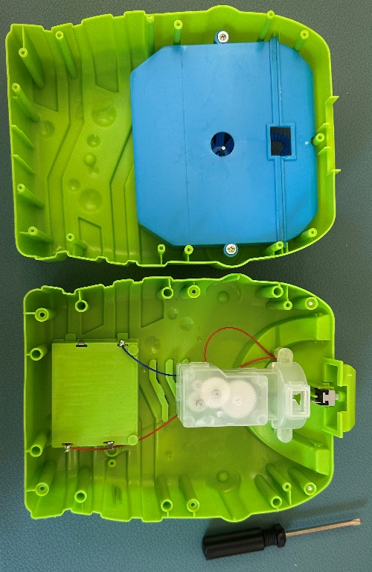
- Mark the prong on the switch that had no wires connected to it using tape, marker, or anything you have on hand to avoid confusion later on. | 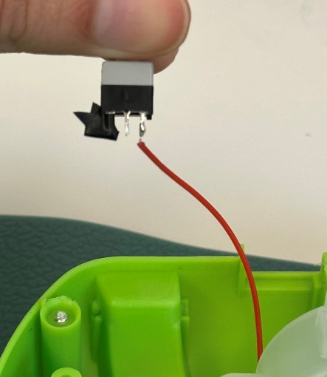
- Using the soldering iron, melt the solder on the middle prong of the switch and remove the wire | 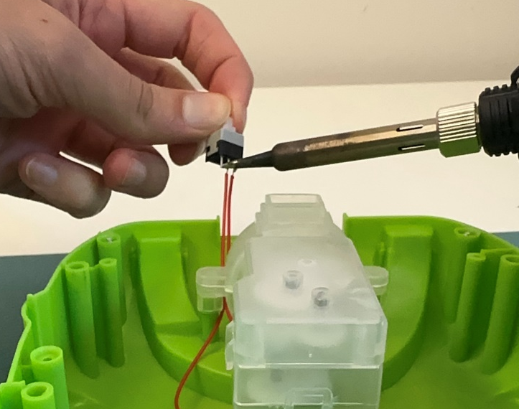
- Strip about 0.5 cm extra off the red wire from the toy. | 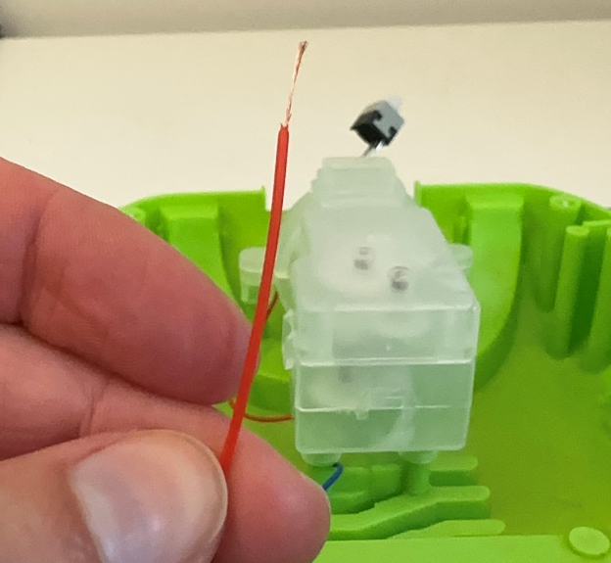
- Cut four pieces of wire approximately 6 cm long. Strip the ends of all wires. | 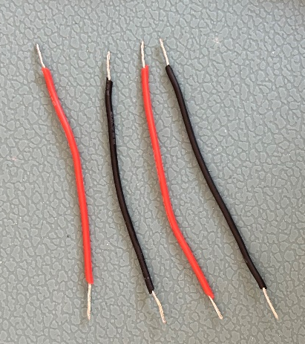  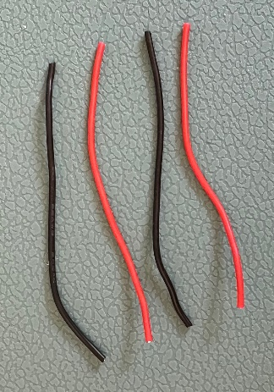
- Take two of the wires and twist the ends together. Then twist the end of the red wire from the toy. Solder this connection | 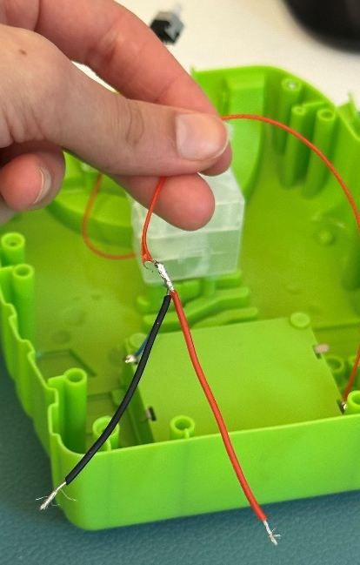  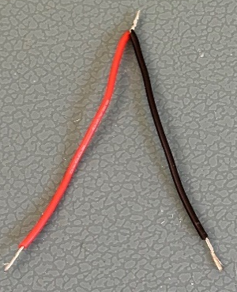
- Repeat steps 4-7 with the other wire on the switch.
- The toy should look like this. | 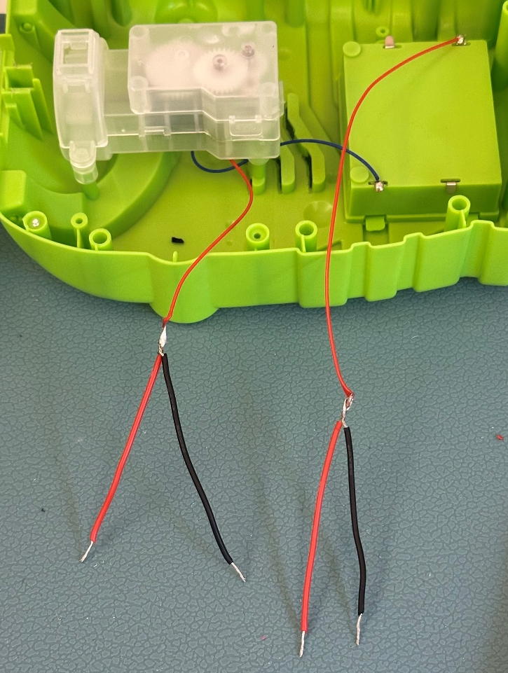
- Take one of the wires coming from the motor (the two wires on the left in the picture above). Solder the wire to the right prong of the original toy switch.  Note: It does not matter if you use the red or black wire.  Tip: It helps to bend the exposed wire to wrap around the prong (like a hook) | 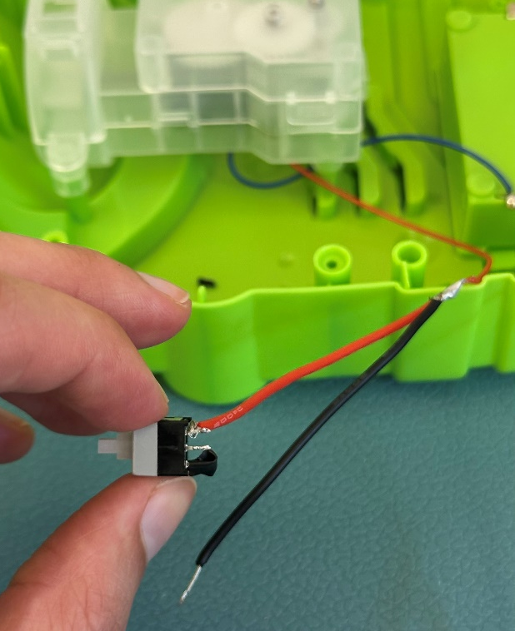
- Do the same thing, but this time solder a wire coming from the battery compartment to the middle prong of the switch.  Note: Do not put too much solder on the prongs. You do not want the two connections to be touching. This will cause a short circuit. | 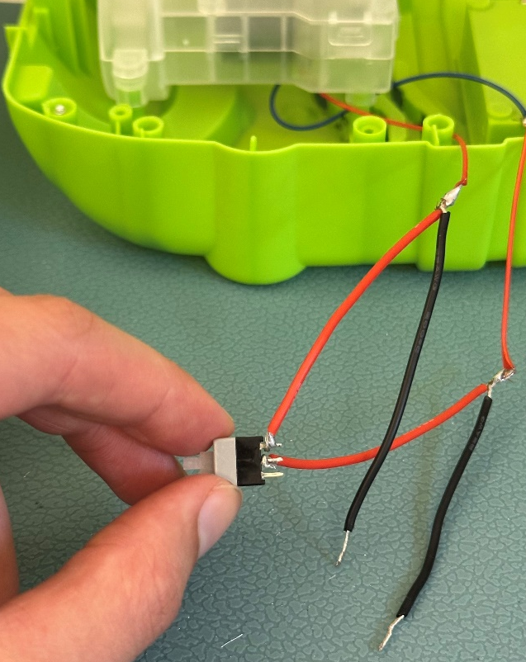
- Now we will solder the mono jack. Solder the two remaining wires to the two prongs on the mono jack that are closest to the jack. The order does not matter. | 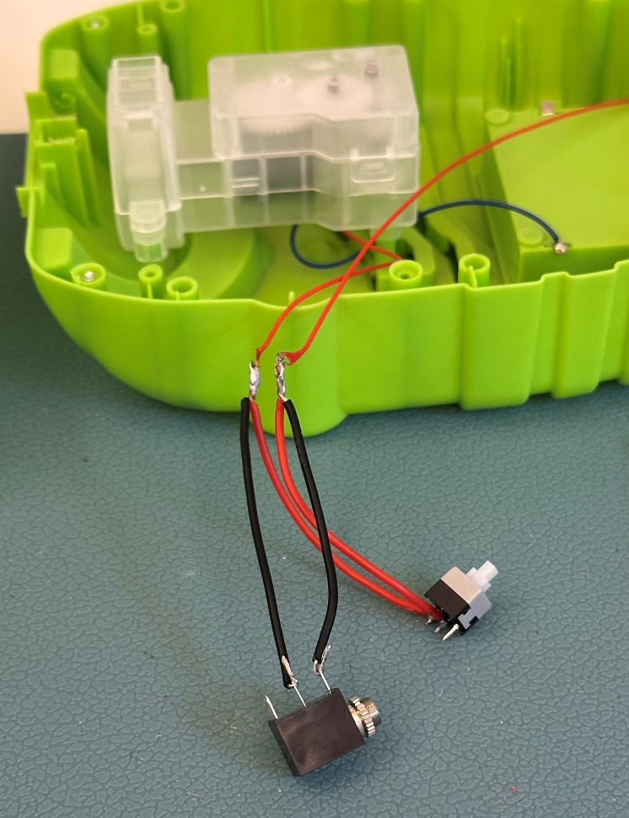
- Put batteries in the toy. Plug in an assistive switch and test the toy. If it does not work, check the solder connections. | 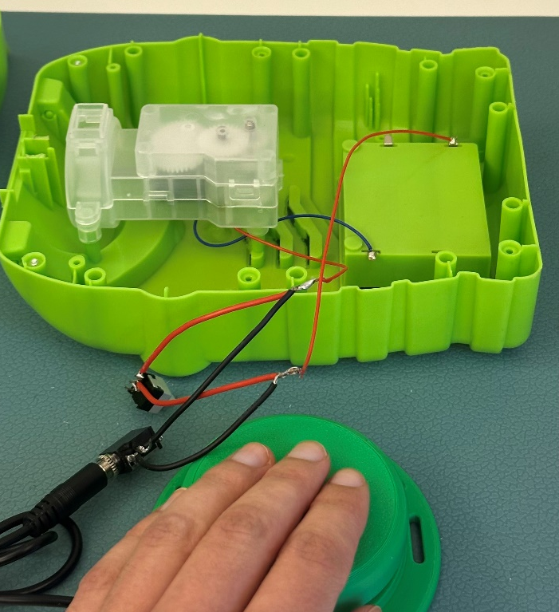
- Wrap the solder connections in electrical tape  Note: You can also wrap the connections to the mono jack and switch in electrical tape | 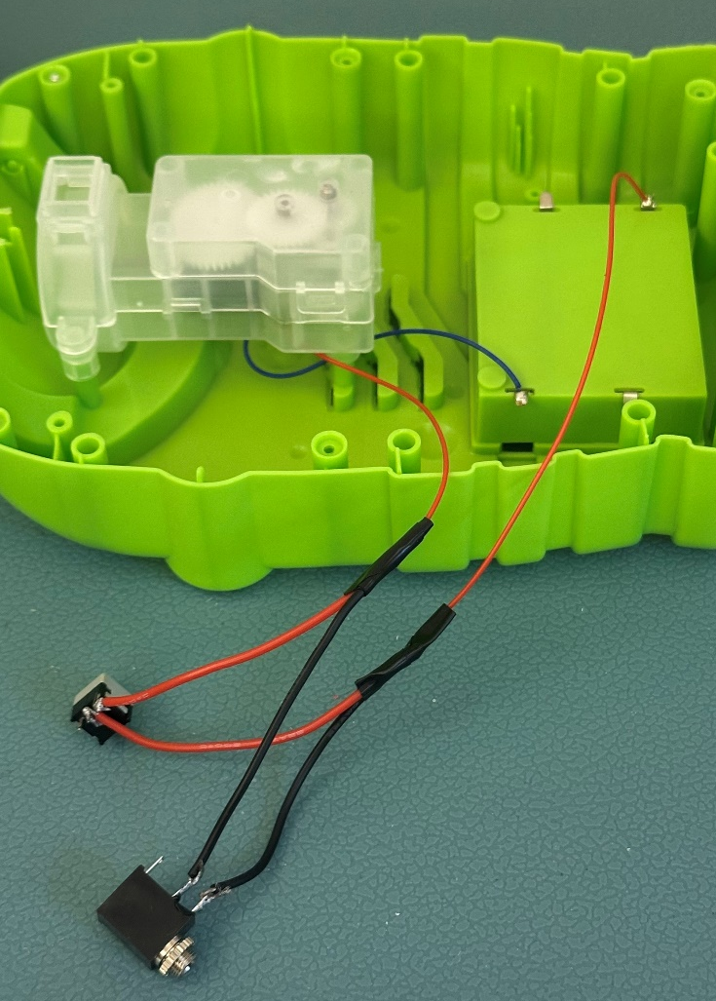
- Put the original button in the slot. See where the mono jack falls. | 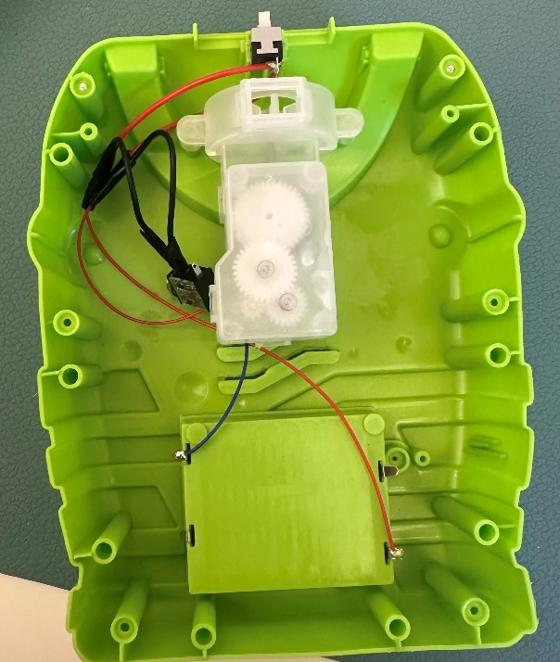
- Using a drill and ¼’’ drill bit, drill a hole in the back of the toy for the mono jack. | 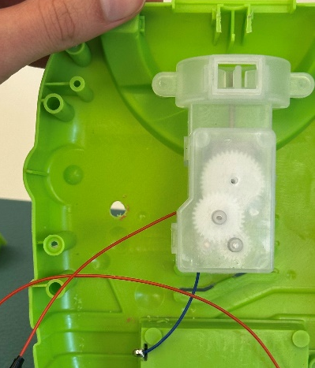  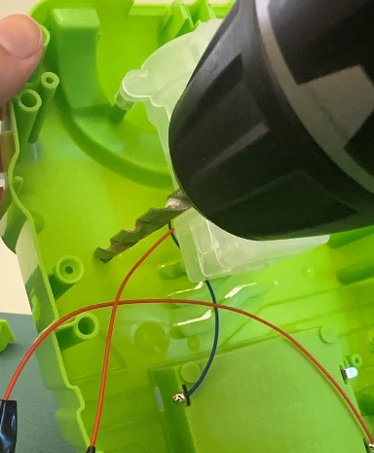
- Remove the retaining ring from the mono jack. Insert the jack through the drilled hole and secure it with the retaining ring on the outside of the toy.  Place the button cover over the button. | 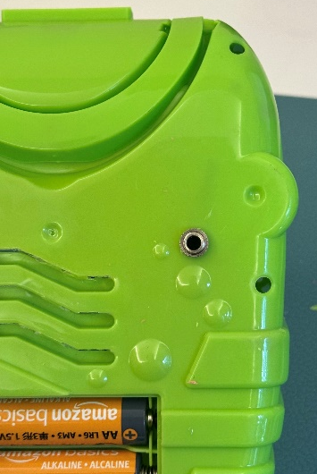  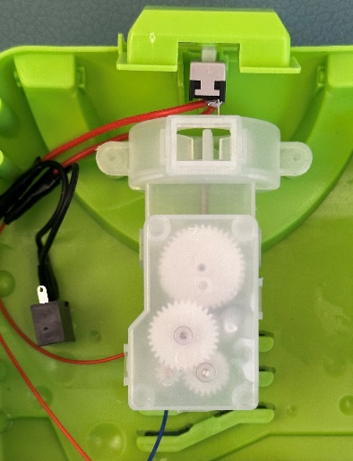
- The gears may have moved around while adapting. Make sure the hole of the large gear is in line with the hole on the gearbox. When you reassemble the toy, the metal shaft from the fan will go through these holes. | 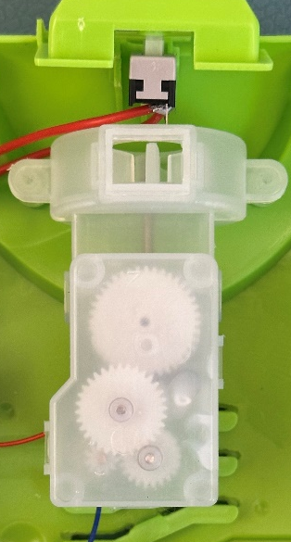  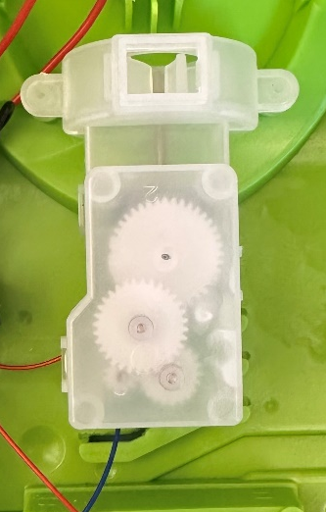
- Reassemble the toy using the screws set aside earlier. Test the toy again. If it works, repackage the toy and the adapted toy is complete! | 