Required Components
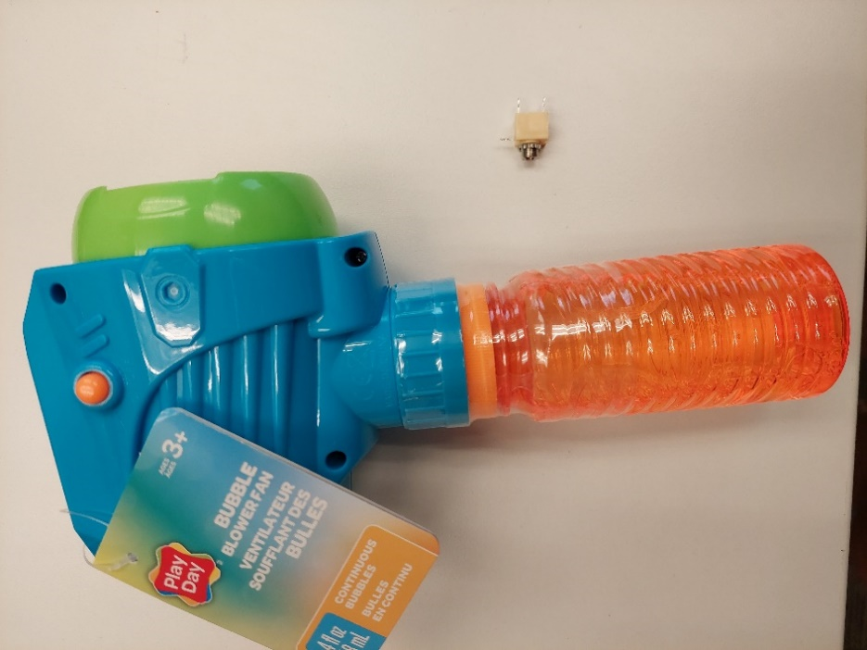  1  2 | BOM  - Play Day Bubble Blower Fan  - 3.5 mm Mono Switch Jack  - 2 X 8 cm of Wire  Refer to the Tool and Component List for purchasing details.

Required Tools
- Screwdriver – skinny Phillips
- Soldering iron
- Solder Sucker / Desoldering Braid
- Hot glue gun

Required Personal Protective Equipment (PPE)
- Protective eyewear

Assembly Instructions
Step 1  Remove bubble solution from gun by removing 5 screws that holds device together, as marked in the photo. | 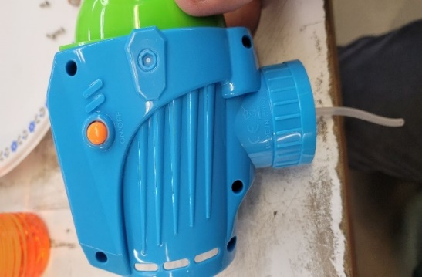

Step 2  Gently pry open the top of device. Remove battery holder.  You should see the wires going to the switch that turns device on and off.  Note: The bottom does not open as it is like a clam shell. | 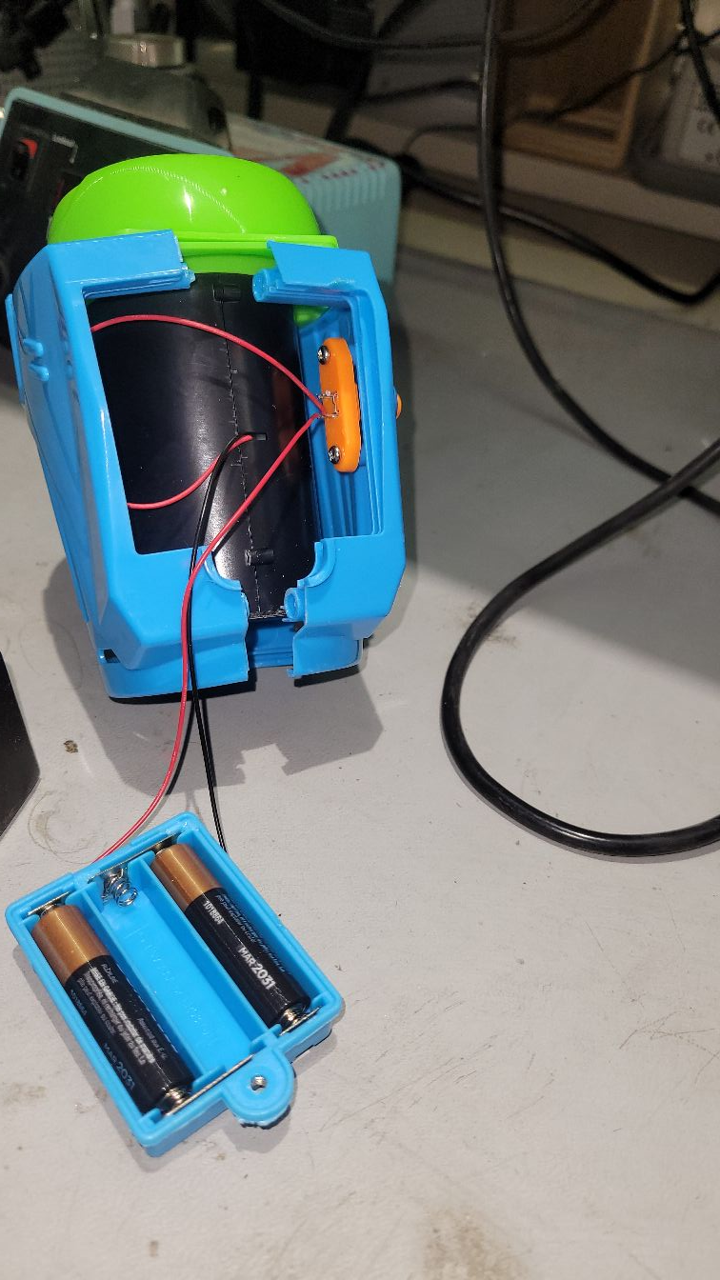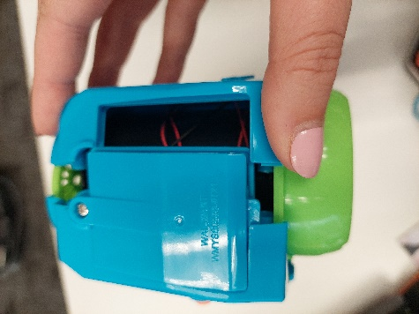

Step 3  Remove the two screws that are holding the orange switch in place.  (We will not need these when we put the toy back together) | 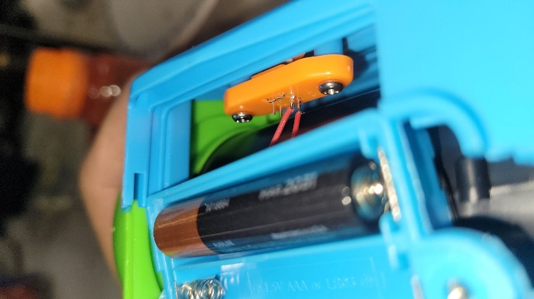

Step 4  Unsolder the 2 wires from the orange switch mechanism. The wires may be both red, or black and red.  Remove the orange switch mechanism and set it aside.  (This orange switch mechanism is not required when the toy is reassembled.) | 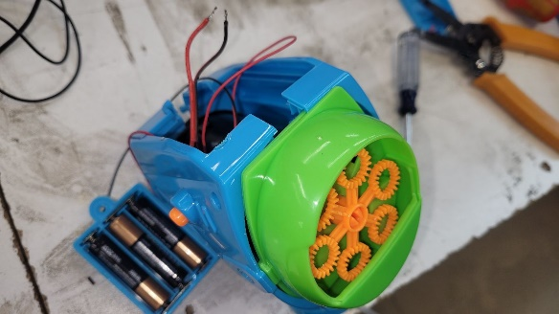

Step 5  Solder the wires to the tip and sleeve contacts of the switch jack. | 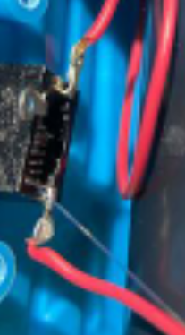

Step 6

Before reassembling the toy, test the Switch Adapted Bubble Blower Fan by plugging in an assistive switch.

Step 7  Insert the switch jack into the hole left by the original switch.  It may be helpful to bend the switch contacts on the jack to make it easier to reassemble the toy. | 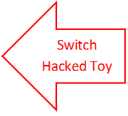  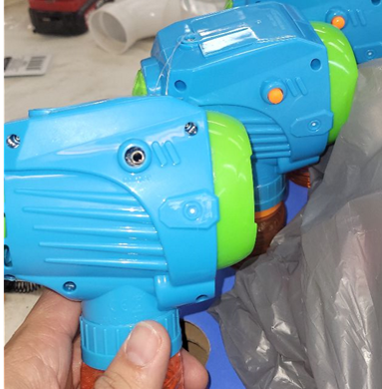
 | 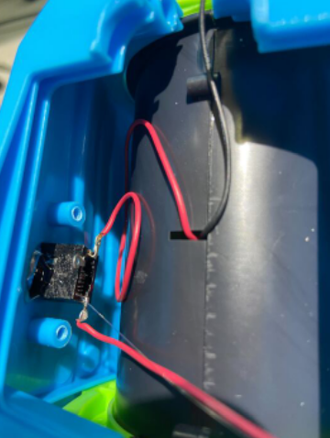

Step 8  Place switch that is soldered into the slot of the original switch.  Apply hot glue around switch hole.  Clear extra glue from outside of bubble gun once it hardens. | 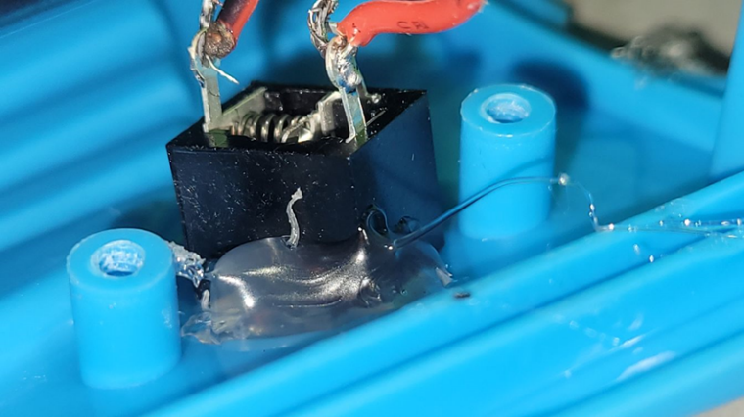

Step 9  Replace the battery cover. | 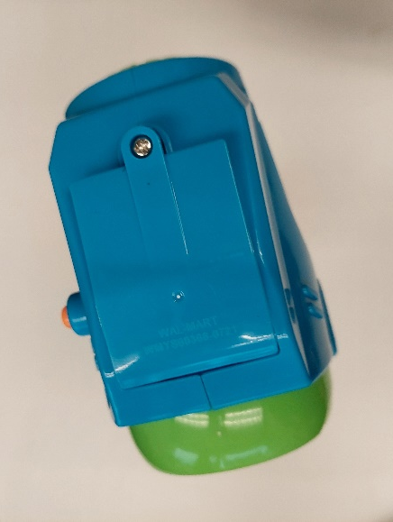

Step 10

Replace the casing and reinsert the 5 screws.

Complete  Test the Switch Adapted Bubble Complete final test with switch.  Begin blowing bubbles. | 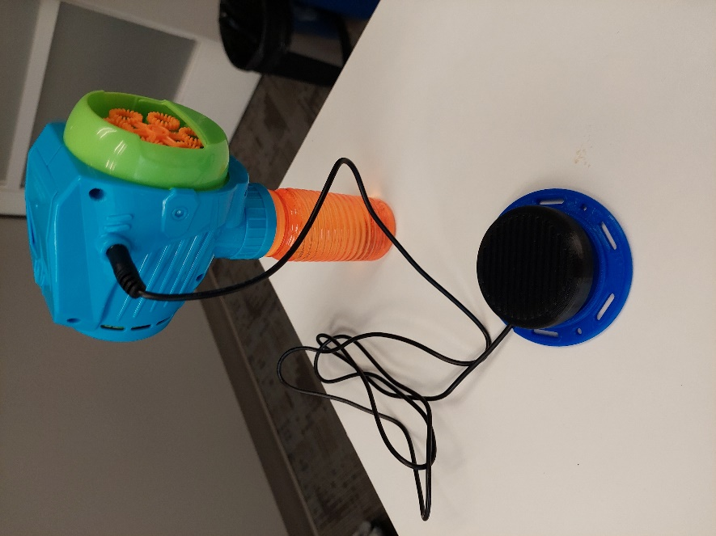

CUI Devices  Model: MJ-3507  DigiKey PN: 102-5674-ND | 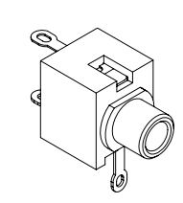  Tip  Sleeve

