Required Components
 | 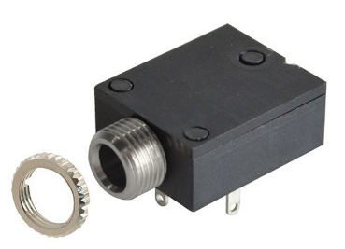 | BOM  - Play Day Light-up Bubble Blaster  - 3.5 mm Flat Rectangular Mono Jack and Nut  - Flex PCB (x1)  - 3D Printed Jack Case  - Cable Ties (x2)  - AA Batteries (x4)  Refer to the Tool and Component List for purchasing details.
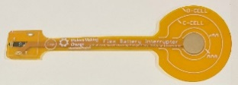 | 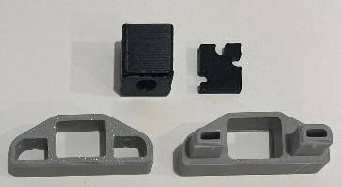
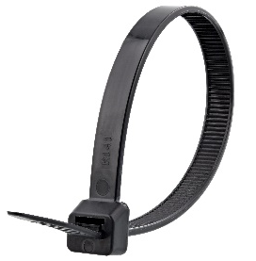 | 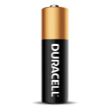

Required Tools
- Screwdriver
- Scissors
- Soldering iron and solder

Required Personal Protective Equipment (PPE)
- Safety glasses

Assembly Instructions
- Locate your battery interrupter PCB and mono jack. The prongs from the mono jack match up with the holes in the PCB. Lay the battery interrupter on top of the mono jack, with the metal prongs sticking through the holes. | 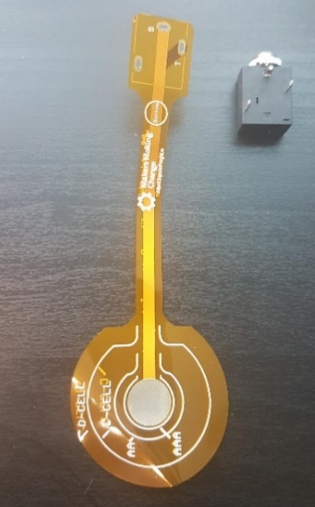
- At the base, add solder to the metal prongs so the PCB and mono jack are connected. Make sure the PCB is as flat against the mono jack as possible. The metal ring, or nut, that is around the input of the mono jack can be removed and set aside.  Note: It is helpful to put something heavy on the battery interrupter while soldering so it lays flat | 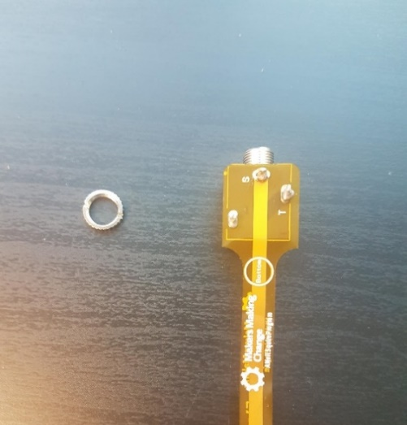
- This toy uses AA batteries. There are circles on the orange PCB which indicate battery size. Locate the circle labeled AA and cut the PCB around that line. | 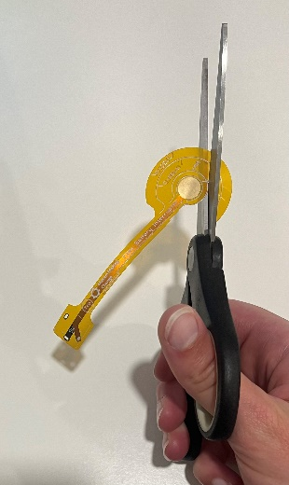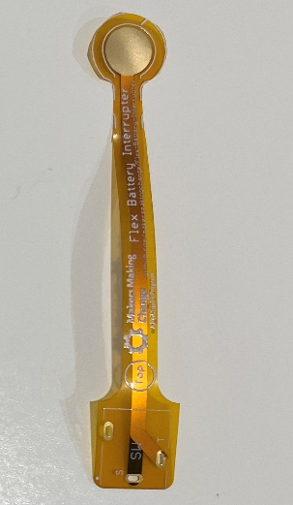
- Line the 3D printed spacer up with the mono jack. It should lay flat, if it does not, you may need to remove some solder using the soldering iron.  Place the mono-jack end of the battery interrupter into the 3D printed casing. Slide the other piece of the case over the battery interrupter and snap in place | 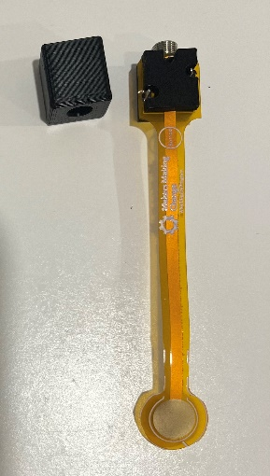
- Insert the mono jack and spacer into the case. Note that there is a correct orientation for this, ensure the mono jack hole and hole in the case are aligned before pushing through the hole. Secure the ring on the outside of the case. | 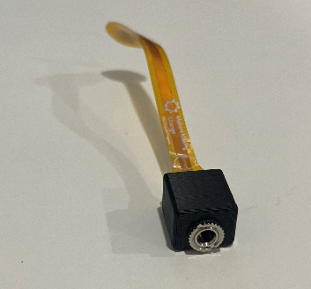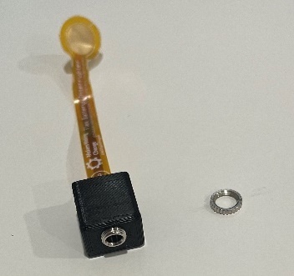
- Insert this assembly into the larger casing piece with the two extruding pieces. | 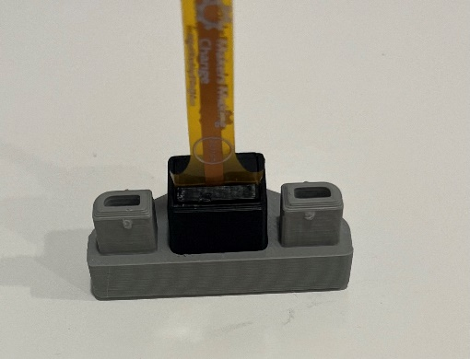
- Insert the last piece of the casing overtop | 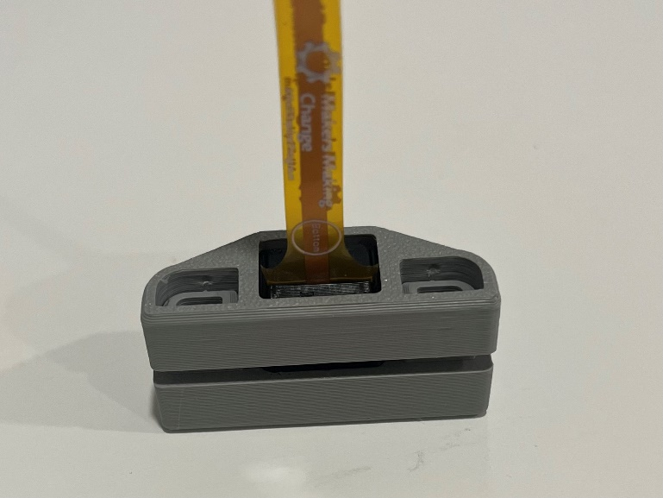
- Snap the two pieces together. The casing is now complete. | 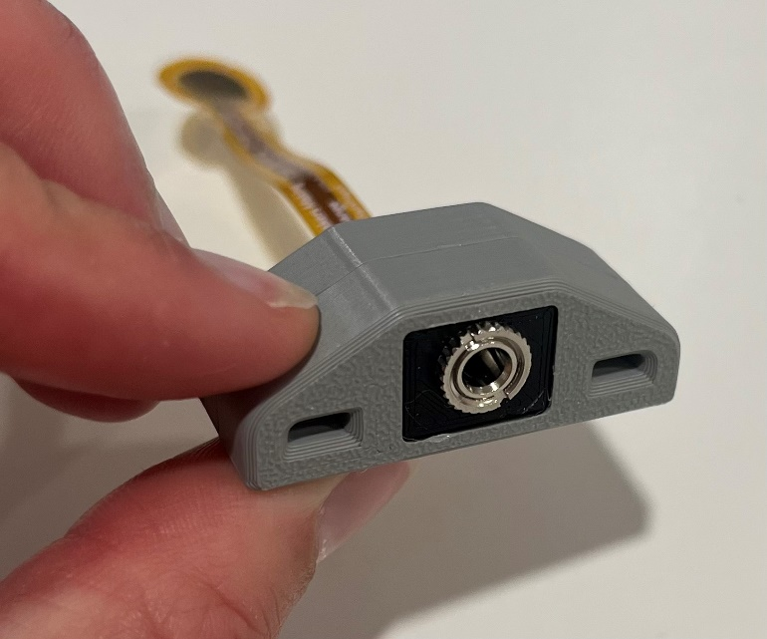
- Using a Philips screwdriver, open the battery compartment located on the bottom of the toy. | 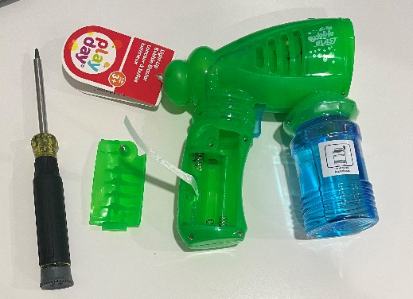
- Place the circular end of the battery interrupter over the end of one battery, then close the battery compartment | 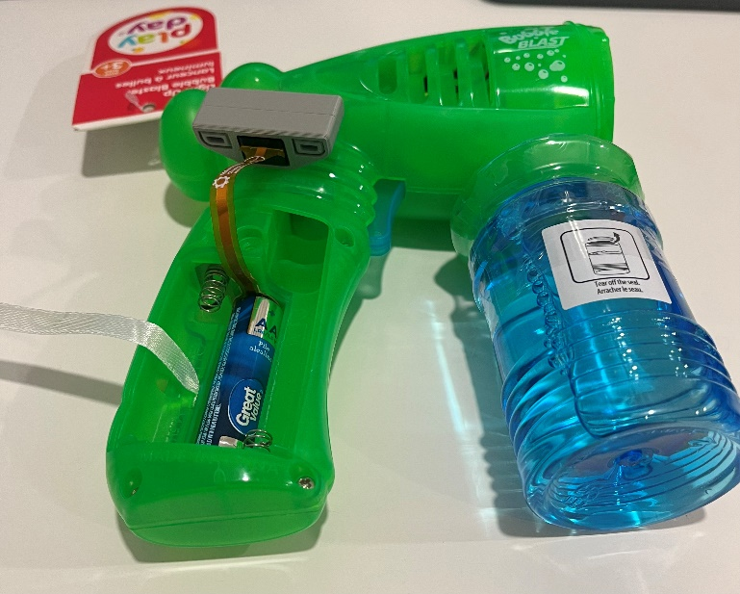  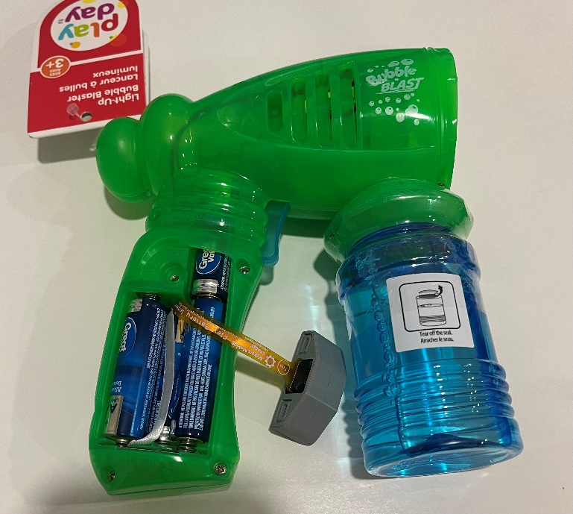  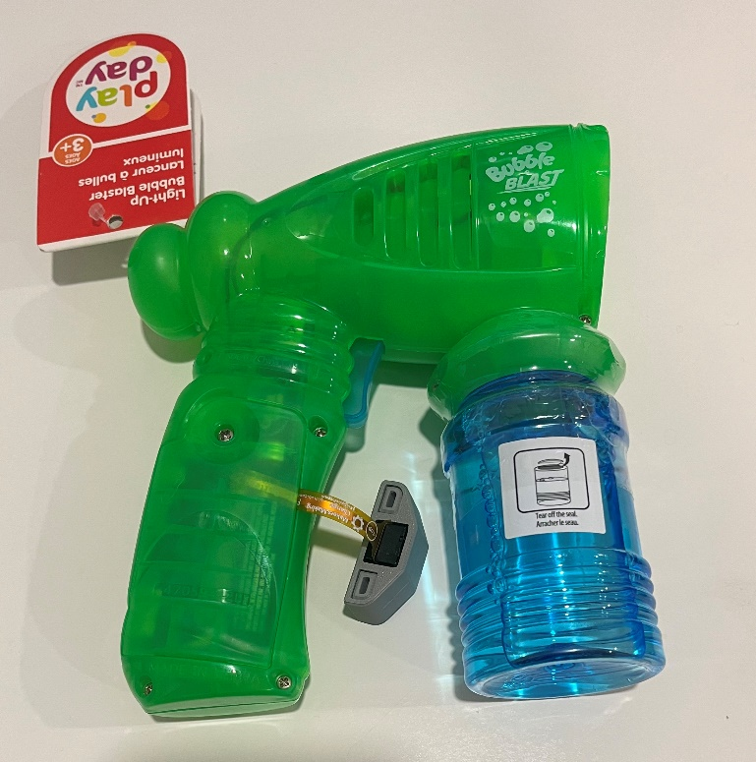
- Test the toy
- Use cable ties to secure the mono jack end of the battery interrupter to the handle of the bubble blaster. The cable ties will be threaded through the two holes in the 3D printed casing, and wrap around the toy handle. | 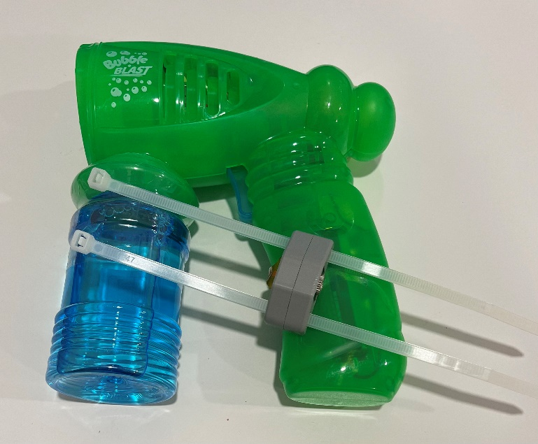  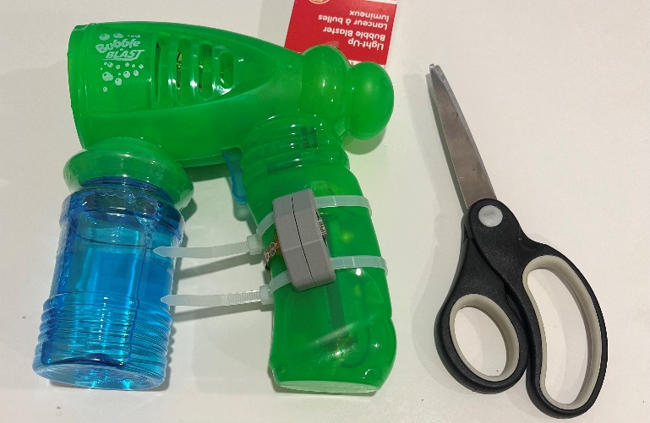
- The toy can now be paired with an assistive switch. When the switch is plugged in and activated, the toy will turn on! The toy should also stand independently.  *Note: You may need to press the trigger once for the toy to start working | 