Required Components
 | 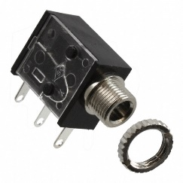 | BOM  - Play Day – Strawberry Bubble Blower  - 3.5 mm Mono Jack and Ring  - 22 AWG Wire  - 4 AA Batteries  Refer to the Tool and Component List for purchasing details.
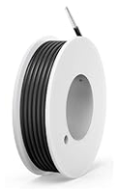 | 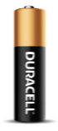

Required Tools
- Phillips Screwdriver
- Ruler
- Wire strippers
- Soldering iron and solder
- Drill and 1/4” drill bit

Required Personal Protective Equipment (PPE)
- Safety glasses

Assembly Instructions
- Remove the toy from its original packaging.  Please keep the original packing in good shape, the toy will be repackaged once completed. | 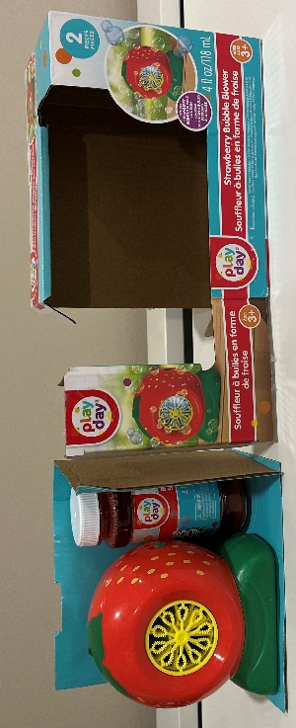
- Twist the black plastic pieces to remove the bubble blower.  Do not open or remove bubble solution from packaging | 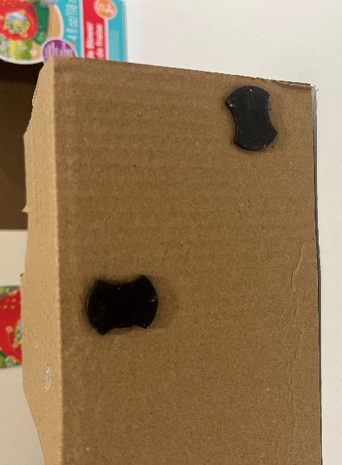
- Remove the six screws on the back of the bubble blower. Keep in a safe place for later. | 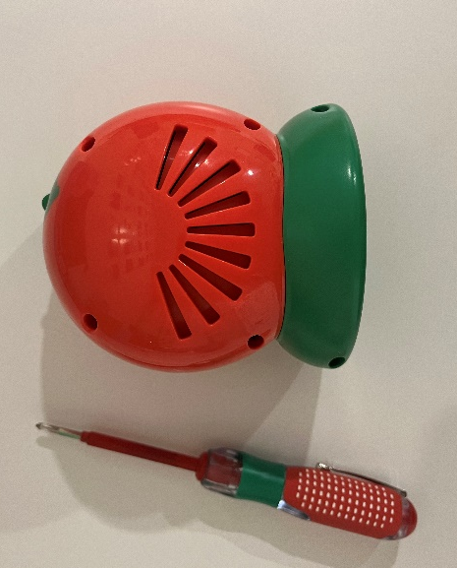
- Separate the two halves of the bubble blower. | 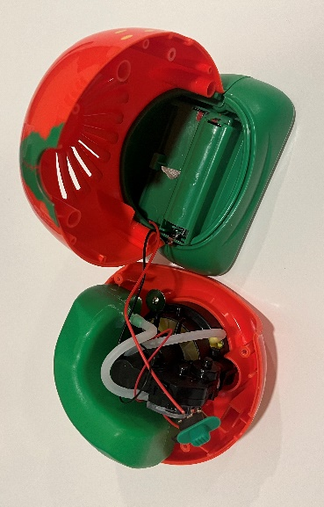
- Cut two pieces of wire, each about 8 cm long. | 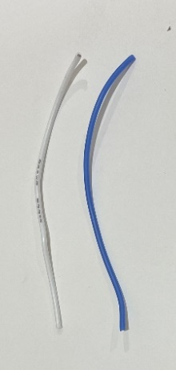
- Strip approximately 0.5cm off the end of each wire. | 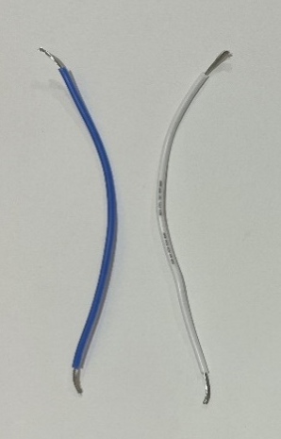
- Solder the wires onto the legs of the mono jack closest to where the cable is inserted. | 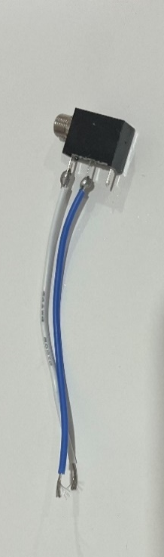
- Tin the other ends of the wires by covering them in a small amount of solder. This will make the next steps easier. | 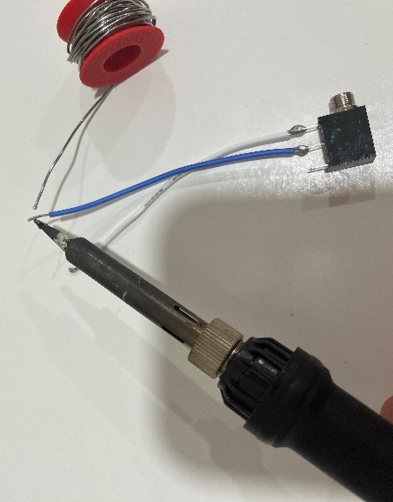
- Locate a wire that connects from the battery compartment to the switch. Use the soldering iron to heat up the original solder and release ONE wire from the switch. | 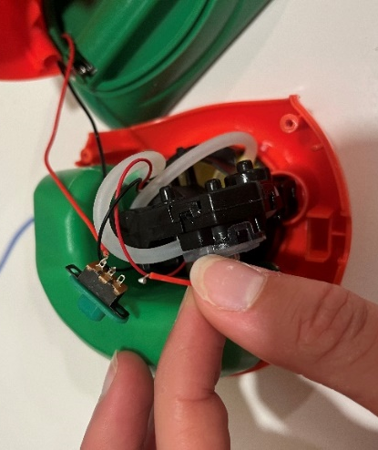
- Solder the end of the released wire to one end of the wire connected to the mono jack. | 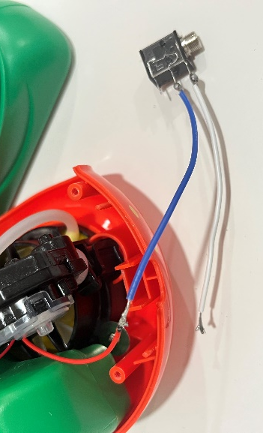
- Wrap the new connection with electrical tape. | 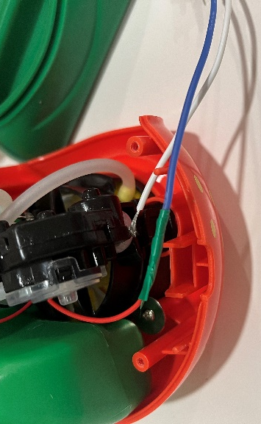
- Solder the end of the other wire connected to the mono jack to the board where the wire was removed. | 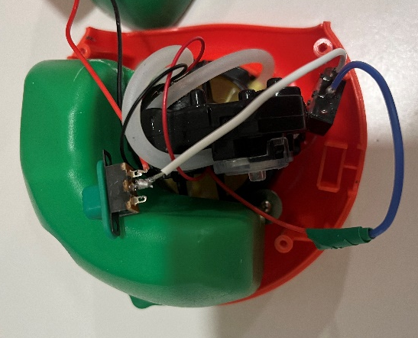
- It is now time to test the toy. Insert batteries into the battery compartment and insert an assistive switch into the mono jack. When the switch is pressed, the bubble motor and light will turn on and you can move onto the next step. You will need to have the original switch on for the adapted switch to work.  Note: If the toy does not turn on, please check the soldered connections. | 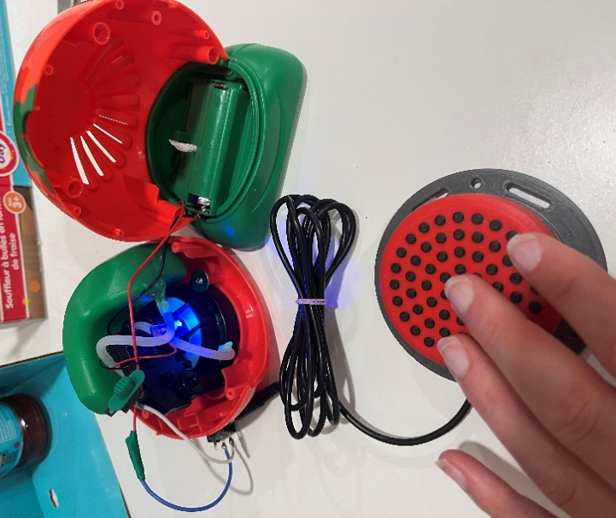
- Using a ¼” drill bit, drill a hole into the back of the bubble blower, near the original switch. Cut away any loose plastic. | 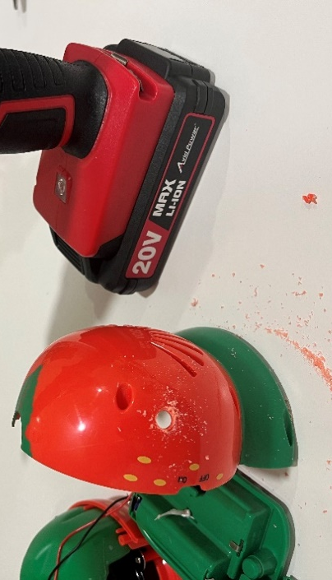
- Remove the nut from the mono jack and push the mono jack through the hole from the inside. | 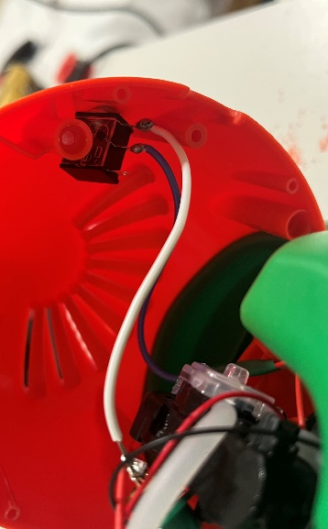
- Reinstall the nut on the outside of the toy and tighten to secure. | 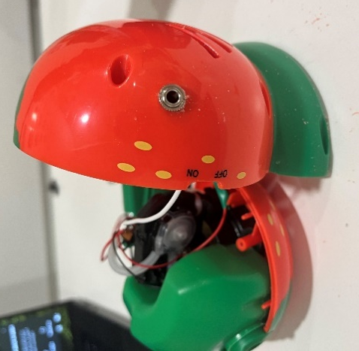
- Reassemble the toy halves, being careful the wires and tubes are not pinched when put back together and the original switch is in the correct position. | 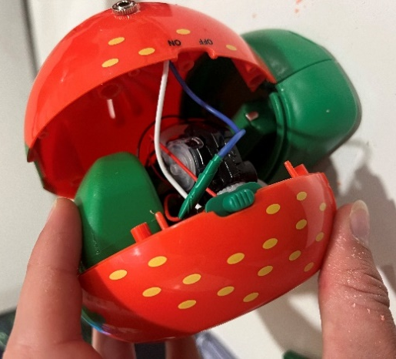
- Test the toy again. If it is still working properly, remove the batteries and re-install the battery cover.  Repackage the toy and the adapted toy is complete! | 