Required Components
 | 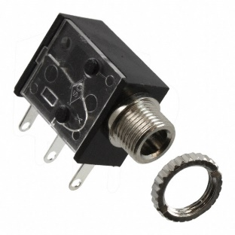 | BOM  - Reenovan Frog Bubble Machine  - 3.5 mm Mono Jack and Ring  - 22 AWG Wire  - 4 AA Batteries  Refer to the Tool and Component List for purchasing details.
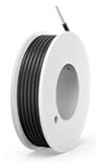 | 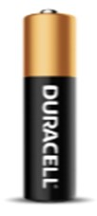

Required Tools
- Phillips Head Screwdriver
- Soldering iron
- Wire stripper
- Flush Cutters
- Drill and ¼ drill bit
Required Personal Protective Equipment (PPE)
- Goggles

Assembly Instructions
- Remove screw, open cover from battery compartment from bottom of the frog. Set cover and screw aside. | 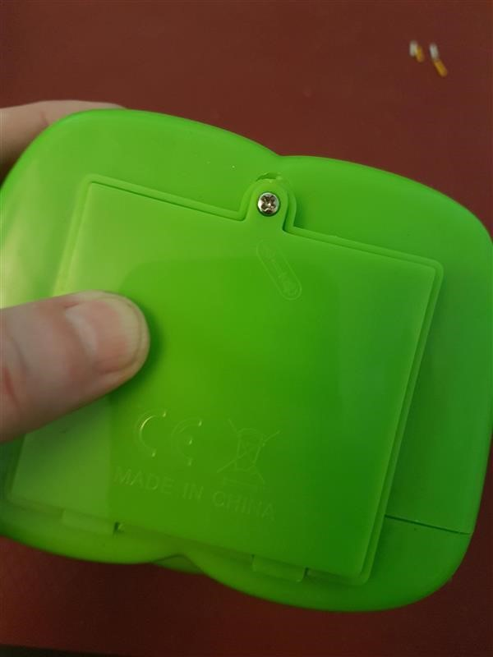
- Using the screwdriver, unscrew 6 screws from the back of frog | 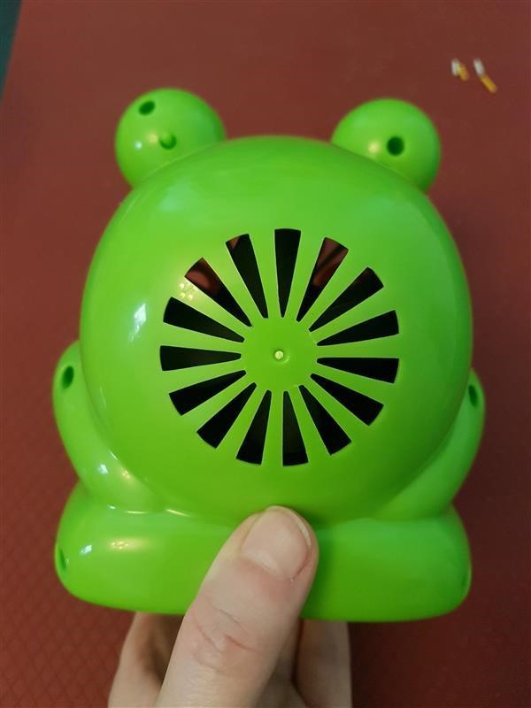
- Carefully open the frog, giving you a front half and back half of the frog.  Be careful with wires and fan parts as they may move. The front half of frog will be left intact.  Battery compartment can also be slid out from bottom of frog to give more space to work with, be gentle as to not pull existing wires from spots they are connected to. | 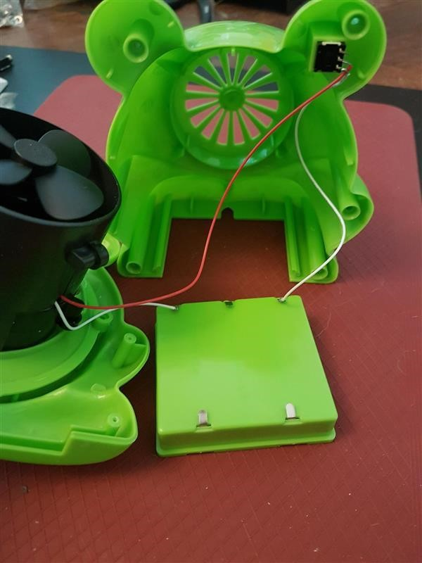
- Locate the original switch, located in the eye of the frog. Gently remove the original switch from the plastic compartment which holds the switch in place.
- With flush cutters, cut and remove 2 sides of plastic compartment to make room for new switch input.  Use a drill to increase size of hole in the eye to accommodate mono jack input.  Check that the space is large enough to fit mono jack input. | 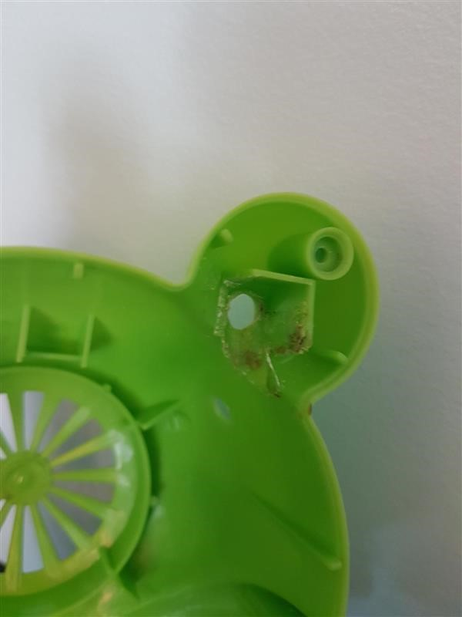  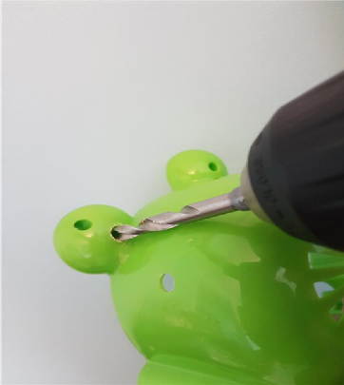
- Desolder wires from original switch. To do this, hold soldering iron tip where the wire is connected to original switch. When hot (2-3 seconds) you can gently pull the wire from the switch.  Desolder both wires from the original switch, one red wire and one white wire. | 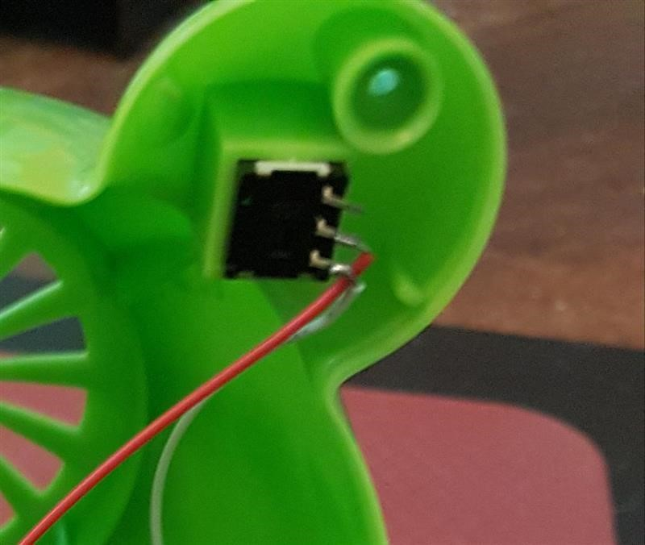
- Slide exposed end of white wire onto first metal arm of mono jack. Then slide exposed end of red wire onto middle metal arm of mono jack.  Solder red wire and white wire onto mono jack, which will replace the original switch with the new input.  Wires can be stripped more to provide more area to solder if needed  Please note: Check that the wire ends are soldered to correct metal arms on mono jack | 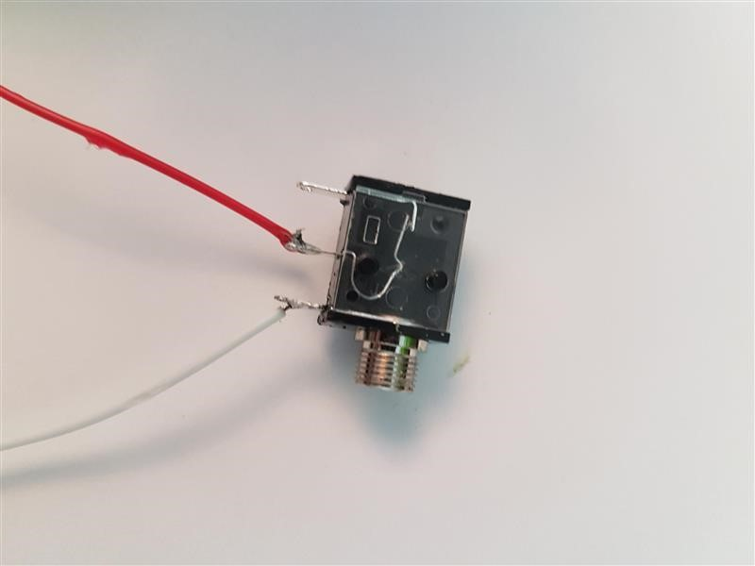
- When soldering is complete, check the connectivity by plugging switch into mono jack input.  If motor does not start when switch button is activated, check soldered connections.  If motor stays on, check connections.  Please note: batteries will need to be put in battery compartment to check connections. | 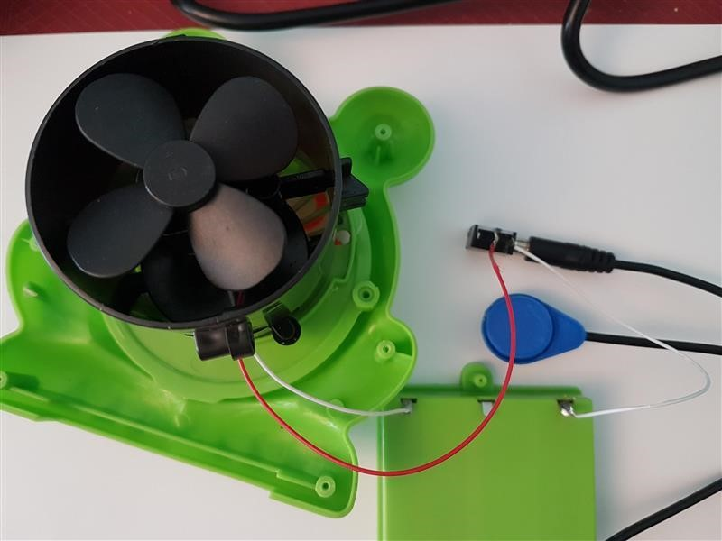
- Carefully slide mono jack into space in frog’s eye where the original switch was previously.  The mono jack input should be sticking out back of eye.  Twist small ring onto input of mono jack on the outside (or back of frog) to keep mono jack secure. | 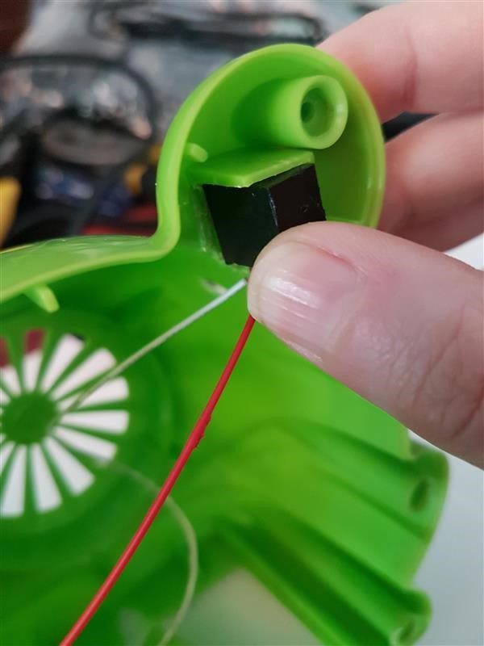
- Carefully close 2 halves of frog together being careful to not catch wires in sides of frog (you can tape wires to side to keep in place if you choose).  Check switch is still working before completing securing screws.  Replace screws and secure two parts of frog back together. | 