Required Components
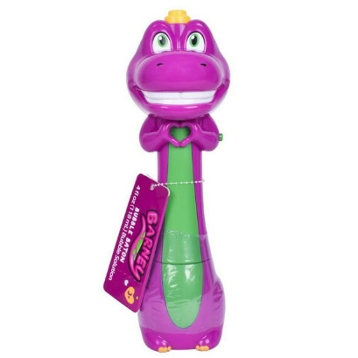 | 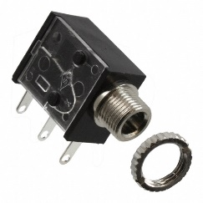 | BOM  - Barney Bubble Baton  - 3.5 mm Mono Jack and Nut  - 3 AA Batteries  Refer to the Tool and Component List for purchasing details.
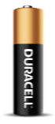

Required Tools
- Phillips Screwdriver
- Ruler
- Wire strippers
- Soldering iron and solder
- Drill and 1/4” drill bit

Required Personal Protective Equipment (PPE)
- Safety glasses

Assembly Instructions
- Remove the toy from its packaging. Locate and remove the screws along the body of the toy. Open the toy.  *Note: keep screws, and keep track of where they came from if there are multiple different sized screws | 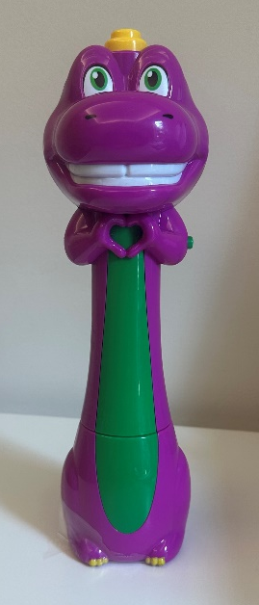
- Carefully separate the two halves of the toy. Remove the arms. | 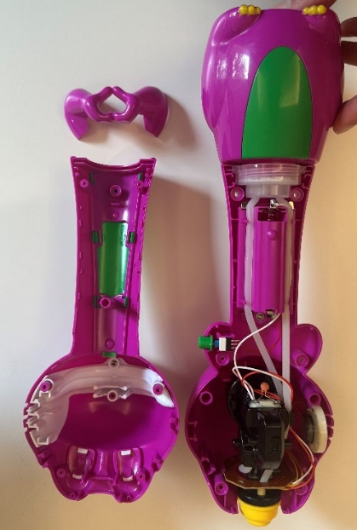
- Use wire cutters to cut off the original switch from the two red wires | 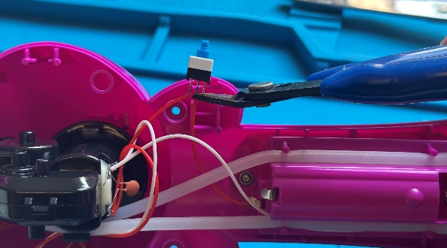
- Using a ¼” drill bit, drill a hole in the back half of the toy, in the space above the battery compartment. Use a hobby knife to remove the excess plastic. | 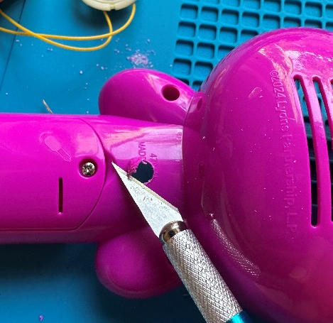  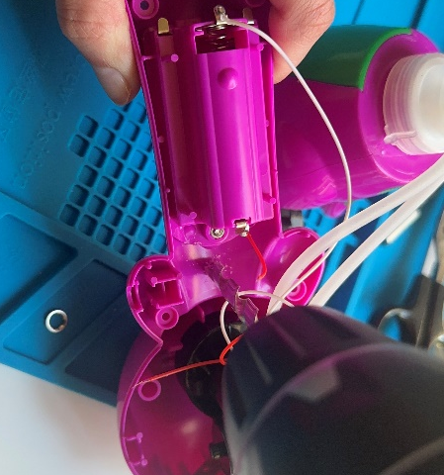
- Use wire strippers to strip approximately 0.5 cm off each end of the wires | [Image for step 5]
- Solder the two wires onto the two legs of the jack closest to the mono jack hole. | 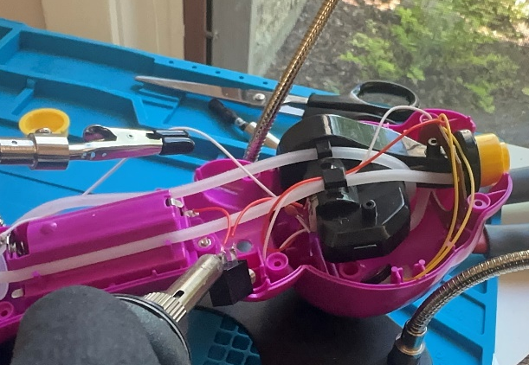
- It is now time to test the toy. Insert batteries into the battery compartment and insert an assistive switch into the mono jack. When the switch is pressed, the toy will turn on and you can move onto the next step.  Note: If the toy does not turn on, please check the soldered connections. | 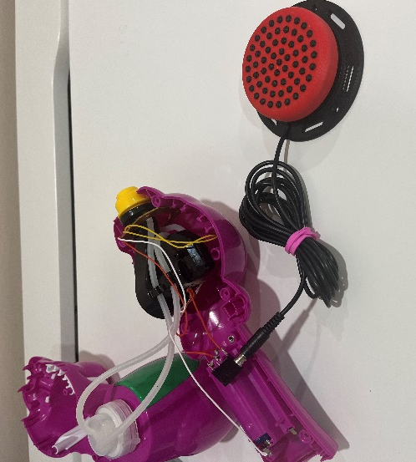
- Unscrew the nut from the jack. Place the jack through the hole and secure the nut. | 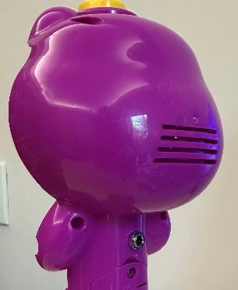  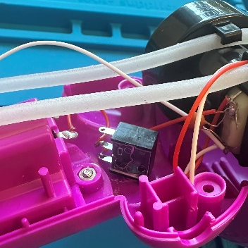
- Place all internal components back in their spot. Refer to the image. | 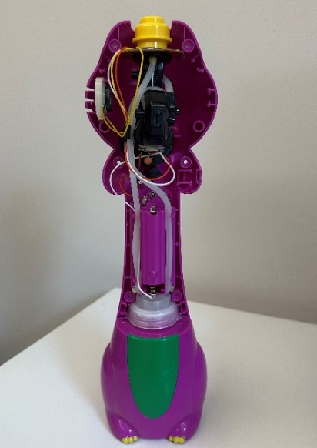
- To place the yellow topper, locate the small notch on the inside of the piece. Fit the topper over the yellow piece fixed to the toy, such that the notch and key fit together. Ensure that the lip of the yellow topper is underneath the outer lip on the toy. | 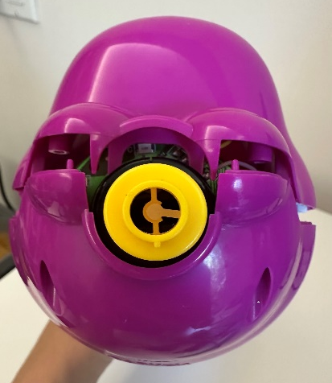  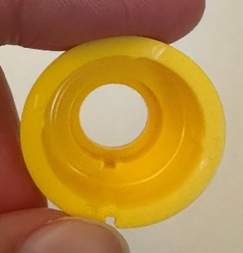
- Snap the toy back together. Place the arms back on and fasten with screws. Start with the screws behind the arms. | 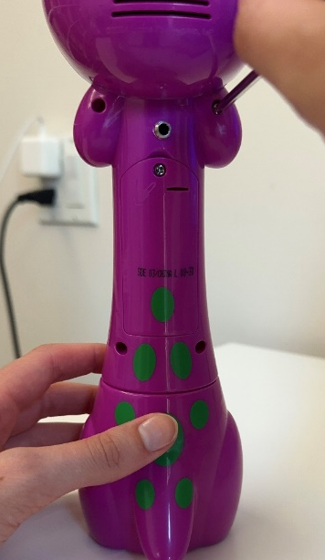
- Test the toy again. If it is still working properly, repackage the toy and the adapted toy is complete! | 