Required Components
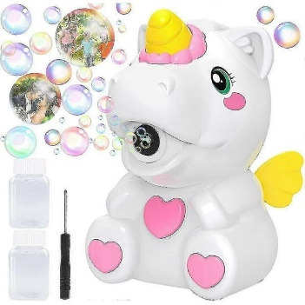 | 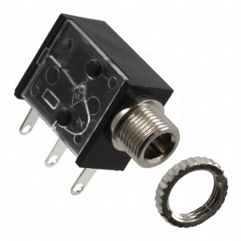 | 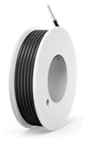 | BOM  - Walmart - Unicorn Bubble Blower  - 3.5 mm Mono Jack and Ring  - 22 AWG Wire  Refer to the Tool and Component List for purchasing details.

Required Tools
- Phillips Head Screwdriver
- Soldering Iron and Solder
- Wire stripper
- Flush cutter
- Drill and ¼” drill bit
Required Personal Protective Equipment (PPE)
- Safety Goggles

Assembly Instructions
- At the bottom of the unicorn, twist button to open compartment in bottom of unicorn. Pull out bottle and set aside, with tubes left in space.  Utilizing a screwdriver, turns screw indicated in the yellow circle to remove covering to battery compartment and set aside.  Utilizing a screwdriver, turns screws indicated in red circles and remove. Set screws aside. | 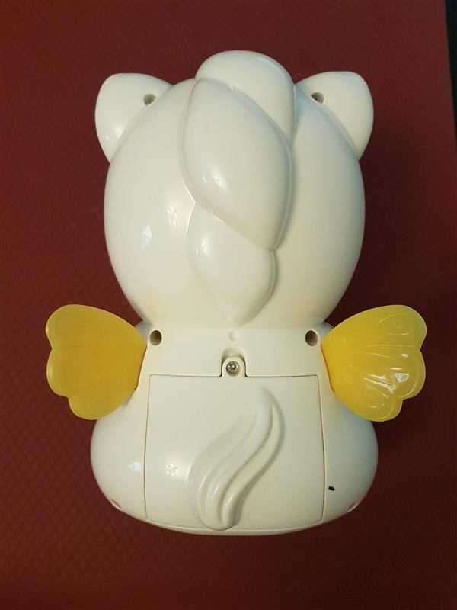
- After screws are undone, open unicorn in half, with a front and back of unicorn and gently lay face down. Place your screws in a secure place. | 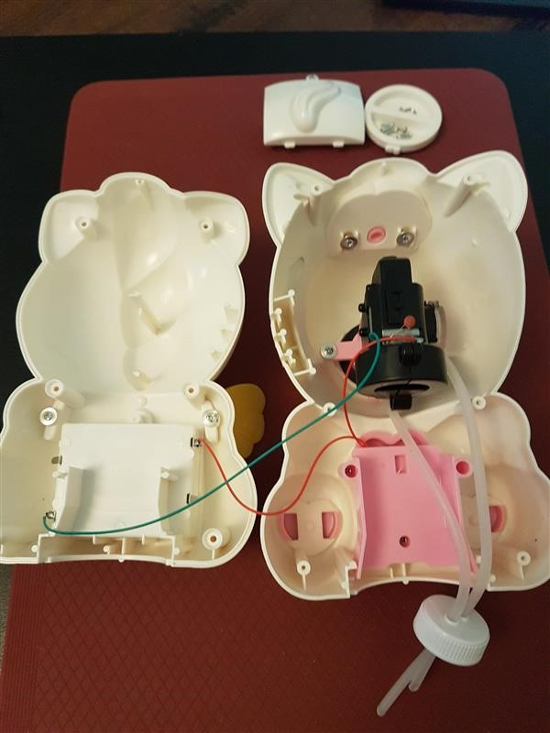
- On the back half of unicorn, move tubes to side and unscrew pink compartment to reveal switch and wires underneath.  Carefully lift pink compartment, the switch is attached to this compartment but can be gently pulled from heart shaped plastic button. | 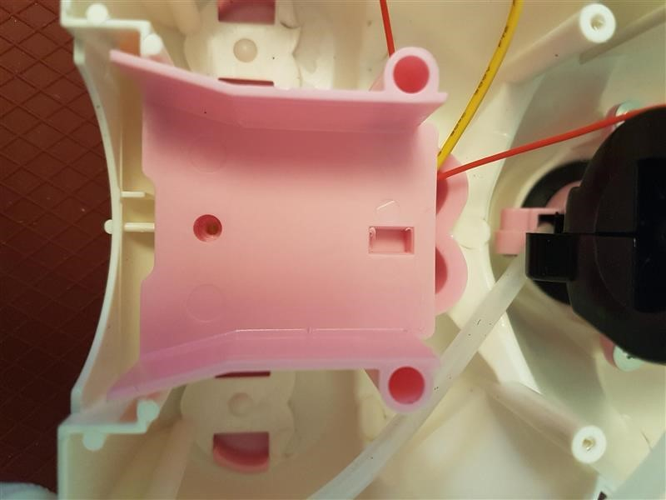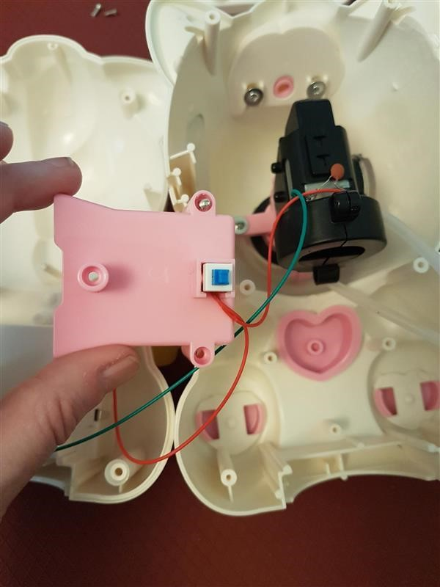
- Cut two wires, 8 cm in length.  Strip both of both wires, leaving about 0.5 cm of exposed wire on each end. | 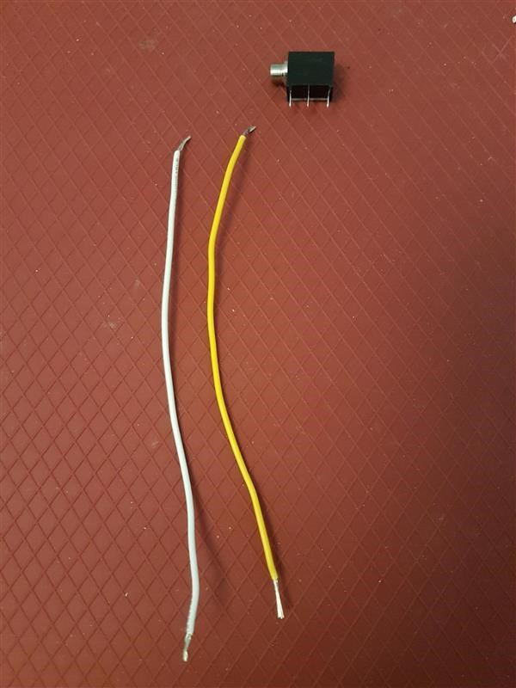  8  cm  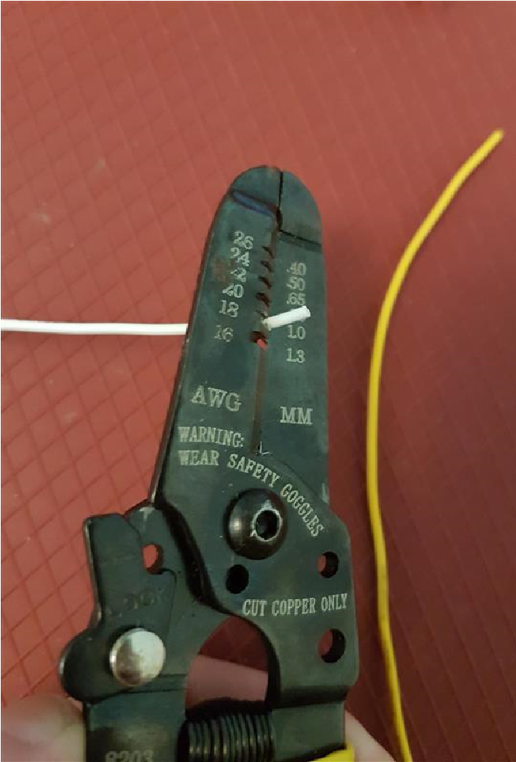
- Pick one wire, slide exposed wire into first metal arm on mono jack.  On second wire, slide one end of exposed wire into the middle metal arm on mono jack.  Solder wire to mono jack.  Please Note: Check that you have the correct metal arms of mono jack, refer to picture. | 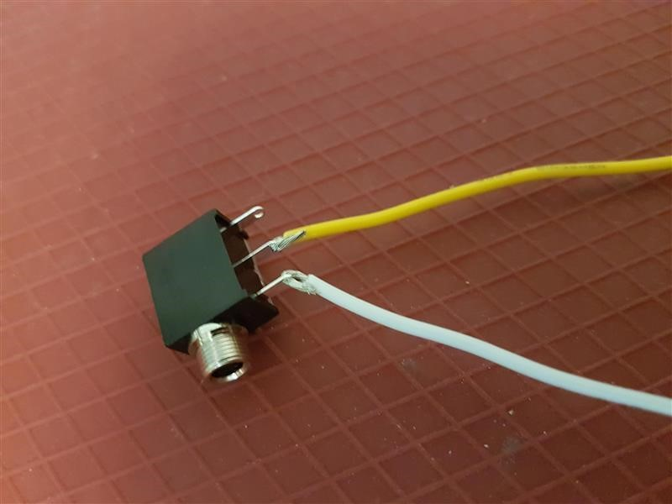
- Carefully slide switch out from pink heart button to access original switch.  Solder one wire end to metal arm on original blue switch, same spot the red wire is attached.  The switch can be removed from pink  plastic if that is easier, just replace into  slot when complete.  When soldering, make sure you do not connect to middle spot. To keep this spot solder free, you can put electrical tape over while completing your soldering.  Please note: you want the original red wire to also stay soldered, have 2 wire ends soldered to same spot (one original and one new wire). | 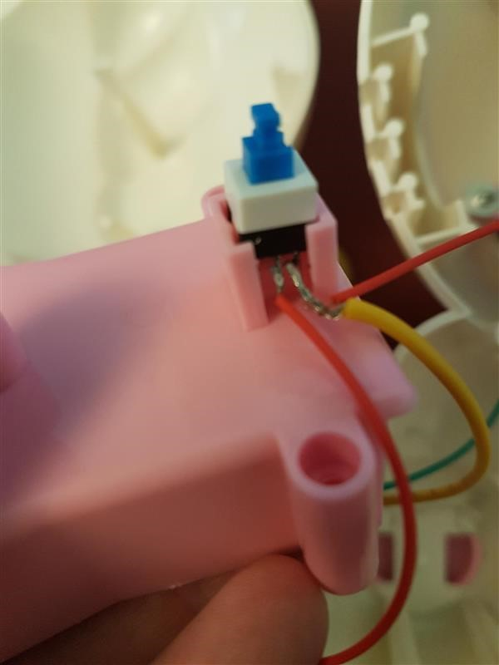
- Solder one end of second wire onto battery compartment where the red wire is attached.  Please note: you want the original red wire to also stay solder, effectively have 2 wire ends soldered to same spot (one original and one new wire). | 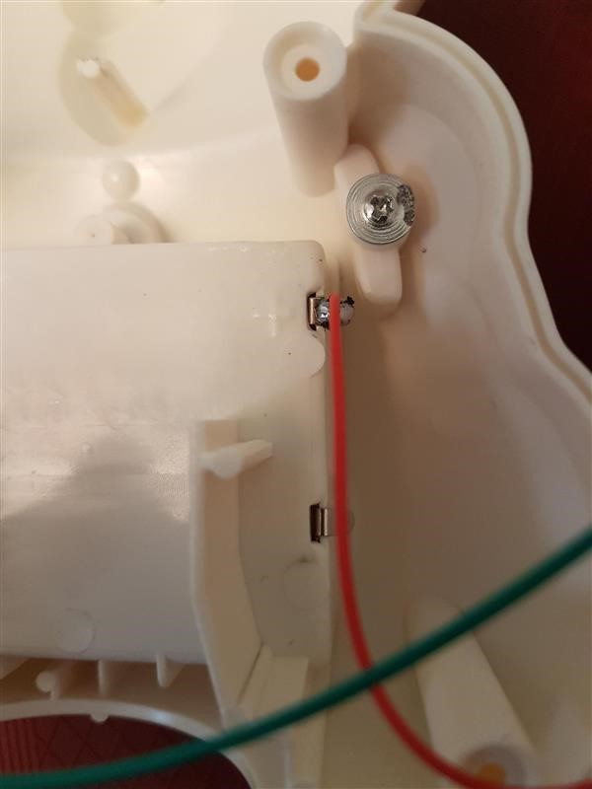
- Check new input and connectivity with switch.  If motor does not start when switch button is activated, check soldered connections.  If motor stays on, check connections.  Please note: you will have to replace batteries for testing. | 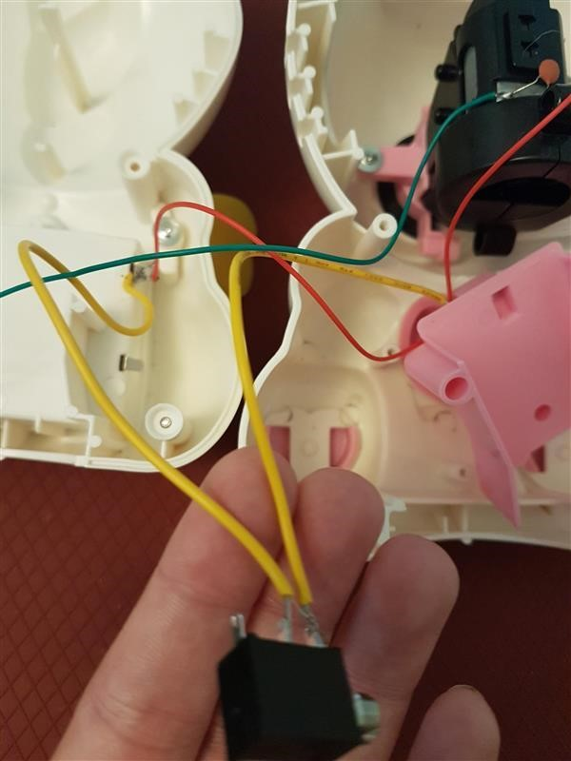
- With ¼ inch drill bit, drill hole in side leg of unicorn – the unicorn’s left side is ideal as the wires will reach more easily.  Check that mono jack out end can fit through the hole to be accessed from outside the unicorn.  Carefully move mono jack input into drilled hole, with input opening on the outside of toy.  Twist ring onto output on the outside of unicorn. | 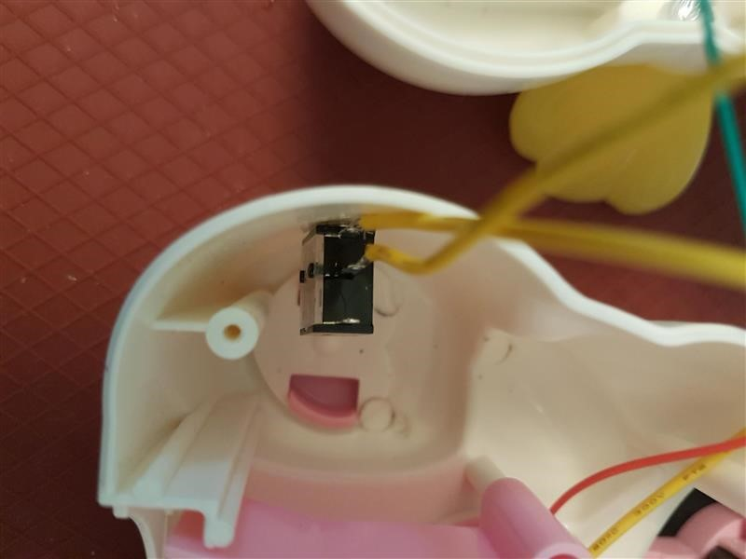
- Carefully slide switch back in pink  plastic compartment.  Reattach pink plastic part with original blue switch in space in pink heart. You can check that when you press the heart in, this clicks the original switch. | 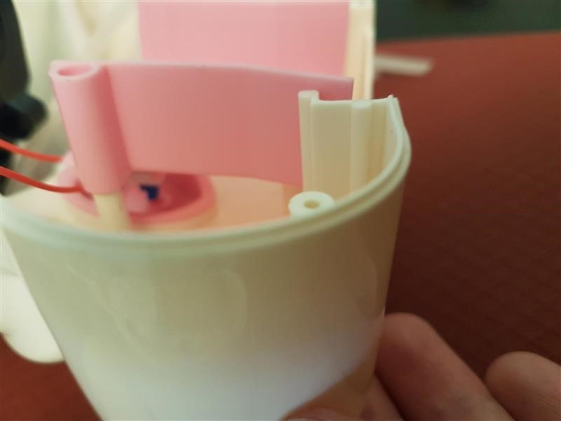
- Screw pink plastic part into place, with wires coming out the top (both original and new wire).  Move tubes into centre of unicorn onto pink plastic.  The tubes will hang down for now until reassembly is complete. | 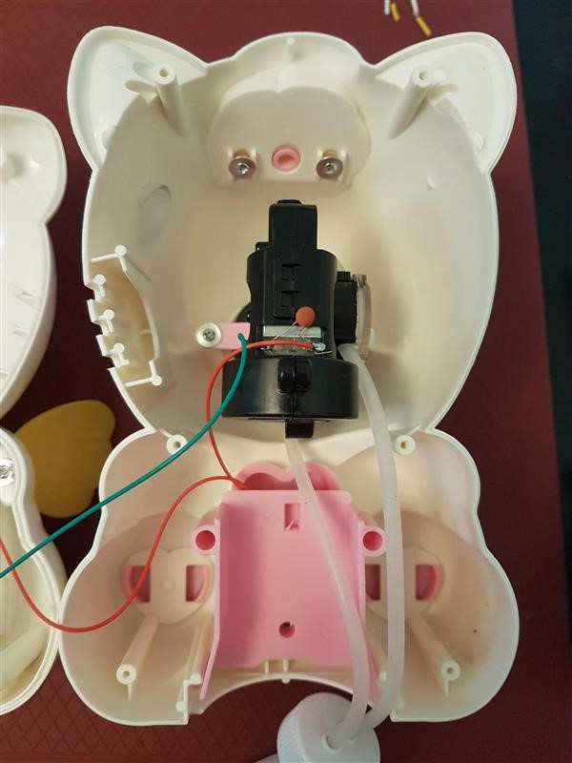
- Carefully put the two halves of unicorn back together, paying attention to the wires.  Check that wires do not get stuck between plastic when screwing the unicorn back together.  Check with switch again before completely screwing unicorn back together.  Secure screws, replace batteries and bottle to finish reassembling unicorn.  Complete! | 