Overview
This document contains the necessary information to switch-adapt a whale bubble blower.
Contents
Overview 1
Maker Checklist 2
Maker To Do List 2
Items to Give to User 2
Tool List 2
Assembly Guide 3
Required Components 3
Required Tools 3
Required Personal Protective Equipment (PPE) 3
Assembly Instructions 4
Step 1 4
Step 2 4
Step 3 5
Step 4 6
Step 5 7
Step 6 7
Step 7 8
Step 8 8
Step 9 9
Step 10 9
Step 11 10
Testing 10

Maker Checklist
This list provides an overview of the steps required to build and deliver the device.

Maker To Do List
- Read through the Maker Guide to become familiar with required components, tools, supplies, and safety gear and overall assembly steps.
- Order hardware components
- Gather tools, supplies, and safety equipment.
- Assemble the device
- Test device
- Print “User Quick Guide”

Items to Give to User
- Assembled, tested device
- “User Quick Guide”

Tool List
- Drill and ¼” drill bit
- Soldering iron
- Solder
- Phillips screwdriver (included with the bubble blower)
- Wire cutters
- Wire strippers
- Ruler

Assembly Guide

Required Components
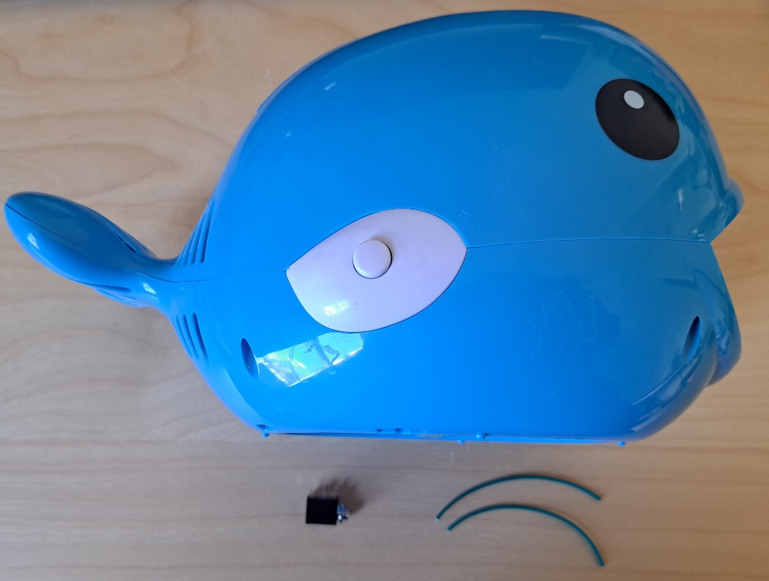  3.  2.  1. | BOM  - Whale bubble blower  - 3.5 mm mono jack  - 22 AWG wire  Refer to the Tool and Component List for purchasing details.

Required Tools
- Drill and ¼” drill bit
- Soldering iron
- Solder
- Phillips screwdriver (included with the bubble blower)
- Wire cutters
- Wire strippers
- Ruler

Required Personal Protective Equipment (PPE)
- Safety glasses

Assembly Instructions

Step 1
Cut two 8 cm lengths of wire.
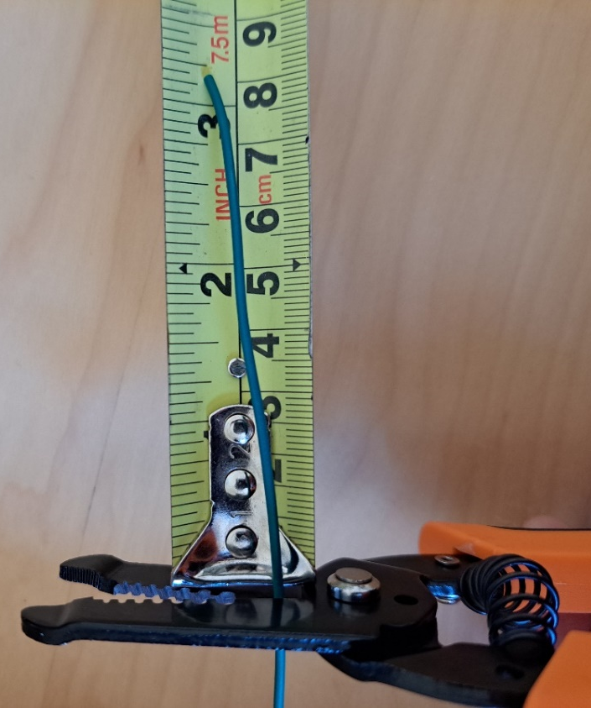

Step 2
Strip 0.5 cm of the insulation off each end of the wires.
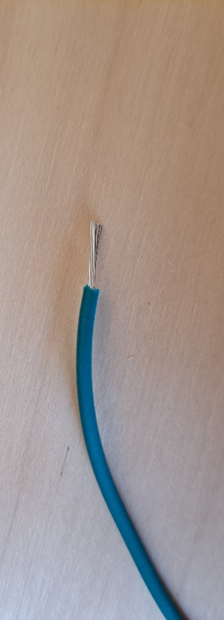
0.5 cm

Step 3
Unscrew the 6 screws in the whale and separate the top and bottom halves. The location of the 6 screws are circled in the picture. Note that the 2 screws in the tail are shorter than the other 4 in the body.
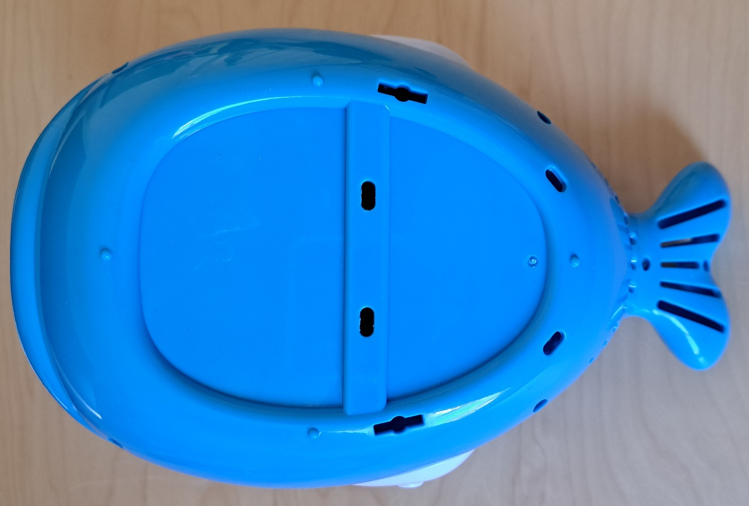

Step 4
Drill a ¼” hole in the side of the top half of whale.
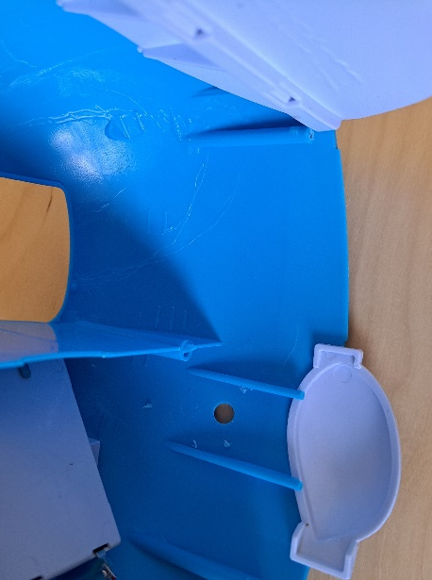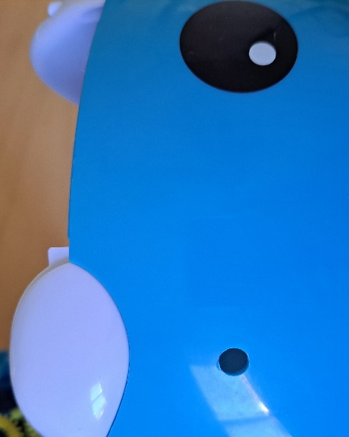

Step 5
Cut the white wire that is connected to original switch, located on one of the whale’s fins, and strip off 1 cm of insulation off the ends of the wire. Be careful when stripping the insulation as the wire inside is quite thin.
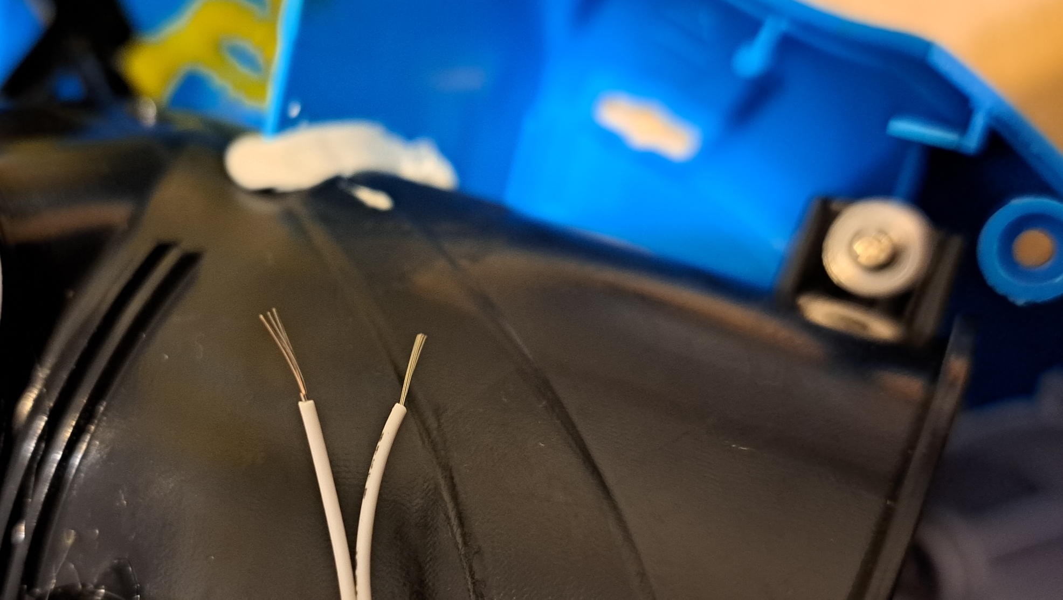

Step 6
Twist the two ends of the white wire back together, and twist one end of one of the 8 cm long wires around the exposed section of white wire.
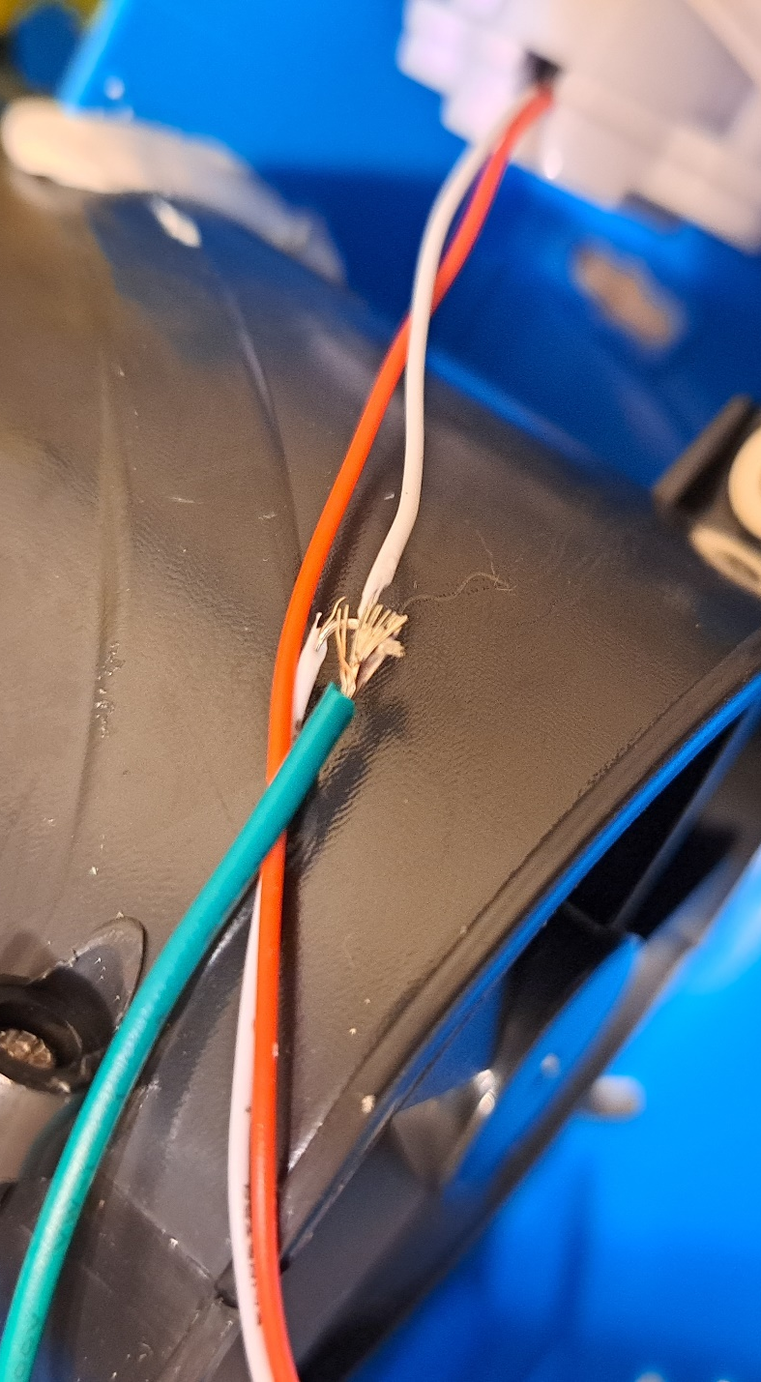

Step 7
Solder the twisted together wires, then wrap the connection in electrical tape.
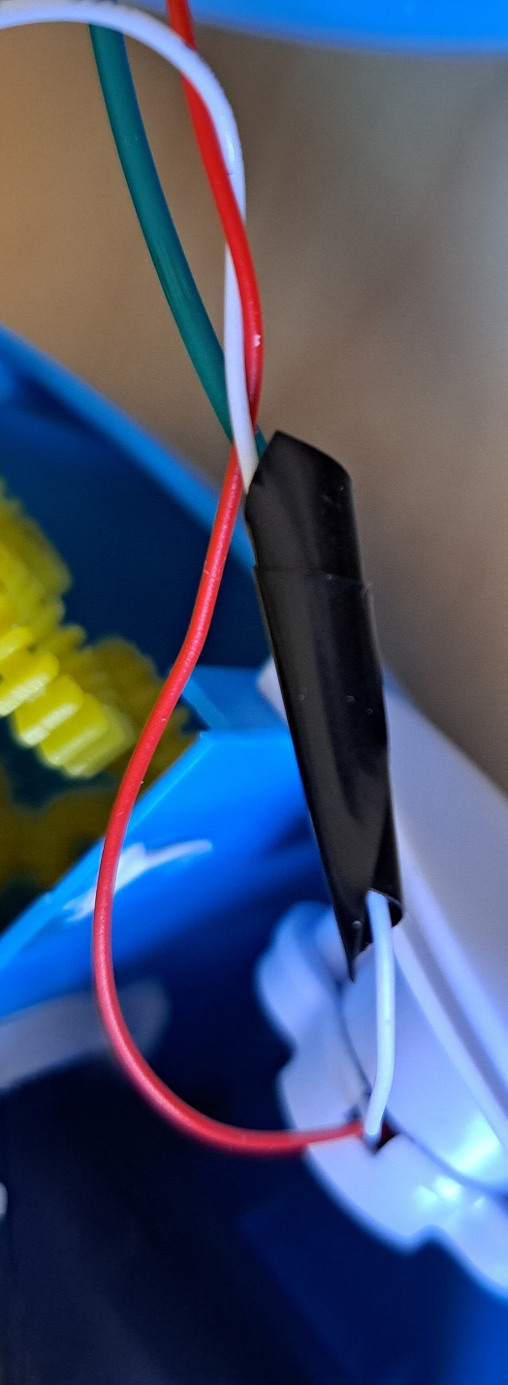

Step 8
Solder the second 8 cm long wire to the tab on the battery power connection as shown. The original red wire from the toy may disconnect from the tab. If that happens, simply solder it back in place.
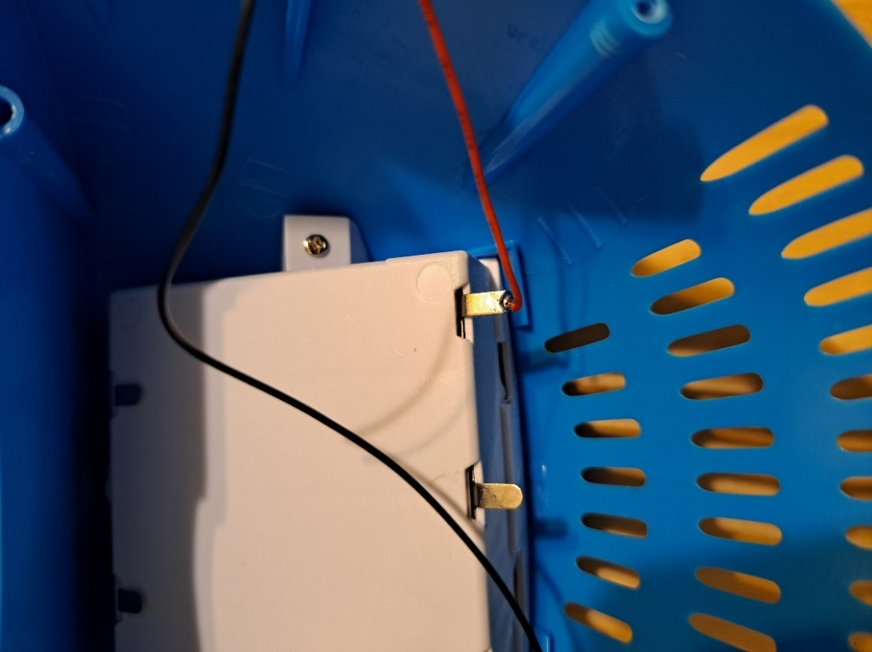

Step 9
Solder one of the 8 cm long wires to the first leg of the mono jack, then solder the second wire to the second leg of the mono jack.
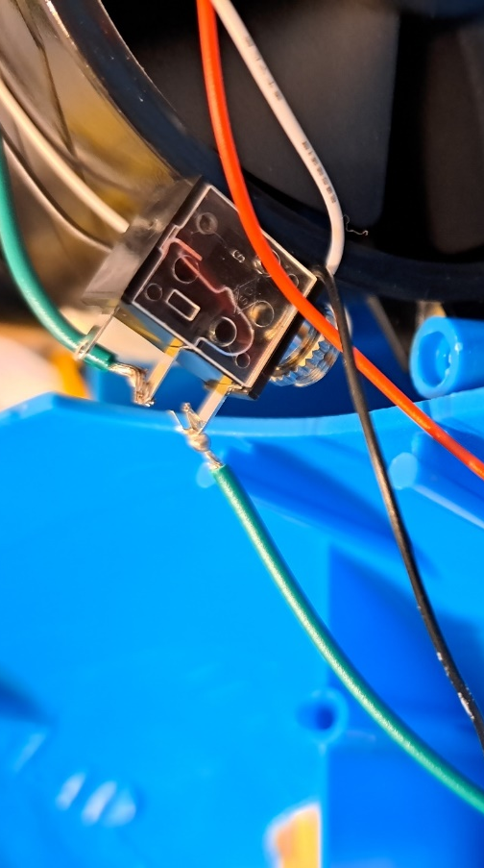

Step 10
Test the switch adapt and original switch to make sure everything works properly before reassembling the whale. Add batteries into the whale (4 AA batteries), then plug an assistive switch into the mono jack. Make sure all wires are away from the spinning wands and fan. Press the original button to make sure it still works. The bubble wands should rotate and air should be blown through them when the button is pressed, then stop when it is pressed again. Plug a switch into the mono jack and press and hold the switch. The bubble wands should rotate and air should be blown through them while the switch is held and stop when it is released. Take the batteries out of the whale after testing.

Step 11
Remove the nut from the mono jack and push the mono jack through the hole from the inside. Reinstall the nut and tighten to secure the mono jack.
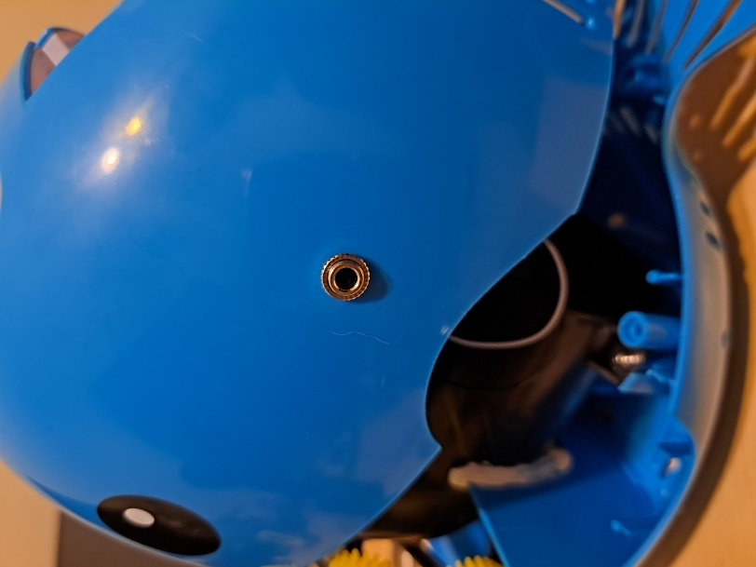

Step 12
Reassemble the whale and screw it back together with the 6 screws. The two shortest screws go into the tail. Make sure the wires do not touch the bubble wands or fan at the back of the whale.
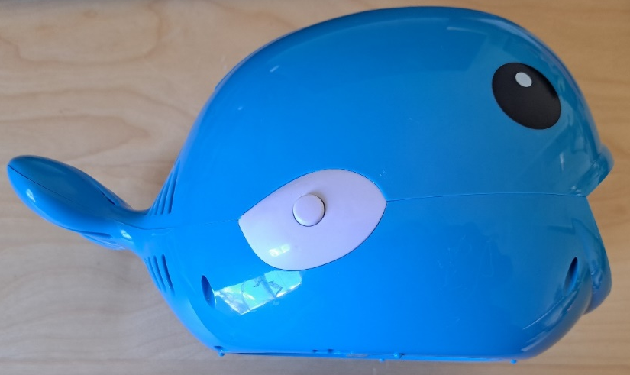

Step 13
Put the whale and the provided screwdriver back into the original packaging.
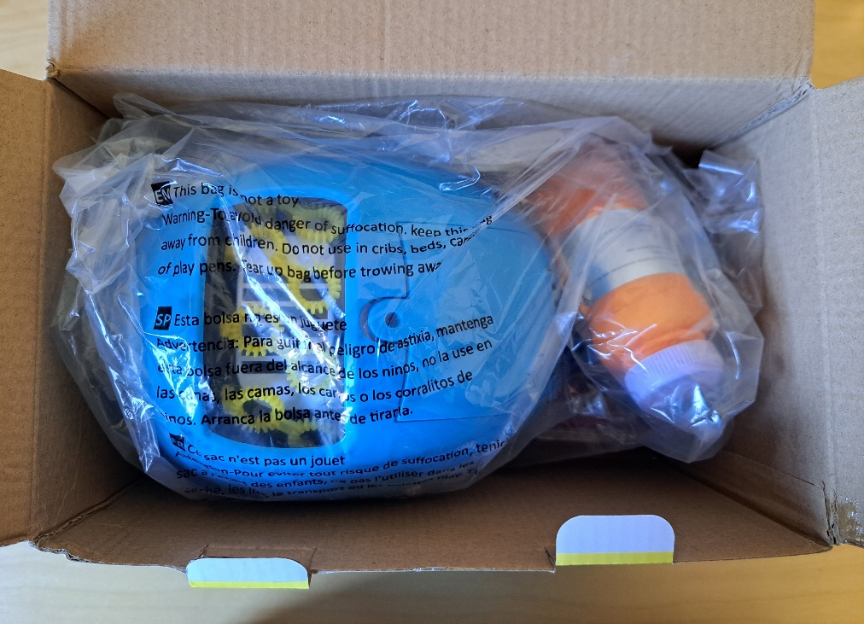

Testing
Put batteries into the whale. Press the original button to make sure it still works. The bubble wands should rotate and air should be blown through them when the button is pressed, then stop when it is pressed again. Plug a switch into the mono jack and press and hold the switch. The bubble wands should rotate and air should be blown through them while the switch is held and stop when it is released. Take the batteries out of the whale after testing so it does not turn on during shipping.

