Required Components
 | 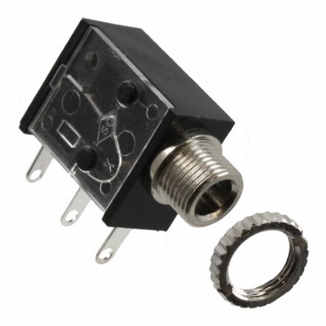 | BOM  - Amazon LED Electric Duck Climbing Stairs Toy  - Mono jacks x2  - 22 AWG Wire  - 2 AA Batteries  Refer to the Tool and Component List for purchasing details.
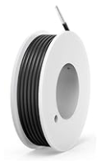 | 

Required Tools
- Phillips Screwdriver
- Soldering iron
- Wire stripper
- Flush cutter
- Drill and ¼ drill bit

Required Personal Protective Equipment (PPE)
- Safety Glasses

Assembly Instructions

Step 1
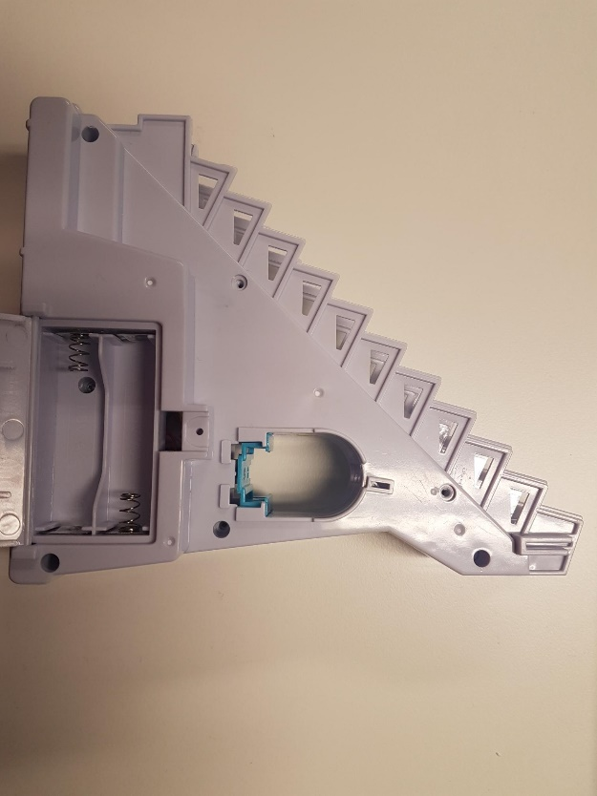 | - Carefully remove toy from packaging, the toy will be put back in packaging (if possible) after it is adapted  - This toy has a lot of parts – ducks and a track that can be kept in the box  - Using a screwdriver, turns screws indicated in the red circles to open the toy – including the screw inside the batter compartment  - Set screws aside in a safe place

Step 2
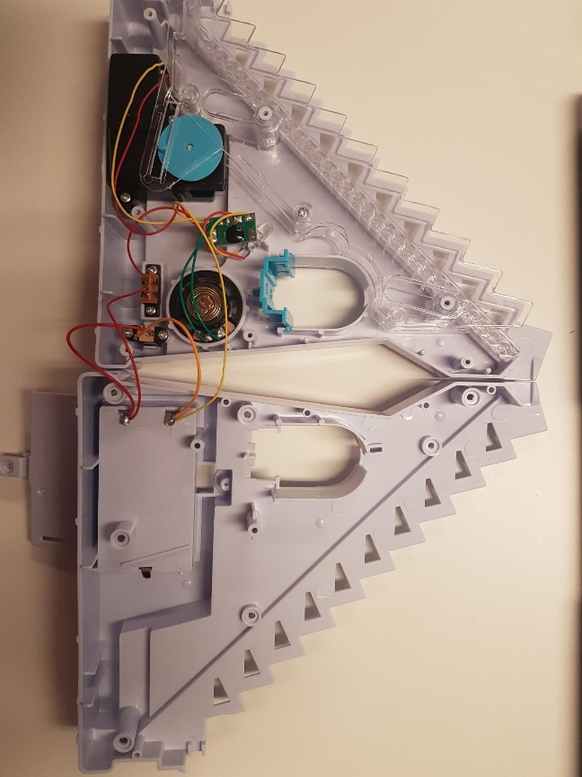 | - After screws are undone, gently pull the toy into two halves. Be very careful while doing this as to not pull off any existing wires or connections  - If some parts move, just take note of how everything fits together but they can also be set aside while you work on the toy.

Step 3
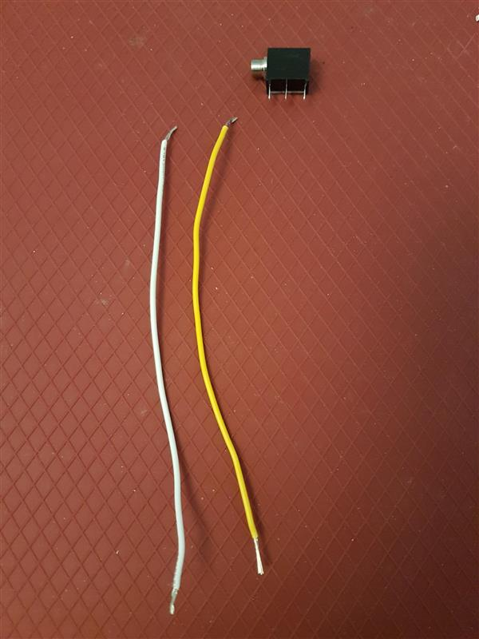 | Next we will prepare the mono jack and wires.  Cut 2 pieces of wire each 8 cms in length  Strip both ends of both wires, leaving about .5 cm of exposed wire on each end | 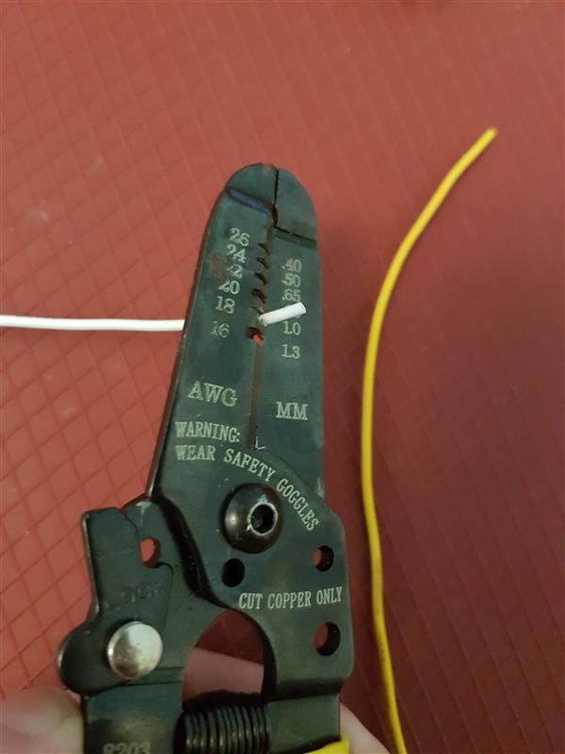

Step 4
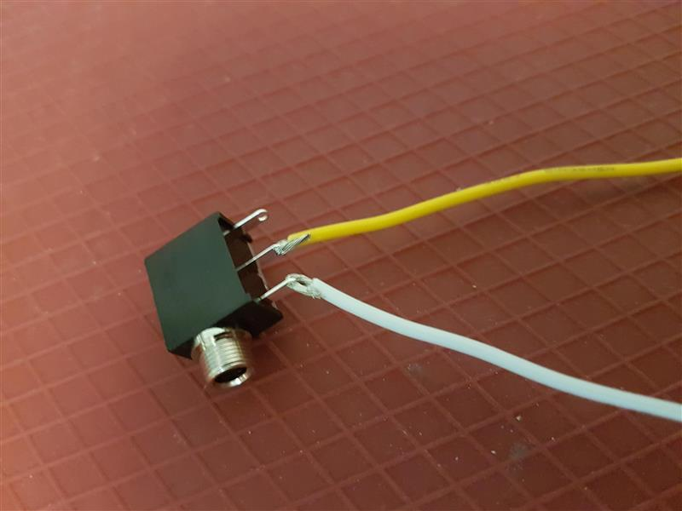 | - Pick one wire, slide exposed wire into first metal arm on mono jack (the arm closest to the circular jack)  - With second wire, slide one end of exposed wire into the middle metal arm on mono jack  - Solder wire to mono jack  Please Note: Check that you have the correct metal arms of mono jack, refer to picture

Step 5
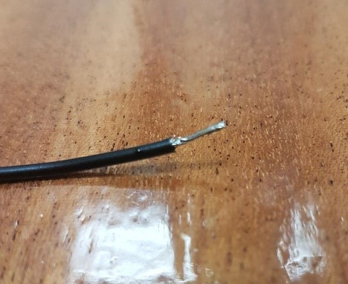 | - Tin the ends of your wire. The best way to do this is cover the exposed wire end in solder.  - This will help you stick the wires to an existing spot where the is solder

Step 6
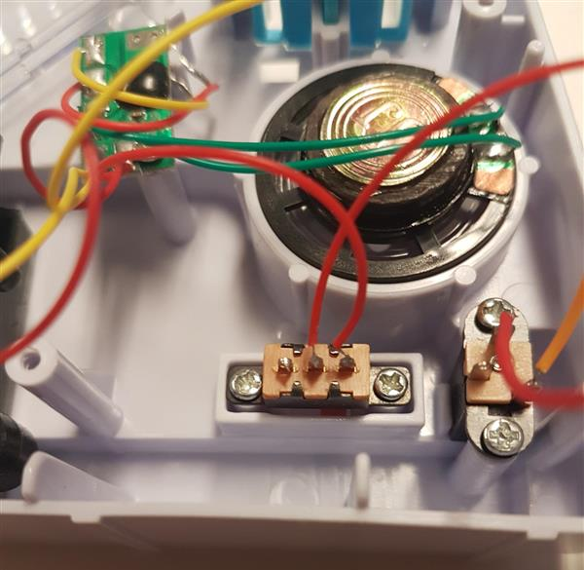 | - Locate where the on/off switch is located. Undo the screws and gently pull the switch to give yourself space to work with it  - For this assembly, we are attaching our mono jack + wires to the same spots on the original switch

Step 7
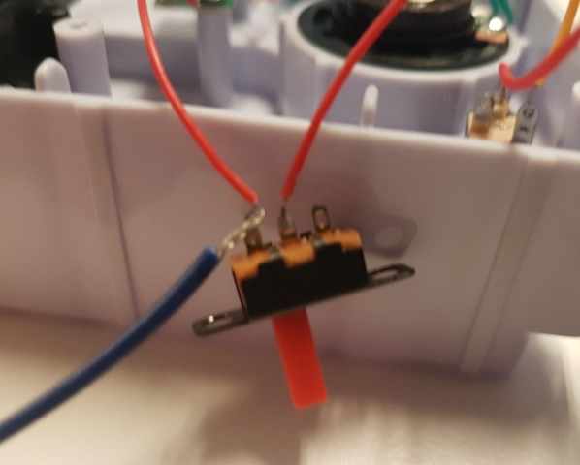 | - Using the wires and mono jack you previously prepared, you will solder the ends of your new wire to where the current red wires are.  - You will have one new wire and one old wire coming from each spot indicated in the circles  - Test your connections using an assistive switch. Listen for the motor to start when the switch is activated.  Please note: you will need batteries to test

Step 8
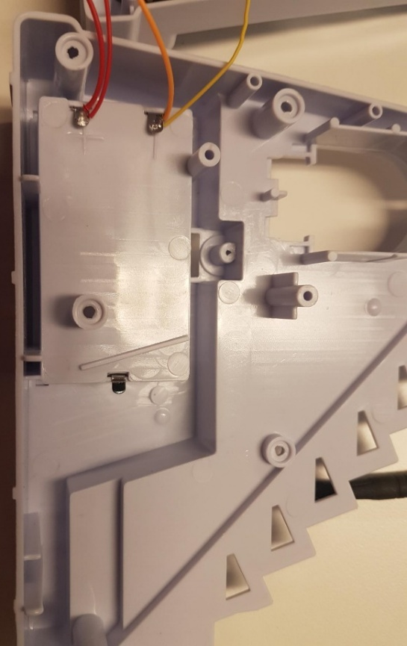 | - Using a ¼ inch drill bit, drill a hole to the side of the battery compartment.  - Check that the mono jack end fits through the hole and that it does not interfere with any mechanism of the toy.  - Add the ring to the outside of the toy to hold the mono jack in place.

Step 9
 | - Reassemble the original switch to its original position, close the toy – checking that no wires are being pinched and the mechanics are moving.  - Reassemble by adding the screws to their original spots.  Test the toy again once reassembled.

