Required Components
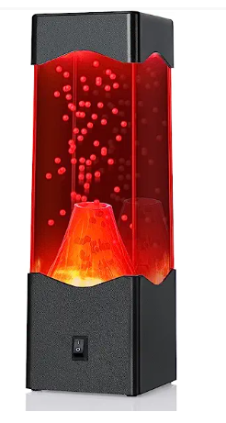  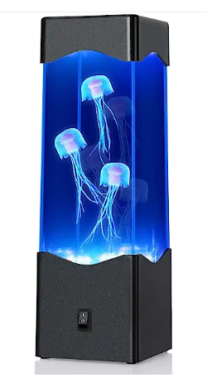 | 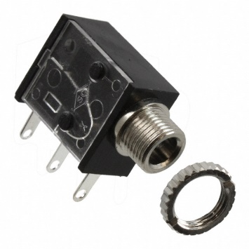 | BOM  - Volcano or Jellyfish Lava Lamp  - 3.5mm Mono jack and Ring  - 22 AWG Wire  - 3 AA Batteries  Refer to the Tool and Component List for purchasing details.
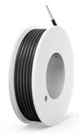 | 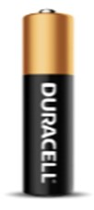

Required Tools
- Phillips Screwdriver
- Soldering iron
- Wire stripper
- Flush cutter
- Drill and ¼ drill bit

Required Personal Protective Equipment (PPE)
- Safety Glasses

Assembly Instructions

Step 1
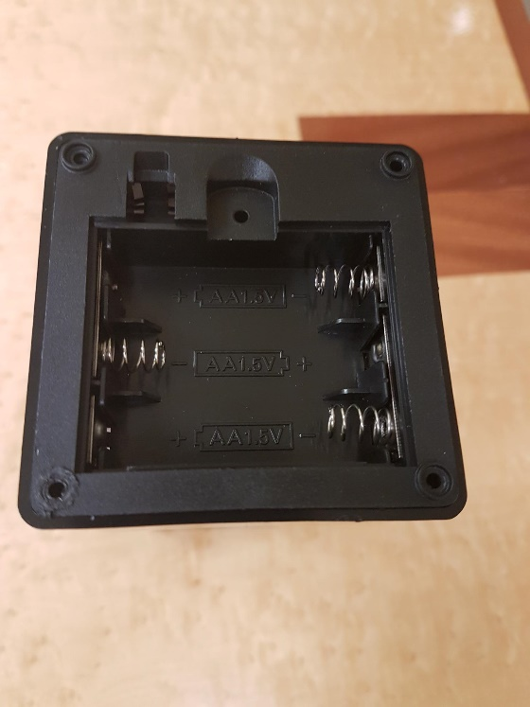 | - On the bottom of the lamp, locate 4 screws that hold the bottom plate in place  - Using a screwdriver, turn screws indicated in the red circles to remove bottom covering  - Set screws aside in a safe place

Step 2
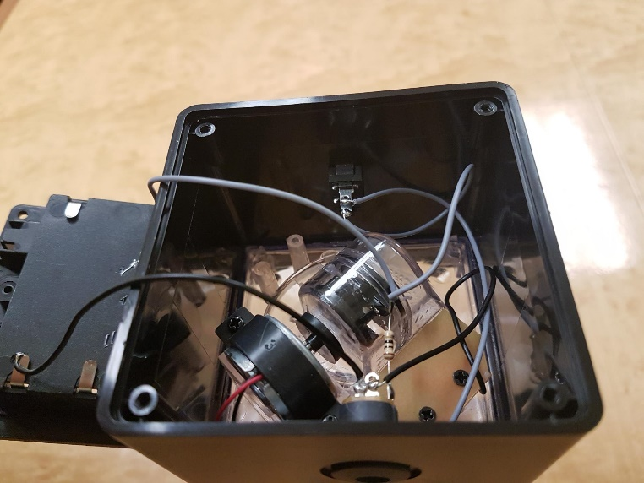 | - After screws are undone, gently take the bottom of lamp off and set to the side. There will be wires connected to the inside of the lamp, and to the batteries on the bottom. Be very careful while doing this as to not pull off any existing wires or connections

Step 3
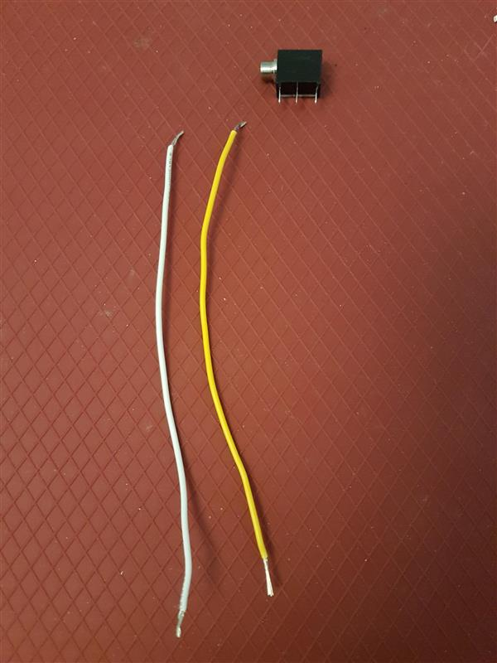  5 cm | Cut 2 pieces of wire each 5 cms in length  Strip both ends of both wires, leaving about .5 cm of exposed wire on each end | 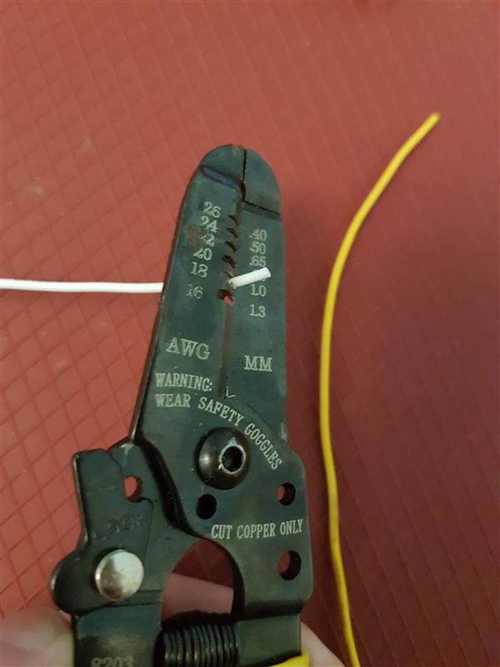

Step 4
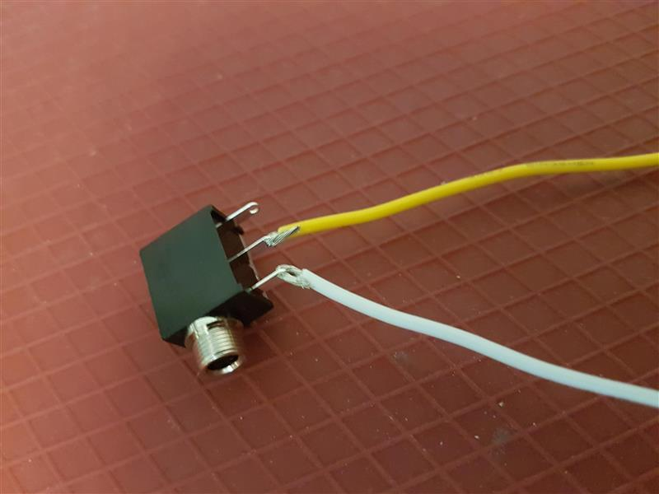 | - Pick one wire, slide exposed wire into first metal arm on mono jack  - With second wire, slide one end of exposed wire into the middle metal arm on mono jack  - Solder wire to mono jack  - Double check that you have the correct metal arms of mono jack, refer to picture

Step 5
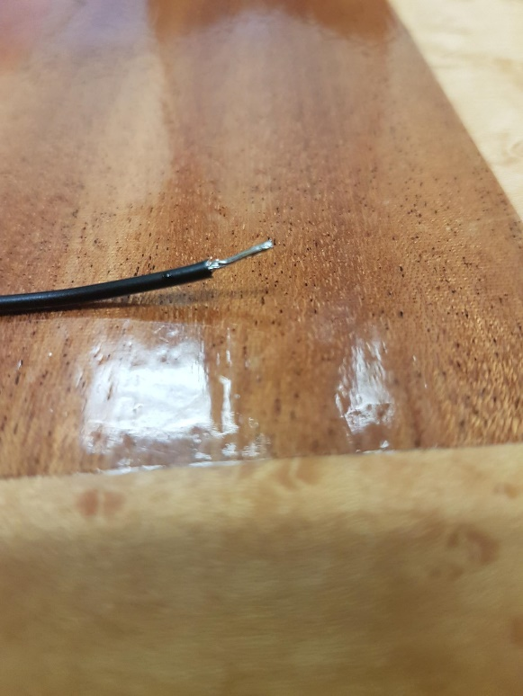 | - The ends of the wire not connected to the mono jack will be attached to the original switch inside the lamp. The best way to do this is cover the exposed wire end in solder before connecting it to the inside of the lamp

Step 6
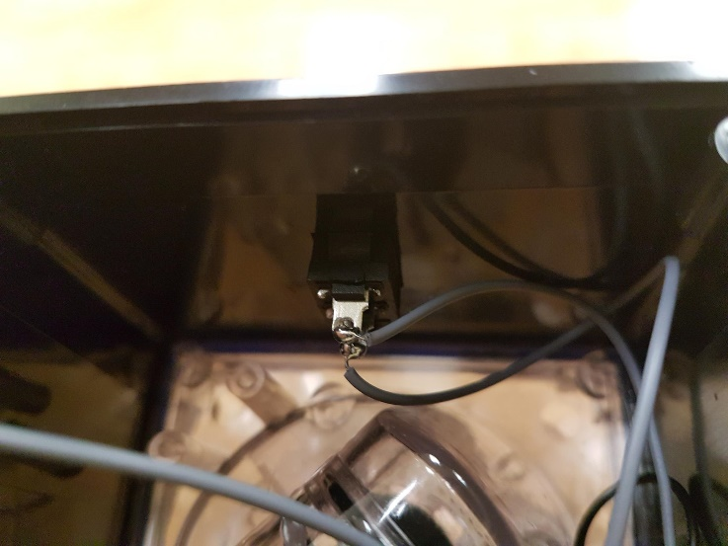 | - The original switch inside the lamp has 2 metal prongs with existing wires coming from them. You will be attaching your wires, one to each metal prong, while also keeping those original wires in attached.  - Hold each wire end to metal prong, use your solder iron to heat up the solder on your wire and the original solder on the metal prong. When you lift up your iron, the solder should dry and hold both wire ends (the original and new wire) to the switch

Step 7
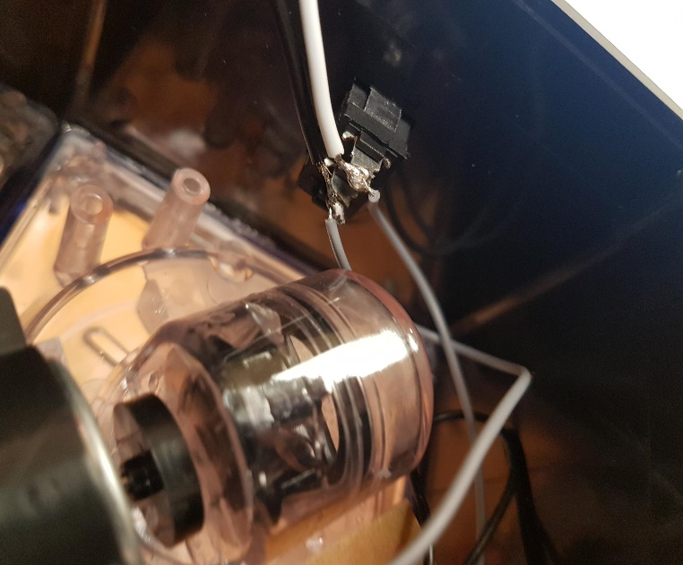 | - Be careful to not remove the original wire, or to have any solder going between the two metal prongs.  - When finished, you can check your connections by using a switch. Plug the switch into the mono jack, and squeeze to activate. This should make the lights and motor of lamp turn on.  - You will need to batteries in place for testing.

Step 8
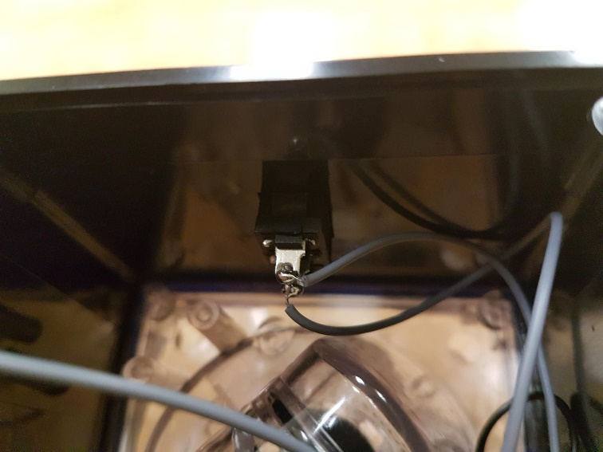 | - With ¼ inch drill bit, you will drill hole in the plastic, just to the side of the original switch.  - Before drilling, make sure your mono jack will reach the drilled hole.  - Check that mono jack out end can fit through the hole to be accessed from outside the lamp  - Twist ring onto input on the outside of lamp to secure the mono jack in place

Step 9
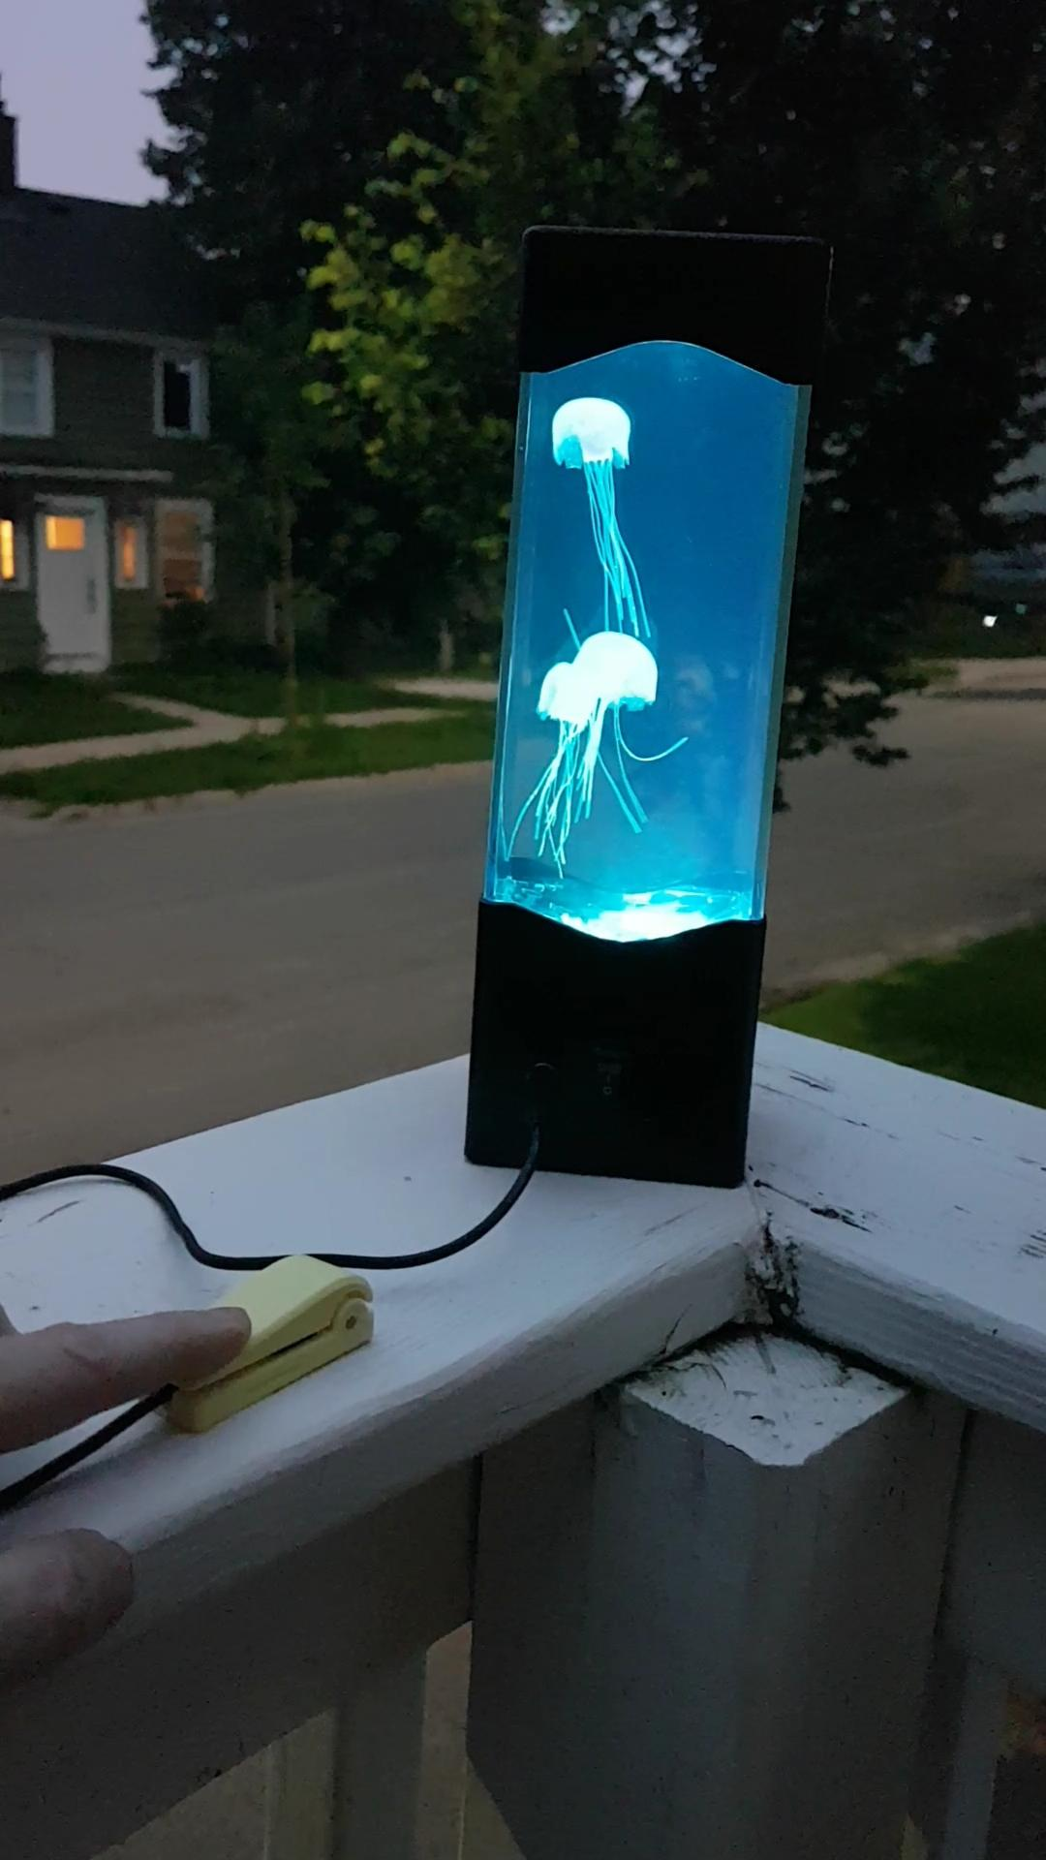 | - Replace the bottom to the lamp, secure screws  Complete!

