Required Components
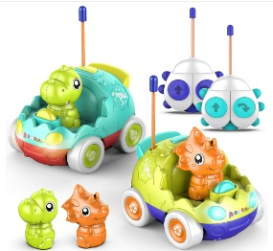 | 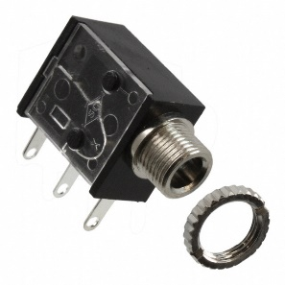 | BOM  - AEROQUEST RC Dinosaur Car  - 3.5 mm Mono Jack (x4)  - 22 AWG Wire  - 10,000 pf (103) Capacitor (x2)  Note: Requires total of 10 AA batteries  Refer to the Tool and Component List for purchasing details.
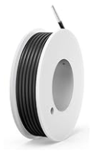 | 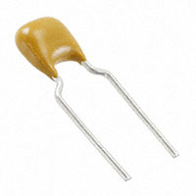

Required Tools
- Small Phillips screwdriver
- Drill and 1/4” drill bit
- Wire strippers
- Soldering iron and solder
- Flush Cutters

Required Personal Protective Equipment (PPE)
- Safety glasses

Assembly Instructions
- Turn over the toy remote and remove all 4 screws. | 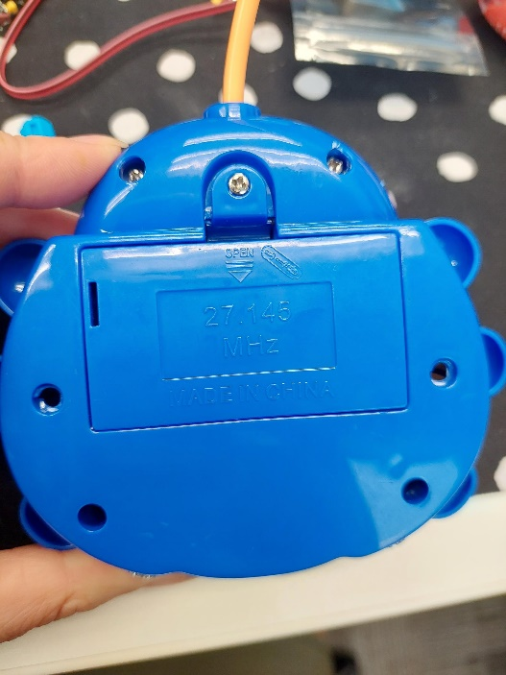
- Take apart the two halves and set aside the top half. When the toy is open, flip over the protoboard. | 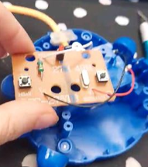
- Cut 4 lengths of wire about 10cm long | 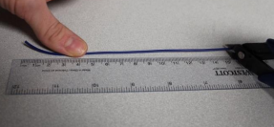
- Strip approximately 0.5cm off of the small wires.  Repeat on all four wires, both ends. (8 times total)  Note: using your fingers twist together the loose wires to ease soldering. | 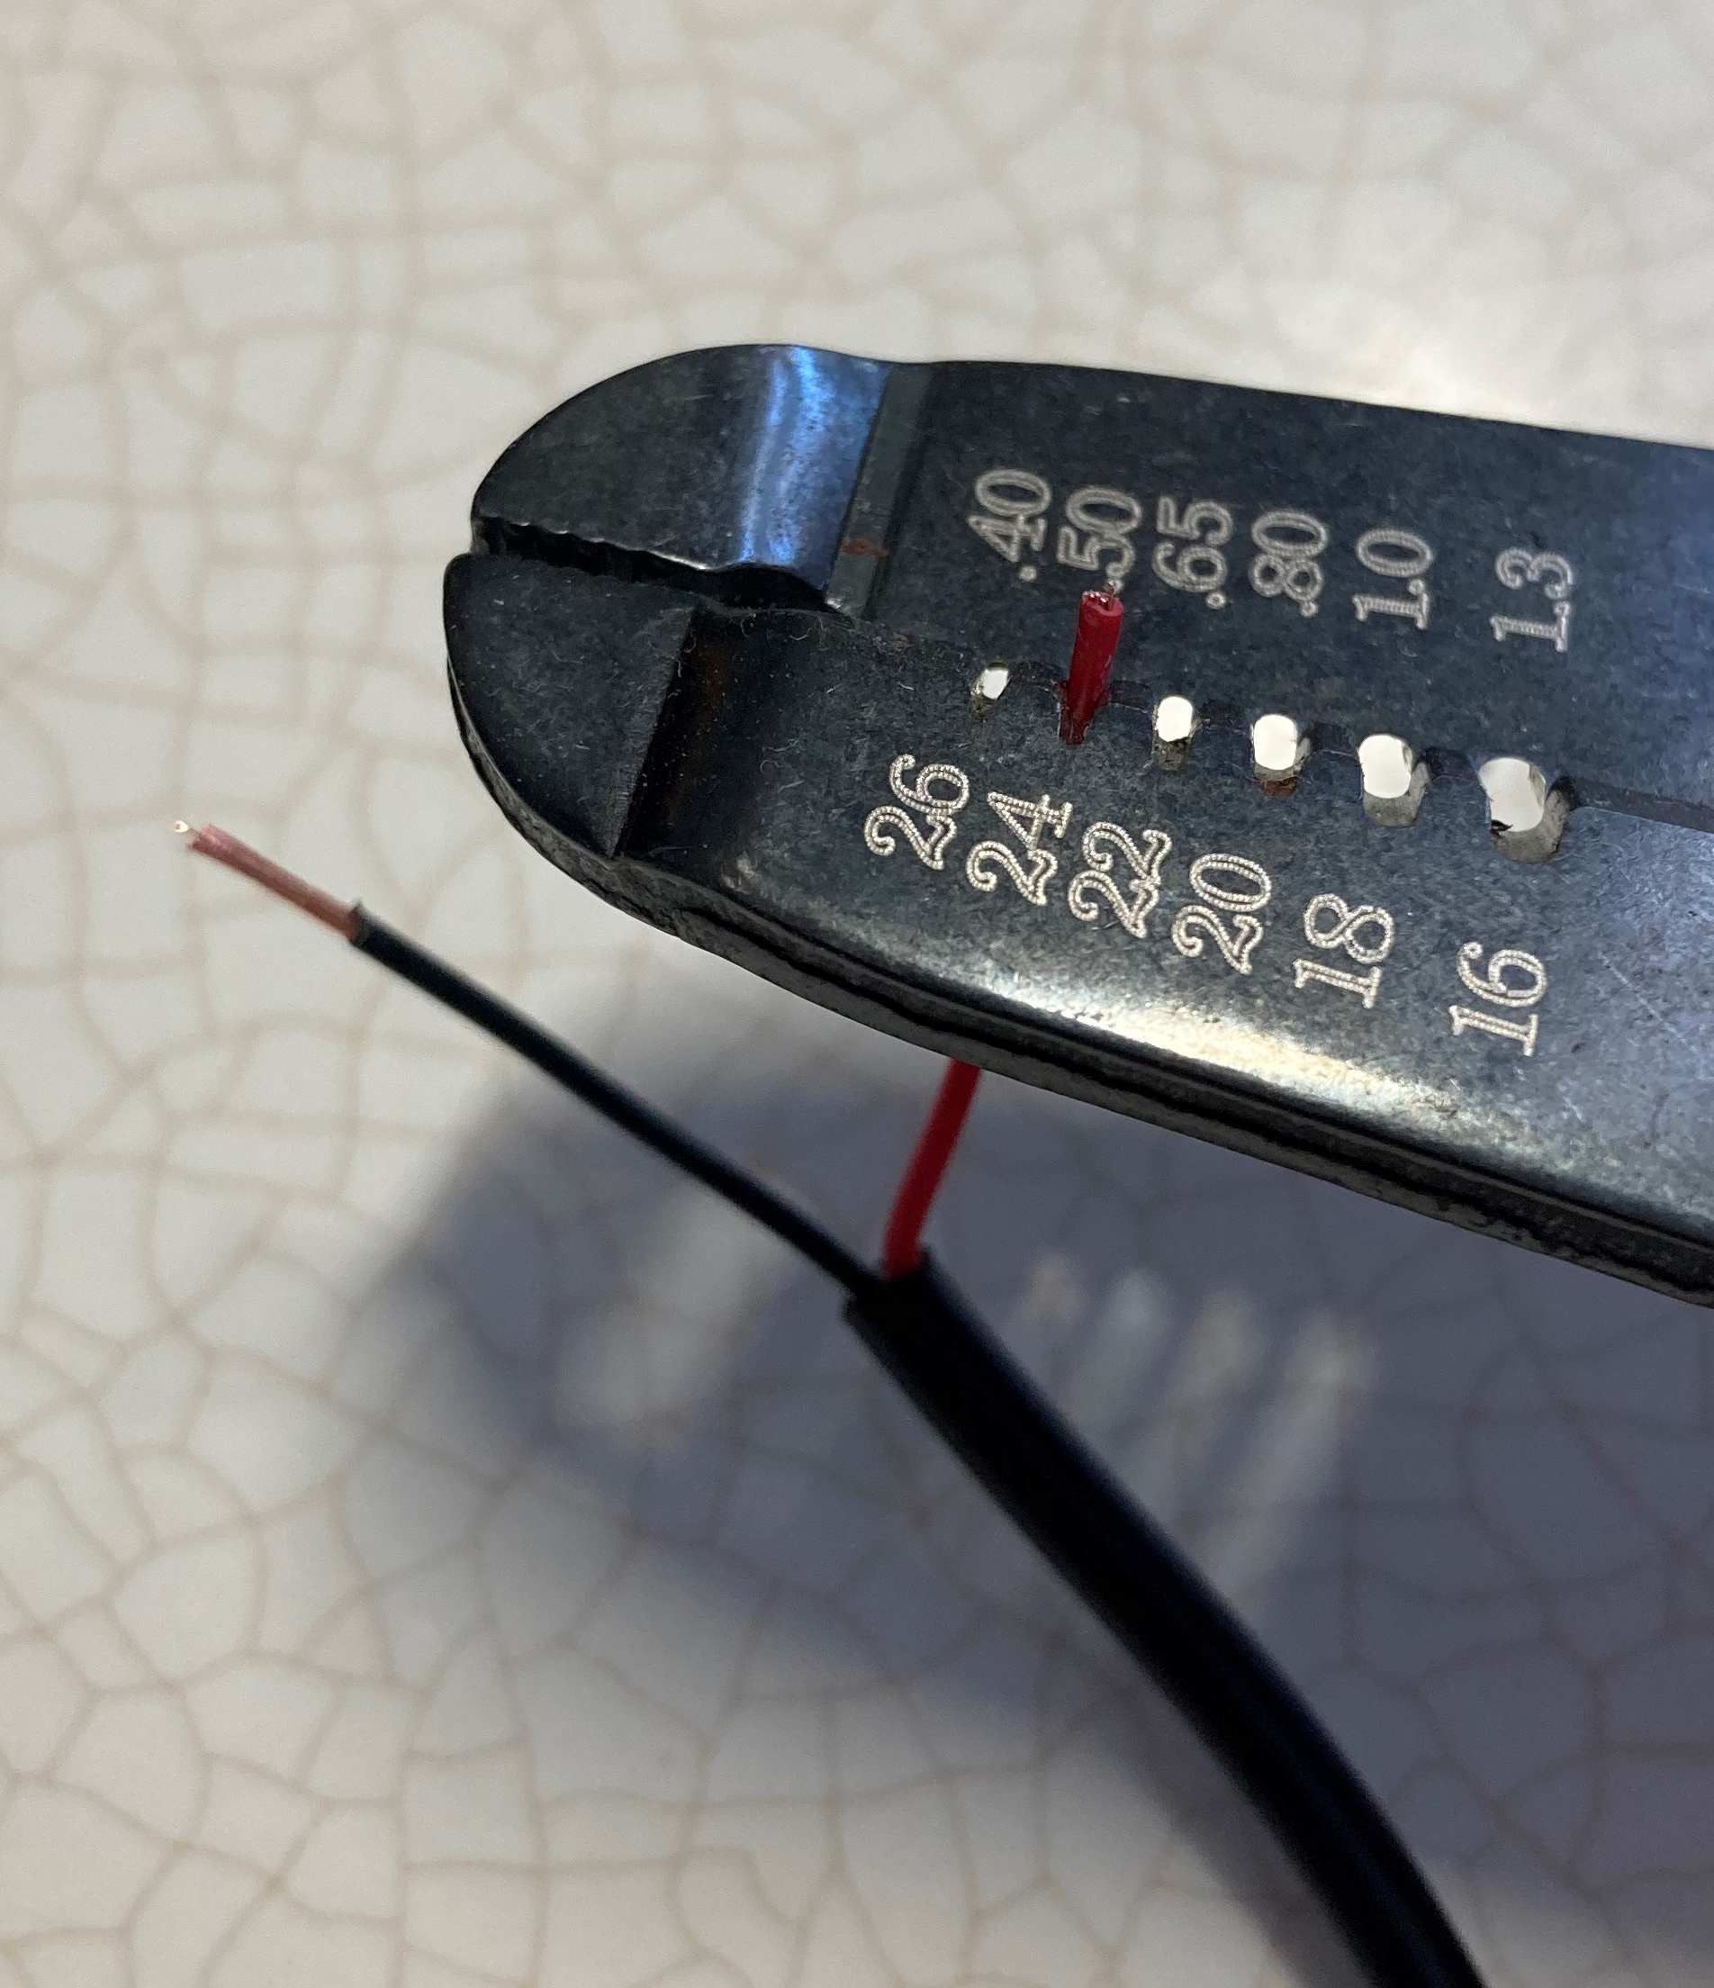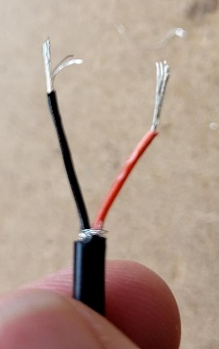
- Solder a wire to the first leg of a mono jack (closest to the port), solder a second wire to the second leg of the mono jack.

Repeat with the second mono jack and remaining wires.
- Prior to soldering to the device, cover the exposed wire end in solder. | 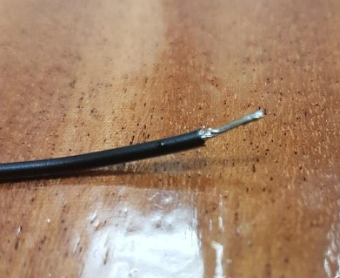
- The pink and blue circles shown in the picture to the right will be where we are soldering the connection to. | 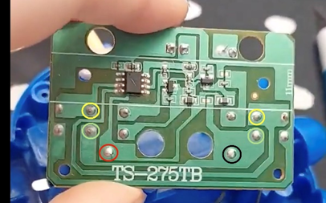
- Solder the two wires of a jack onto the circuit board as shown. Solder the capacitors with the wire.  With your flush cutters, trim the leads of the capacitor past where they were soldered.  Repeat on all four points.  Note: It is easy to melt the board; use caution.  CHECK: make sure no solder or wires are connecting the two solder blobs together. | 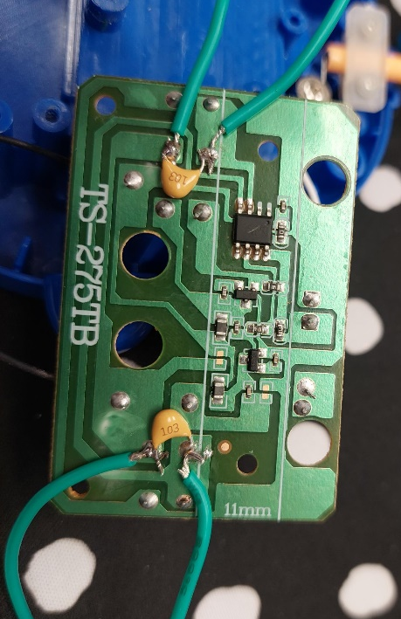
- Using a drill with a ¼ inch drill bit, drill two holes in the bottom casing of the remote.  Repeat for 2 hole.  Note: Make sure you are adjusting the location for the space of the two jacks. | 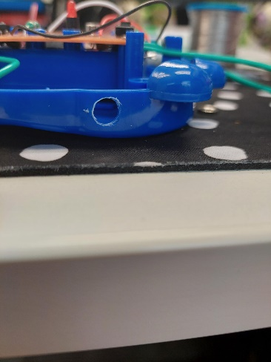
- Remove the nuts from the mono jacks and push the input of the mono jack through the holes you drilled. Reinstall the nuts onto mono jacks appearing on the outside of the plastic. Tighten to secure. | 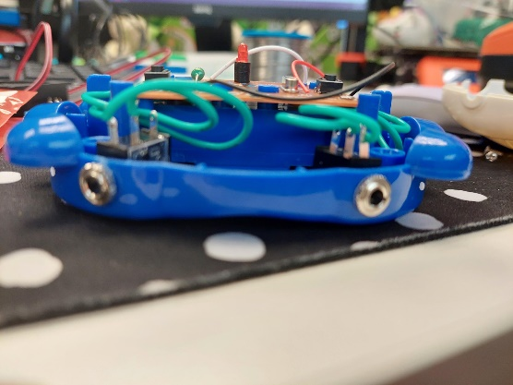
- Carefully, while ensuring no wires are pinched, line up all the screw holes of the top and bottom of the controller. Reinstall screws from step one.
- Plug in an assistive switch and test.
If the toy doesn’t turn on when the switch is activated, open the toy back up and check all the solder connections.

