Required Components
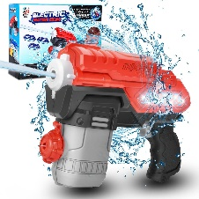 | 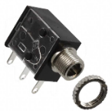 | 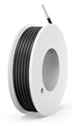 | BOM  - Ansee – Electric Water Gun  - 3.5mm mono jack  - 24 AWG wire  Refer to the Tool and Component List for purchasing details.

Required Tools
- Phillips screwdriver
- Wire strippers
- Soldering iron and solder
- Drill and 1/4” drill bit
- Flush Cutters

Required Personal Protective Equipment (PPE)
- Safety glasses

Assembly Instructions
- Open by the toy by removing the 13 screws securing the toy. | 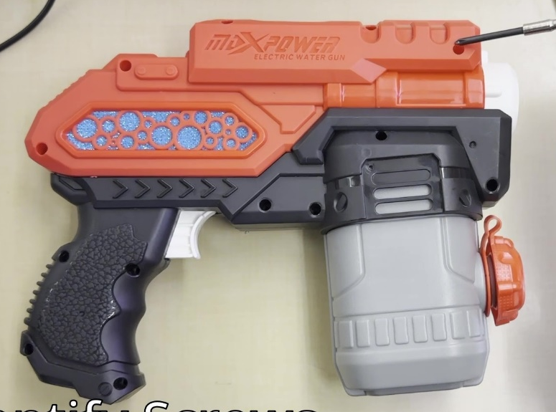
- Disconnect the black battery compartment from the rest of the toy. | 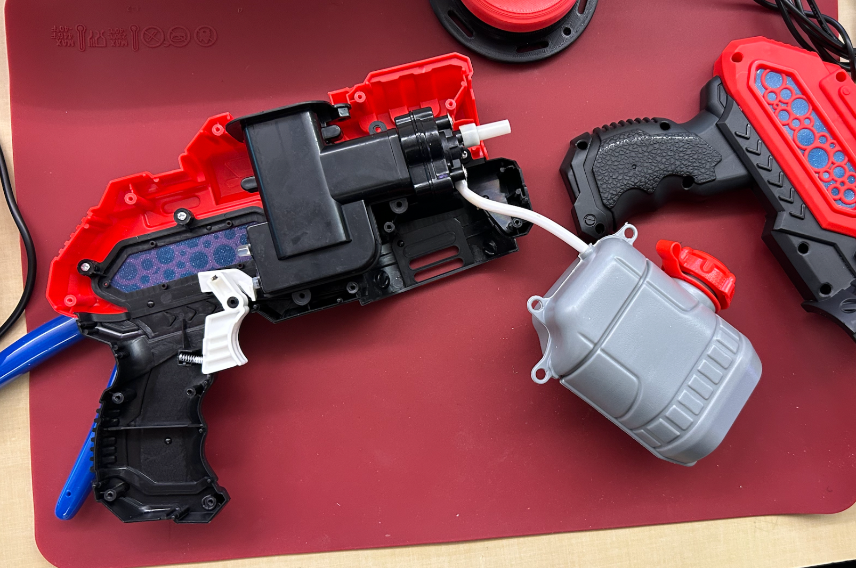
- Pry open the battery compartment from the top. | 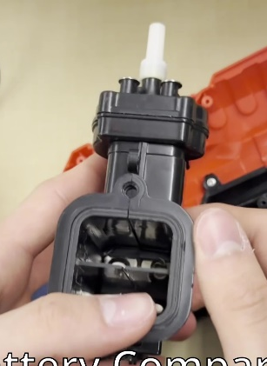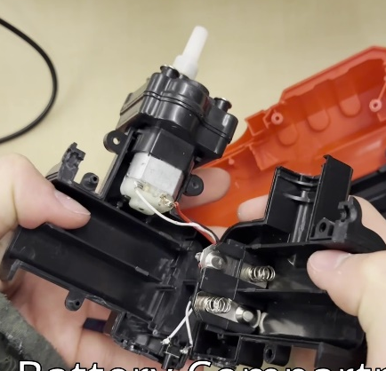
- Cut 2 pieces of wire each 10cm in length  Strip both ends of both wires, leaving about .5 cm of exposed wire on each end | 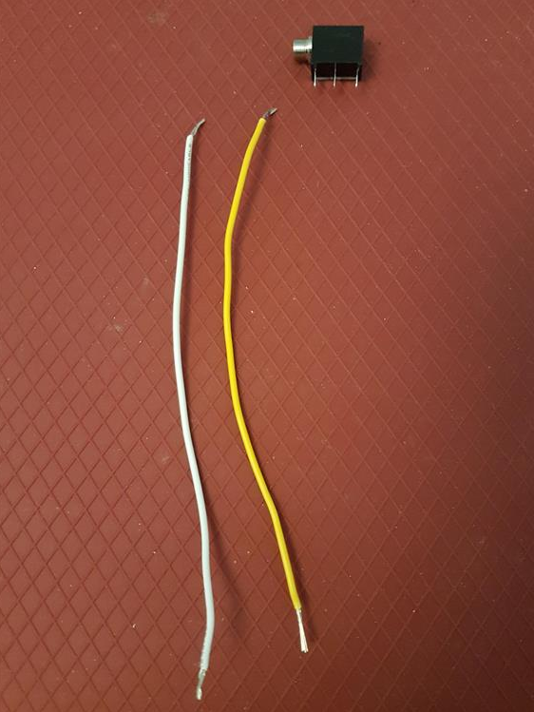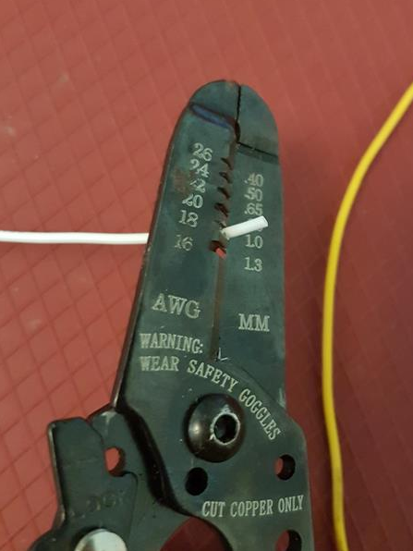  10 cm
- Pick one wire and hook the end onto the left lead on mono jack. Note the jack orientation.  Repeat for the second wire with the middle lead.  Solder wire to mono jack. Double check that you have the correct metal arms of mono jack, refer to picture | 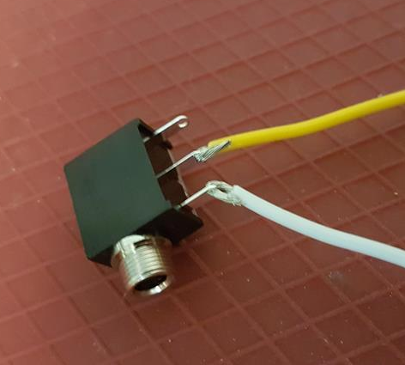
- Prior to soldering to the device, tin your 2 wires. The best way to do this is cover the exposed wire end in solder. | 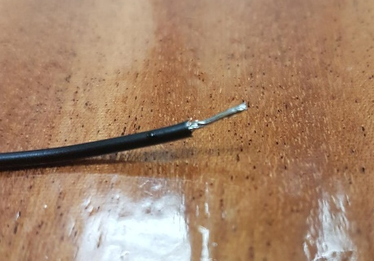
- Identify the black switch in the battery compartment.  Solder the end of one wire prepared in Step 5 to the location depicted. | 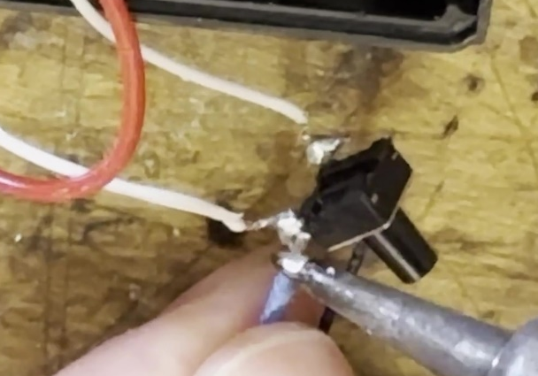
- Solder the end of the second wire prepared in Step 5 to the location depicted.
- Reassemble the battery compartment, making sure the mono jack is on the outside. | 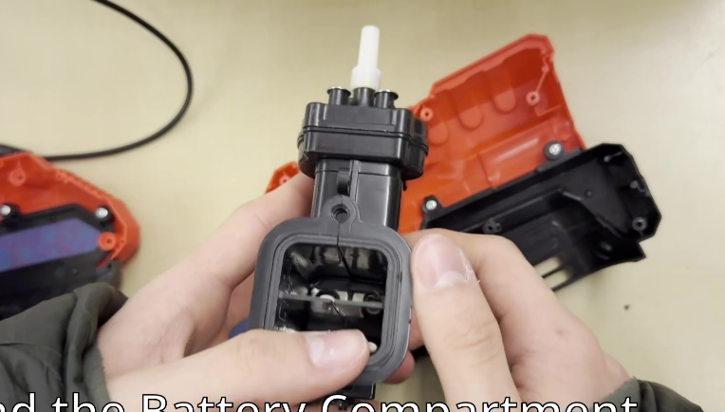
- Use a drill to make a hole in the depicted location. | 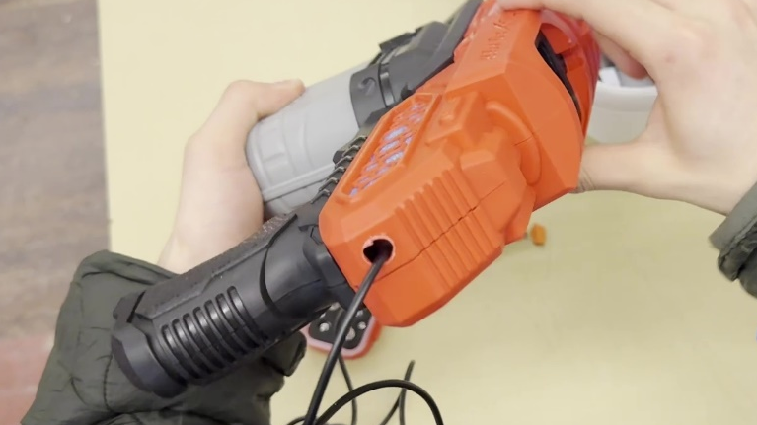
- Insert the mono jack into the hole from the inside of the casing.  Secure it in place by twisting on the jack ring from the outside. | 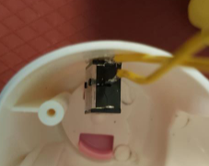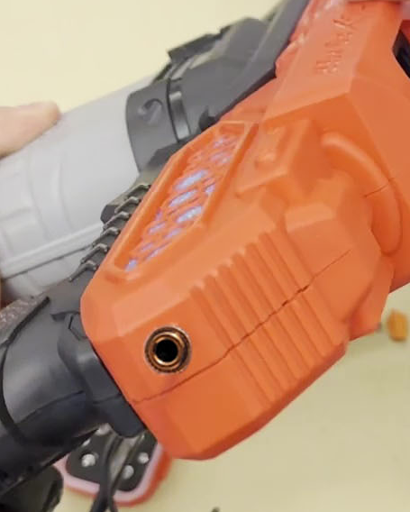
- Reassemble the toy and test with an assistive switch | 