Required Components
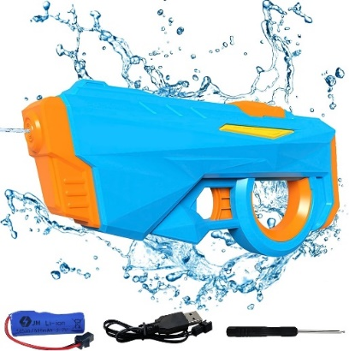 | 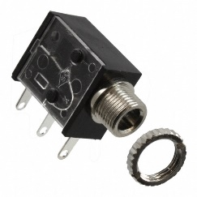 | 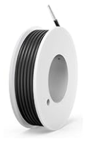 | BOM  - MEMOVAN Electric Water Gun  - 3.5 mm Mono jack and ring  - 22 AWG Wire  Refer to the Tool and Component List for purchasing details.

Required Tools
- Precision Philips Screwdriver (may be included with water gun)
- Soldering iron
- Wire stripper
- Drill and ¼ drill bit

Required Personal Protective Equipment (PPE)
- Safety Glasses

Assembly Instructions

Step 1
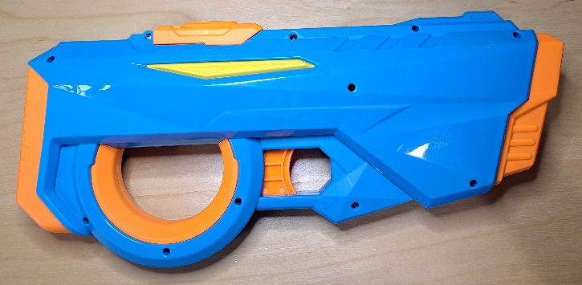  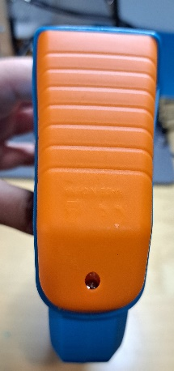 | - Carefully remove toy from cardboard, the toy will be put back in cardboard (if possible) after it is adapted  - Remove the 12 screws from the toy (11 on the side, one on the back battery compartment)  - Set screws aside in a safe place

Step 2
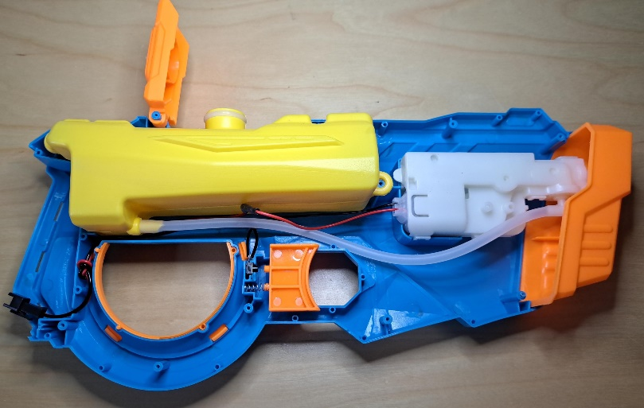 | - After screws are undone, separate the two halves of the toy

Step 3
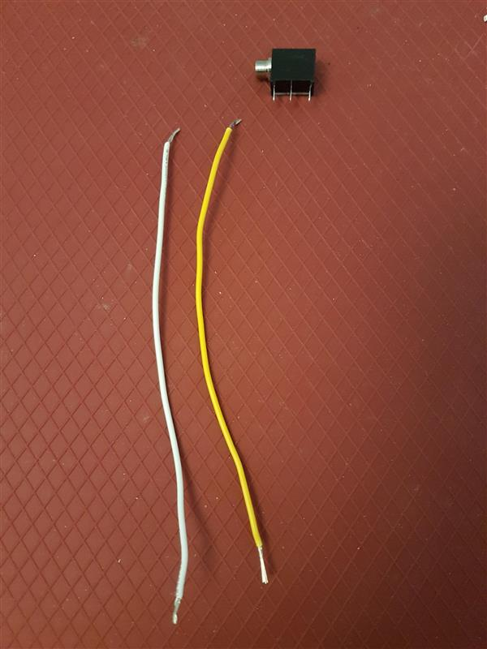  10 cm | Next we will prepare the mono jack and wires.  Cut 2 pieces of wire each 10 cm in length  Strip both ends of both wires, leaving about .5 cm of exposed wire on each end | 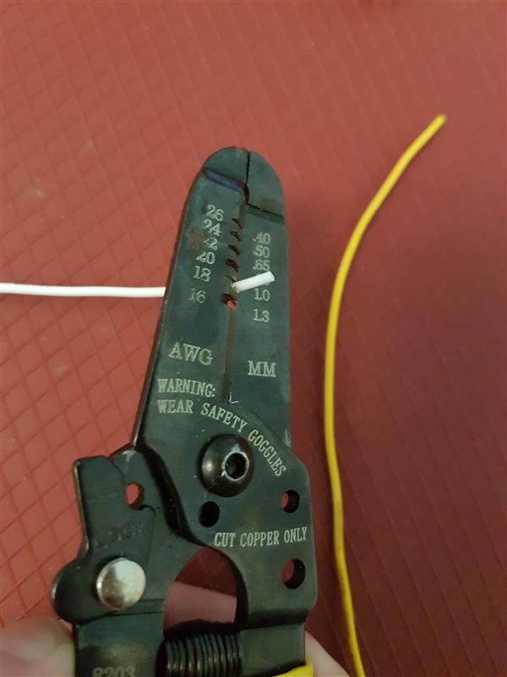

Step 4
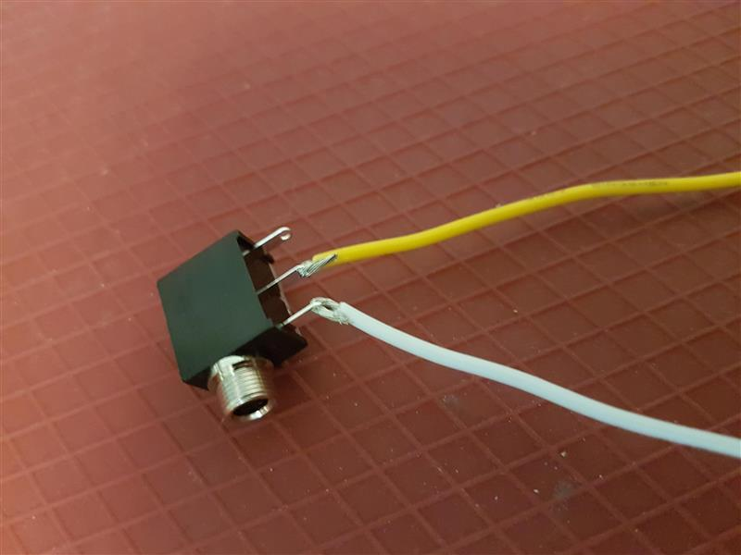 | - Pick one wire, slide exposed wire into first metal arm on mono jack  - With second wire, slide one end of exposed wire into the middle metal arm on mono jack  - Solder wire to mono jack  - Make sure no wire or solder connects the two leads of the mono jack  Please Note: Check that you have the correct metal arms of mono jack, refer to picture.

Step 5
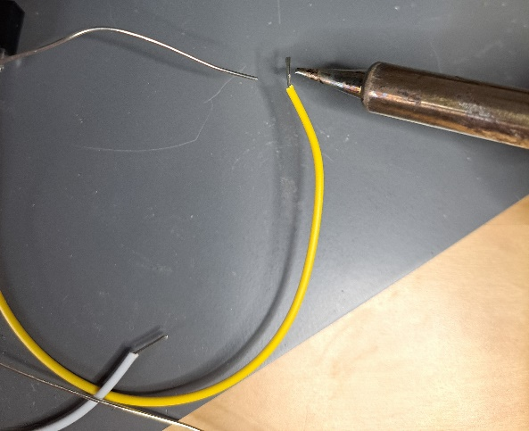 | - Using the soldering iron, add solder to the remaining ends of the wires you soldered to the mono jack

Step 6
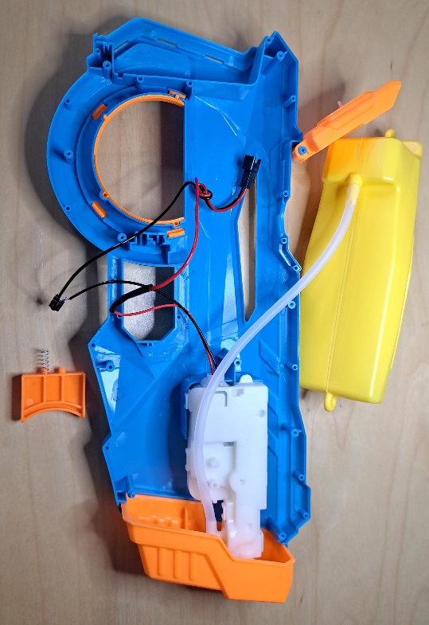 | - Locate the switch that controls the toy. It rests behind the orange trigger.  - Pull the switch out of the toy, leaving all wires connected.  - If it helps, you can also take out/move any of the other loose parts in the toy, just take note of how it all fits together so you can reassemble easily.

Step 7
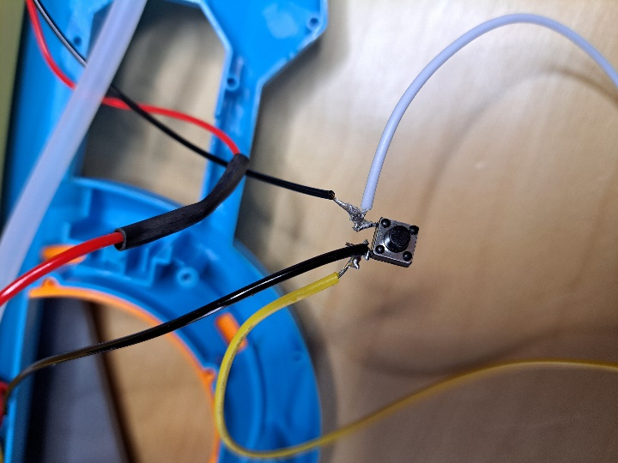 | - Solder one wire from the mono jack to one side of the switch, and solder the other wire to the other side, as the existing wires are soldered.  - Make sure no solder or wires connect the two sides of the switch together.  - If the existing wires come off while soldering, simply solder them back on where they were originally connected.

Step 8
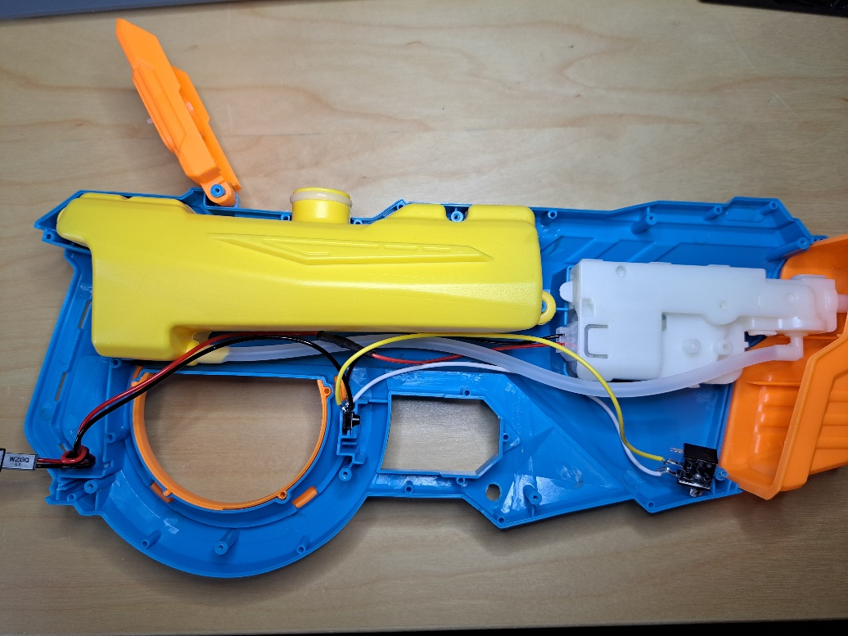 | - Using the ¼” drill bit, drill a hole as indicated in the photo, to access the mono jack.

Step 9
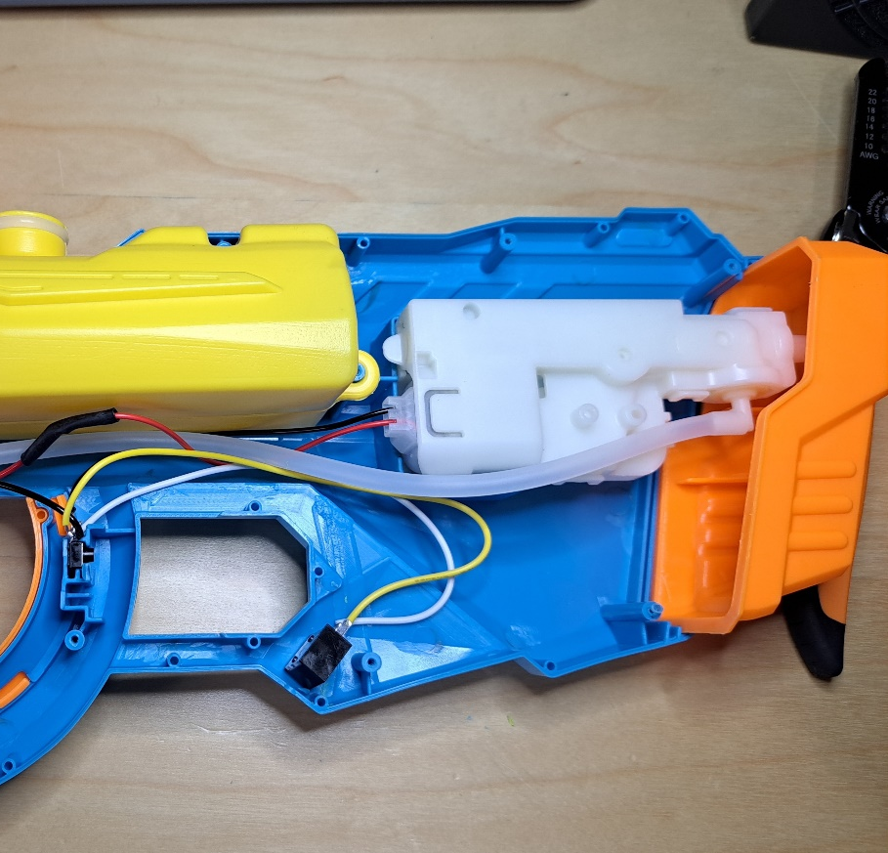 | - Slide the original switch back into position where it was before soldering.  - Push the threads of the mono jack through the hole you previously drilled.  - If the threads do not poke out the other side, double check if the nut is attached to the jack still. If it is, remove it.

Step 10
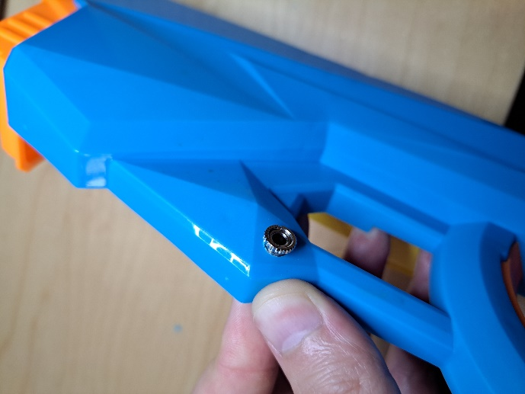 | - Tighten the nut onto the jack from the outside of the toy, locking the mono jack in place.  - You may want to use the front portion of your wire strippers to tighten it securely.

Step 11
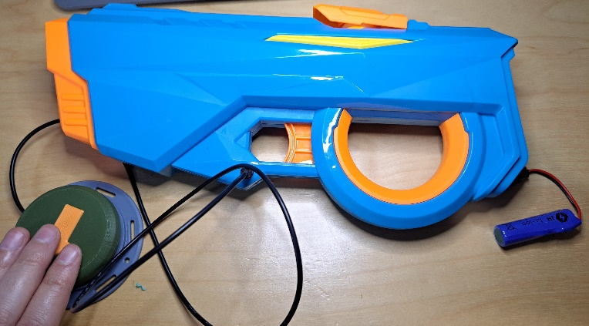 | - Test the toy before fully reassembling.  - Connect the provided battery to the toy.  - Plug an assistive switch into the mono jack.  - Test both the original switch in the toy and the assistive switch  - The toy should turn on only when the assistive switch or original switch is pressed  - If the toy is constantly on, double check if any wire or solder is connecting the two sides of the original switch, or the two leads of the mono jack.  - If the toy never turns on, check to make sure you soldered the correct leads of the mono jack, and that wires are connected properly to the original switch in the toy.

Step 12
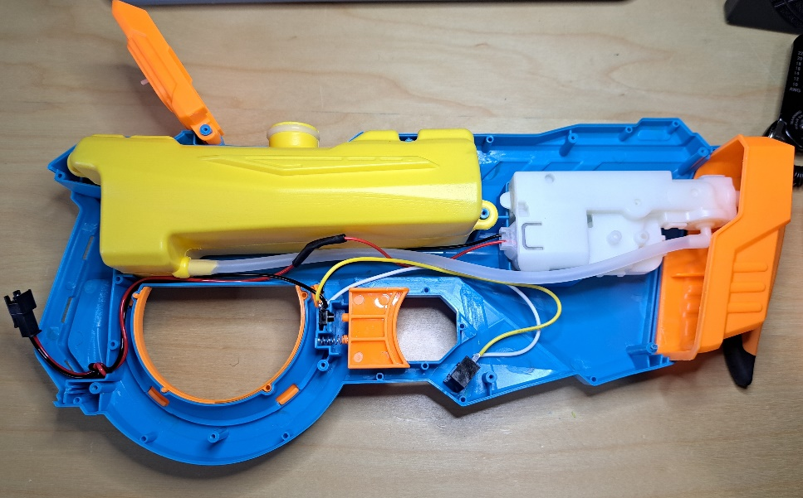 | - Put all parts back into place.  - Arrange all wires and the clear water tube so they won’t get pinched when reassembling the toy.  - Make sure the knot on the battery connection will sit inside the toy when it is closed

Step 13
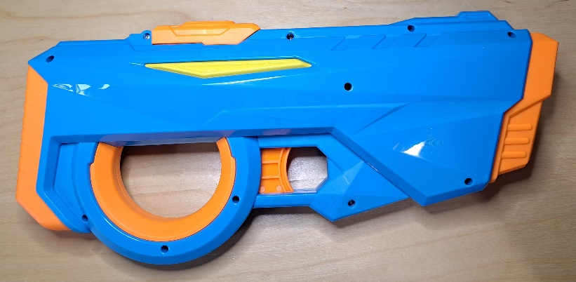  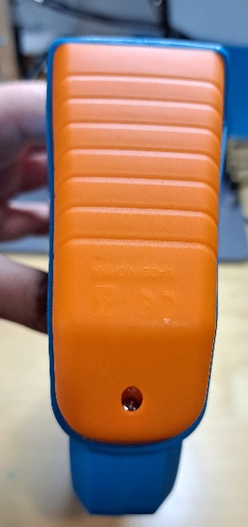 | - Connect the two halves of the body of the toy, and put all the screws back in.  - Once the toy is fully reassembled, double check the mono jack and original trigger both work.

