Required Components
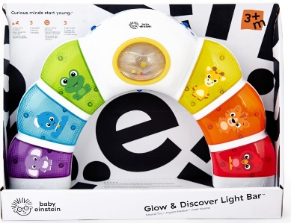 | 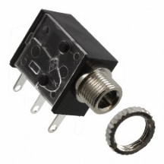 | 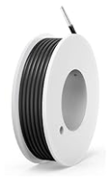 | BOM  - Baby Einstein – Glow  & Discover Light Bar  - 3.5 mm Mono Jack and Nut  - 22 AWG Wire  Refer to the Tool and Component List for purchasing details.

Step 1: Unbox the Light Bar  Pry open the cardboard flap on the box | 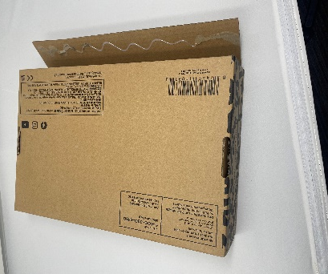
Step 2: Remove Screws  Remove the 12 screws on the back side of the toy | 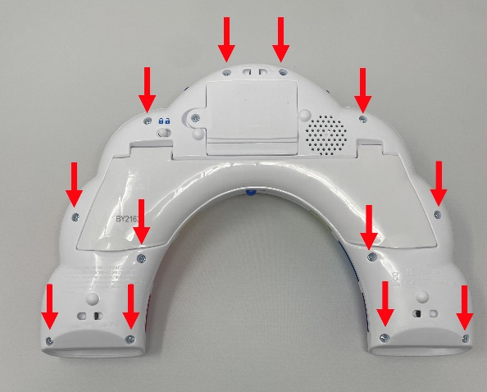
Step 3: Remove additional screws  Lift the white toy stand and remove the 4 screws under it | 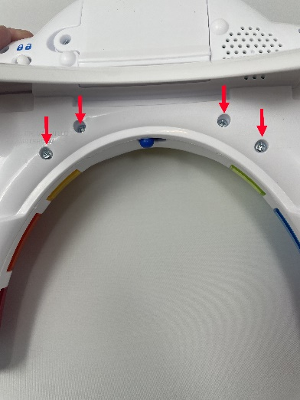
Step 4: Pry the Toy Open  Gently pry the toy open to access the internal electronics | 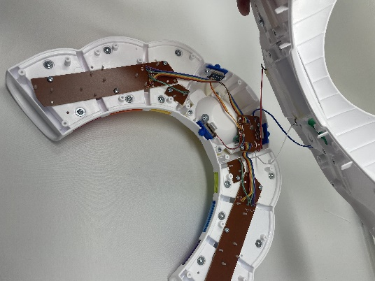
Step 5: Detach the Switch PCB  Unscrew the two screws on the main switch PCB. This will allow us to access the solder points on the other side | 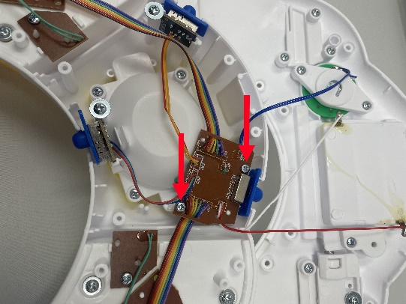
Step 6: Cut and prepare 2 wires  Cut two pieces of wire about 10-15 cm long. Using wire strippers, remove the plastic insulation from the last 2 cm on each end | 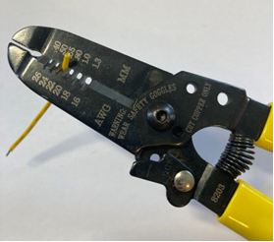
Step 7: Tin one end on each wire  Twist one end of each wire so that the individual strands are tight, then heat the wire with the soldering iron, then apply some solder to the wire | 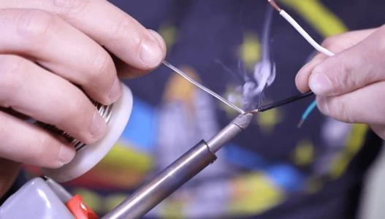
Step 8: Solder the wires into place on the PCB  With the tinned wire in one hand and the soldering iron in the other, heat the solder on the highlighted spots on the PCB, then insert the tinned wire. Remove the iron and the wire should stay in place | 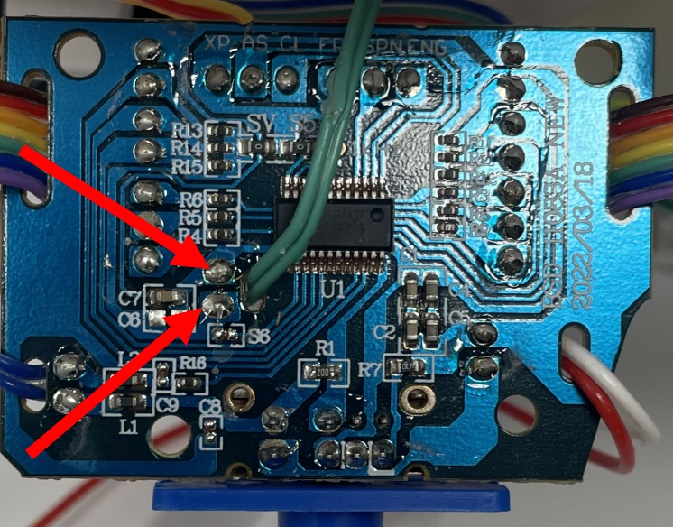
Step 9: Ensure that wires aren’t bridged  Check that the new wires and solder aren’t touching other parts of the PCB | 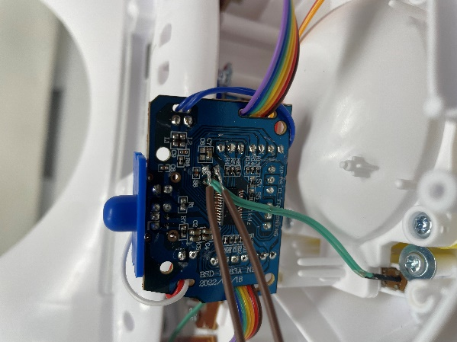
Step 10: Solder the Wires to the Switch Jack  Solder the wires to the 2 legs closest to the threaded end. | 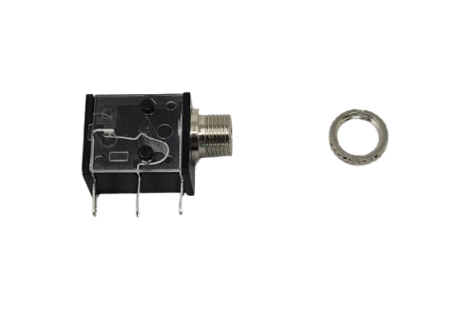  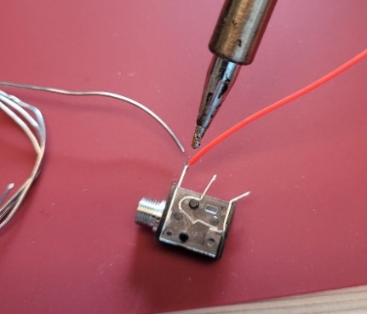
Step 11: Test!

Insert 3 batteries into the toy, then plug a switch into the switch jack. The toy should start playing music when you touch the switch.

Step 12: Drill a hole in the toy  Using a drill with a 1/4” drill bit, put a hole in the toy enclosure as indicated | 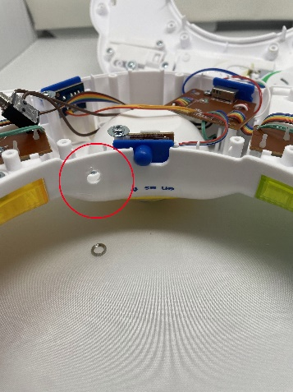
Step 13: Install the Jack Nut  This will keep the jack locked to the side of the toy enclosure | 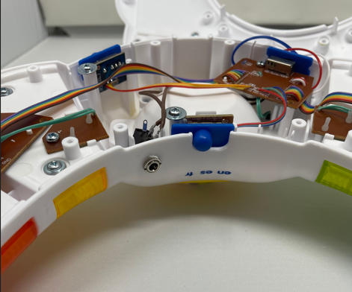
Step 14: Reassemble the toy  Remount the switch PCB using two screws, then close up the toy and re-screw the toy enclosure. | 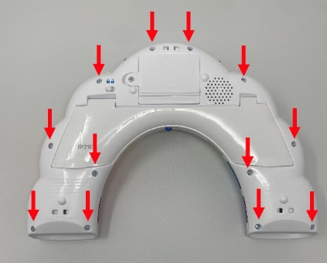  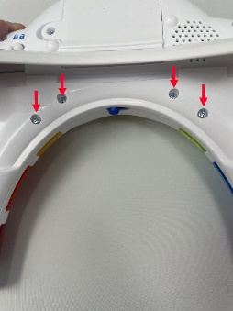
Step 15: Replace it in the Box

Carefully re-box the toy into its original packaging, and secure the top flap with Clear Tape.

