Required Components
 | 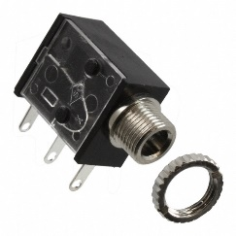 | BOM  - Dan&Darci Paint Spin Art Machine  - 1 Mono jack and nut  - 22 AWG Wire  - 4 AA Batteries  Refer to the Tool and Component List for purchasing details.
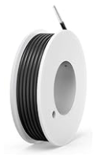 | 

Required Tools
- Phillips Screwdriver
- Wire stripper
- Flush cutter
- Soldering iron and stand
- Drill and ¼ inch bit

Required Personal Protective Equipment (PPE)
- Safety Glasses

Assembly Instructions

Step 1
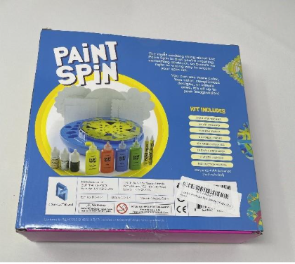 | - Carefully cut the tape and open the box  - Set the paints and markers aside, we will reassemble the kit once the toy is adapted

Step 2
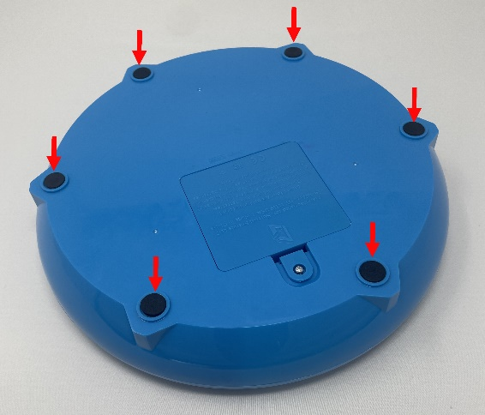 | - On the bottom of the toy, locate the black foam pads, lift these up and set aside  - Utilizing a screwdriver, turns screws indicated in the red arrows to remove bottom covering  - Set screws aside in a safe place

Step 3
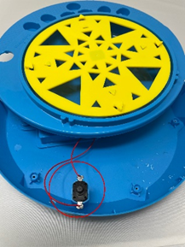 | - After the screws are out, you can gently pull the toy open. It will not come completely apart, but enough to access the inside of the toy.  - Locate the original on/off switch and pull it out of its original spot

Step 4
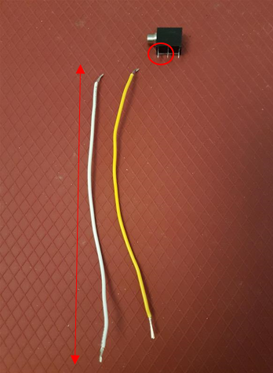 | - Cut two pieces of wire about 15 cm long. Using wire strippers, remove the plastic insulation from the last 1 cm on both ends of each wire

Step 5
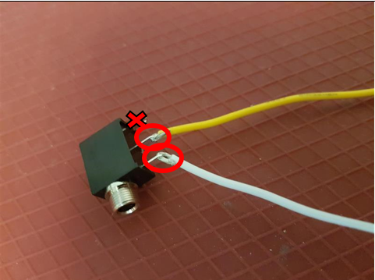 | - Pick one wire, slide exposed wire into first metal arm on mono jack (the arm closest to the circular jack)  - With second wire, slide one end of exposed wire into the middle metal arm on mono jack  - Solder wire to mono jack  - Please Note: Check that you have the correct metal arms of mono jack, refer to picture

Step 6
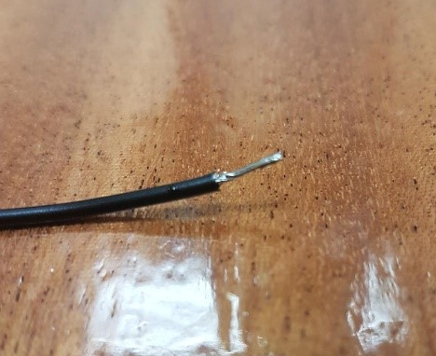 | - Tin the ends of your wire. The best way to do this is cover the exposed wire end in solder  - This will help you stick the wires to an existing spot where there is solder

Step 7
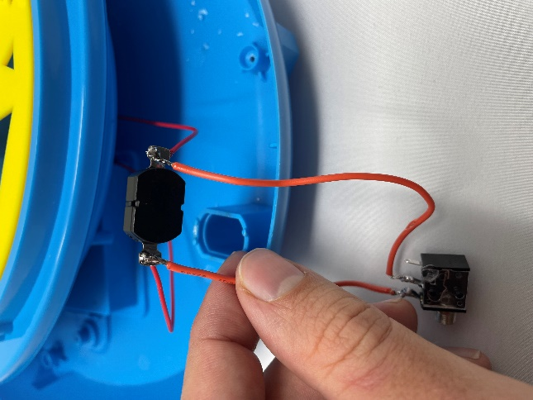 | - You will now connect the wires to the original switch  - While holding one wire end (which you just tinned) onto the metal tab, use your iron to heat up the original solder and the new solder, merging the solder  - Let the solder dry, leaving the original wire and new wire attached to the original switch  Important: Add batteries and test that your toy works with your assistive switch

Step 8
  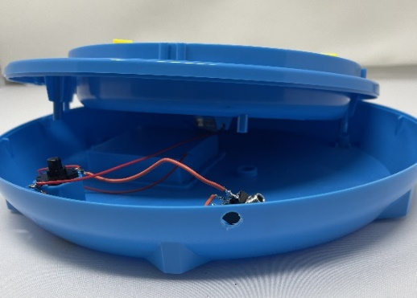 | - Drill a hole in the plastic enclosure with a ¼” drill bit, in the location noted in the picture

Step 9
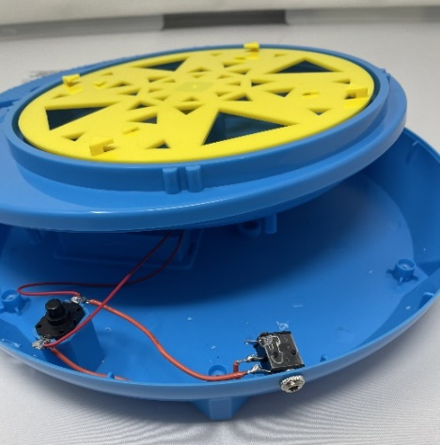 | - Push the jack through the enclosure and install the Jack Nut on the outside  - This will keep the jack in place during use

Step 10
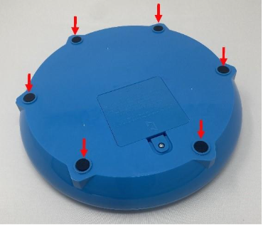 | - Place the yellow switch cap, then using the Phillips head screwdriver, reinstall the six screws

Step 11
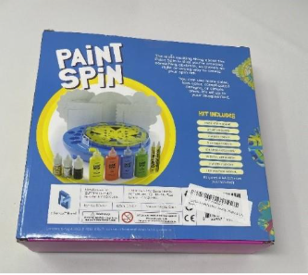 | - Carefully re-box the toy into its original packaging and secure the top flap with Clear Tape.

