Required Components
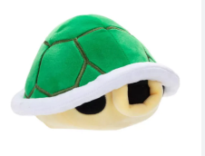  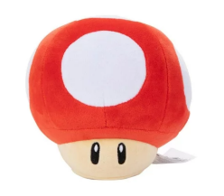  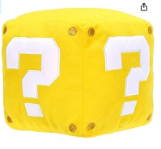 |  | BOM  - Nintendo Toy: Green Shell, Super Mushroom, or Question Block  - 7” cable with 3.5 mm jack (female) end  - Cable tie (small – around 15 cm is good)  Refer to the Tool and Component List for purchasing details.
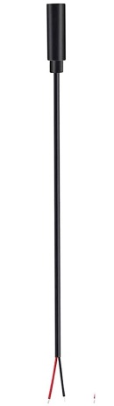 | 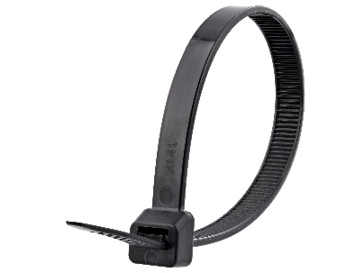

Required Tools
- Phillip screwdriver
- Wire strippers
- Flush cutters
- Soldering iron and solder
- Drill and1/8 drill bit

Required Personal Protective Equipment (PPE)
- Safety glasses

Assembly Instructions
- To start, pull the inside compartment from inside the toy  - Unscrew the screws in the four corners, this will allow you to take the two halves of this compartment apart and reveal the inside. | 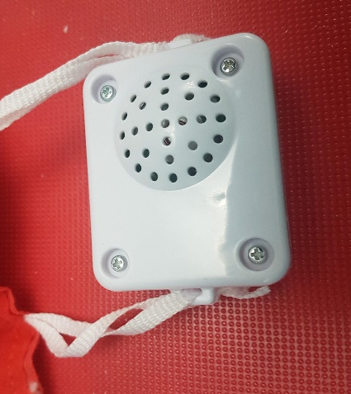
- Lay the two parts flat but be gentle as to not pull the wires from any connections. Other parts may move when you open the compartment so play close attention to where parts go. | 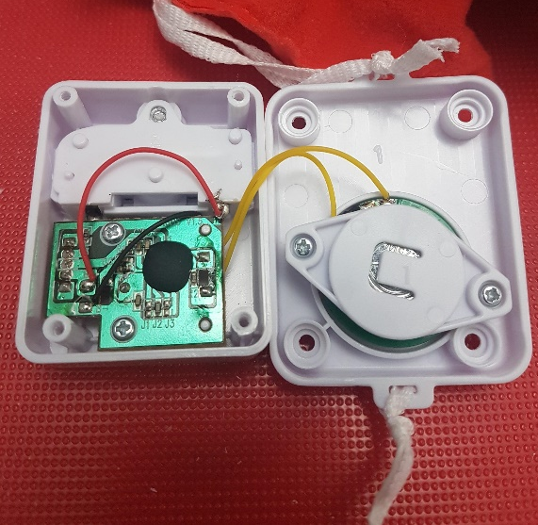
- This toy will be adapted via cable. To do this, drill a hole with a 1/8 drill bit in the side of the compartment.  The cable will be threaded through this hole so you can check that the cable fits and that there is enough room for the cable and the compartment to be closed again. | 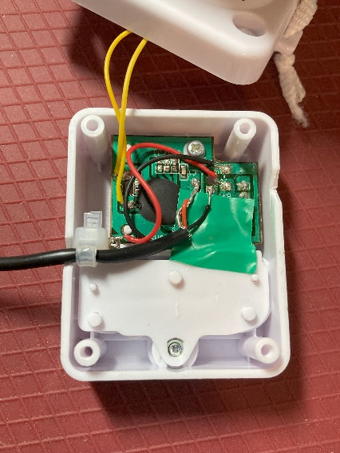
- Before threading through the compartment, we can prepare the cable. Using the open end, or cut end, of your wire strip approximately 2 cm of the outside wire. This will reveal the wires on the inside. (Depending on your cable, this may already be done)
- Next strip approximately 0.5 cm of the individual internal wires
- Tin the ends of your wire. The best way to do this is cover the exposed wire end in solder. This will help you solder onto the board later. | 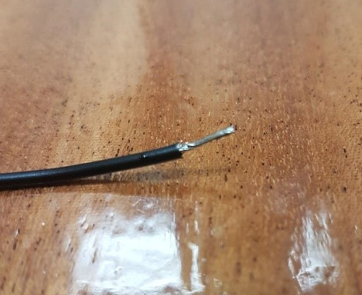
- Thread the end of the cable through the drilled hole. You want the open end, or the end showing internal wires to be inside the compartment. You will be soldering these wires onto the board. | 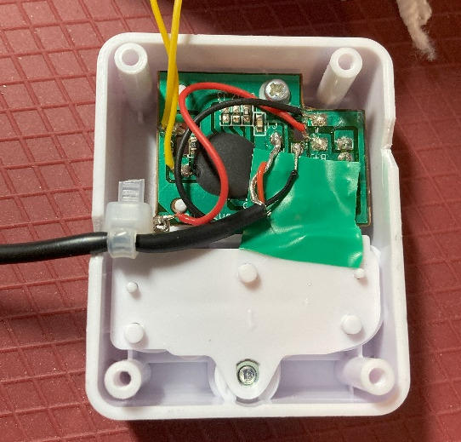
- To access the spots you will be soldering into, you will need to move 2 original wires to the side. Do this gently, and tape them to the side.  The spots you will be soldering you new on are indicated in circles. | 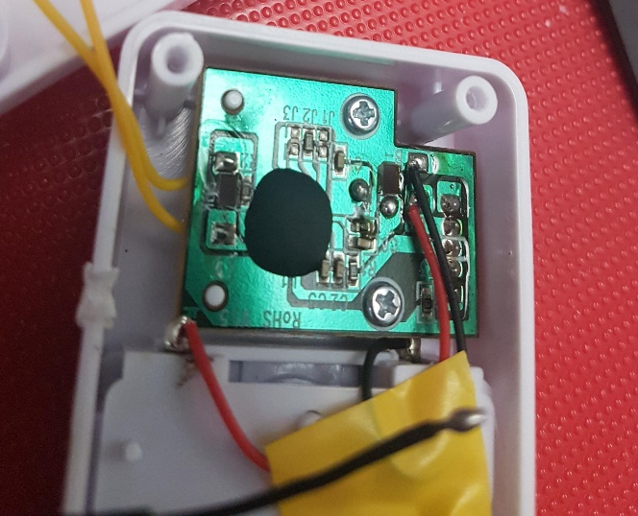
- To solder your wires, add a small blob of solder to the spot on the board. Then, while holding the end of the wire to the spot, use your iron to heat the spot and solder already on the wire and board. When you lift your iron, the wire should stay connected to the board.  - Solder the other wire on to the other spot indicated on the board. It does not matter which wire is soldered to which spot. | 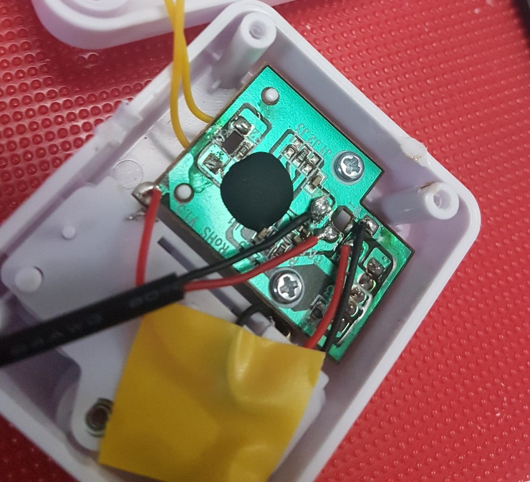
- Once the wire is connected, attach a cable tie to the cable, on the inside of the white case- as close as possible to where it enters. Tighten the cable tie as much as you can.  This cable tie will serve as strain relieve, so that if the cable is pulled it won’t break the solder connections. | 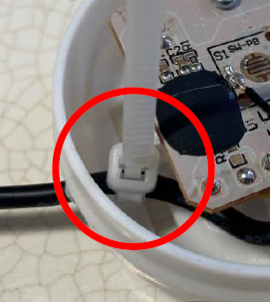
- The toy can now be tested by plugging a switch into the cable.  - Reassemble the compartment with screws and the cable coming out of the side. The compartment can be put back inside the toy, with the cable coming out so a switch can be plugged in without opening the toy back up. | 