Required Components
 | 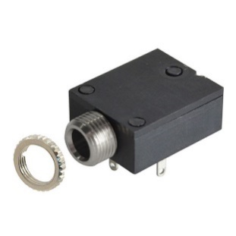 | BOM  - Kid Connection Spinning Light Wand Toy  - Rectangular Mono jack  - PCB Battery Interrupter  - 2 #4 ½” screws  - 3D printed stand, cover and button clamp  Refer to the Tool and Component List for purchasing details.
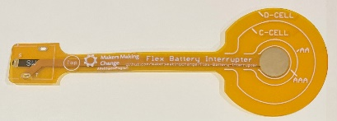 | 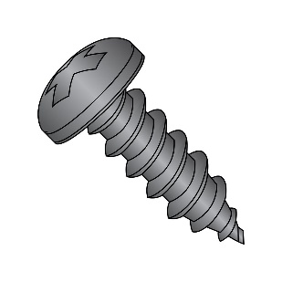
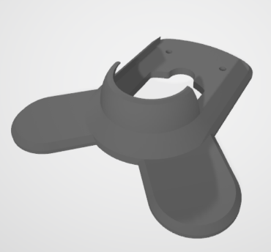
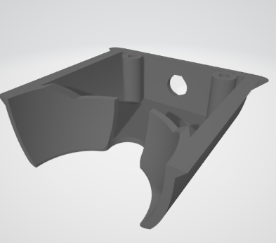

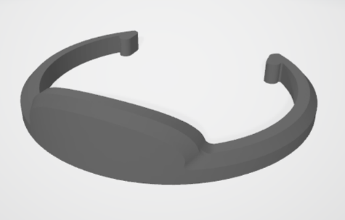

Required Tools
- Screwdriver
- Soldering iron
- Scissors

Required Personal Protective Equipment (PPE)
- Safety Glasses

Assembly Instructions

Step 1
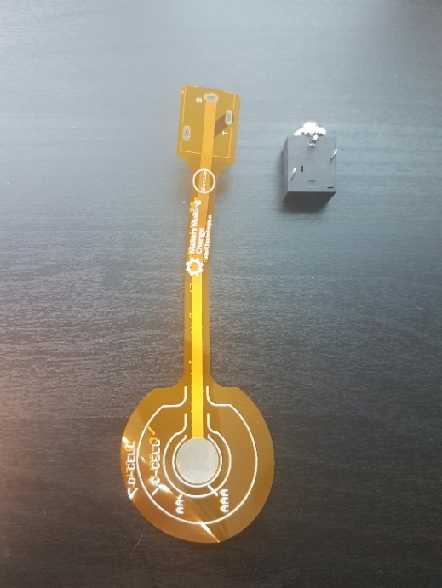 | To start, locate your battery interrupter PCB and mono jack.  You will notice the prongs from the mono jack match up with the holes in the PCB. Lay the battery interrupter on top of the mono jack, with the metal prongs going through the holes.

Step 2
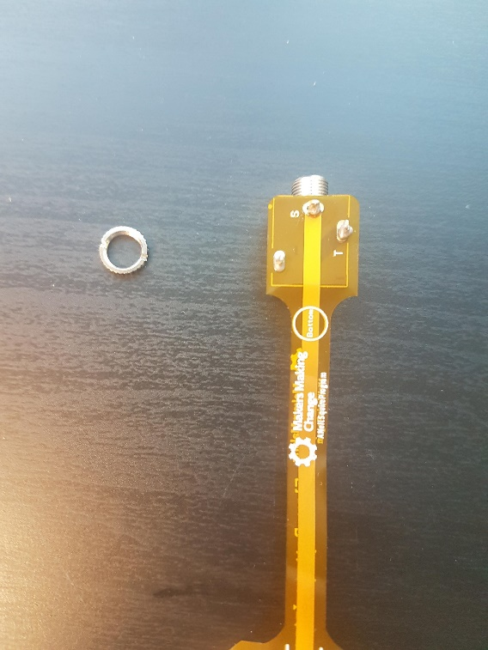 | At the base, add solder to the metal prongs so the PCB and mono jack are connected.  Make sure the PCB is flat against the mono jack as possible  The metal ring, or nut, that is around the input of the mono jack can be removed and set aside.

Step 3
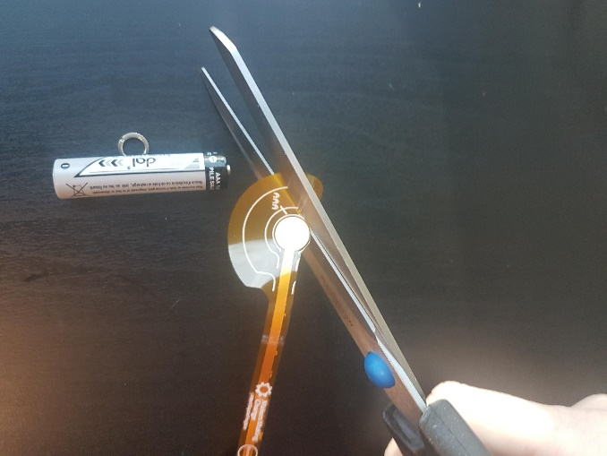 | Check what size the batteries are of the toy you wish to use the interrupter with. This toy uses AAA batteries. There are circles on the orange PCB indicated battery size.  Locate the circle labeled AAA and cut the PCB to that size.

Step 4
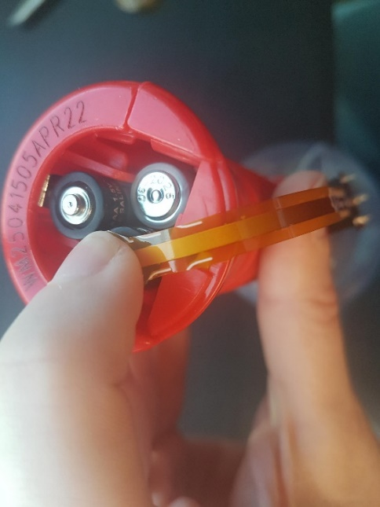 | Unscrew the battery cover from the toy. Match the circle that you just cut with the positive end of one of the batteries. Hold in place and replace the battery cover. Tighten the battery cover very tight to make sure the interrupter is pushed up against the battery.  When it is secure enough, the toy will not turn on with the original button. | 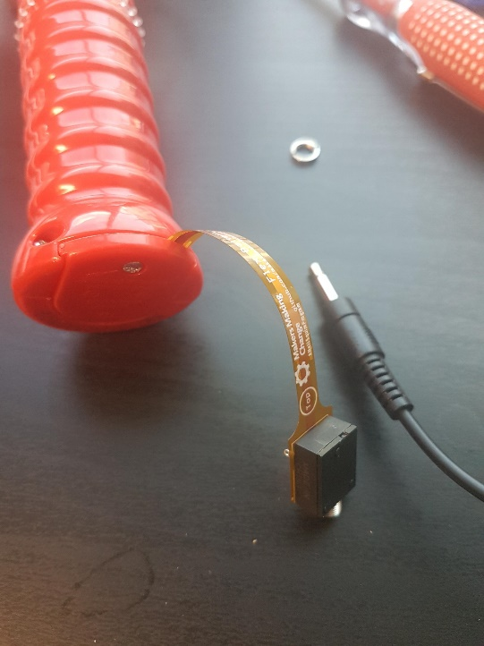

Step 5
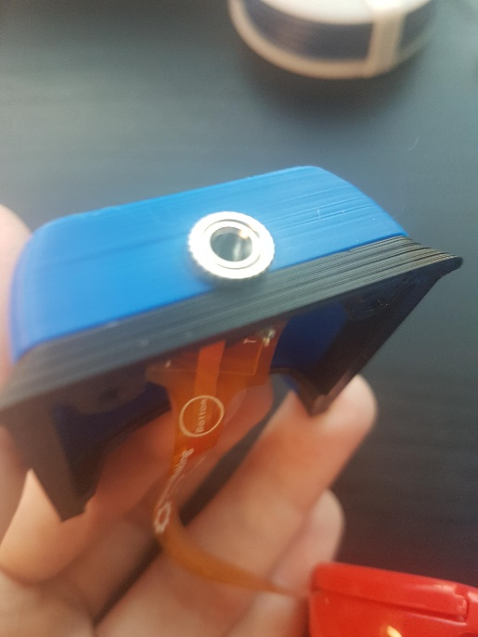 | Locate the 3D printed cover, which will have a hole in one end. Push the input end of the mono jack out of the hole and use the ring or nut (that you previously took off the mono jack) and tighten it around the mono jack. This will hold the mono jack in the 3D printed part.

Step 6
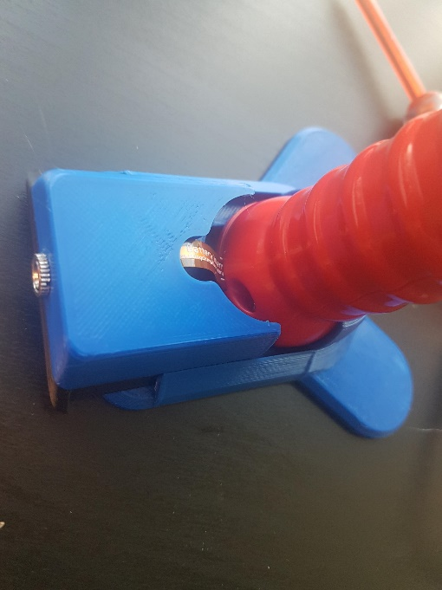 | In the 3D printed stand, stand the spinning wand up. Check to make sure the battery interrupter is not bent or folded and slide the cover into the slot.  When the cover is pushed up against the wand, the toy should stand independently.

Step 7
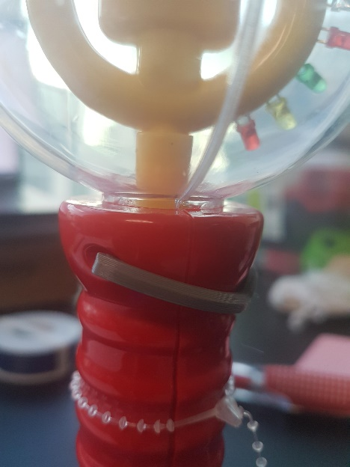 | Next, locate the 3D printed button clamp. The hooks on the ends of the clamp should fit into the screw slot of the toy, and the middle of the clamp should be pushing the toy’s button, so that the toy is stuck in the on position | 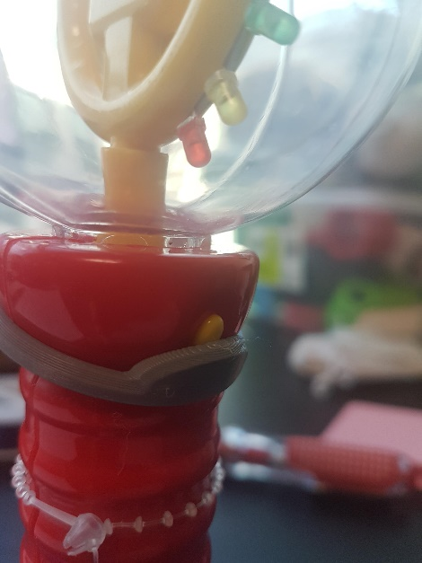

Step 8
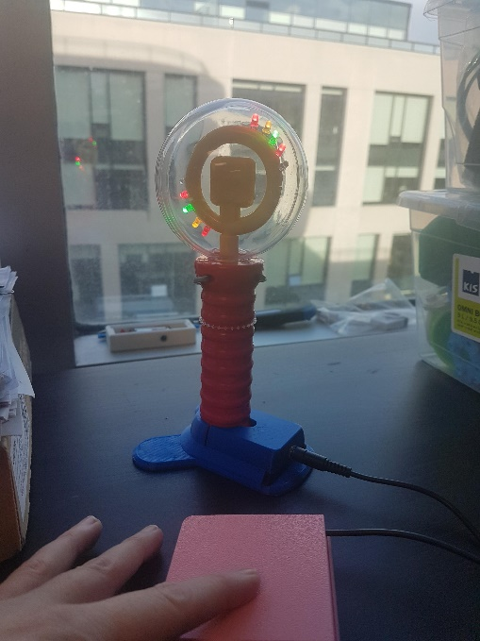 | The toy can now be paired with an assistive switch. When the switch is plugged in and activated, the toy will turn on! The toy should also stand independently.  If the toy does not work, make sure the clamp is pushing the button on, and check the position of the interrupter.

