Required Components
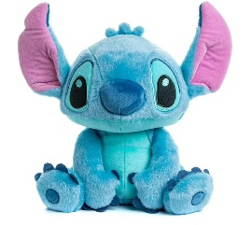 | 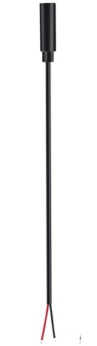 | BOM  - Kids preferred - Laughing and Spinning Stitch Plush Toy  - 7” cable with 3.5 mm jack (female) end  - Cable tie (small – around 15 cm)  - Cable tie (large – around 35 cm  Refer to the Tool and Component List for purchasing details.
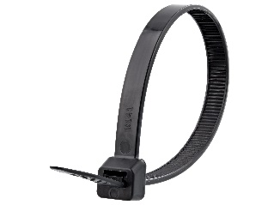 | 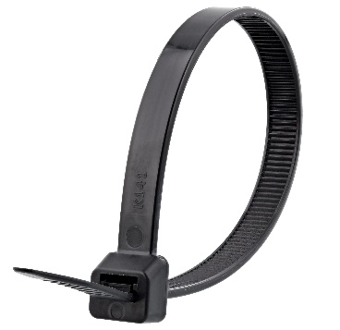

Required Tools
- Phillip screwdriver
- Wire strippers
- Flush cutters
- Soldering iron and solder
- Drill and 1/8” drill bit

Required Personal Protective Equipment (PPE)
- Safety glasses

Assembly Instructions

- To start, locate the original cable tie at the base of the toy. This cable tie is holding the internal plastic compartment inside the toy and is what we need to access to solder. The cable tie will be in the seam of the fabric going around the plastic compartment.  - Find an opening (you may have to snip a bit of fabric) to then snip the cable tie. When this happens, the plastic will be free from the fabric | 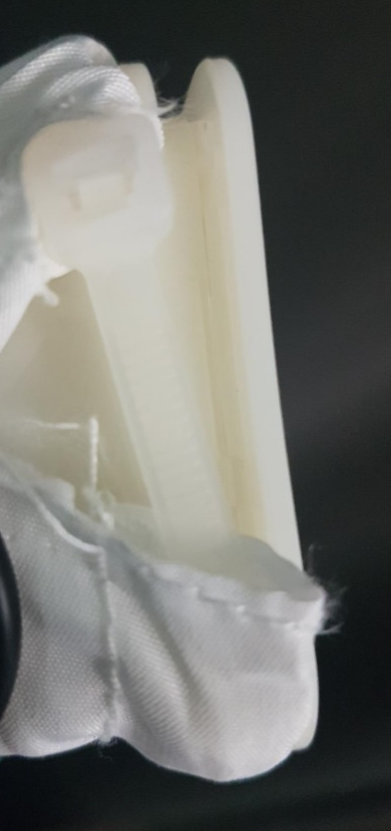
- You can now pull out the internal compartments and mechanics of the toy. There will be loose stuffing so gently pull the compartment out.  - Locate the screws on the back of the compartment and unscrew them to reveal the internal circuit board.  Gently open to reveal the inside electronics. | 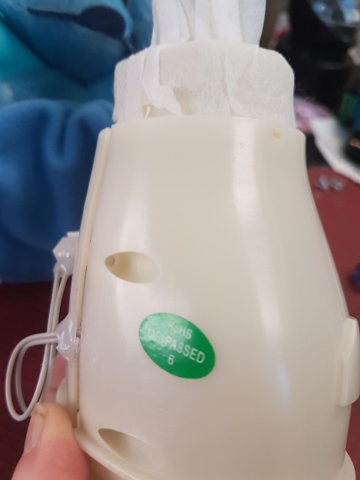
- On the back of the compartment, there is an existing hole that we will use for our mono cable.  We use a mono cable for this toy, so the cable can be accessed externally. Locate this hole, and thread your cable through with your wires being “inside” the toy. Once through, you can also tie your cable in a knot – this will help the cable to not be pulled back through. You may also use your small cable tie for this. | 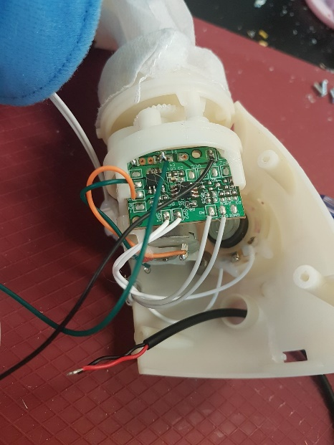
- Next you will prepare your mono cable by tinning your wire. The best way to do this is cover the exposed wire in solder. You will use your soldering iron and melt solder onto the exposed wire end, and this will help you solder onto the board.  Before soldering confirm your cable is through the hole. | 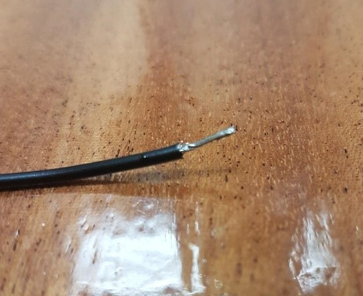
- One the circuit board, you will notice spots that have 4 white wires. You will be attaching your wires from the cable to the two spots circled in the pictures. Make sure you have the correct spots before soldering.  It also does not matter which cable wire goes to each spot. | 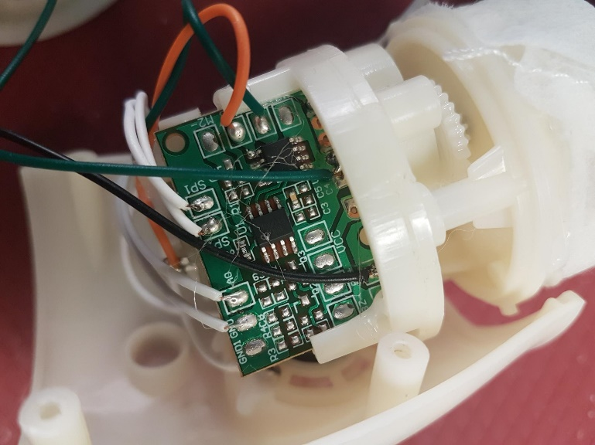
- To connect your new wire: hold your new wire on the spot you wish to connect it to. You can then use your soldering iron to heat up the existing solder on the board and the solder on the end of the wire. When hot, lift your iron but continue holding your wire on the spot. The new and old solder should merge together and dry as one spot, leaving your new wire and the original wire on the board.  Be careful to keep the solder to just the small spots on the board and to not combine with any other spots on the board. | 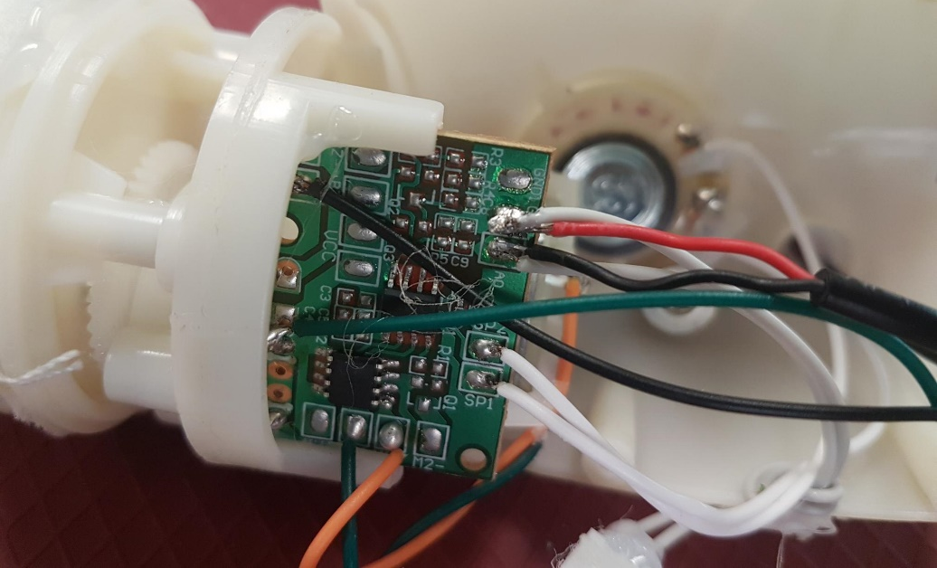
- If both new wires are connected to their spots, along with the original white wires, you can not test the toy.  Be careful, this toy has moving parts when activated.  If you had issues with the original wires coming off the board, they will need to stay connected. If this happens, you can solder the end of the original white wire to the end of your new cable wire – then solder them on the board at the same time. | 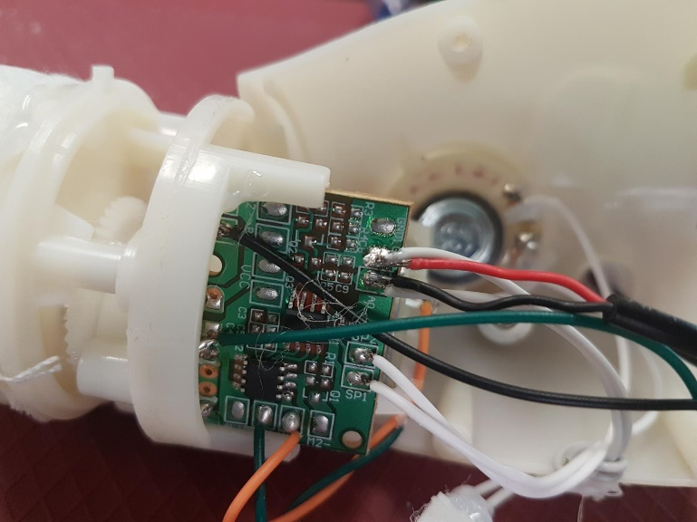
- With the wires connected and the toy tested, you can now reassemble the toy.  - If you did not tie a know in the cable, you can attach your small cable tie around your cable – make sure the cable tie is inside the toy.  - Carefully reassemble the toy, including screws, and make sure everything is in the correct spot. | 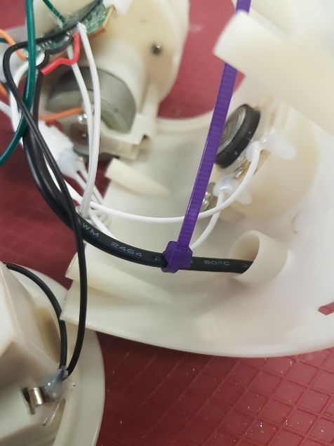
- When you have the internal compartment back inside the toy, you will need to replace the large cable tie.  - Remove the original cable tie if you have not already. Locate your large tie and thread it through the seam in the fabric. Tighten the cable tie so it is secure, keeping the internal compartment inside the toy.  - Make sure your cable is able to be accessed. | 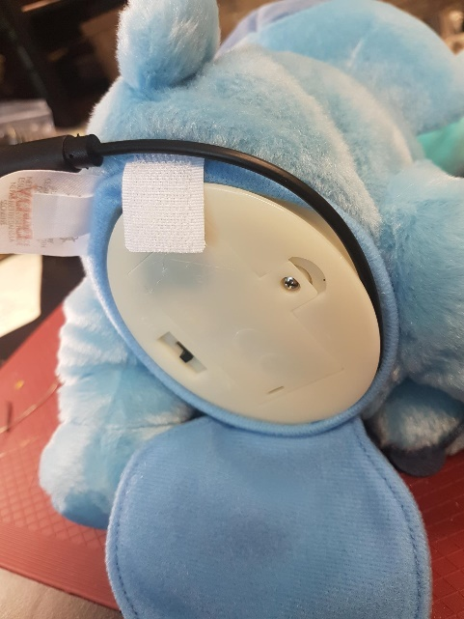
Your toy is now complete!

