Required Components
1. 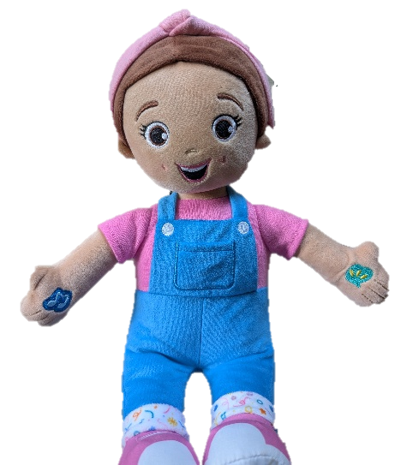 | 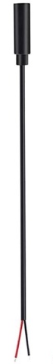  2. | 3.  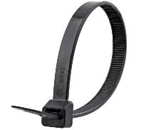  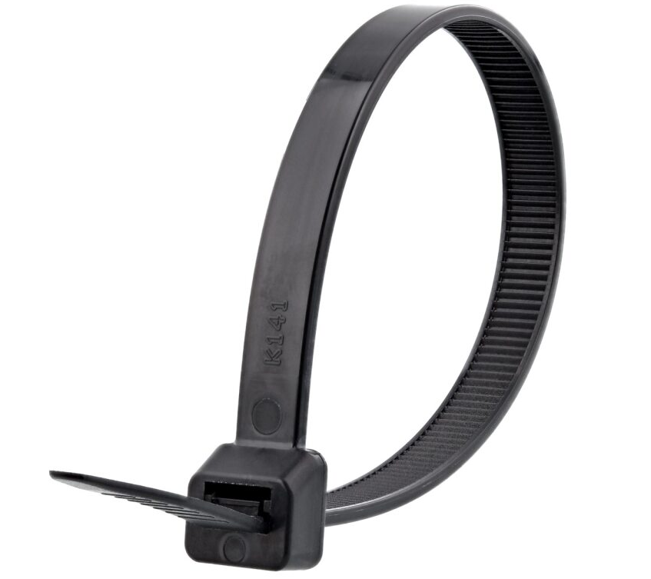 | BOM  - Ms. Rachel Speak and Sing Toy  - 3.5mm Female Mono Cable (x2)  - Cable Tie (x2)  Refer to the Tool and Component List for purchasing details.

Required Tools
- Wire strippers
- Soldering iron and solder
- Flush Cutters
- Electrical Tape
- Seam ripper

Required Personal Protective Equipment (PPE)
- Safety glasses

Assembly Instructions
- Carefully remove the toy from its packaging without damaging it. Open the hook and loop fastener and pull the plastic box out of the back of the toy. | 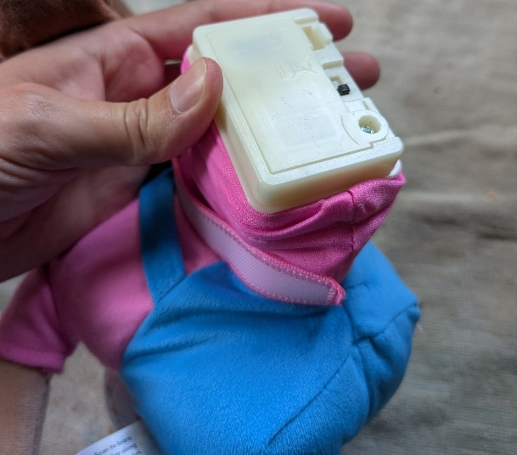
- Using the seam ripper, open a hole in the fabric below the plastic box, and pull the two wires that lead into the box out of the hole | 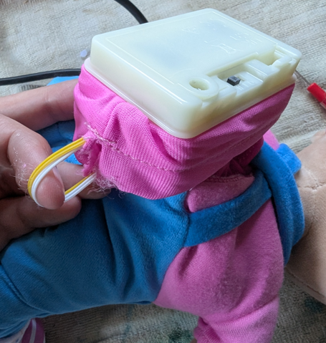
- Using the flush cutters or wire strippers, cut both wires in half, about an inch and a half from the plastic box. | 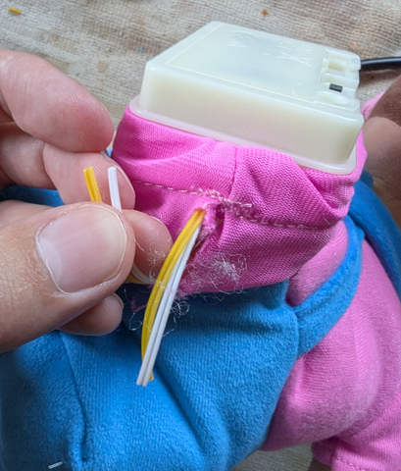
- Using wire strippers, strip both ends of each of the cut wires, and separate the two strands in each wire half an inch down the wire. | 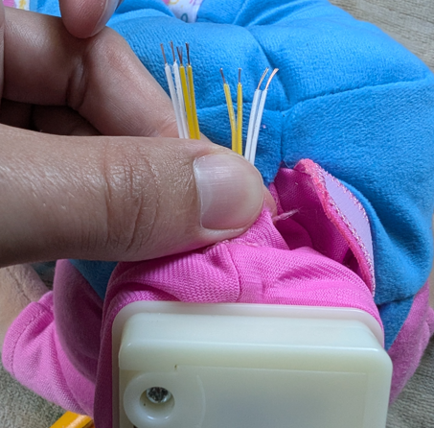
- Take the mono cables, using the wire strippers, strip approximately 2 cm of the outer wire casing, revealing the internal wires.  Skip this if the two internal wires are already showing. | 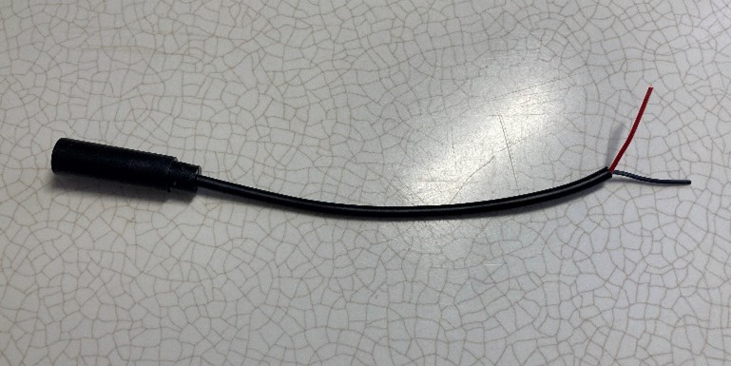
- If there are 2 internal wires, strip approximately 0.5 cm of each wire.  Skip this step if the internal wires have already been stripped, and the metal is exposed. | 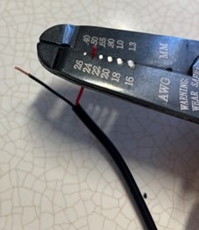
- If there are three internal wires (red, black, and exposed), strip off 1.5 cm of the red insulation and twist the red wire and exposed wire together. Strip 0.5 cm from the black wire. | 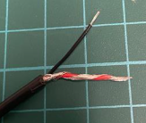  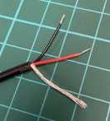
- Melt a small amount of solder over the exposed ends of the wire. | 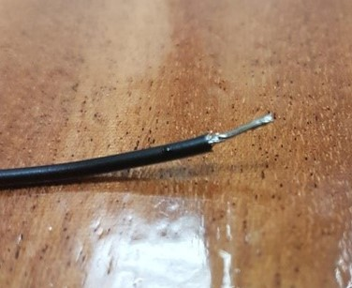
- Take a wire that leads to the box, and a wire of the same colour from the side that was cut. Twist these two wires together with one of the wires from the mono cable, then solder the three wires together. | 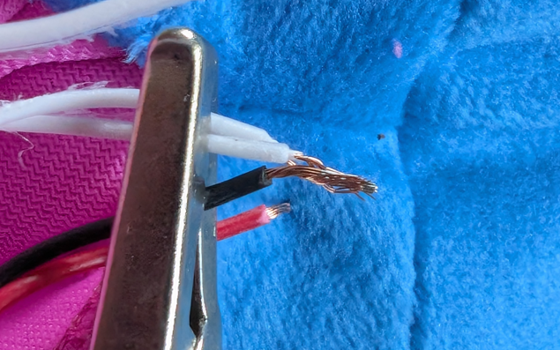  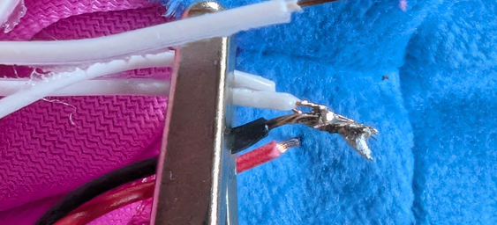

- Take a one-inch piece of electrical tape, and wrap it around the solder joint to insulate it. Pinch the wrapped piece of tape to help squish it in place. | 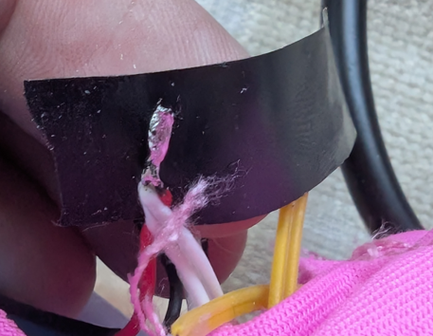  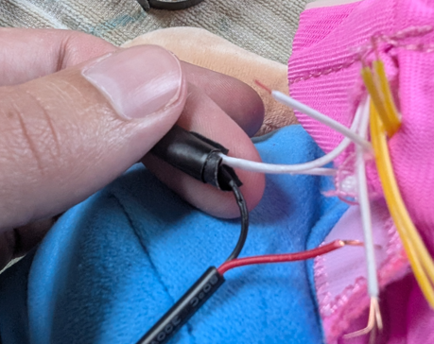
- Repeat the previous two steps for each of the wires. At the end of this step, the wires that were cut in half in step 4 should be soldered back together with the mono cable spliced in.  Each mono cable should connect only to one colour of wire. For each cable, the black wire should connect to each side of a cut wire, and the red to each side of the other cut wire of that colour.  At this point, test the toy with a switch to verify that the mono cables work. | 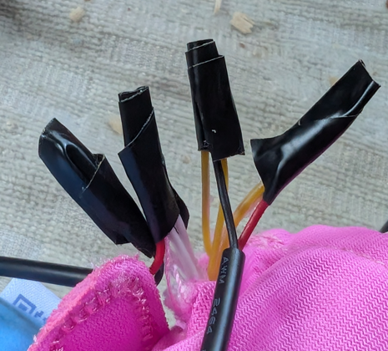
- Take the cable ties and tie each mono cable to the cable that it is spliced to. Pull each cable tie tight and use the flush cutters to trim off the ends. | 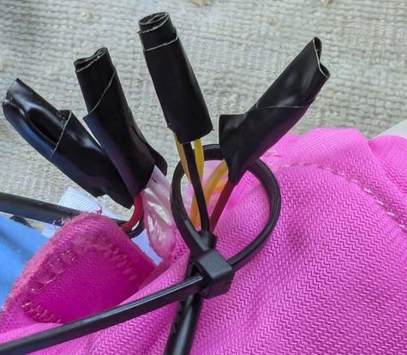  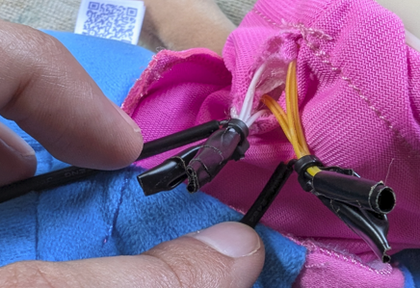
- Tuck the original cables and the spliced joints back through the hole in the fabric. | 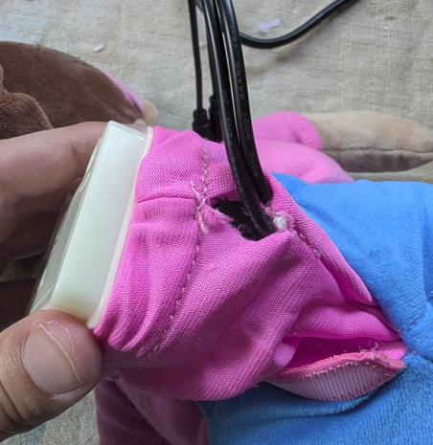
- Tuck the plastic box back into the toy, and refasten the back, tucking the mono cables out the bottom of the hole | 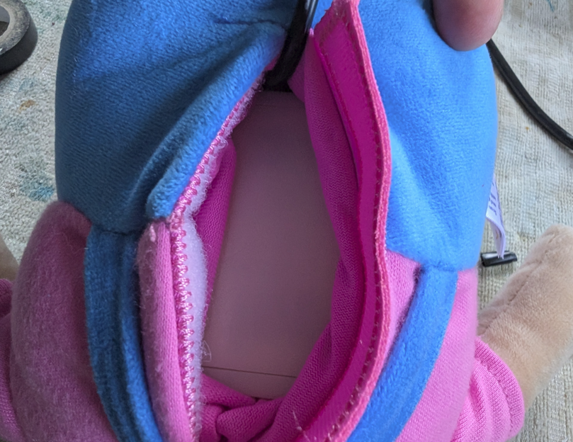  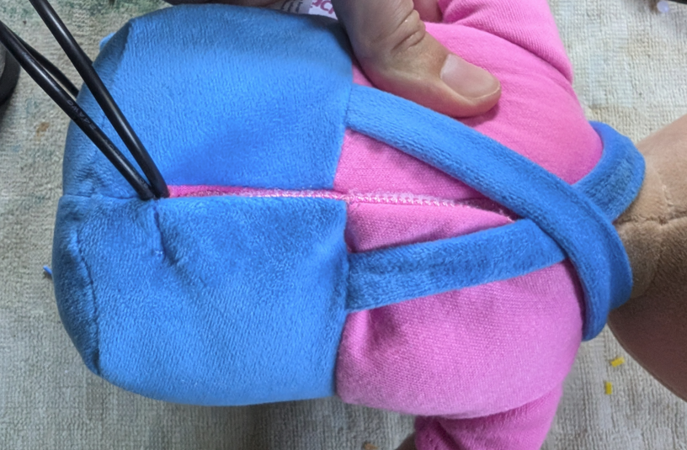
- Test the toy again. If it is still working properly, repackage the toy and the adapted toy is complete! | 