Required Components
 | 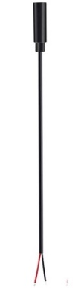 | BOM  - PlaySkool Explore ‘N Grow Busy Gears Toy  - 3.5mm Female Mono Cable  Refer to the Tool and Component List for purchasing details.

Required Tools
- Small Phillips screwdriver
- Drill and 1/8” drill bit
- Wire strippers
- Soldering iron and solder
- File (optional)

Required Personal Protective Equipment (PPE)
- Safety glasses

Assembly Instructions
- Turn over the Busy Gears and remove all 10 screws.  Remove the blue cover to reveal the inside compartment.  Note: The red and black wires connected to the battery pack are easy to accidentally disconnect. Disconnections require re-soldering. | 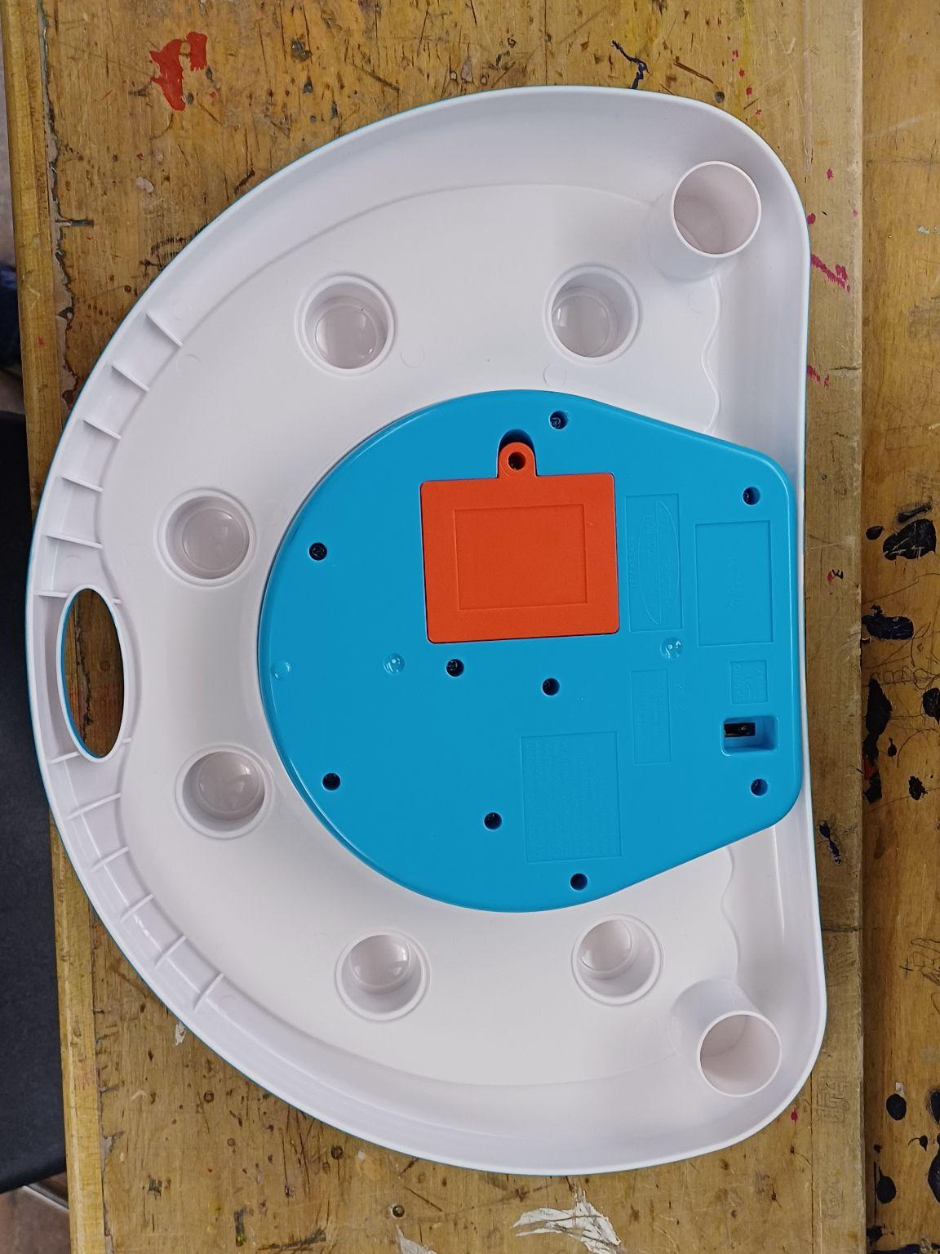
- Remove the two screws holding the circuit board down (highlighted in red).  Flip the circuit board over. | 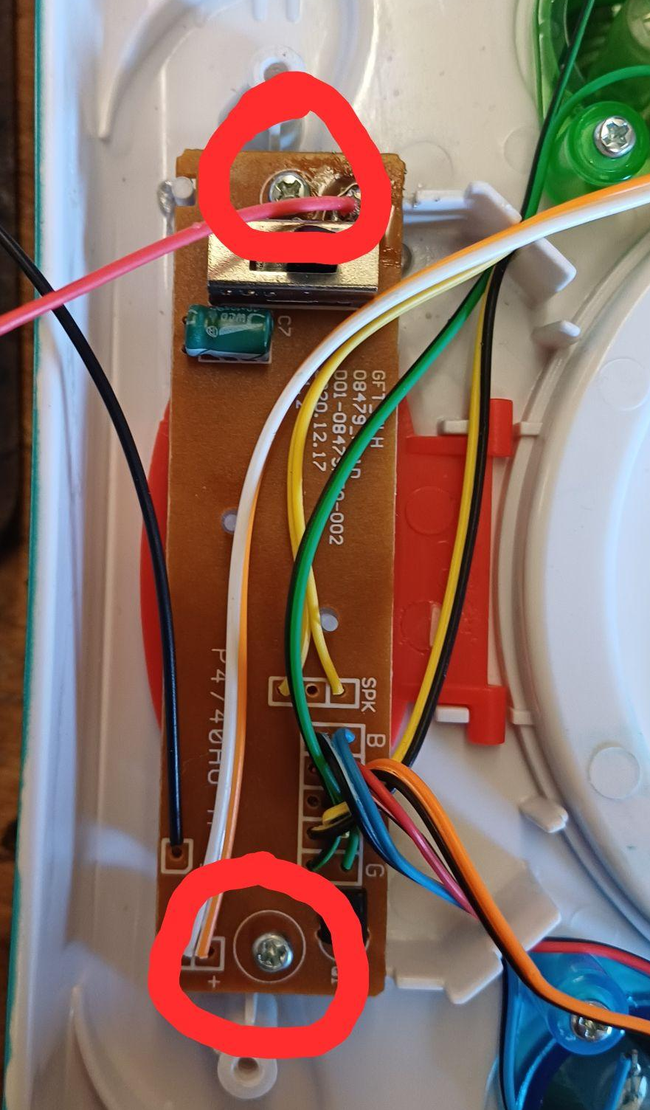
- Remove the silicone button circled in red. You should be able to pull the two silicone legs out of the small holes. | 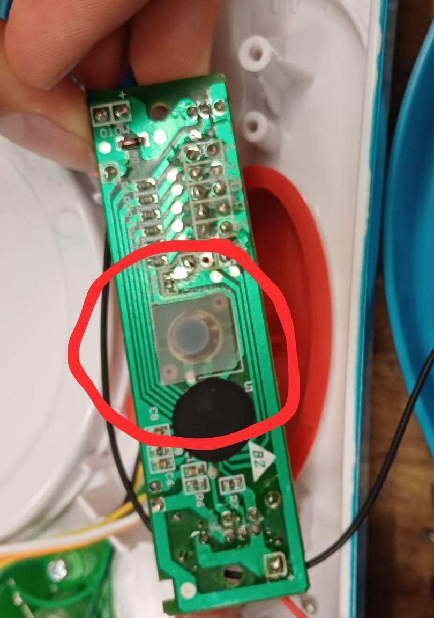
- Strip 2 cm off of the cable using a wire stripper, revealing small wires inside. | 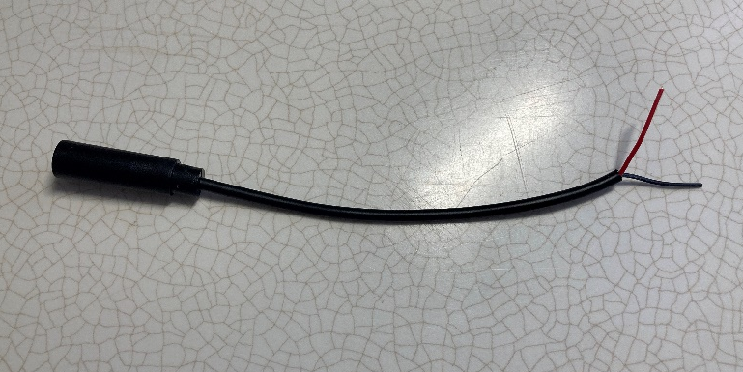  2 cm
- Strip approximately 0.5cm off of the small wires.  Note: if there are 3 wires, strip all the wires first then twist the ends of the Tip and Ring wires together. | 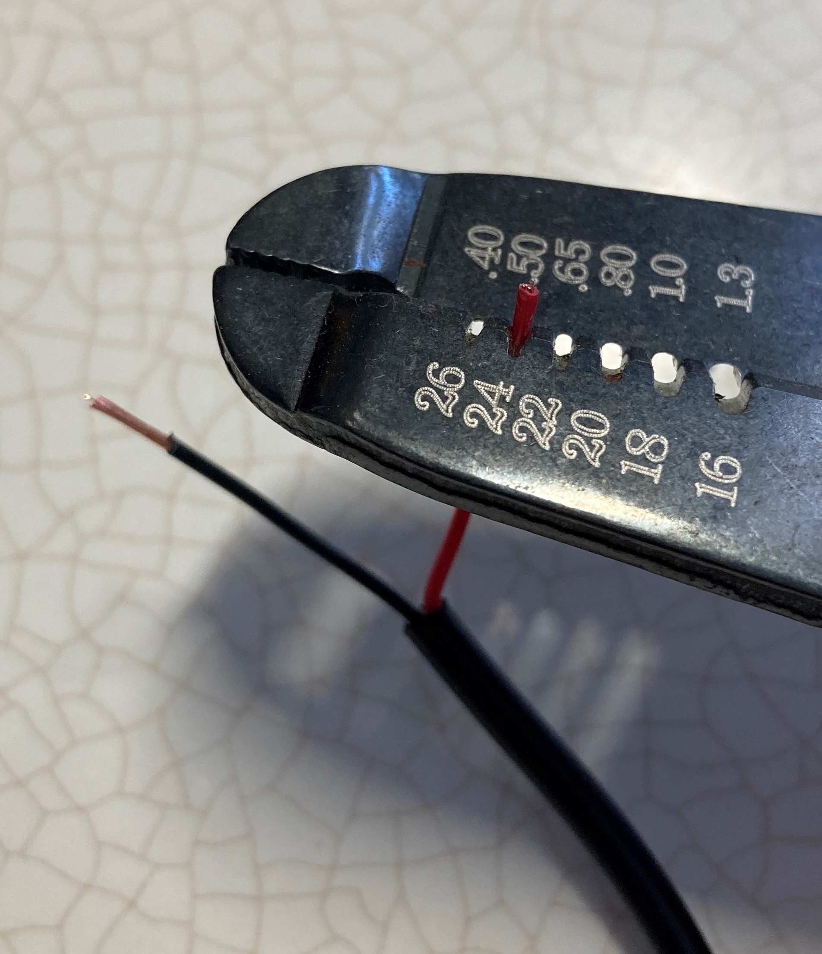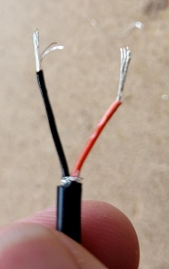
- Prior to soldering to the device, tin your wire. The best way to do this is cover the exposed wire end in solder. | 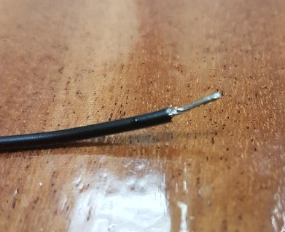
- Solder the two wires of the jack onto the circuit board as shown. Any wire of the two wires will work.  Note: It is easy to melt the board; use caution. | 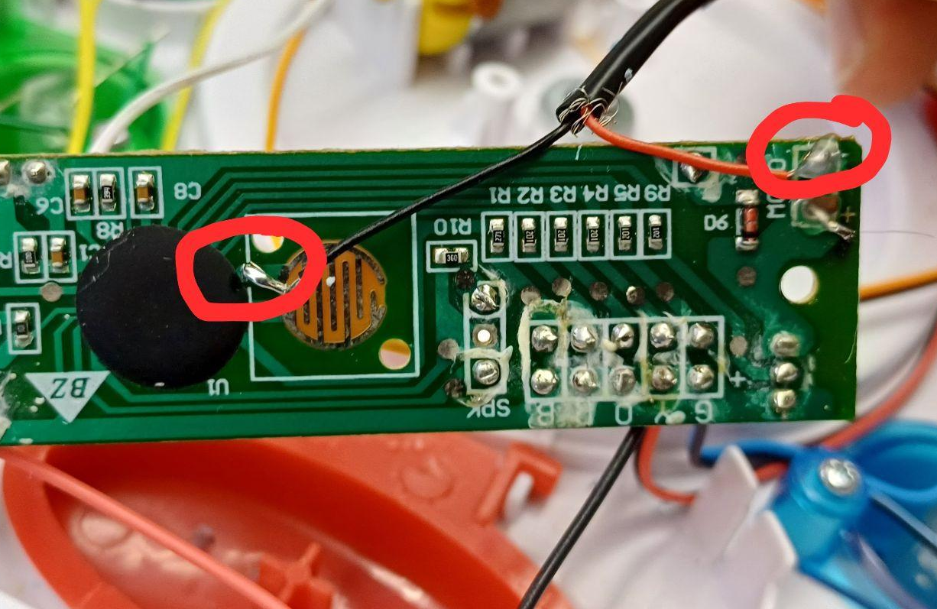
- Drill a small notch along the edge of the casing for the cable. Smooth out with a file if necessary.  Slot the cable into the notch with the female jack sticking out of the toy. | 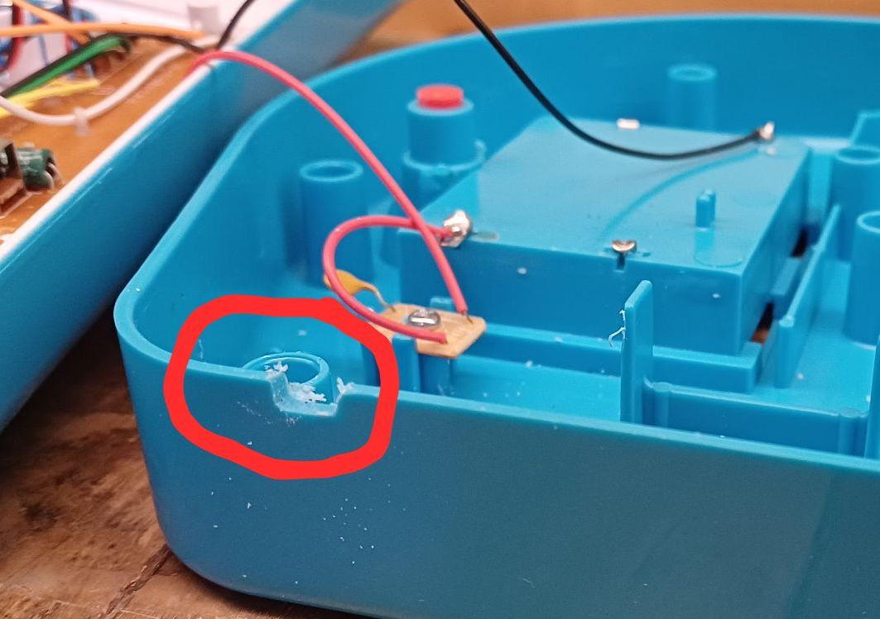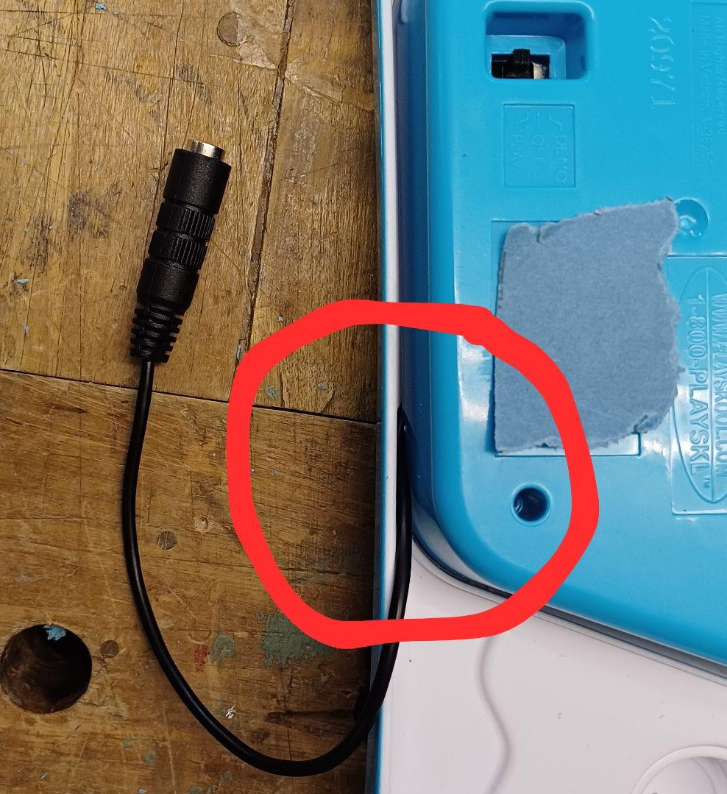
- Plug in an assistive switch and test.  If the toy doesn’t turn on when the switch is activated, open the toy back up and check all the solder connections. | 