Required Components
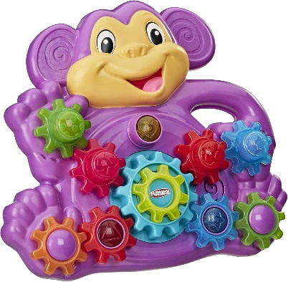 | 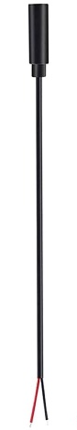 | BOM  - Playskool Stack ‘n Spin Monkey Gears Toy  - Female/Male Mono Cable  - Cable Tie  - AA Batteries (x3)  Refer to the Tool and Component List for purchasing details.
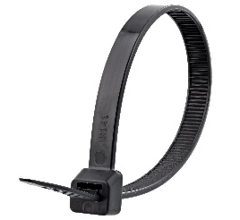 | 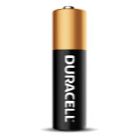  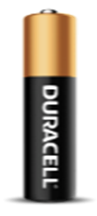

Required Tools
- Flat head screwdriver
- Possibly a Triangle Screwdriver
- Wire strippers
- Soldering iron and solder
- No Clean Flux Paste
- Drill and 1/8” drill bit
- Glue Gun

Required Personal Protective Equipment (PPE)
- Safety glasses

Assembly Instructions
- Flip the toy over and remove the screws on the back panel. Place screws in a safe space for reassembly.  Note: Some of the screws may be a TA Triangle Screw that can be removed with a Triangle Head Screwdriver | 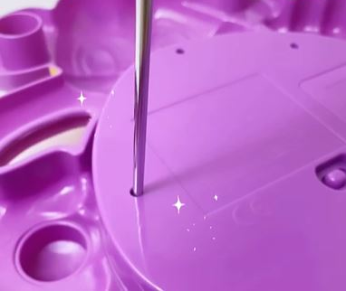
- Carefully lift and remove the back panel of the toy. | 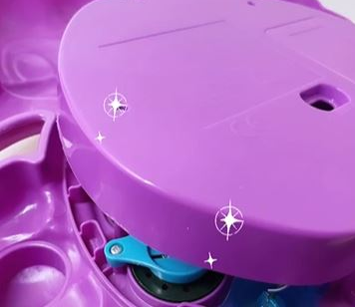
- With a 1/8 drill bit, drill a hole on the side of the back panel.  Note: Ensure you are drilling in a spot that won’t impact reassembly. | 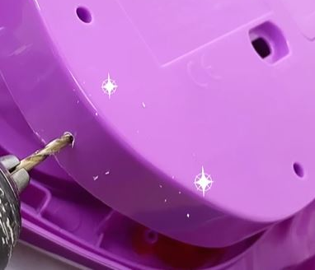
- Thread the female cable through the pre-drilled hole.  Note: some cables come pre-wire stripped. If not please wire strip your cables. | 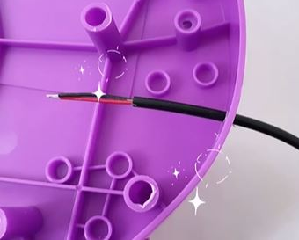
- On the base of the toy find the circuit board and remove the two remaining screws and the pink power switch. Put the screws and switch in a safe space for reassembly. | 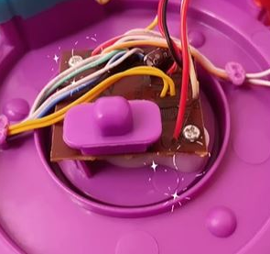
- Turn the circuit board over. In the image you will see the button we will solder to by the circle on the image. There will be a silicone cover on it. Please remove.  - Dab flux on the two contact points.  Add a small globe of solder to the two spots. | 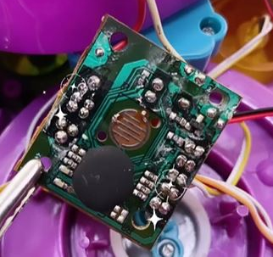
- Tin each exposed end of wire with solder. | 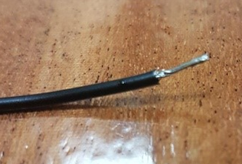
- Solder the two wires to either side of the button contacts.  Note: colour does not matter to each spot. | 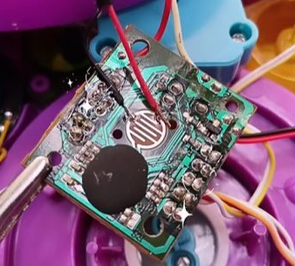
- To help hold the connection add glue to the soldered points. | 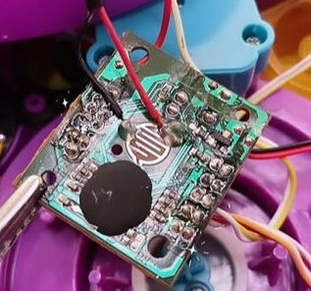
- Flip the circuit board right side up. Reinstall the two screws and the power switch. | 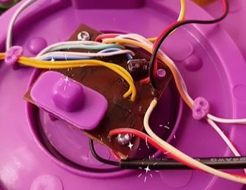
- Add a small zip tie to the female cable to prevent it from being pulled out. | 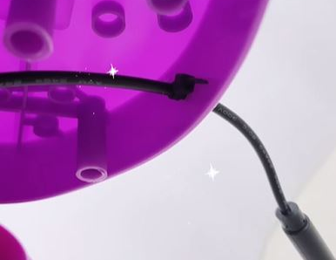
- Reassemble the screws. | 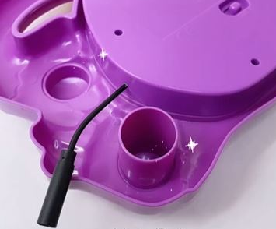
- Test Toy!

